My analysis was focused on Global and USA COVID 19 data including cases, testing, vaccination numbers etc. for each country.

Covid is the pandemic which took many lives and disrupt whole world’s economy as well as individual social life style. So, I thought to find answers for some of my questions.

This helped me to find answers of my own questions and also it may help many of us to understand how one pandemic can affect and disrupt whole world’s economy as well as creating supply chain problems and effect people’s lifestyle and many more. This also helps to identify needs of vaccination and testing across the developing countries to control the pandemic.

Health professionals, governments uses the outcome of this analysis to understand focus area e.g which country/state having covid surge to understand diff patterns. This also gives government clear understanding on where to focus to contain the pandemic. Government and health care professionals plays critical role in this pandemic to keep everyone safe with proper safety guidelines, medications, vaccination, testing etc..

I had below questions before I started working on this analysis.

1. which country most effected by covid pandemic with higher mortality rate (although this doesn't consider population factor) -

2. which state within US effected the most? -

3. which country had most fully vaccinated people? -

4. which area of the world has more need of vaccination? -

5. are all does administer to ensure people are fully vaccinated?

**Data** - I used data sources from Johns Hopkins University of Medicine. They have different set of datasets online on their website (https://coronavirus.jhu.edu/about/how-to-use-our-data) - Cases and Deaths, Vaccinations, Testing etc. This data was significantly helpful to derive the analysis on Covid.

I wanted to analyze how efficiently vaccination is administered across the globe. How Testing proactively helping people and % of outcome coming positive.

I always believed that US was the top most country administering vaccination however I derived that India was the country which was on top of the chart with ~4 bn doses - That is also India is one of the populated countries hence vaccination needs are much higher compared to US.

**Covid 19 Global Analysis**

**Global Case Analysis**

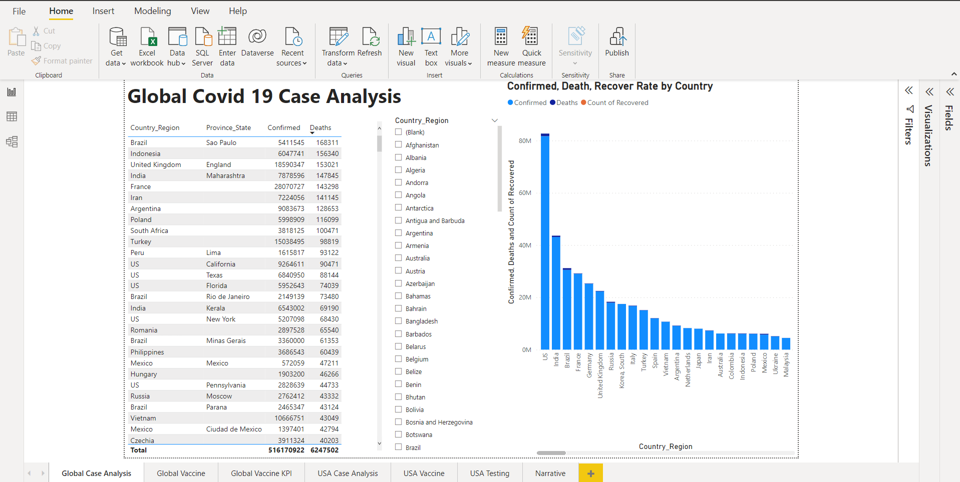

**Global Vaccine Analysis**

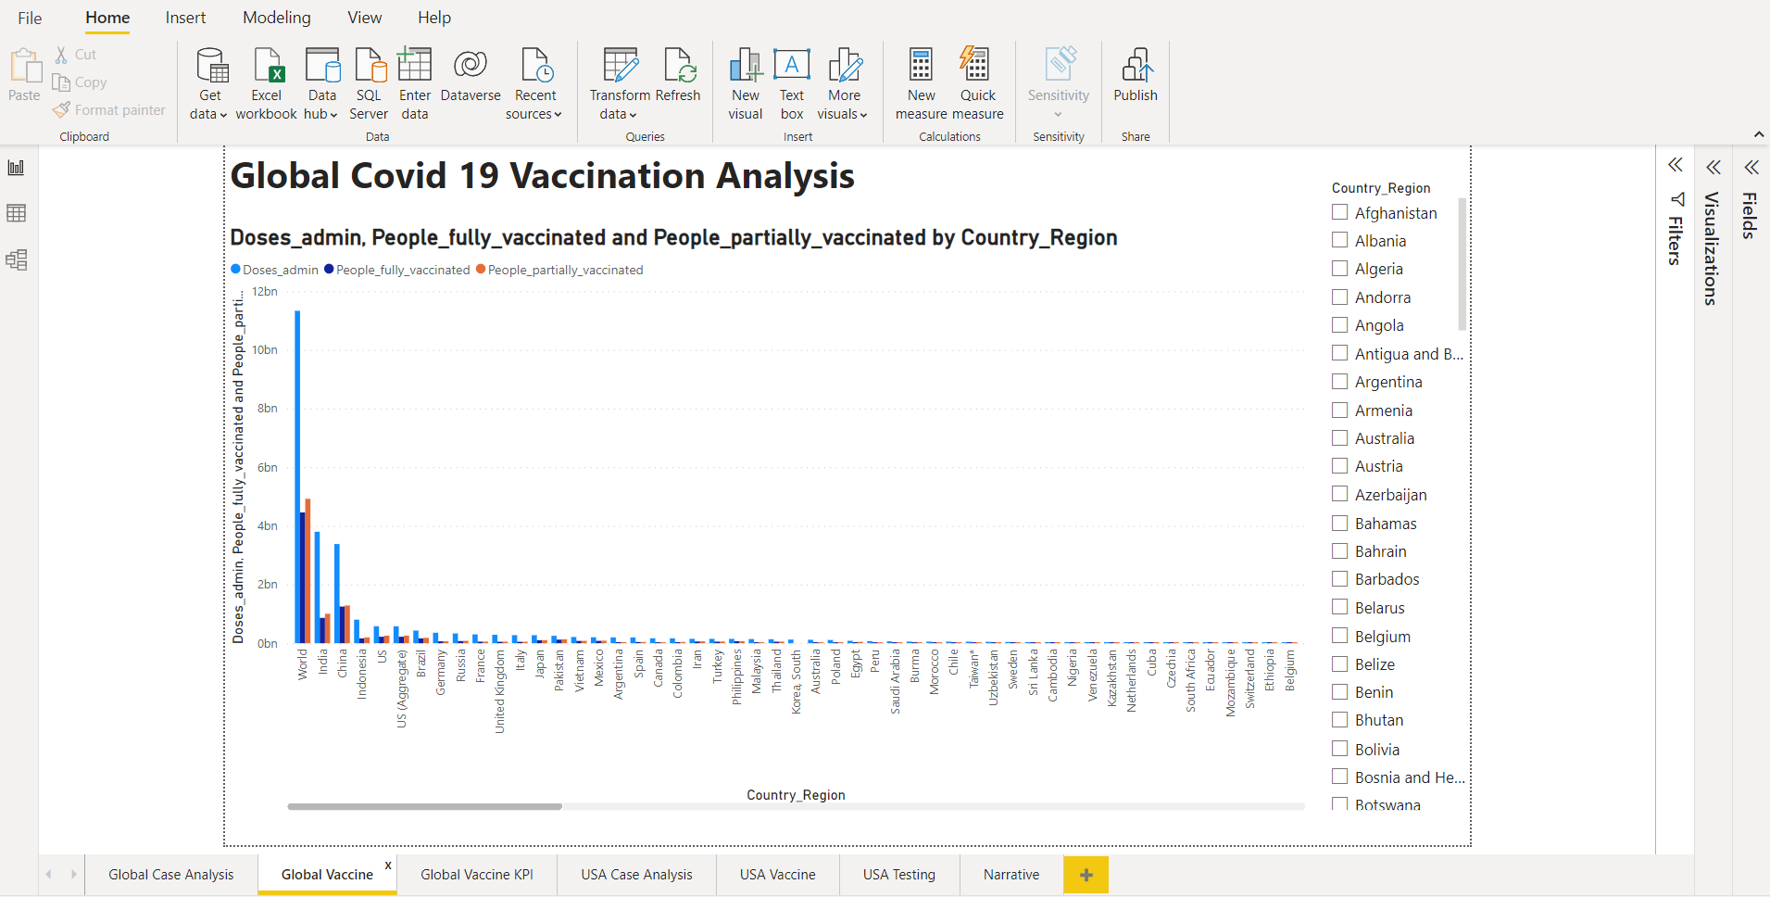

**Global Vaccine KPI**

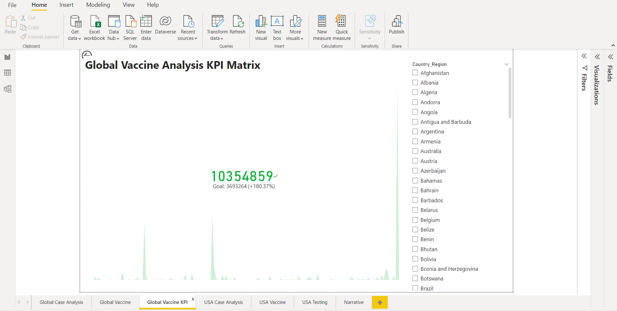

**USA Case Analysis**

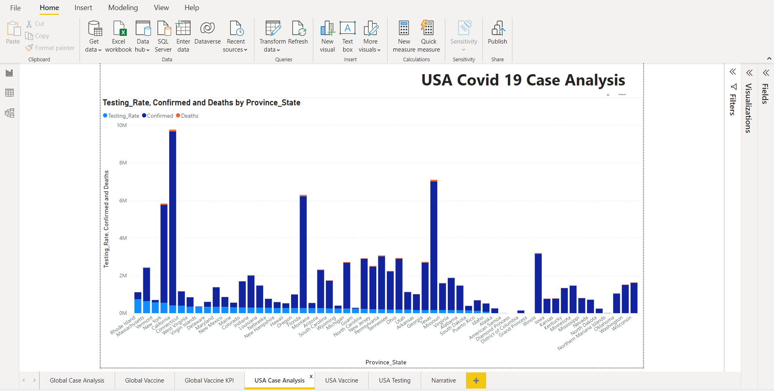

**USA Vaccine Analysis**

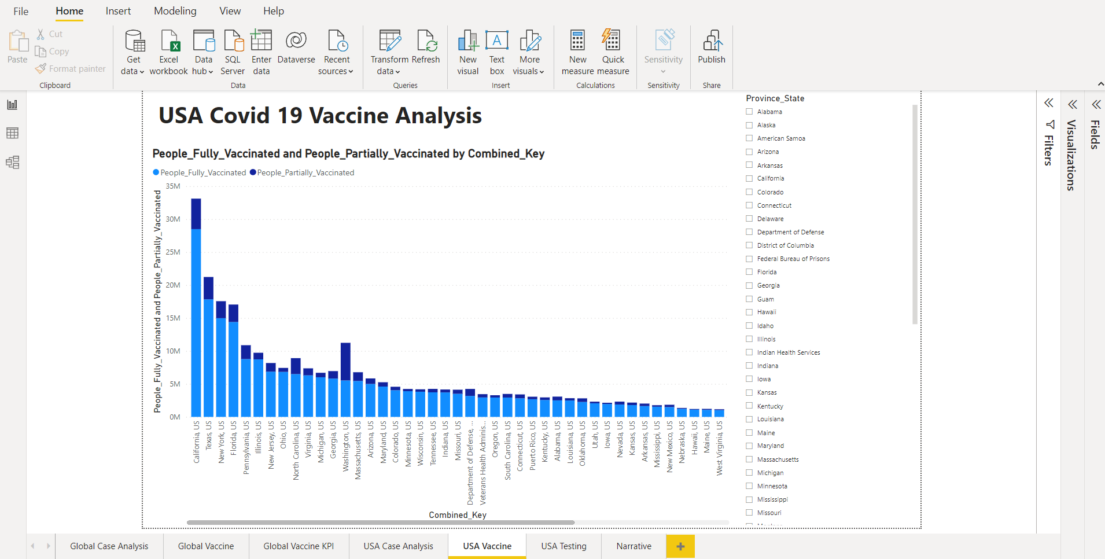

**USA Testing Analysis**

