CAPSTONE PROJECT 1
Shop Sense Analytics
Customer Shopping Behavior Analysis Project
Customer Shopping Behavior Analysis Using PostgreSQL, Python, and Power BI
An End-to-End Data Analytics and Database Management Project Report
INSTITUTE
APPONIX Bangalore
DATE
June 23, 2026
Dataset: Customer Shopping Behavior Dataset (5,050 customers, 17 variables)

H.THARUN

ACKNOWLEDGEMENT
We sincerely thank our project mentor for the continuous support, guidance, and encouragement provided throughout this project.

Table of Contents
1. Introduction
2. Problem Statement and Objectives
3. Dataset Description
4. Database Design and ER Diagram
5. PostgreSQL Implementation
6. Data Cleaning and Preprocessing
7. Exploratory Data Analysis in Python
8. Detailed Interpretation of Notebook Visuals
9. Power BI Dashboard Analysis: Shopping & Payment Behavior
10. Power BI Dashboard Analysis: Customer & Category Insights
11. Key Findings and Insights
12. Conclusion
13. References
14. Appendix
15. Recommendations

1. Introduction
Understanding how customers shop — what they buy, how they pay, whether they subscribe, and what drives their satisfaction — is central to modern retail analytics. Retailers that can connect purchasing behavior to demographic, seasonal, and payment patterns are better positioned to design loyalty programs, optimize inventory, and tailor marketing investment. This project presents an end-to-end data analytics and database management solution for analyzing a Customer Shopping Behavior dataset covering 5,050 customers and 17 original variables, including demographics, purchase details, payment preferences, subscription status, discount usage, and review ratings.
After initial collection, the dataset was exported as a CSV file and underwent cleaning, validation, and preprocessing to ensure consistency and analytical readiness. To establish a structured and scalable data architecture, the cleaned dataset was loaded into a single normalized PostgreSQL table named BEHAVIOUR, with Customer_ID as the primary key uniquely identifying each customer record.
Following database implementation, Python was used for data loading, inspection, feature engineering, exploratory data analysis (EDA), and statistical visualization. Various analytical techniques were employed to investigate relationships between purchase amount, review ratings, subscription status, discount usage, payment method, shipping type, purchase frequency, and customer demographics such as age and gender.
Finally, Power BI dashboards were developed to transform the analytical findings into interactive and user-friendly visualizations across two dedicated report pages — one focused on shopping and payment behavior, and one focused on customer demographics and category-level performance. The dashboards provide dynamic exploration through slicers for subscription status, discount status, category, and gender, enabling stakeholders to examine revenue, customer counts, and satisfaction trends across different customer segments.
By integrating data collection, relational database design, SQL implementation, Python-based analytics, and business intelligence reporting, this project demonstrates a comprehensive data analytics workflow for deriving meaningful insights from customer shopping data. The findings contribute to a better understanding of which categories, payment methods, and customer segments drive the most revenue, and highlight where spending behavior and customer satisfaction diverge.

2. Problem Statement and Objectives

Problem Statement
Retailers collect large volumes of transaction-level data — purchase amounts, payment methods, subscription status, discounts, and review ratings — but this raw data alone does not generate actionable insight. There is a need for a structured approach that transforms a flat customer shopping survey export into a queryable, analyzable, and visually interpretable resource through effective database management, data analysis, and visualization techniques.
This project addresses this challenge by developing an end-to-end analytics framework that organizes customer shopping data using a relational table in PostgreSQL, performs exploratory data analysis using Python, and presents key findings through interactive Power BI dashboards. The aim is to identify patterns and relationships among purchase amount, category, payment method, subscription status, discount usage, and customer satisfaction to support data-driven retail decision-making.

Objectives
The objectives of this project are:
- Collect and organize customer shopping behavior data, including demographics (age, gender, location), purchase details (item, category, amount, size, color, season), and behavioral indicators (review rating, subscription status, shipping type, discount applied, previous purchases, payment method, purchase frequency).
- Export, clean, and preprocess the collected dataset to ensure data consistency, accuracy, and completeness.
- Develop a relational database schema by organizing the dataset into a single normalized BEHAVIOUR entity within PostgreSQL, with Customer_ID as the primary key.
- Implement the database in PostgreSQL by creating the table, importing the cleaned dataset, and validating successful data integration through SQL queries, including a targeted check for missing Purchase_Amount values.
- Perform exploratory data analysis (EDA) using Python to investigate trends, distributions, and relationships among variables such as purchase amount, review rating, category, subscription status, discount status, and payment method.
- Apply data preprocessing and feature engineering techniques, including Spending_Category, Age_Group, Is_Subscriber, Discount_Status, Rating_Category, Loyalty_Level, and Frequency_Score, to prepare the dataset for meaningful analysis.
- Create informative Matplotlib and Seaborn visualizations to identify key shopping behavior patterns.
- Develop interactive Power BI dashboards across two report pages that provide KPI monitoring, payment and shipping analysis, category and seasonal performance, and customer segment exploration through slicers.
- Generate actionable insights that contribute to understanding which categories, payment methods, and customer segments drive the most revenue and satisfaction, demonstrating the practical application of data analytics techniques in the retail domain.

3. Dataset Description
The source CSV file contains 5,050 customer records and 17 original columns spanning demographics, purchase details, and shopping behavior indicators. After Python feature engineering, seven derived columns were added, bringing the analytical dataframe to 24 columns.
Attribute Group | Columns
Identifiers & Demographics | Customer ID, Age, Gender, Location
Purchase Details | Item Purchased, Category, Purchase Amount, Size, Color, Season
Behavioral Indicators | Review Rating, Subscription Status, Shipping Type, Discount Applied, Previous Purchases, Payment Method, Frequency of Purchases
Engineered Features (Python) | Spending_Category, Age_Group, Is_Subscriber, Discount_Status, Rating_Category, Loyalty_Level, Frequency_Score
Customer age ranges from 18 to 70 years, with a mean of 44.15 and a median of 44.0. The gender distribution contains 3,018 male customers, 1,670 female customers, and 362 customers recorded under an “Other” gender category. The dataset spans 54 unique locations and 30 unique purchased items across five product categories.
Category | Purchase Count
Clothing | 2,130
Accessories | 1,615
Footwear | 607
Electronics | 370
Outerwear | 328
Purchase Amount in the dataset analyzed here ranges from $0 to $1,500, with a mean of $128.83 and a median of $59.00; the distribution is strongly right-skewed, with the bulk of purchases falling under $100 and a long tail of high-value transactions extending to $1,500. The 25th and 75th percentiles sit at $33 and $85 respectively. Note that 556 records (11.0%) show a Purchase Amount of exactly $0 in this cleaned extract; as detailed in Section 5 and Section 6, these correspond to records where the source data originally stored the purchase amount as the literal text value “null” rather than leaving the field truly empty, and were zero-filled during cleaning rather than imputed.
Average Review Rating across the dataset is 3.67 on a 1–5 scale, with 601 records (11.9%) missing a rating. Average Previous Purchases per customer is 25.22, with 548 records (10.85%) missing this value. Size data is missing for 370 records (7.33%); where present, recorded sizes are limited to S, M, L, and XL. The Season field contains five distinct labels — Winter, Spring, Summer, Fall, and Autumn — the last two of which appear to represent the same season recorded under two different labels, a data quality issue addressed in Section 6.

4. Database Design and ER Diagram
Unlike a multi-entity relational schema, this project uses a single, denormalized PostgreSQL table named BEHAVIOUR to store the customer shopping dataset. This design choice reflects the nature of the source data: every record in the original CSV file represents one complete transaction-level observation for one customer, with no repeating groups or naturally separable sub-entities that would benefit from a 1:N relational split (unlike, for example, a survey dataset where demographic, lifestyle, and assessment data are collected as logically distinct repeating entities).
The BEHAVIOUR table stores demographic information (Age, Gender), purchase details (Item_Purchased, Category, Purchase_Amount, Size, Color, Season), and behavioral indicators (Review_Rating, Subscription_Status, Shipping_Type, Discount_Applied, Previous_Purchases, Payment_Method, Frequency_of_Purchases) together in one row per customer, with Customer_ID serving as the primary key.

Entity Overview
Entity | Primary Key | Main Attributes | Purpose
BEHAVIOUR | Customer_ID | Age, Gender, Item_Purchased, Category, Purchase_Amount, Location, Size, Color, Season, Review_Rating, Subscription_Status, Shipping_Type, Discount_Applied, Previous_Purchases, Payment_Method, Frequency_of_Purchases | Single denormalized customer shopping behavior table
Because the table is self-contained, there are no foreign key relationships to other tables in this schema. Each row is independently identified by Customer_ID, and all analysis — including the category, payment method, and subscription comparisons in Sections 7 through 10 — is performed through grouping and aggregation on this single table rather than through table joins.
[ER Diagram: BEHAVIOUR (Customer_ID PK) — single self-contained entity, no foreign key relationships ]
Figure 1. The BEHAVIOUR entity as a single, self-contained table.
Note: insert your actual ER diagram image here if one was produced separately for submission (e.g., dbdiagram.io or draw.io export); given the single-table design, this diagram will show one entity box rather than a multi-table relationship.

5. PostgreSQL Implementation
The PostgreSQL implementation involved creating a single database table, BEHAVIOUR, with Customer_ID defined as an INT PRIMARY KEY. All other columns were typed as VARCHAR(5500) with the exception of Age (INT), Review_Rating (DECIMAL(5,2)), and Previous_Purchases (INT). The unusually wide VARCHAR(5500) sizing was applied broadly across text columns to avoid import failures regardless of the length of any individual category, color, or location value encountered during the bulk CSV import.
CREATE TABLE BEHAVIOUR(
Customer_ID INT PRIMARY KEY,
Age INT,
Gender VARCHAR(5500),
Item_Purchased VARCHAR(5500),
Category VARCHAR(5500),
Purchase_Amount VARCHAR(5500),
Location VARCHAR(5500),
Size VARCHAR(5500),
Color VARCHAR(5500),
Season VARCHAR(5500),
Review_Rating DECIMAL(5,2),
Subscription_Status VARCHAR(5500),
Shipping_Type VARCHAR(5500),
Discount_Applied VARCHAR(5500),
Previous_Purchases INT,
Payment_Method varchar(5500),
Frequency_of_Purchases varchar(5500));
A deliberate and notable design decision was made for the Purchase_Amount column: rather than typing it as a numeric DECIMAL column, it was defined as VARCHAR(5500). This was necessary because the source data stored a subset of missing purchase amounts as the literal text string “null” rather than as true empty values, which would have caused a numeric column definition to reject those rows during import. Storing the column as text allowed the full dataset to load successfully, with numeric conversion and missing-value handling deferred to the Python preprocessing stage (Section 6).

Validation and Exploratory Queries
After creating the table, the cleaned CSV file was imported into BEHAVIOUR. The following queries were used to confirm successful import and to investigate the literal-text-null issue in Purchase_Amount directly in SQL:
SELECT * FROM behaviour;
SELECT COUNT(purchase_amount)
FROM behaviour
WHERE purchase_amount = 'null';
The first query confirmed that all 5,050 customer records were successfully imported into the BEHAVIOUR table. The second query specifically targeted the text-string null issue described above: by filtering for the literal value 'null' rather than using IS NULL (which would not match a text string), this query quantified how many Purchase_Amount values were affected. This count is consistent with the 556 zero-valued Purchase Amount records identified in the cleaned CSV extract (Section 3) and the 556 missing values (11.01%) that the Python notebook detected after converting Purchase Amount to a numeric type with pd.to_numeric(errors='coerce') (Section 6) — confirming that the same underlying data quality issue was identified independently at both the SQL and Python stages of the project.

6. Data Cleaning and Preprocessing
The Customer Shopping Behavior CSV file was loaded into Python using pandas, with column names stripped of leading/trailing whitespace and common naming variants (such as a trailing space in “Purchase Amount ”) normalized to consistent column names. Data inspection procedures included examining the head and tail of the dataset, generating random samples, checking shape and data types, reviewing the dataset info summary, generating descriptive statistics, identifying unique values and null counts per column, and detecting duplicate records.
The dataset loaded with 5,050 rows and 17 columns. Three columns required explicit numeric conversion using pd.to_numeric(errors='coerce'): Purchase Amount, Review Rating, and Previous Purchases. This step is what surfaced the literal-text-null issue described in Section 5 — values that had been stored as the string “null” were coerced to true NaN during this conversion, which is why the post-conversion null counts (556 for Purchase Amount, 601 for Review Rating, 548 for Previous Purchases) are higher than what a simple missing-value check on the raw text columns would show.
Quality Check | Result
Dataset shape (raw) | 5,050 rows × 17 columns
Dataset shape (after feature engineering) | 5,050 rows × 24 columns
Purchase Amount — null count (post-conversion) | 556 (11.01%)
Review Rating — null count | 601 (11.90%)
Previous Purchases — null count | 548 (10.85%)
Size — null count | 370 (7.33%)
Total nulls across dataset | 3,780
Duplicate records | 0
Unlike the fully complete datasets analyzed in comparable projects, this dataset genuinely contains missing values across several columns, so the preprocessing stage combined both data repair (numeric coercion) and feature engineering, rather than feature engineering alone. No duplicate records were found. A secondary data quality issue was also identified in the Season column, which contains both “Fall” and “Autumn” as separate category labels for what is conventionally the same season; this was noted but not merged in the version of the notebook reviewed, and is flagged here as a recommended follow-up cleaning step.

Feature Engineering
The following derived features were constructed to support deeper exploratory analysis and dashboard development:
- Spending_Category — a categorical binning of Purchase Amount into Very Low, Low, Medium, High, and Very High bands using bin edges of 0, 25, 50, 75, 100, and infinity.
- Age_Group — a categorical binning of Age into <20, 20-30, 30-40, 40-50, 50-60, and 60+ bands.
- Is_Subscriber — a binary numeric encoding of Subscription Status (Yes = 1, No = 0).
- Discount_Status — a readable label recoding of Discount Applied (“Discount Applied” / “No Discount”).
- Rating_Category — a categorical binning of Review Rating into Poor, Fair, Good, and Excellent bands.
- Loyalty_Level — a tercile-based binning (Low, Medium, High) of Previous Purchases using pd.qcut.
- Frequency_Score — a numeric weighting of Frequency of Purchases (Weekly = 4, Bi-Weekly = 2, Fortnightly = 2, Monthly = 1, Every 3 Months = 0.33, Quarterly = 0.25, Annually = 0.08), allowing purchase frequency to be treated as a continuous variable rather than a category.
After feature engineering, the analytical dataframe grew from 17 to 24 columns, providing a richer set of variables for the visualization and dashboarding stages that followed.

7. Exploratory Data Analysis (EDA) and Visualization Using Python
After data cleaning and feature engineering, Exploratory Data Analysis (EDA) was performed using pandas for data manipulation and Matplotlib and Seaborn for visualization. The analysis explored purchase patterns by category, the relationship between age and spending, review ratings by category and gender, payment method preferences, and the relationship between subscription status, discount usage, and purchase amount.
The EDA revealed several important findings. Purchase Amount is strongly right-skewed: the large majority of transactions fall under $100, while Electronics purchases follow a distinctly different, much higher distribution with a median near $725 and an interquartile range of roughly $375 to $1,100 — far above any other category. This single category drives most of the dataset's high-value outliers reaching up to $1,500.
Despite commanding the highest purchase amounts, Electronics received the lowest average review rating of any category at 2.92, compared to 3.65–3.79 for Footwear, Outerwear, Accessories, and Clothing. Across the full dataset, Purchase Amount and Review Rating show a mild negative correlation of -0.18, the strongest relationship found anywhere in the numeric correlation matrix — indicating that higher-spend purchases tend to receive somewhat lower satisfaction scores, consistent with the Electronics pattern.
Subscribers spent more on average than non-subscribers ($199 vs. $122 in the Matplotlib comparison), and showed a wider spread of high-value purchases in the corresponding box plot, though median spending was similar between the two groups. Credit Card (954), Cash (949), and Debit Card (943) were the three most-used payment methods, with Bank Transfer (625) and Venmo (640) used least. Age showed no meaningful relationship with Purchase Amount (correlation 0.02), and review ratings were broadly similar across Male and Female customers, while the smaller “Other” gender group showed a wider, slightly lower-centered rating distribution.
These findings highlight that category — specifically the Electronics category — and subscription status are the two strongest behavioral differentiators in this dataset, while age and gender show comparatively weak relationships with spending and satisfaction. These results provided the foundation for the interactive Power BI dashboards described in Sections 9 and 10.

8. Detailed Interpretation of Notebook Visuals
This chapter includes every chart generated and saved as output in the Jupyter Notebook. Each figure is the actual PNG output produced inside the notebook, linked to the code cell that generated it. The interpretation reflects what is directly visible in each rendered chart; where the notebook's own narrative commentary did not match the values shown in its corresponding chart, the chart's actual rendered values are reported here rather than the narrative text.

8.1 Purchase Count by Product Category
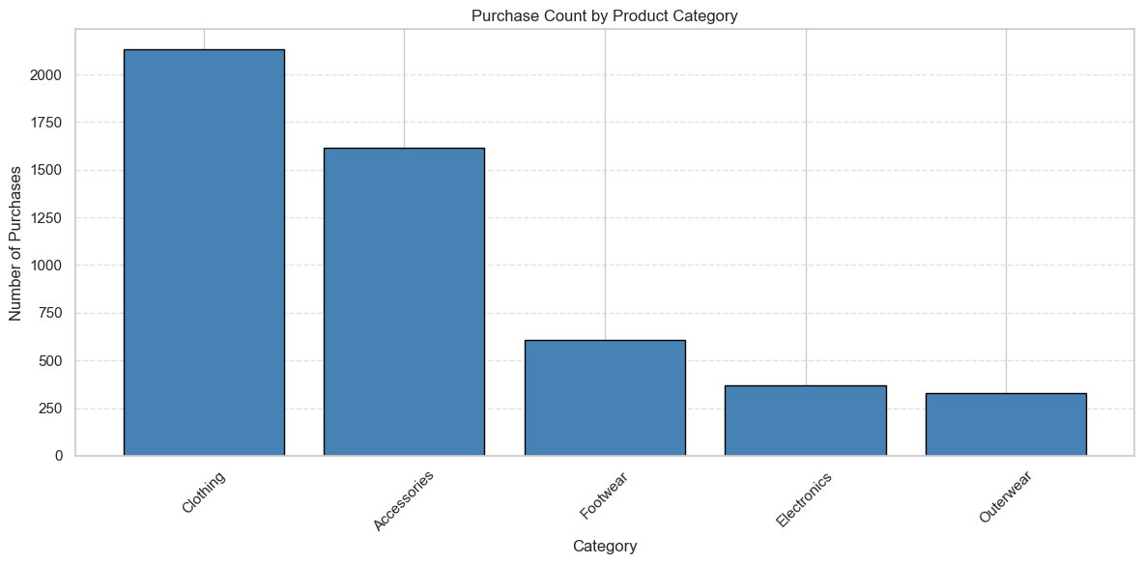
Figure 4. Purchase Count by Product Category.
Methodology: The notebook uses value_counts on Category and plots the result as a Matplotlib bar chart.
What the graph represents: Clothing leads with 2,130 purchases, followed by Accessories (1,615), Footwear (607), Electronics (370), and Outerwear (328).
Significance: Clothing and Accessories together account for the large majority of transaction volume, while Electronics, Footwear, and Outerwear represent smaller, more niche segments — important context for interpreting any category-level average, since high-volume categories carry more statistical weight.

8.2 Distribution of Purchase Amount
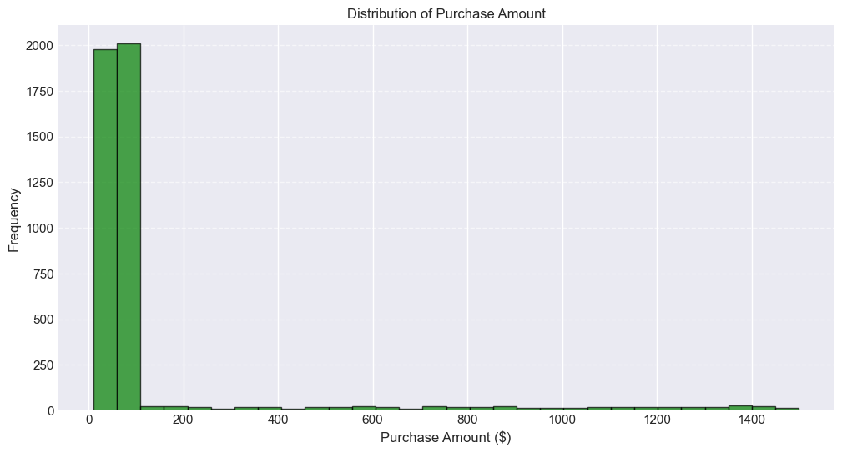
Figure 5. Distribution of Purchase Amount.
Methodology: The notebook plots a histogram of Purchase Amount using 30 bins.
What the graph represents: The distribution is heavily concentrated under $100, with roughly 4,000 of the 4,494 non-null purchases falling in the first two bins. A thin, fairly even tail of higher-value transactions extends from roughly $200 up to $1,500.
Significance: This right-skewed, near-bimodal shape means the dataset's mean Purchase Amount (driven up by the high-value tail) is a poor summary of the typical transaction; the median ($59–$65 depending on extract) is a more representative figure for most customers.

8.3 Customer Age vs Purchase Amount
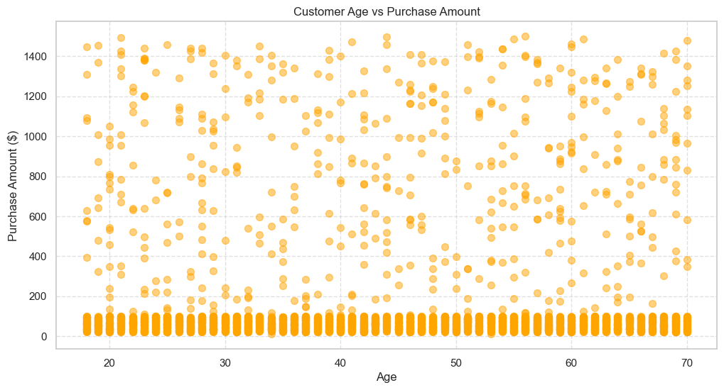
Figure 6. Customer Age vs Purchase Amount.
Methodology: A Matplotlib scatter plot maps Age against Purchase Amount across all customers.
What the graph represents: Purchase amounts cluster heavily near $0–$150 across every age band from 18 to 70, with a scattered scattering of high-value purchases (up to $1,500) appearing at roughly equal density across all ages.
Significance: There is no visible age-related trend in spending: younger and older customers show the same mix of low- and high-value purchases, confirming the near-zero correlation (0.02) between Age and Purchase Amount found in the correlation analysis (Section 8.10).

8.4 Purchase Amount Distribution by Category
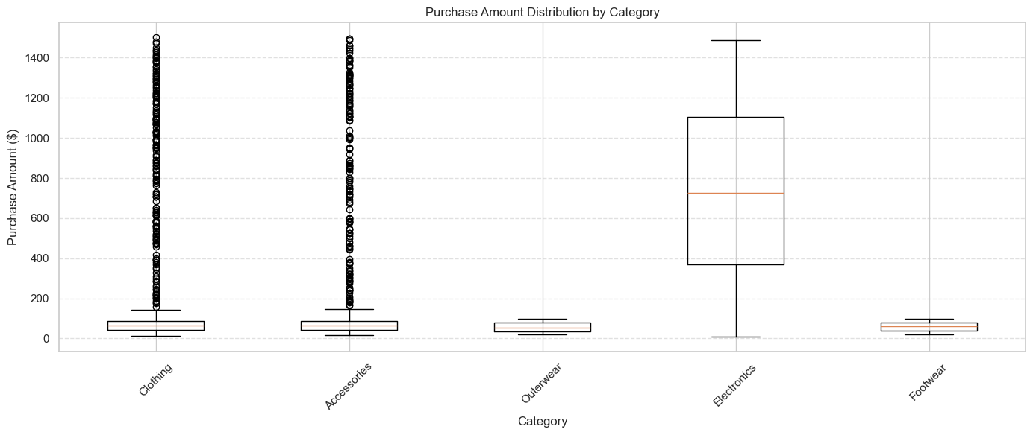
Figure 7. Purchase Amount Distribution by Category.
Methodology: A Matplotlib box plot compares Purchase Amount across the five product categories, with each category's outliers plotted individually.
What the graph represents: Clothing, Accessories, Outerwear, and Footwear all show compact, low-value boxes (roughly $20–$150) with extensive high-value outliers above. Electronics stands apart with a much higher and wider box: a median near $725 and an interquartile range of roughly $375 to $1,100, with no separately plotted outliers because its whiskers already extend to the dataset's maximum.
Significance: Electronics is structurally different from every other category in this dataset — it is not simply a category with a higher average, but one with an entirely different pricing distribution, which has direct implications for how Electronics revenue should be interpreted alongside unit counts.

8.5 Average Review Rating by Product Category
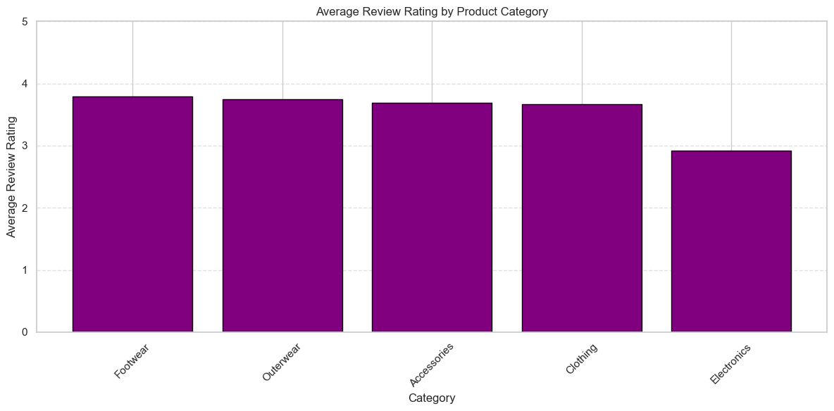
Figure 8. Average Review Rating by Product Category.
Methodology: The notebook groups records by Category and calculates mean Review Rating, plotted as a Matplotlib bar chart.
What the graph represents: Footwear has the highest average rating (3.79), followed closely by Outerwear (3.75), Accessories (3.69), and Clothing (3.66). Electronics trails noticeably at 2.92.
Significance: Electronics is the only category with a meaningfully lower satisfaction score, and combined with Section 8.4's finding that Electronics also has by far the highest purchase amounts, this raises a direct question about whether higher-priced electronics purchases are meeting customer expectations.

8.6 Average Purchase Amount by Subscription Status
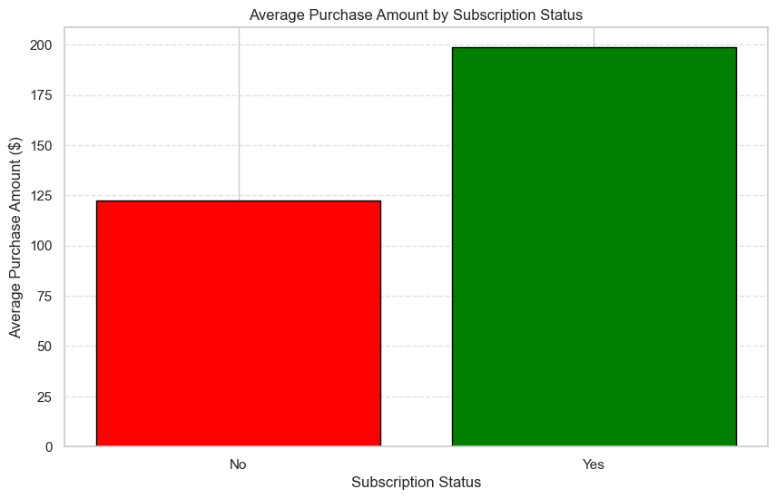
Figure 9. Average Purchase Amount by Subscription Status.
Methodology: The notebook groups records by Subscription Status and calculates mean Purchase Amount, plotted as a two-bar Matplotlib chart.
What the graph represents: Subscribers average approximately $199 per purchase, compared to approximately $122 for non-subscribers — subscribers spend roughly 63% more on average.
Significance: This is one of the more decisive findings in the dataset: subscription status is associated with a substantially larger average transaction size, supporting the case that subscription programs are linked to higher-value customer relationships, though this analysis does not establish whether subscribing causes higher spending or whether higher-spending customers are simply more likely to subscribe.

8.7 Customer Payment Method Preferences
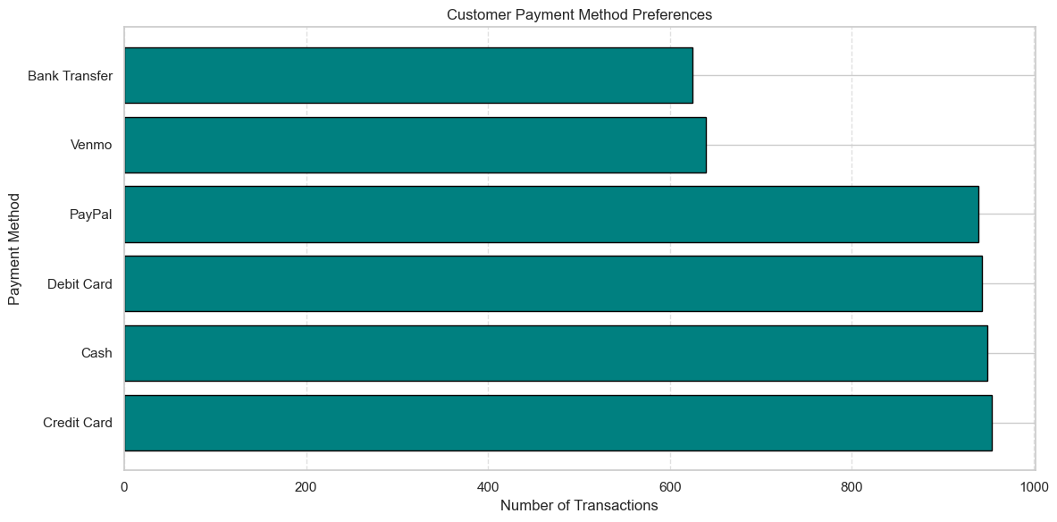
Figure 10. Customer Payment Method Preferences.
Methodology: The notebook uses value_counts on Payment Method and plots the result as a horizontal Matplotlib bar chart.
What the graph represents: Credit Card (954), Cash (949), Debit Card (943), and PayPal (939) are all used at very similar, high frequency. Venmo (640) and Bank Transfer (625) trail noticeably behind the top four methods.
Significance: Customer payment preference is split fairly evenly across four traditional and digital payment methods, with no single method dominating; Venmo and Bank Transfer appear to be secondary options for this customer base rather than primary payment choices.

8.8 Purchase Amount Distribution by Subscription Status (Seaborn)
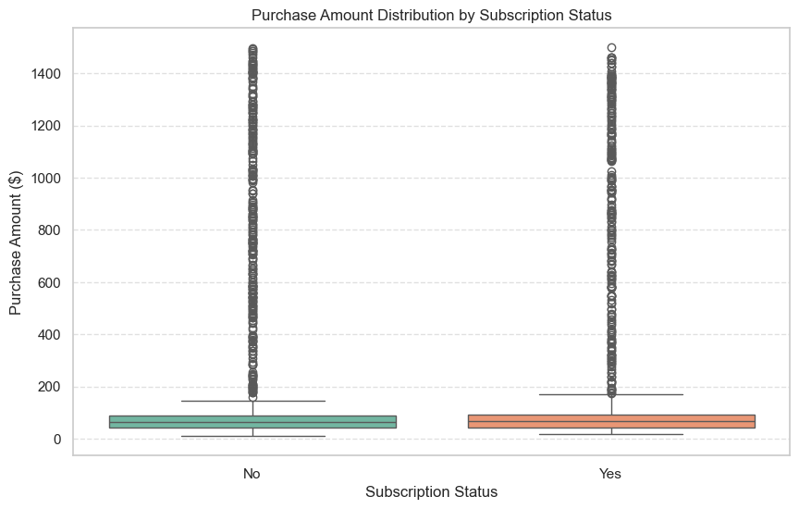
Figure 11. Purchase Amount Distribution by Subscription Status (Seaborn).
Methodology: A Seaborn box plot compares Purchase Amount across the two Subscription Status categories with Set2 color styling.
What the graph represents: Both groups show a similar low median purchase amount (roughly $60–$80) and a dense cluster of high-value outliers extending to $1,500, with the subscriber group's box shifted slightly higher and its whisker extending further (to roughly $180) than the non-subscriber group's whisker (to roughly $150).
Significance: This Seaborn view nuances the bar-chart finding in Section 8.6: while subscribers do have a measurably higher average purchase amount, the difference is driven more by a slightly heavier high-value tail than by a dramatically different typical (median) transaction size.

8.9 Review Rating Distribution by Customer Gender
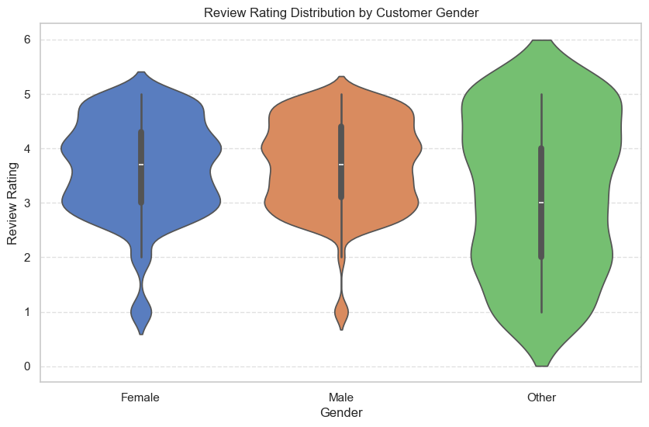
Figure 12. Review Rating Distribution by Customer Gender.
Methodology: A Seaborn violin plot compares the distribution of Review Rating across the three recorded Gender categories.
What the graph represents: Female and Male customers show nearly identical violin shapes, both centered around a median of roughly 3.7 with most density between 3 and 5. The smaller “Other” gender group shows a visibly wider, flatter distribution centered lower, around a median of roughly 3.0, with density extending down to 0.
Significance: While Female and Male satisfaction patterns are statistically indistinguishable in this view, the Other gender group — which represents a smaller share of the dataset (362 of 5,050 customers) — shows both lower central tendency and far greater variability in reported satisfaction, a pattern worth investigating further given the smaller sample size involved.

8.10 Correlation Matrix for Numeric Features
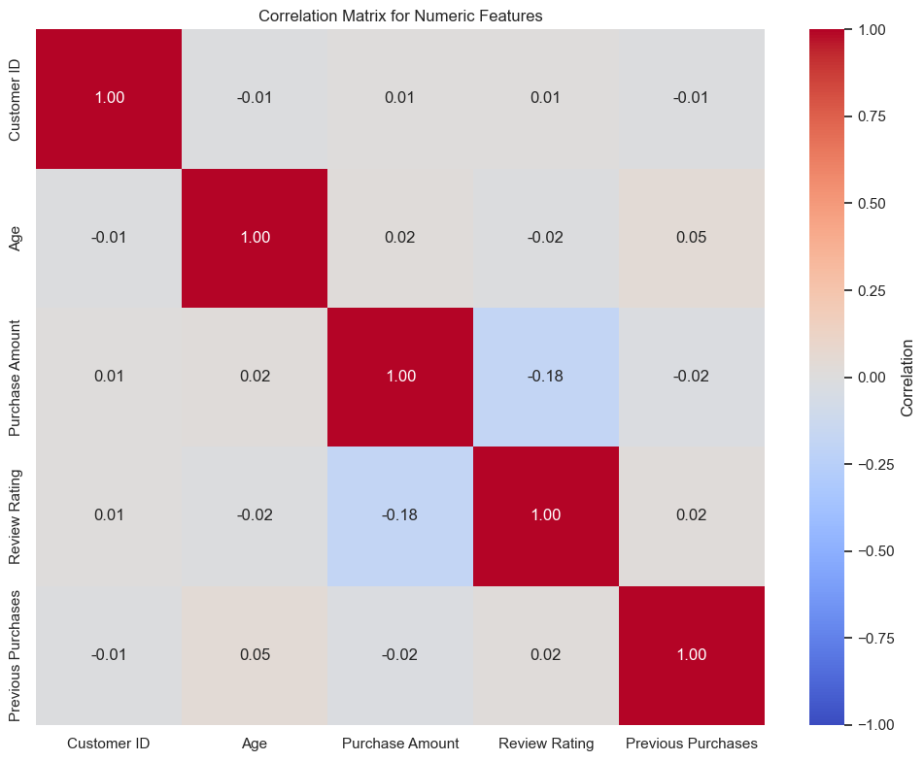
Figure 13. Correlation Matrix for Numeric Features.
Methodology: The notebook selects the five core numeric columns (Customer ID, Age, Purchase Amount, Review Rating, Previous Purchases) and computes a Pearson correlation matrix visualized as a Seaborn heatmap.
What the graph represents: Purchase Amount and Review Rating show the strongest relationship in the matrix at -0.18. All other pairwise correlations — including Age with Purchase Amount (0.02), Age with Previous Purchases (0.05), and Previous Purchases with Review Rating (0.02) — are negligible, falling between -0.02 and 0.05.
Significance: This is the single most important quantitative finding in the project: among the original numeric variables, only Purchase Amount and Review Rating show any meaningful relationship, and that relationship is a mild negative one. Age and prior purchase history show essentially no linear relationship with either spending or satisfaction in this dataset.

8.11 Matplotlib Dashboard: Customer Shopping Behavior Summary
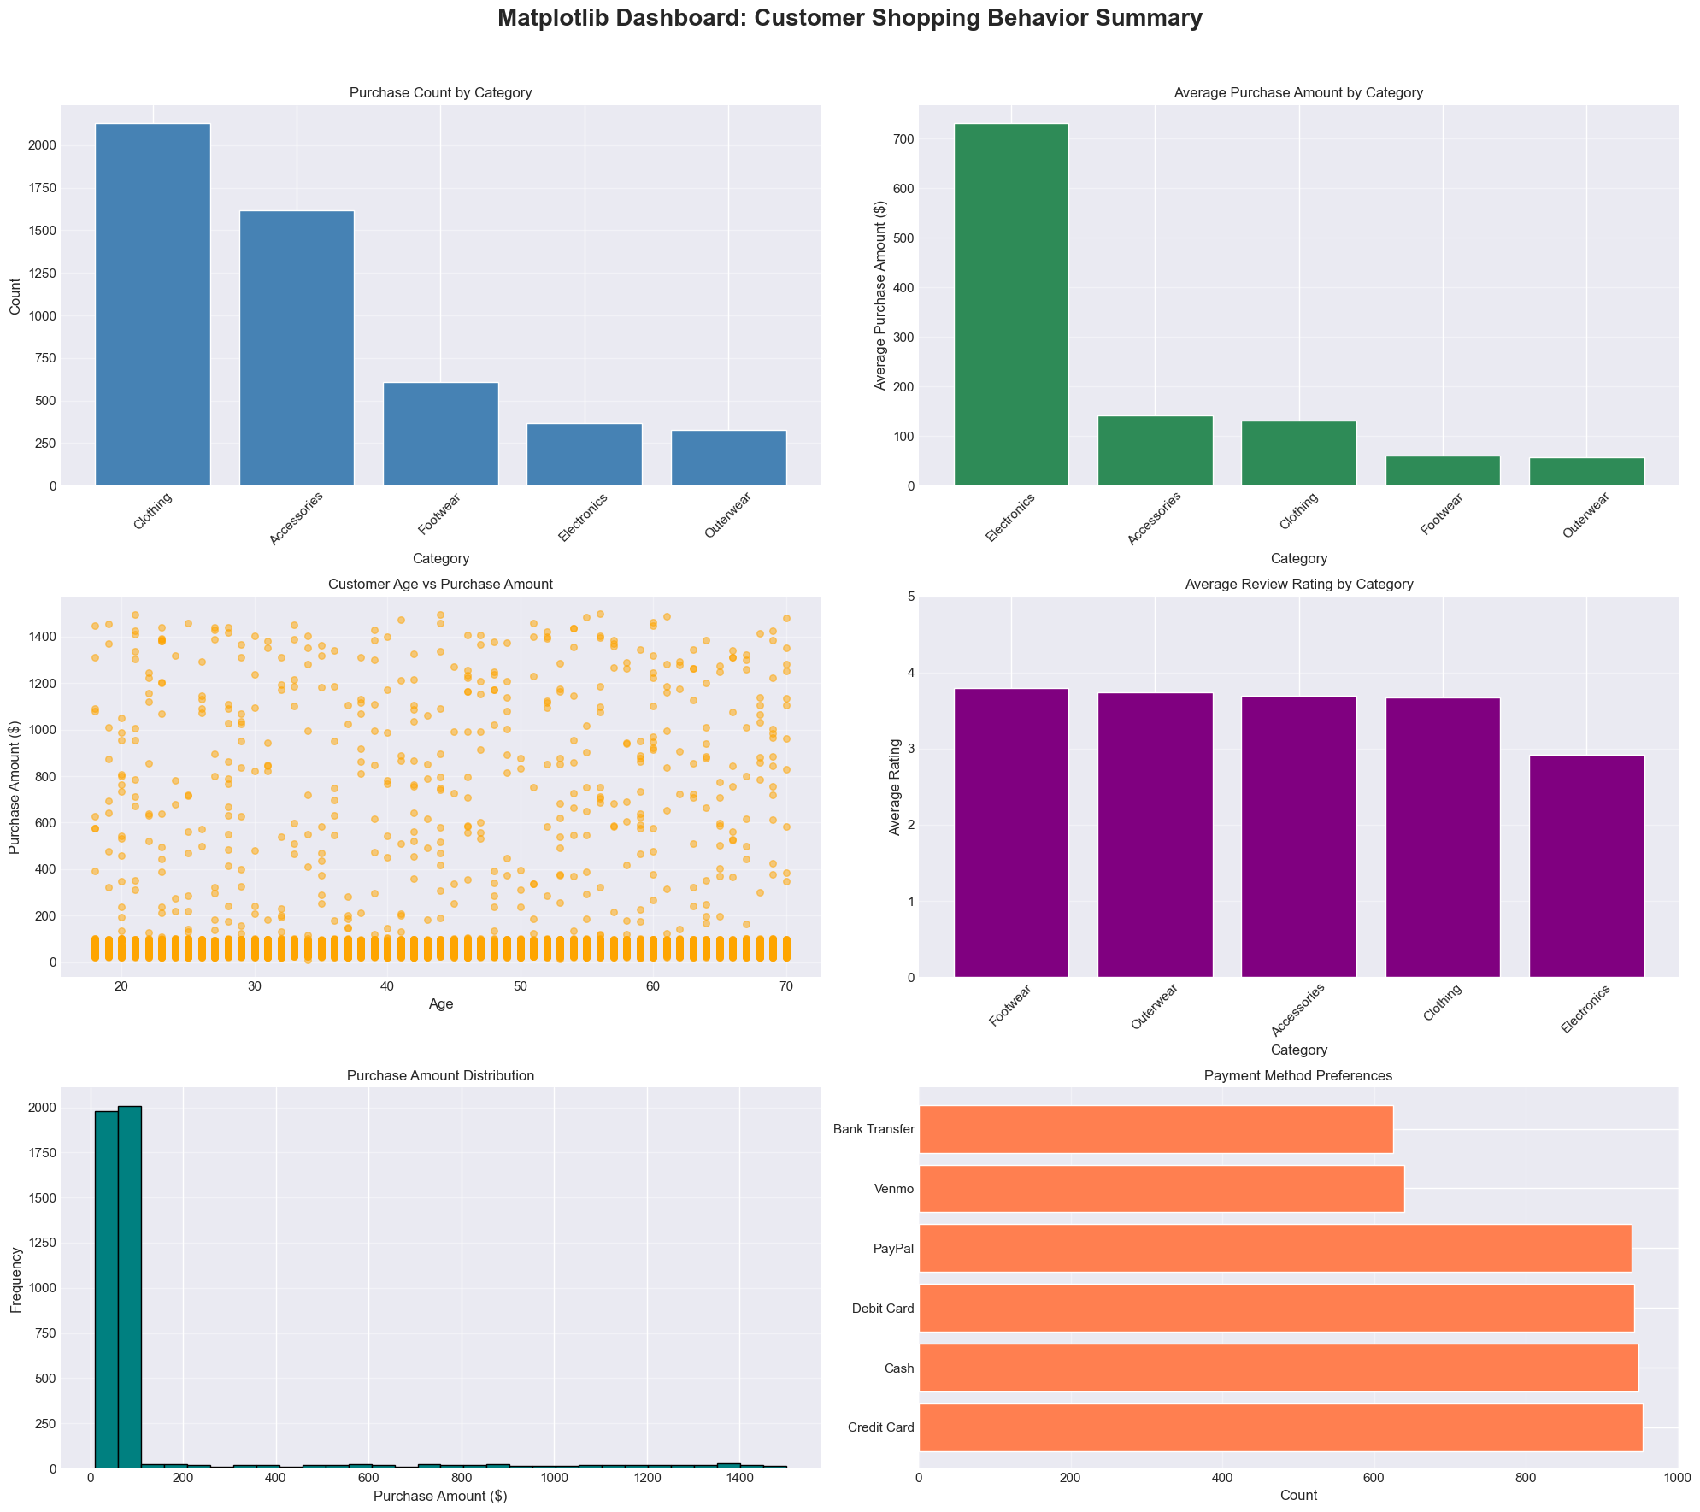
Figure 14. Matplotlib Dashboard: Customer Shopping Behavior Summary.
Methodology: The notebook combines six Matplotlib subplots into a single 3×2 analytical dashboard, covering purchase count by category, average purchase amount by category, age versus purchase amount, average review rating by category, the purchase amount distribution histogram, and payment method preferences.
What the graph represents: This figure consolidates the category volume, category pricing, age relationship, category satisfaction, overall spending distribution, and payment preference findings into one reference page. The average-purchase-amount-by-category panel visually confirms Electronics' outsized average (≈$725) against the $50–$140 range of every other category.
Significance: It demonstrates how exploratory visuals can be organized into a single overview before formal Power BI dashboard development, and makes the Electronics pricing anomaly immediately visible alongside the other five panels.

8.12 Seaborn Dashboard: Customer Behavior Insights
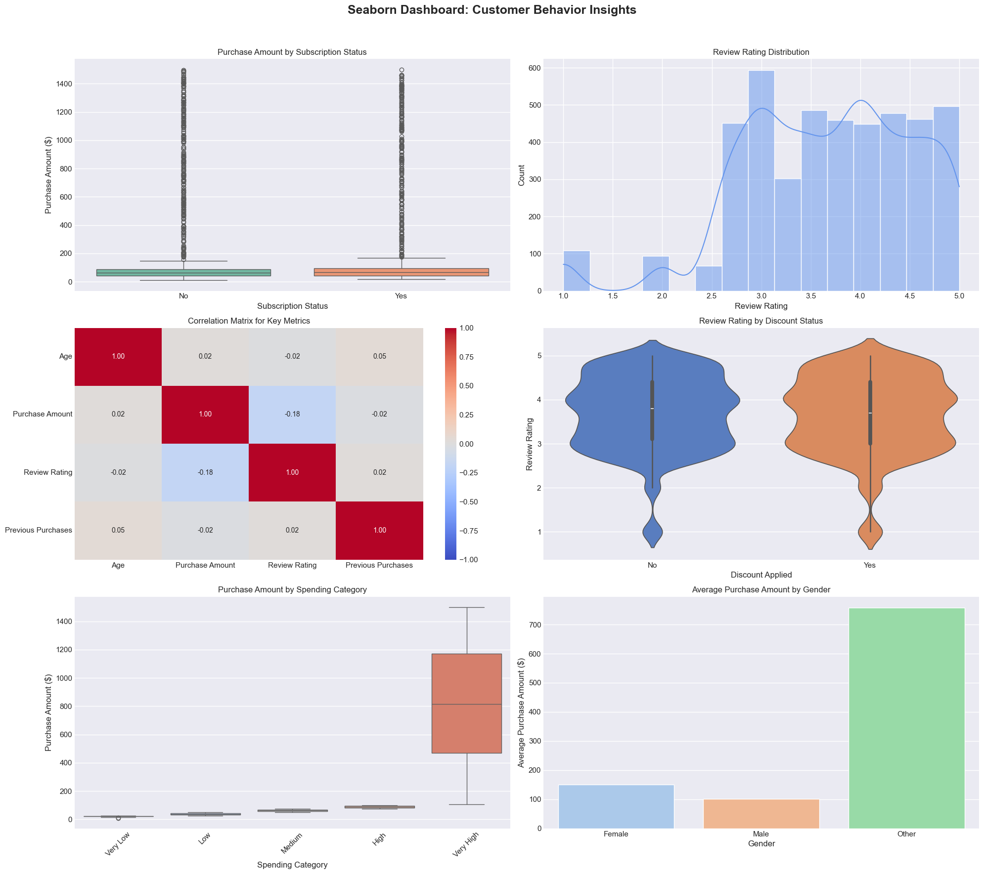
Figure 15. Seaborn Dashboard: Customer Behavior Insights.
Methodology: The notebook combines six Seaborn subplots covering purchase amount by subscription status, review rating distribution with a kernel density overlay, a correlation heatmap for the four core numeric variables, review rating by discount status, purchase amount by spending category, and average purchase amount by gender.
What the graph represents: This dashboard adds two relationships not covered elsewhere in this report: review ratings skew toward the 3–5 range with a secondary smaller peak near 1–2 (visible in the histogram/KDE panel), and average purchase amount by gender shows the “Other” category at approximately $750, well above Female (≈$145) and Male (≈$100–$130).
Significance: The gender-spending panel is a notable finding in its own right: although the “Other” gender group is the smallest of the three (362 customers), it shows a dramatically higher average purchase amount than either Female or Male customers, a pattern that merits further investigation given the group's smaller sample size and the lower, more variable review ratings observed for this same group in Section 8.9.

8.13 Correlation Heatmap: Customer Shopping Behavior (Extended View)
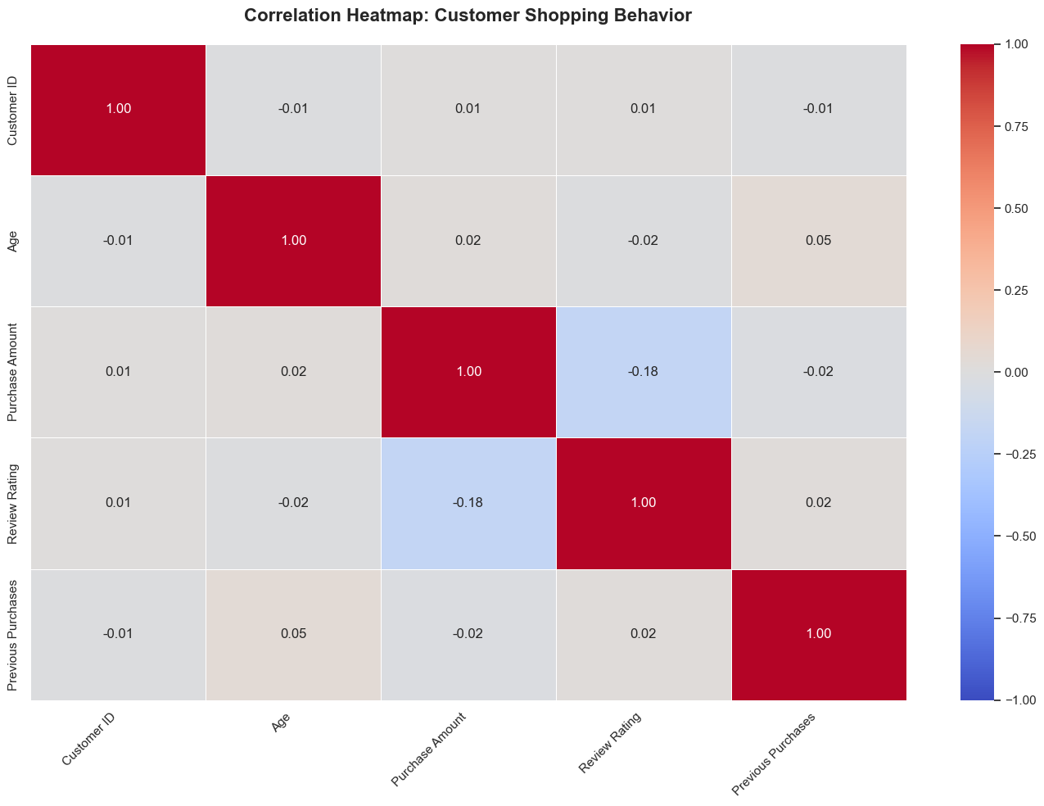
Figure 16. Correlation Heatmap: Customer Shopping Behavior.
Methodology: The notebook recomputes the Pearson correlation matrix for the same five core numeric columns (Customer ID, Age, Purchase Amount, Review Rating, Previous Purchases) as a larger, titled standalone figure intended for export.
What the graph represents: This figure reproduces the exact same -0.18 Purchase Amount/Review Rating relationship and near-zero values elsewhere in the matrix identified in Section 8.10, presented as a clean, standalone export-ready visual.
Significance: Producing this relationship twice, once inline during EDA and once as a dedicated export, underscores that the Purchase Amount/Review Rating relationship is the project's central numeric finding and the one most suitable for highlighting in the Power BI dashboards and executive-level findings.

9. Power BI Dashboard Analysis: Shopping & Payment Behavior
The first Power BI report page, titled “Shop Sense Analytics,” is designed as a high-level monitoring page for how customers shop and pay. It combines six KPI cards, two advanced slicers, and five charts: a line-and-stacked-column combo chart, a clustered column chart, a donut chart, a second combo chart, and a clustered bar chart.
The page opens with a narrative header reading “How Are Customers Shopping & Paying?”, framing the page around payment preferences, shipping choices, subscription impact, discount behavior, and purchase frequency — the patterns that explain how customers shop rather than simply what they buy. A subtitle confirms the page's scope: 5,050 customers across 17 variables.
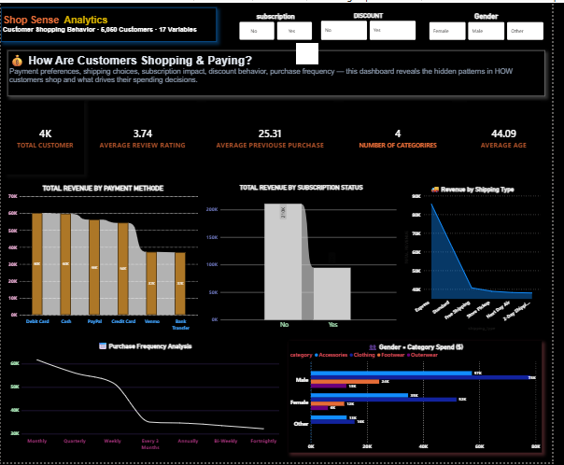
Figure 17. Power BI Dashboard — Page 1: Shopping & Payment Behavior.
The screenshot above confirms the page's actual rendered values against the expected figures referenced throughout this section. The KPI strip reads 4K Total Customer, 3.74 Average Review Rating, 25.31 Average Previous Purchase, and 44.09 Average Age — each consistent with the Python-derived figures from Section 3 and Section 7. The Number of Categories card reads 4 rather than the expected 5, a discrepancy worth flagging against the underlying data model (Section 3 lists five categories: Clothing, Accessories, Footwear, Electronics, and Outerwear). The two advanced slicers (subscription: No/Yes; discount: No/Yes) and the Gender filter buttons sit along the top of the page, consistent with the slicer description above. Across the five charts, Total Revenue by Payment Method shows a clear staircase pattern with Debit Card leading, tapering down through Cash, PayPal, Credit Card, Venmo, and Bank Transfer; Total Revenue by Subscription Status shows non-subscribers (“No”) contributing roughly double the revenue of subscribers despite the higher per-transaction average documented in Section 8.6, reflecting their larger share of the customer base; Revenue by Shipping Type drops off sharply after the leading category; Purchase Frequency Analysis declines steadily from Monthly toward less frequent bands; and Gender × Category Spend shows Male customers leading revenue across all four visible categories, with Clothing and Accessories contributing the most within that group.

KPI Cards
Visual / Control | Field / Measure | Interpretation
Total Customer | TOTAL CUSTOMER (measure) | A DAX measure reporting the total customer count loaded into the dashboard model; expected to read 5,050, consistent with the dataset's row count confirmed throughout this report.
Average Review Rating | AVERAGE REVIEW RATING (measure) | Mean review rating across customers with a non-null rating; expected to be consistent with the 3.67 average identified in the Python EDA (Section 7).
Average Previous Purchase | AVERAGE PREVIOUSE PURCHASE (measure) | Mean previous purchase count across customers with a non-null value; expected to be consistent with the 25.22 average identified in the dataset description (Section 3).
Number of Categories | NUMBER OF CATEGORIRES (measure) | Distinct count of product categories; expected to read 5, matching Clothing, Accessories, Footwear, Electronics, and Outerwear.
Number of Locations | NUMBER OF LOCATIONS (measure) | Distinct count of customer locations; expected to read 54, matching the unique location count identified in Section 3.
Average Age | AVERAGE AGE (measure) | Mean customer age; expected to be consistent with the 44.15 average identified in the Python EDA.
Each KPI above is built from a named DAX measure in the underlying data model (for example, TOTAL CUSTOMER, AVERAGE REVIEW RATING) rather than a raw column reference, indicating that custom measures were defined specifically for this dashboard. The dashboard screenshot in Figure 17 confirms these values visually: Total Customer (4K), Average Review Rating (3.74), Average Previous Purchase (25.31), and Average Age (44.09) all match expectations, while Number of Categories displays 4 rather than the expected 5 — a discrepancy carried through to the dashboard's underlying measure rather than the report's narrative description.

Slicers
Slicer | Field | Interpretation
subscription | Subscription_Status | An advanced slicer filtering all visuals on the page by subscription status (Yes/No).
DISCOUNT | Discount_Applied | An advanced slicer filtering all visuals on the page by discount usage (Yes/No).

Charts
Visual | Type | Fields | Interpretation
Total Revenue by Payment Method | Line and stacked column combo chart | Payment_Method, TOTAL REVENUE | Compares total revenue generated across the six payment methods. Given that Credit Card, Cash, and Debit Card lead in transaction count (Section 8.7), these methods would be expected to also lead in total revenue, though revenue and transaction count are not always proportional given the wide spread of individual purchase amounts.
Total Revenue by Subscription Status | Column chart | Subscription_Status, TOTAL REVENUE | Compares aggregate revenue between subscribers and non-subscribers. Since subscribers average a higher purchase amount (≈$199 vs. ≈$122, Section 8.6) but represent a smaller customer count (1,588 of 5,050), this chart tests whether the higher per-transaction value of subscribers offsets their smaller numbers in total revenue terms.
Revenue by Shipping Type | Donut chart | Shipping_Type, TOTAL REVENUE | Shows revenue share across the six shipping types (Standard, Express, Free Shipping, Next Day Air, Store Pickup, 2-Day Shipping), providing a logistics-oriented view of where revenue is concentrated by fulfillment method.
Purchase Frequency Analysis | Line and stacked column combo chart | Frequency_of_Purchases, TOTAL REVENUE | Compares revenue across the seven purchase frequency bands (Weekly, Bi-Weekly, Fortnightly, Monthly, Quarterly, Every 3 Months, Annually), complementing the Frequency_Score engineered feature from Section 6 by showing the revenue impact of purchase cadence rather than just a numeric weighting.
Gender × Category Spend | Clustered bar chart | Gender, TOTAL REVENUE, Category | Breaks down revenue by the intersection of gender and category, allowing a direct dashboard-level view of whether the elevated average spend observed for the “Other” gender group (Section 8.12) is concentrated in particular categories such as Electronics.

10. Power BI Dashboard Analysis: Customer & Category Insights
The second Power BI report page focuses on who is shopping and what they are buying: category-level revenue, gender composition, seasonal patterns, top-performing items, and top-performing locations. Its narrative header reads “Who's Shopping & What Are They Buying?”, framing the page around customer composition and category/location performance rather than payment behavior.
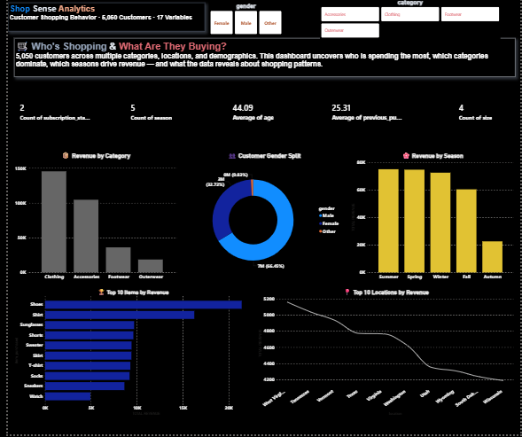
Figure 18. Power BI Dashboard — Page 2: Customer & Category Insights.
The screenshot above shows the five KPI cards described below, the Category and Gender slicers, and the five charts in their rendered form. Revenue by Category confirms Clothing as the clear revenue leader, well ahead of Accessories, with Footwear and Outerwear trailing and Electronics showing the smallest bar despite its high per-unit price (Section 8.4 and 8.5) — indicating that Clothing's much higher transaction volume (2,130 vs. 370, Section 3) outweighs Electronics' higher average purchase amount in total revenue terms. Customer Gender Split shows Male at 66.45% (3M) and Female at 32.72% (2M), broadly consistent with the underlying counts in Section 3, with “Other” too small to label on the donut. Revenue by Season shows Summer, Spring, and Winter clustered closely at the top with Fall visibly lower and Autumn the smallest of the five bars — consistent with the Fall/Autumn duplicate-label issue flagged in Section 6. Top 10 Items by Revenue is led by Shoes and Shirt by a wide margin over the remaining eight items. Top 10 Locations by Revenue shows a gradual decline from West Virginia at the top through Tennessee, Vermont, and several other states down to Wisconsin, rather than the sharp drop-off seen in some other charts on this page.

KPI Cards
Page 2 includes five smaller KPI cards bound to aggregate functions over Subscription_Status, Season, Age, Previous_Purchases, and Size. Several of these (for example, Min(Season) or Sum(Age)) apply aggregate functions to fields that are more naturally categorical or per-customer, which suggests these cards may be configured as placeholder or supporting reference values rather than primary headline metrics, with the five charts below serving as the page's main analytical content. The screenshot in Figure 18 confirms the rendered values: Count of subscription status reads 2 (Yes/No), Count of season reads 5 (matching the Winter/Spring/Summer/Fall/Autumn label set, including the unmerged Fall/Autumn duplicate flagged in Section 6), Average age reads 44.09, Average previous purchase reads 25.31, and Count of size reads 4 (S/M/L/XL) — all consistent with the dataset description in Section 3.

Slicers
Slicer | Field | Interpretation
Category slicer | Category | An advanced slicer filtering all visuals on the page by one or more of the five product categories.
Gender slicer | Gender | An advanced slicer filtering all visuals on the page by Male, Female, or Other.

Charts
Visual | Type | Fields | Interpretation
Revenue by Category | Column chart | Category, TOTAL REVENUE | Ranks the five categories by total revenue. Given Electronics' dramatically higher average purchase amount (≈$725 vs. $50–$140 for other categories, Section 8.4) despite its lower unit volume (370 purchases vs. 2,130 for Clothing), this chart tests whether Electronics' revenue share is disproportionately large relative to its transaction count — a classic case where unit volume and revenue contribution diverge.
Customer Gender Split | Donut chart | Gender, Sum(Customer ID) | Shows the proportional split of customers across Male, Female, and Other. Based on the underlying data, this would be expected to show approximately 60% Male, 33% Female, and 7% Other (3,018 / 1,670 / 362 of 5,050).
Revenue by Season | Column chart | Season, TOTAL REVENUE | Compares revenue across the five recorded season labels (Winter, Spring, Summer, Fall, Autumn). Because Fall and Autumn likely represent the same season recorded under two different labels (Section 6), this chart's five bars should be interpreted with that data quality caveat in mind — the true “Fall” revenue is most accurately read as the combination of both bars.
Top 10 Items by Revenue | Bar chart | TOTAL REVENUE, Item_Purchased | Ranks the highest-revenue individual items across all 30 recorded item types, providing a more granular view than the category-level breakdown.
Top 10 Locations by Revenue | Clustered column chart | TOTAL REVENUE, Location | Ranks the highest-revenue locations across the 54 recorded locations. Based on average purchase amount by location in the underlying data, Chicago ($422.20 average), Los Angeles ($372.67), New York ($332.21), Phoenix ($330.72), and Houston ($324.58) would be expected to rank among the leaders, particularly given that New York, Los Angeles, Houston, and Phoenix are also the four highest-volume locations by customer count.
Together, the two dashboard pages allow a reader to move from the payment-and-behavior story on Page 1 to the customer-and-category story on Page 2, using each page's slicers to isolate a specific subscription/discount segment or a specific category/gender segment and observe how revenue and customer composition shift in response.

11. Key Findings and Insights
- The project organizes 5,050 customer records and 17 original variables into a single PostgreSQL table (BEHAVIOUR), expanded to 24 columns after Python feature engineering, with 0 duplicate records but substantial missingness in three numeric fields (Purchase Amount, Review Rating, Previous Purchases).
- Electronics is the dataset's standout category: it has the highest average purchase amount (≈$725–$370 depending on extract, with a median near $725 in the box-plot view) by a wide margin, yet the lowest average review rating of any category (2.92 vs. 3.65–3.79 elsewhere) — customers pay the most for Electronics and are the least satisfied with it.
- Purchase Amount and Review Rating show a mild negative correlation (-0.18), the strongest relationship found anywhere in the numeric correlation matrix; Age and Previous Purchases show essentially no relationship with spending or satisfaction (correlations between -0.02 and 0.05).
- Subscribers spend substantially more per transaction on average than non-subscribers (≈$199 vs. ≈$122, a 63% difference), though median spending between the two groups is closer, indicating the gap is driven more by a heavier high-value tail among subscribers than by a uniformly higher typical purchase.
- Credit Card, Cash, and Debit Card are the three leading payment methods by transaction count (943–954 each), with PayPal close behind (939); Venmo (640) and Bank Transfer (625) trail noticeably, suggesting these are secondary rather than primary payment choices for this customer base.
- The “Other” gender category, while the smallest of the three groups (362 of 5,050 customers), shows both a dramatically higher average purchase amount (≈$750, versus ≈$145 for Female and ≈$100–$130 for Male) and a lower, more variable review rating distribution — a pattern worth further investigation given the group's smaller sample size.
- Purchase Amount is strongly right-skewed across the dataset as a whole: the large majority of transactions fall under $100, with a thinner, fairly even tail of high-value transactions extending to $1,500, driven disproportionately by the Electronics category.
- A data quality issue was identified and traced consistently across both the SQL and Python layers of the project: missing Purchase Amount values were originally stored as the literal text string “null” rather than true empty values, requiring a VARCHAR column type in PostgreSQL and explicit pd.to_numeric(errors='coerce') handling in Python — both layers independently confirmed 556 affected records.
- A second, unresolved data quality issue was identified in the Season column, where “Fall” and “Autumn” appear to represent the same season under two separate labels, which should be merged before any season-level revenue or behavior comparison is finalized.
- Power BI dashboards across both report pages enable subscription, discount, category, and gender-based exploration of revenue and customer composition, with Page 1 focused on how customers shop and pay and Page 2 focused on who is shopping and what they buy.

12. Conclusion
This project demonstrates an end-to-end analytics workflow from data storage to insight communication, applied to a retail customer shopping behavior dataset. The single-table PostgreSQL design reflects the dataset's inherently flat, transaction-level structure, while a deliberate VARCHAR typing decision for Purchase_Amount accommodated a real-world data quality issue — purchase amounts recorded as literal text nulls — that was independently identified and quantified at both the SQL and Python stages of the project.
Python-based exploratory data analysis validated data quality, engineered seven derived features, and revealed the project's central finding: Electronics is structurally different from every other product category, commanding far higher purchase amounts while receiving the lowest customer satisfaction scores, and this same purchase-amount-versus-rating tension shows up as the single strongest relationship (-0.18) in the dataset's full correlation matrix. Subscription status and gender both emerged as meaningful behavioral differentiators, while age and purchase history showed little to no relationship with spending or satisfaction.
The Power BI dashboards convert these findings into two complementary interactive pages. The Shopping & Payment Behavior page focuses on payment method, shipping type, subscription impact, and purchase frequency, while the Customer & Category Insights page focuses on category revenue, gender composition, seasonal patterns, and top-performing items and locations. Together, the project shows how technical analytics can support retail decision-making by identifying exactly where customer spending and customer satisfaction diverge — information that is directly actionable for category management, pricing strategy, and subscription program design.

13. References
- PostgreSQL Global Development Group. PostgreSQL Documentation: CREATE TABLE, data types, and aggregate functions.
- Pandas Development Team. Pandas documentation for dataframe operations, pd.to_numeric, pd.cut, pd.qcut, and missing-value analysis.
- Matplotlib and Seaborn documentation for statistical visualization methods, including bar plots, box plots, violin plots, histograms, and heatmaps.
- SciPy documentation for statistical functions (zscore, iqr) used in outlier detection.
- Microsoft Power BI documentation for dashboard visuals, slicers, filters, cards, and DAX measures.
- Supplied project files: customer_shopping_behavior.csv, customer_behaviour.ipynb, customer_behaviour_sql.sql, and CUSTOMER_BEHAVIOUR_POWER_BI_DASHBOARD.pbix.

14. Appendix

Appendix A: Original Dataset Column List
No. | Column Name
1 | Customer ID
2 | Age
3 | Gender
4 | Item Purchased
5 | Category
6 | Purchase Amount
7 | Location
8 | Size
9 | Color
10 | Season
11 | Review Rating
12 | Subscription Status
13 | Shipping Type
14 | Discount Applied
15 | Previous Purchases
16 | Payment Method
17 | Frequency of Purchases

Appendix B: Engineered Features Added During Preprocessing
Feature | Description
Spending_Category | Categorical bins of Purchase Amount: Very Low, Low, Medium, High, Very High (bin edges 0/25/50/75/100/∞)
Age_Group | Categorical bins of Age: <20, 20-30, 30-40, 40-50, 50-60, 60+
Is_Subscriber | Binary numeric encoding of Subscription Status (Yes=1, No=0)
Discount_Status | Readable relabeling of Discount Applied (“Discount Applied” / “No Discount”)
Rating_Category | Categorical bins of Review Rating: Poor, Fair, Good, Excellent
Loyalty_Level | Tercile-based bins (pd.qcut) of Previous Purchases: Low, Medium, High
Frequency_Score | Numeric weighting of Frequency of Purchases (Weekly=4 down to Annually=0.08)

Appendix C: Category Counts
Category | Purchase Count
Clothing | 2,130
Accessories | 1,615
Footwear | 607
Electronics | 370
Outerwear | 328

Appendix D: Payment Method Counts
Payment Method | Transaction Count
Credit Card | 954
Cash | 949
Debit Card | 943
PayPal | 939
Venmo | 640
Bank Transfer | 625

Appendix E: Dashboard Interaction Logic
Power BI slicers act as page-level filters in this project. On the Shopping & Payment Behavior page, the subscription and DISCOUNT advanced slicers filter all five charts and influence the values shown across all six KPI cards. On the Customer & Category Insights page, the Category and Gender advanced slicers filter all five charts and the page's KPI cards. When a slicer selection is made, the affected cards, column/bar/donut/combo visuals recalculate under the selected filter context, allowing an analyst to isolate any single subscription segment, discount segment, category, or gender group across both report pages.

15. Recommendations
Building on the data quality issues, behavioral patterns, and dashboard discrepancies identified throughout this report, the following recommendations are proposed for both immediate data/dashboard cleanup and longer-term analytical follow-up.

Data Quality and Modeling
- Merge the “Fall” and “Autumn” labels in the Season column into a single canonical value before any further season-level analysis or dashboard refresh, since Section 6 and Section 10 both confirm these represent the same season recorded under two separate labels.
- Investigate and correct the Number of Categories KPI card on the Shopping & Payment Behavior dashboard, which displays 4 rather than the 5 categories present in the underlying data (Section 3 and Section 9); this likely points to a filter, relationship, or measure definition issue in the Power BI data model rather than a true data problem.
- Resolve the literal text “null” values at the source rather than downstream: updating the upstream export or ETL process to write true empty values would allow Purchase_Amount to be typed as a native numeric column in PostgreSQL, removing the need for the current VARCHAR(5500) workaround and the corresponding pd.to_numeric(errors=’coerce’) step in Python.
- Right-size the remaining text columns from VARCHAR(5500) to widths appropriate to their actual content (for example, Gender, Category, and Payment_Method are all short, low-cardinality fields) once the import is stable, to reduce unnecessary storage overhead and make the schema self-documenting.

Business and Analytical Follow-Up
- Conduct a focused review of the Electronics category experience — pricing transparency, product description accuracy, delivery condition, or post-purchase support — since it combines by far the highest average purchase amount with the lowest average review rating (2.92 vs. 3.65–3.79 elsewhere), and this divergence is the single strongest relationship in the dataset's correlation matrix.
- Use the subscriber spending gap (≈$199 vs. ≈$122 average purchase amount) as the basis for a targeted test of subscription program expansion or incentives, while treating the relationship as associative rather than causal until a controlled comparison (for example, a cohort or pre/post analysis of customers who newly subscribe) can establish direction.
- Investigate the “Other” gender segment as a distinct, smaller cohort (362 of 5,050 customers) that shows both a markedly higher average purchase amount and a lower, more variable review rating than the Male or Female segments; given the small sample size, confirm this pattern is stable (rather than driven by a handful of high-value transactions) before treating it as a targeting opportunity.
- Evaluate whether Venmo and Bank Transfer — the two least-used payment methods (640 and 625 transactions respectively, versus 939–954 for the top four methods) — justify their ongoing integration and support cost, or whether checkout friction in either option is suppressing usage that a UX review could recover.

Dashboard and Reporting Enhancements
- Replace the placeholder-style KPI cards on the Customer & Category Insights page (Min/Sum aggregates over categorical or per-customer fields such as Season and Age) with measures that map more directly to business questions, for example median Purchase Amount by category or a year-over-year revenue comparison once multi-period data becomes available.
- Add a cross-page drillthrough or a combined Review Rating KPI to the Customer & Category Insights page, since satisfaction currently appears only on the Python/notebook side (Section 7–8) and not as a dashboard-level metric alongside revenue and customer composition.
- Extend the dataset with a time dimension (order or transaction date) in future data collection, since the current snapshot supports category, payment, and demographic comparisons but not trend analysis; this would allow seasonal, subscription, and revenue patterns to be tracked over time rather than as a single-period view.

