Routine ultrasound reports for intestinal malrotation rarely document duodenal landmarks: an audit of 740 preoperative index examinations in 410 surgically confirmed children
[Author names, affiliations, and corresponding-author details have been removed for double-blind peer review and are provided on the separate title page.]
Word count: 2,994 (main text, excluding abstract, key points, figure and table legends, references and declarations); Tables: 4; Figures: 3; Supplementary: 3 Online Resources

Abstract
Objectives Ultrasound is increasingly advocated as first-line for suspected intestinal malrotation, based on sensitivities of 93–97% under dedicated protocols. We audited what routine reports document and whether the diagnosis was reported.
Methods Retrospective case-only report audit at one tertiary children's hospital (December 2012–June 2026). Preoperative examination episodes closest to operation were classified for detection by a rule-based algorithm with blinded surgical adjudication, and separately audited for documented technical content. The cohort being surgically confirmed, the outcome is report-level detection among children who underwent the test; specificity, predictive values and comparative accuracy are not estimable.
Results Among 465 children (volvulus in 86.7%), 410 underwent at least one index test. Three of 119 ultrasound examinations (2.5%) documented the third portion of the duodenum or the duodenojejunal junction, 12 (10.1%) the mesenteric artery–vein relationship and 2 (1.7%) enteric fluid; a whirlpool sign was reported in 48.7%. Ultrasound reported malrotation in 64 of 119 examinations (53.8%): in 58 of 58 recording a whirlpool and 6 of 61 without one, whereas a whirlpool appeared in only 58 of 113 children with confirmed volvulus. Ultrasound detection rose from 41.0% to 60.0% between eras; adjusting for a shift towards great-vessel sessions reduced the difference from +19.0 to +8.2 percentage points, an interval including zero.
Conclusions Routine ultrasound functioned as a whirlpool-dependent test for volvulus rather than a protocolised assessment of duodenal position. Whether the missing elements would close the gap to published performance cannot be tested here, but the deficit is measurable.
Critical relevance statement Departments adopting ultrasound-first pathways for malrotation should audit whether their own reports document the duodenal landmarks that produced the published sensitivities; in this department they almost never did.
Keywords: Intestinal malrotation; Intestinal volvulus; Infant, Newborn; Ultrasonography; Radiology report

Key Points
• Intestinal malrotation with volvulus is a surgical emergency; ultrasound is advocated as first-line imaging based on sensitivities from dedicated protocols, not routine reporting.
• Among 410 surgically confirmed children, routine ultrasound reports documented duodenal landmarks in only 2.5% of examinations; detection tracked the whirlpool sign almost exclusively.
• Departments adopting ultrasound-first pathways for malrotation should audit whether their own reports document the duodenal landmarks that produced the published sensitivities; in this department they almost never did.

Introduction
Intestinal malrotation predisposes to midgut volvulus, which can progress within hours to bowel necrosis, short-bowel syndrome or death [1, 2]. Bilious vomiting in a neonate is a surgical emergency until malrotation with volvulus has been excluded, although older children may present atypically and be diagnosed late [3, 4].
The upper gastrointestinal (UGI) contrast series has long been the reference imaging test, based on the position of the duodenojejunal junction and the course of the proximal small bowel [5–7], although its interpretation has well-described mimics [8]. Abdominal CT is not a dedicated test, and the mesenteric swirl it may show is neither reliably present nor specific in children [9, 10]. The field has moved towards ultrasound: series report sensitivities of 93–97% under dedicated protocols, a systematic review of 17 studies and 2,257 children estimated a pooled sensitivity of 94% [11–13], and a single-centre study of 539 children investigated for clinical suspicion supported ultrasound as a safe first-line test [14]. This performance is attributed to specific technical elements rather than to the modality itself: the third portion of the duodenum (D3), the duodenojejunal junction, the superior mesenteric artery–vein relationship, enteric fluid and dynamic graded compression [12, 13, 15–17]. The same literature records these elements as demanding and not universally achievable, and D3 position alone as insufficient for diagnosis [18].
Those studies describe what ultrasound achieves under favourable conditions; clinicians act on the routine report issued during unselected care. To our knowledge, no study has examined the content of routine malrotation ultrasound reports at scale, or related it to whether the diagnosis was reported.
We therefore audited 13.5 years of routine reports at a tertiary children's hospital. Because every child had surgically confirmed malrotation, the study measures how often the disease was reported and with what documented content, not how accurate the tests are. The contrast series and CT are reported alongside ultrasound to show where ultrasound sat in the diagnostic pathway, not to rank them.

Methods

Design, terminology and estimable quantities
This was a retrospective, single-centre, case-only report audit approved by the institutional review board with waiver of consent. Reporting follows STROBE [19]; STARD was not used, as the design is not that of a diagnostic accuracy study. The cohort includes no children in whom malrotation was suspected and excluded. The outcome is the report-level detection rate among surgically confirmed children who underwent the test. We avoid the term "sensitivity", which applies only within the indication-selected group that underwent each test and does not transfer to children investigated for suspicion. Specificity, predictive values and any accuracy-based ranking cannot be estimated. Malrotation, midgut volvulus and malrotation with volvulus are distinguished throughout; the whirlpool sign is a sign of volvulus rather than of malrotation [20].

Participants, reference standard and index tests
We searched the institutional surgical records database for operations performed between December 2012 and June 2026 in which the operative diagnosis named intestinal malrotation or the procedure was recorded as a Ladd procedure, and reviewed every record retrieved (search strings in Online Resource 1). Of 559 operative records in 499 children, 503 records in 465 consecutive children met this criterion, the reference standard. Midgut volvulus was defined by an explicit operative statement of torsion or by a documented degree of midgut or mesenteric rotation, with no minimum degree required (see Limitations). No sample-size calculation was performed.
Three modalities were evaluated: ultrasound (sessions booked as gastrointestinal, abdominal great-vessel or pyloric), abdominal CT and the UGI contrast series; contrast enemas were not counted. For each child and modality, the index unit was the examination episode closest to operation, pooling every report of that modality issued that day, as the department routinely issues separate gastrointestinal and great-vessel reports for one ultrasound session. This yielded 740 index examinations from 778 reports; 34 earlier repeat examinations were not audited (Fig. 1). The clinical indication on each request was not retrievable, so confounding by indication is displayed through the characteristics of each modality group (Table 1) rather than adjusted for.
Examinations were reported during routine care by radiologists unaware of the operative findings but not blinded to clinical history or previous imaging, within the general paediatric ultrasound service rather than by a designated reader group. Reports were free text, with no structured malrotation template in use. The department reports no change in ultrasound equipment, reporting staff or protocol during the study period, and attributes the change in practice from about 2021 to growing awareness of the diagnosis; this account was given retrospectively rather than recorded at the time.

Report-content audit and classification
Each index unit was coded for documented technical content using text patterns applied to the findings and conclusion sections: for ultrasound, D3 or the duodenojejunal junction, the mesenteric artery–vein relationship and vessel inversion, a whirlpool appearance, enteric fluid, dynamic and graded-compression technique, limiting bowel gas, caecal position and bedside performance; for CT and the UGI series, the corresponding landmarks (Online Resource 1). Technique elements were counted as documented whether the finding was normal or abnormal; the whirlpool sign, a finding rather than a technique, was counted only where not negated.
An examination was classified as positive when its conclusion named malrotation or midgut volvulus, including tentative phrasing, or described a modality-specific sign: for ultrasound, a whirlpool or an explicit statement of mesenteric vessel inversion; for the UGI series, a corkscrew or spring appearance or a malpositioned duodenojejunal junction; for CT, a mesenteric whirl or an abnormal duodenal position. Explicit negation was classified as negative, and isolated gastric volvulus was not counted. Because the whirlpool is both an audited element and a positivity criterion, we report how often conclusions named the diagnosis outright. Tentative phrasing is standard here, so the certainty tier of every positive conclusion was tabulated and the analyses repeated with "possible" tiers counted as negative.
Report text was classified using a rule-based, clause-level algorithm with explicit negation handling [21]; the rule dictionary, negation logic, per-modality label distribution and worked misclassification examples are given in Online Resource 1. A paediatric surgeon blinded to the operative findings adjudicated 32 reports. Agreement was 92% (Cohen kappa 0.83) in a stratified random sample of 24, and a targeted review of 8 suspected discordances identified 5 further under-calls, corrected from the full report text and excluded from the agreement statistics. All seven being under-calls, every index unit was then screened in both directions, returning nine positives whose text matched no diagnostic term or sign pattern and no negative naming the diagnosis. Source review confirmed three of the nine as over-calls, corrected to negative. Because adjudication read the whole report, the final label is the algorithmic label after review, not the conclusion alone. With a single adjudicator, interobserver agreement could not be estimated.

Statistical analysis
Detection rates are presented with Wilson 95% confidence intervals (CIs), with denominators shown wherever a rate appears. All analysis variables were complete. Between-modality comparison used a generalised estimating equation (GEE) logistic model [22] with an exchangeable working correlation, patient-level clustering and cluster-robust standard errors, unadjusted and adjusted for era (2012–2018 vs 2019–2026) and age group. A modality a child did not undergo enters as an unobserved outcome, which is not missing at random here, so these coefficients describe reporting among children who underwent each test. A pre-specified modality-by-volvulus interaction was not estimable in the three-modality model, as no ultrasound examination was positive among the six children without volvulus; the estimable UGI-versus-CT interaction and a Firth penalised estimate of the separated contrast are given in Online Resource 2 [23, 24]. In the subgroup that underwent all three modalities, detection was compared using Cochran's Q, the exact McNemar test and paired differences with bootstrap CIs (Online Resource 2). The temporal change was examined using modality-specific logistic models of detection on era, before and after adding that modality's content variable, reported as odds ratios and as average marginal effects (Table 4); the era boundary was varied from 2019 to 2022. Attenuation was interpreted as consistent with the change operating through examination content rather than calendar time, not as a mediation estimate; era-by-content interaction terms were also fitted. P values were not adjusted for multiplicity, and Online Resource 2 lists which analyses were pre-specified and which were decided after inspection of the data. Analyses used Python 3.12 (statsmodels 0.15, SciPy 1.17).

Results

Cohort and children without an index test
Of 465 children with surgically confirmed malrotation, 302 (64.9%) were neonates and 403 (86.7%) had midgut volvulus (Table 1). An index examination was available in 301 children for the UGI series, 320 for CT and 119 for ultrasound; 410 underwent at least one and 59 all three. The remaining 55 (11.8%) underwent none of the three, but all had other preoperative imaging; in five it was documented before transfer (Table 1, Fig. 1).
Table 1. Characteristics of the 465 children with surgically confirmed intestinal malrotation, overall and according to which preoperative index test they received
Characteristic | All children | Received UGI series | Received CT | Received ultrasound | Received none of the three
Children, n | 465 | 301 | 320 | 119 | 55
Age at operation, median (IQR), days | 13 (7–85) | 12 (8–35) | 11 (6–47) | 10 (5–27) | 63 (4–932)
Neonate ≤28 days, n (%) | 302 (64.9) | 216 (71.8) | 222 (69.4) | 90 (75.6) | 23 (41.8)
Age >1 year, n (%) | 93 (20.0) | 45 (15.0) | 54 (16.9) | 15 (12.6) | 16 (29.1)
Male, n (%) | 352 (75.7) | 226 (75.1) | 250 (78.1) | 94 (79.0) | 39 (70.9)
Operated 2019–2026, n (%) | 166 (35.7) | 96 (31.9) | 105 (32.8) | 80 (67.2) | 19 (34.5)
Midgut volvulus at operation, n (%) | 403 (86.7) | 268 (89.0) | 281 (87.8) | 113 (95.0) | 42 (76.4)
Vomiting documented, n (%) | 441 (94.8) | 288 (95.7) | 308 (96.2) | 113 (95.0) | 50 (90.9)
Bilious vomiting documented, n (%) | 219 (47.1) | 166 (55.1) | 165 (51.6) | 58 (48.7) | 12 (21.8)
Abdominal distension, n (%) | 183 (39.4) | 119 (39.5) | 137 (42.8) | 57 (47.9) | 24 (43.6)
Blood in stool, n (%) | 113 (24.3) | 64 (21.3) | 88 (27.5) | 32 (26.9) | 11 (20.0)
Abdominal pain, n (%) | 72 (15.5) | 33 (11.0) | 46 (14.4) | 10 (8.4) | 13 (23.6)
Recurrent/intermittent symptoms, n (%) | 221 (47.5) | 152 (50.5) | 148 (46.2) | 53 (44.5) | 21 (38.2)
Shock or poor perfusion, n (%) | 11 (2.4) | 3 (1.0) | 6 (1.9) | 3 (2.5) | 4 (7.3)
Groups overlap, because a child could receive more than one index test; columns therefore do not sum to the cohort total. Age at operation was calculated as age at admission for the operative encounter plus the interval from admission to operation. Presenting features were extracted from admission records by text search and are documentation rates, not verified prevalences. The rightmost column shows the 55 children who received none of the three index tests; all of them nonetheless had other preoperative imaging (Fig. 1). IQR interquartile range, UGI upper gastrointestinal.
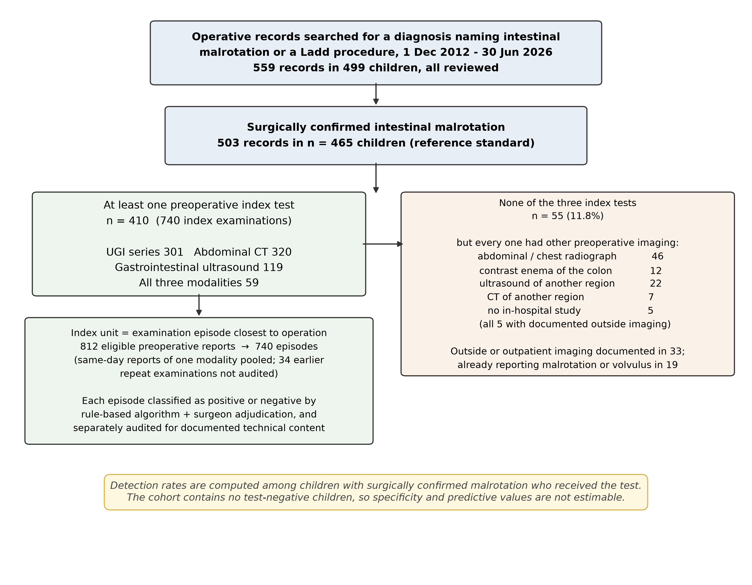
The modality groups were not interchangeable (Table 1). Ultrasound was performed more often in children with volvulus, its use rising from 13% to 48% of operated children between eras. Among children who underwent more than one index test, the UGI series was the last preoperative test in 75.1% of those who received it against 19.2% for CT, and detection was higher in that position (80.4% vs 70.5% for the UGI series), a feature of the pathway rather than of the test.

Detection and certainty of wording
Detection was 237/301 (78.7%, 95% CI 73.8–83.0) for the UGI series, 169/320 (52.8%, 47.3–58.2) for CT and 64/119 (53.8%, 44.8–62.5) for ultrasound (Table 2, Fig. 2). These denominators are indication-selected and overlapping, and are not a ranking. CT and ultrasound had lower odds of a positive report than the UGI series (adjusted odds ratio 0.29 and 0.26), and the same model showed higher detection above 1 year of age (3.02, 1.64–5.54) and in the later era (1.75, 1.18–2.62); these coefficients absorb indication, pathway position and examination content (Online Resource 2). Reclassifying possible-tier conclusions as negative reduced detection to 51.2%, 33.4% and 26.9% (Table 2).
Table 2. Report-level detection of intestinal malrotation among surgically confirmed children, with the certainty of the wording used in positive conclusions
Index test | Positive/total | Detection rate, % (95% CI) | Definite wording, n (%) | Probable wording, n (%) | Possible wording, n (%) | Detection excluding possible wording, %
UGI contrast series | 237/301 | 78.7 (73.8–83.0) | 78 (32.9) | 76 (32.1) | 83 (35.0) | 51.2
Abdominal CT (all) | 169/320 | 52.8 (47.3–58.2) | 33 (19.5) | 74 (43.8) | 62 (36.7) | 33.4
Gastrointestinal ultrasound | 64/119 | 53.8 (44.8–62.5) | 15 (23.4) | 17 (26.6) | 32 (50.0) | 26.9
CT, contrast-enhanced | 42/52 | 80.8 (68.1–89.2) | – | – | – | –
CT, unenhanced | 127/268 | 47.4 (41.5–53.4) | – | – | – | –
Wilson 95% confidence intervals. Denominators differ between modalities and are drawn from overlapping but non-identical, indication-selected groups of children; the rates are not directly comparable between modalities and are not sensitivities. Certainty tiers were assigned from the conclusion text: definite (unqualified statement), probable ("most likely", "first consideration"), possible ("suspected", "cannot be excluded", "?"). The final column repeats the detection rate after reclassifying all possible-tier conclusions as negative. Percentages for certainty tiers are of positive reports; detection rates are of all index reports of that modality. Contrast-enhanced and unenhanced CT were performed for different indications and in children of different ages, so their comparison is confounded and is presented as an exploratory subgroup only.
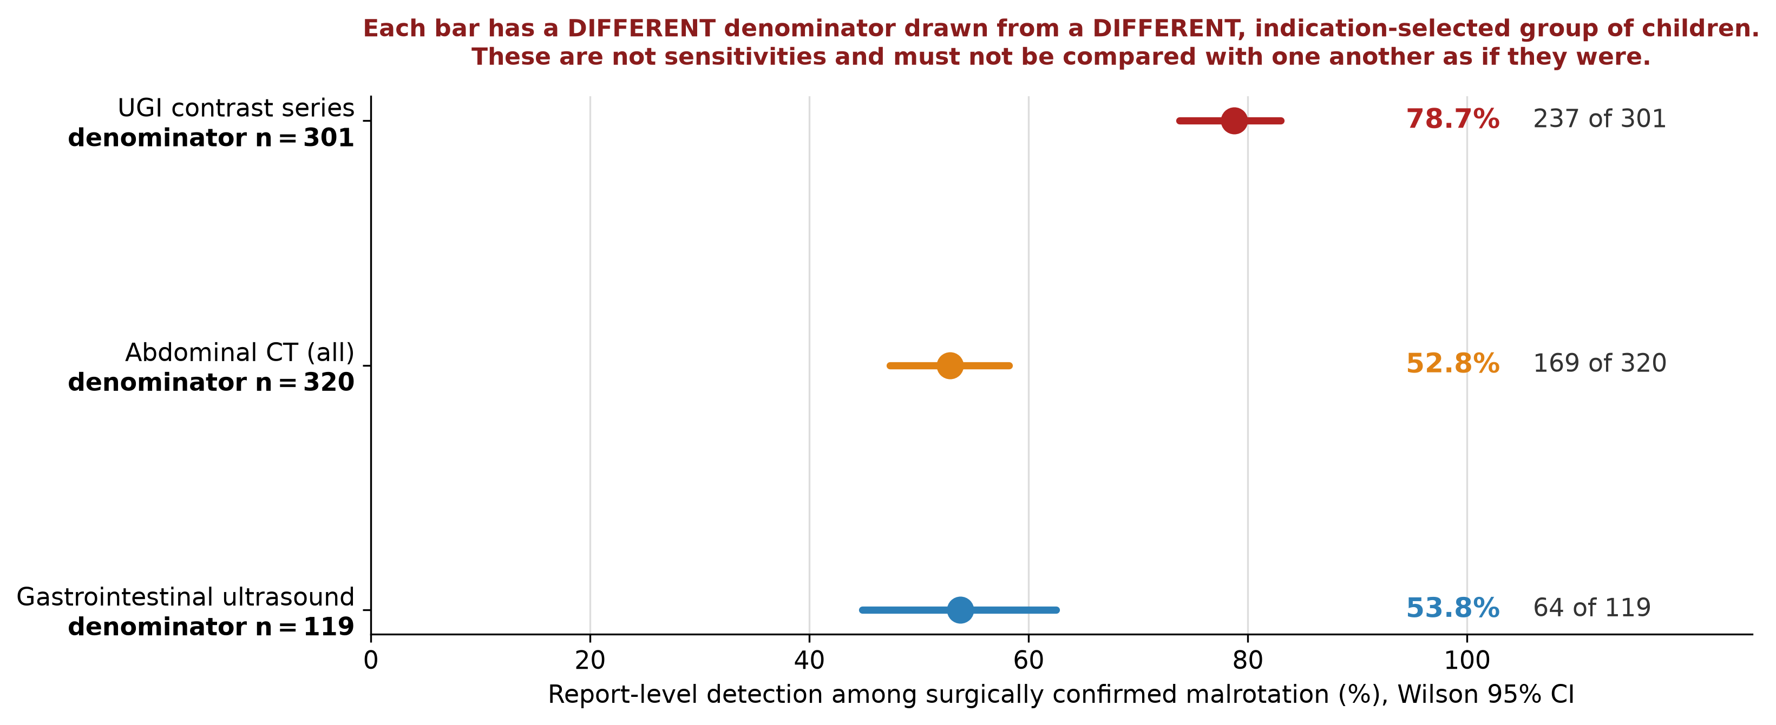

Documented content of ultrasound examinations
Of the 119 ultrasound index examinations, three (2.5%; 95% CI 0.9–7.2) documented D3 or the duodenojejunal junction and seven (5.9%) mentioned the duodenum (Table 3, Fig. 3). Twelve (10.1%) addressed the mesenteric artery–vein relationship, and one stated that the vessels were inverted, although inversion was one of the two positivity criteria. Enteric fluid was recorded twice and graded compression once; a whirlpool was reported in 58 examinations (48.7%) and bowel gas limited 30 (25.2%).
In 2018 the horizontal duodenum was described passing anterior to the superior mesenteric artery after oral contrast; in 2022 it was followed between the artery and the aorta with the duodenojejunal junction identified, the only examination resembling the published protocol; in 2024 it could not be filled and further imaging was advised.
Detection followed this content closely. Malrotation was reported in 58 of the 58 examinations recording a whirlpool and in 6 of the 61 without one (9.8%, 95% CI 4.6–19.8). This contrast is partly definitional, as a whirlpool is itself a positivity criterion, and all 58 of those conclusions named malrotation or volvulus explicitly. The converse is more informative: a whirlpool was recorded in only 58 of the 113 children (51.3%) in whom operation confirmed midgut volvulus.
Table 3. Documented content of the 119 routine gastrointestinal ultrasound index examinations, and report-level detection conditional on that content
Documented content of the ultrasound examination | n (%) of 119 | 2012–2018 (n=39) | 2019–2026 (n=80) | Detection when documented | Detection when not documented
Third portion of duodenum or duodenojejunal junction | 3 (2.5) | 1 | 2 | 2/3 | 62/116 (53%)
Duodenum mentioned in any form | 7 (5.9) | 3 | 4 | 3/7 | 61/112 (54%)
Superior mesenteric artery–vein relationship | 12 (10.1) | 3 | 9 | 10/12 (83%) | 54/107 (50%)
Explicit statement of vessel inversion | 1 (0.8) | 0 | 1 | 1/1 | 63/118 (53%)
Enteric fluid administration recorded | 2 (1.7) | 1 | 1 | 1/2 | 63/117 (54%)
Dynamic (real-time) assessment | 3 (2.5) | 0 | 3 | 1/3 | 63/116 (54%)
Graded compression | 1 (0.8) | 1 | 0 | 1/1 | 63/118 (53%)
Caecal position | 5 (4.2) | 1 | 4 | 4/5 | 60/114 (53%)
Colour Doppler used | 116 (97.5) | 38 | 78 | 63/116 (54%) | 1/3
Whirlpool, swirl or spiral appearance reported | 58 (48.7) | 16 | 42 | 58/58 (100%) | 6/61 (10%)
Bowel gas explicitly limiting the study | 30 (25.2) | 11 | 19 | 12/30 (40%) | 52/89 (58%)
Booked as abdominal great-vessel study | 67 (56.3) | 13 | 54 | 46/67 (69%) | 18/52 (35%)
Booked as gastrointestinal ultrasound | 75 (63.0) | 29 | 46 | 37/75 (49%) | 27/44 (61%)
Booked as pyloric ultrasound | 12 (10.1) | 4 | 8 | 7/12 (58%) | 57/107 (53%)
Performed at the bedside | 9 (7.6) | 0 | 9 | 1/9 | 63/110 (57%)
The index unit is the examination episode closest to operation, pooling all reports of that modality issued that day. Content was coded from the findings and conclusion text by pre-specified patterns (Online Resource 1). This is an audit of what was recorded and is a lower bound on what was performed: an element assessed but not documented cannot be distinguished from one never assessed. Technique elements count as documented whether the finding was normal or abnormal; the whirlpool sign counts only where it is not negated, and agrees with the separately adjudicated whirlpool variable in 118 of 119 examinations. Enteric fluid administration counts only examinations stating that fluid was given (oral contrast or nasogastric instillation); observed luminal fluid without a stated route was not counted. Booking categories are not mutually exclusive: 28 sessions were booked as both a gastrointestinal and a great-vessel study. Denominators of fewer than 10 are shown without a percentage.
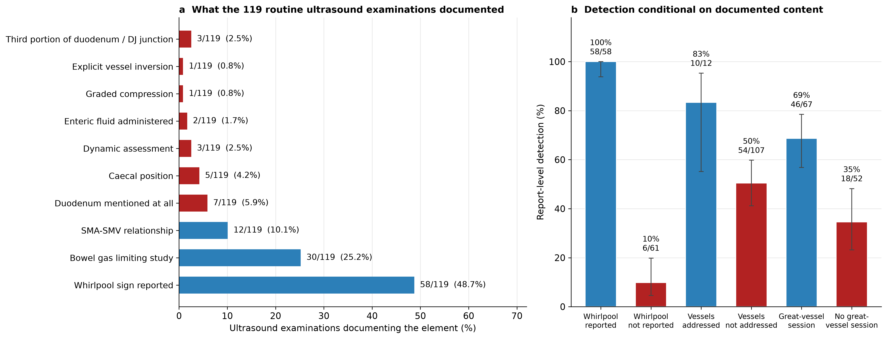

Change in detection over time
Ultrasound detection was 41.0% (16/39) in 2012–2018 and 60.0% (48/80) in 2019–2026, and rose for CT but not the UGI series (Table 4). For ultrasound the change tracked how the examination was booked. Sessions including a great-vessel study rose from 33.3% to 67.5%, and adding this indicator reduced the era effect from +19.0 (95% CI +0.6 to +37.6) to +8.2 (−11.6 to +27.8) percentage points, the indicator carrying an odds ratio of 3.73 (1.67–8.33). Moving the era boundary from 2019 to 2022 left the examination-type odds ratio between 3.44 and 4.31, while the era odds ratio ranged from 2.67 to 1.14 (Online Resource 2). The era-by-booking interaction was not significant, giving no evidence that the effect of examination type itself changed between eras, although these subgroups are small. The change in booking tracked whirlpool reporting but not duodenal assessment. CT showed a comparable change that contrast enhancement explained only in part, and the UGI series showed none (Table 4).
Table 4. Change in report-level detection between eras, and the examination-content variables associated with it
Modality | Detection 2012–2018 | Detection 2019–2026 | Era odds ratio (95% CI) | Era odds ratio after adjustment for examination content | Examination-content variable, odds ratio (95% CI) | Average marginal effect of later era, percentage points (crude → adjusted)
UGI contrast series | 158/205 (77.1%) | 79/96 (82.3%) | 1.38 (0.75–2.56), p=0.304 | Not applicable (technique unchanged) | – | +5.2
Abdominal CT | 100/215 (46.5%) | 69/105 (65.7%) | 2.20 (1.36–3.58), p=0.001 | 1.95 (1.19–3.22), p=0.009 | Intravenous contrast enhancement 4.21 (2.01–8.81), p<0.001 | +19.2 → +15.5
Gastrointestinal ultrasound | 16/39 (41.0%) | 48/80 (60.0%) | 2.16 (0.99–4.70), p=0.053 | 1.44 (0.62–3.37), p=0.399 | Session included a great-vessel study 3.73 (1.67–8.33), p=0.001 | +19.0 → +8.2
Modality-specific logistic models. For ultrasound the content variable is whether the examination session included an abdominal great-vessel study; this is an ordering and reporting label, not a record of technique. For CT the variable is intravenous contrast enhancement. Odds ratios and average marginal effects are both shown because a conditional odds ratio attenuates when a predictive covariate is added even in the absence of mediation (non-collapsibility), so the marginal effect is the more interpretable measure of how much of the era difference the content variable accounts for. The content variables were not randomised and are themselves confounded by indication: a child suspected of volvulus is both more likely to be booked for a great-vessel study and more likely to have a whirlpool to find. These models are explanatory, not causal. Sensitivity analyses moving the era boundary from 2019 to 2022 are in Online Resource 2.

Selected subgroup and populations not represented
Fifty-nine children underwent all three modalities. This subgroup, in whom the diagnosis remained uncertain, was more severely affected than the other 351 imaged children (volvulus 96.6% vs 86.6%; neonates 83.1% vs 65.5%). The UGI series was positive in 76.3%, ultrasound in 52.5% and CT in 45.8% (Cochran's Q p<0.001; the UGI series exceeded CT by 30.5 percentage points, 95% CI +15.3 to +47.5, and ultrasound by 23.7, +8.5 to +39.0, while the CT–ultrasound difference was compatible with zero, −6.8, −20.3 to +6.8), and was unchanged within 48 h (Online Resource 2). These comparisons describe reporting within one selected subgroup and are not measures of accuracy. Only 6 of the 62 children with malrotation but no volvulus underwent ultrasound, and none had a positive report; a Firth penalised model supports the direction of this contrast but not its magnitude (Online Resource 2). The cohort therefore says little about the children to whom the ultrasound-first debate applies.

Discussion
Over 13.5 years, routine ultrasound reports for children who proved to have intestinal malrotation rarely recorded the duodenal anatomy on which contemporary ultrasound accuracy depends: D3 or the duodenojejunal junction in three of 119 examinations, enteric fluid in two. The finding they did record was the whirlpool sign, present in about half of all examinations and of the children in whom operation confirmed volvulus. In this setting ultrasound functioned as an imperfect test for midgut volvulus.
Malrotation was reported in 53.8% of the surgically confirmed children who underwent ultrasound, compared with 93–97% in the 2025 multicentre series [13] and a pooled 94% in meta-analysis [11], both in children investigated for suspicion. These figures are not interchangeable: ours is conditioned on confirmed disease and on the indications that selected these children, so the difference combines case-mix with technique. The audit nonetheless shows the technical component to be real. The published figures derive from examinations that assessed D3, the most accurate single sign in the 2025 multicentre series [13], and the duodenojejunal junction, often with enteric fluid, in readers alert to the diagnosis [15–17], whereas ours almost never did. The 2021 systematic review likewise found better performance where enteric fluid was given before the examination [11].
The temporal analysis is consistent with this interpretation without establishing it. Detection rose from 41% to 60%, and the change tracked what the examination was: adding the great-vessel indicator more than halved the era effect on the risk-difference scale, whereas the examination-type effect was stable at every boundary tested. The booking category was not randomised, and a child in whom volvulus is suspected is both more likely to be booked for a vessel study and more likely to have a whirlpool present, so indication and technique cannot be separated here. The adjusted marginal effect also has a wide interval that includes zero, so the analysis bounds the era contribution rather than removing it. The department's account is consistent: growing awareness from about 2021 attached to the whirlpool sign rather than to duodenal anatomy, so that the improvement also ran towards volvulus.
Three features of the design make the between-modality differences uninterpretable as accuracy. The reference standard is not independent of the index tests: the surgeon knew the preoperative imaging, and a positive UGI series often precipitated the operation that confirmed the diagnosis, an incorporation bias asymmetrical between tests. Pathway position differed, the UGI series usually being the last preoperative test. The modalities were also used in different children for different reasons (Table 1), which no adjustment can undo.
Departments adopting an ultrasound-first pathway on the basis of sensitivities of 93–97% should first establish that their examinations resemble those that produced them. Here detection rose over the period of reported growing awareness while the duodenal landmarks remained largely unexamined. A structured report requiring explicit statements on D3, the duodenojejunal junction and study adequacy would make this gap auditable. Where such an examination cannot be delivered, a negative ultrasound should not be taken to exclude malrotation.

Limitations
This is not a diagnostic accuracy study: detection among surgically confirmed children who underwent a test does not transfer to children investigated for suspicion [11, 13, 14]. The cohort contains only children who reached an operation, is weighted towards severe neonatal disease, and provides little information on older children with intermittent symptoms, incidental or non-volvulus malrotation, or stable outpatients. The 55 children without an index test were excluded from the denominators, an informative missingness. Excluding children whose operative record states a rotation below 360° changes prevalence from 86.7% to 82.6% without altering any conclusion (Online Resource 2).
Index tests were classified from report text rather than blinded image review, so the study measures reported detection rather than achievable image-based accuracy; a finding seen but not recorded and an inadequate examination reported as normal cannot be distinguished. This bounds the question rather than the answer, since the report is what clinicians act on. The certainty tiers were derived from the same text and, unlike the positive–negative label, were not separately adjudicated. The temporal analysis was not pre-specified, the examination-type variable having been identified after inspection of the data, and is best regarded as hypothesis-generating. Radiation dose could not be captured, and whether the deficit at this centre generalises is unknown.

Conclusion
In routine reports for children with surgically confirmed intestinal malrotation, the duodenal landmarks underpinning contemporary ultrasound accuracy were documented in under 3% of examinations, and the diagnosis was reported almost exclusively when a whirlpool sign was recorded, occurring in about half of the children in whom operation confirmed volvulus. Ultrasound here served in practice as a test for volvulus rather than for malrotation. These rates establish no specificity, predictive value or ranking, and are no argument against ultrasound-first pathways. They indicate that a department's own technique and reporting content are what an audit can measure, and the first thing to examine before assuming that published performance is achievable locally.

Abbreviations
CI: Confidence interval; CT: Computed tomography; D3: Third portion of the duodenum; GEE: Generalised estimating equation; IQR: Interquartile range; OR: Odds ratio; STARD: Standards for Reporting of Diagnostic Accuracy Studies; STROBE: Strengthening the Reporting of Observational Studies in Epidemiology; UGI: Upper gastrointestinal

Supplementary Information
Online Resource 1. Text-classification algorithm and report-content audit: full rule dictionary, negation and scope handling, priority rules, worked examples of misclassification, the per-modality distribution of positive, negative and tentative labels, and a runnable reference implementation of the rule set (`Online_Resource_1_classifier.py`), which reproduces 98.9% of the final labels. That figure measures agreement between the published code and the labels used here; the 92% above measures agreement between the algorithm and the blinded adjudicator.
Online Resource 2. Between-modality generalised estimating equation models; the subgroup receiving all three examinations, with 48-h and 24-h timing sensitivity analyses; detection stratified by midgut volvulus and by age; detection of a volvulus-specific sign among children with confirmed volvulus; and sensitivity analyses varying the era boundary from 2019 to 2022, restricting midgut volvulus to a documented rotation of 360° or more, and taking the earliest rather than the closest preoperative examination as the index unit.
Online Resource 3. Content audit of the 320 CT and 301 upper gastrointestinal series index examinations, with detection conditional on documented content.

Declarations
Acknowledgements: Provided on the separate title page.
Funding: Provided on the separate title page.
Competing interests: The authors declare that they have no competing interests.
Ethics approval and consent to participate: This study was approved by the institutional review board of the participating institution (approval number provided on the title page), and the requirement for informed consent was waived because of the retrospective, de-identified design. All procedures were in accordance with the 1964 Declaration of Helsinki and its later amendments.
Consent for publication: Not applicable. This manuscript does not contain any individual person's data, images, or other identifiable material.
Availability of data and materials: The de-identified analysis dataset used pseudonymised research identifiers rather than direct identifiers; it is nonetheless not publicly available because of institutional and ethical restrictions on sharing patient-level clinical data and the potential for re-identification within this small, single-centre disease cohort. The complete text-classification rule set, a runnable reference implementation of it, and the report-content audit patterns are provided in Online Resource 1. The scripts implementing every model, table and figure are available from the corresponding author on request. De-identified data may be made available by the corresponding author upon reasonable request and with permission of the institutional review board.
Authors' contributions: Provided on the separate title page.

References
1. Marine MB, Karmazyn B (2014) Imaging of malrotation in the neonate. Semin Ultrasound CT MR 35:555–570 https://doi.org/10.1053/j.sult.2014.08.004
2. Martinez SA, Fligor SC, Tsikis S, et al (2023) IMPOWER: a national patient-generated registry for intestinal malrotation exploring diagnosis, treatment, and surgical outcomes. Orphanet J Rare Dis 18:113 https://doi.org/10.1186/s13023-023-02722-5
3. Yang X, Wang W, Wang K, et al (2024) Identification and treatment of intestinal malrotation with midgut volvulus in childhood: a multicenter retrospective study. Front Pediatr 12:1390856 https://doi.org/10.3389/fped.2024.1390856
4. Menghwani H, Piplani R, Yhoshu E, et al (2023) Delayed presentation of malrotation: case series and literature review. J Indian Assoc Pediatr Surg 28:271–277 https://doi.org/10.4103/jiaps.jiaps_2_23
5. Mattioli G, Gallo E, Wong MCY, et al (2024) Diagnostic accuracy of upper gastrointestinal series in children with suspected intestinal malrotation. Updates Surg 76:201–208 https://doi.org/10.1007/s13304-023-01559-8
6. Sizemore AW, Rabbani KZ, Ladd A, Applegate KE (2008) Diagnostic performance of the upper gastrointestinal series in the evaluation of children with clinically suspected malrotation. Pediatr Radiol 38:518–528 https://doi.org/10.1007/s00247-008-0762-8
7. Applegate KE, Anderson JM, Klatte EC (2006) Intestinal malrotation in children: a problem-solving approach to the upper gastrointestinal series. Radiographics 26:1485–1500 https://doi.org/10.1148/rg.265055167
8. Smitthimedhin A, Suarez A, Webb RL, Otero HJ (2018) Mimics of malrotation on pediatric upper gastrointestinal series: a pictorial review. Abdom Radiol (NY) 43:2246–2254 https://doi.org/10.1007/s00261-018-1537-9
9. Taylor GA (2011) CT appearance of the duodenum and mesenteric vessels in children with normal and abnormal bowel rotation. Pediatr Radiol 41:1378–1383 https://doi.org/10.1007/s00247-011-2118-z
10. Sodhi KS, Bhatia A, Saxena AK, et al (2014) Anticlockwise swirl of mesenteric vessels: a normal CT appearance, retrospective analysis of 200 pediatric patients. Eur J Radiol 83:710–714 https://doi.org/10.1016/j.ejrad.2013.12.026
11. Nguyen HN, Kulkarni M, Jose J, et al (2021) Ultrasound for the diagnosis of malrotation and volvulus in children and adolescents: a systematic review and meta-analysis. Arch Dis Child 106:1171–1178 https://doi.org/10.1136/archdischild-2020-321082
12. Nguyen HN, Navarro OM, Bloom DA, et al (2022) Ultrasound for midgut malrotation and midgut volvulus: AJR expert panel narrative review. AJR Am J Roentgenol 218:931–939 https://doi.org/10.2214/AJR.21.27242
13. Nguyen HN, El-Ali AM, Van Tassel D, et al (2025) Diagnostic performance of ultrasound for diagnosing midgut malrotation and volvulus in children: a multiinstitutional retrospective review. AJR Am J Roentgenol 225:e2532660 https://doi.org/10.2214/AJR.25.32660
14. Binu V, Nicholson C, Cundy T, et al (2021) Ultrasound imaging as the first line of investigation to diagnose intestinal malrotation in children: safety and efficacy. J Pediatr Surg 56:2224–2228 https://doi.org/10.1016/j.jpedsurg.2021.04.009
15. McCurdie FK, Meshaka R, Leung G, et al (2024) Ultrasound for infantile midgut malrotation: techniques, pearls, and pitfalls. Pediatr Radiol 54:2099–2111 https://doi.org/10.1007/s00247-024-06067-4
16. Menten R, Reding R, Godding V, et al (2012) Sonographic assessment of the retroperitoneal position of the third portion of the duodenum: an indicator of normal intestinal rotation. Pediatr Radiol 42:941–945 https://doi.org/10.1007/s00247-012-2403-5
17. Hennessey I, John R, Gent R, Goh DW (2014) Utility of sonographic assessment of the position of the third part of the duodenum using water instillation in intestinal malrotation: a single-center retrospective audit. Pediatr Radiol 44:387–391 https://doi.org/10.1007/s00247-013-2839-2
18. Karmazyn B, Cohen MD (2015) Based on the position of the third portion of the duodenum at sonography, it is not possible to confidently diagnose malrotation. Pediatr Radiol 45:138–139 https://doi.org/10.1007/s00247-014-3068-z
19. von Elm E, Altman DG, Egger M, et al (2007) The Strengthening the Reporting of Observational Studies in Epidemiology (STROBE) statement: guidelines for reporting observational studies. Ann Intern Med 147:573–577 https://doi.org/10.7326/0003-4819-147-8-200710160-00010
20. Shimanuki Y, Aihara T, Takano H, et al (1996) Clockwise whirlpool sign at color Doppler US: an objective and definite sign of midgut volvulus. Radiology 199:261–264 https://doi.org/10.1148/radiology.199.1.8633156
21. López-Úbeda P, Martín-Noguerol T, Juluru K, Luna A (2022) Natural language processing in radiology: update on clinical applications. J Am Coll Radiol 19:1271–1285 https://doi.org/10.1016/j.jacr.2022.06.016
22. Zeger SL, Liang KY (1986) Longitudinal data analysis for discrete and continuous outcomes. Biometrics 42:121–130 https://doi.org/10.2307/2531248
23. Firth D (1993) Bias reduction of maximum likelihood estimates. Biometrika 80:27–38 https://doi.org/10.1093/biomet/80.1.27
24. Heinze G, Schemper M (2002) A solution to the problem of separation in logistic regression. Stat Med 21:2409–2419 https://doi.org/10.1002/sim.1047

Figure legends
Fig. 1 Study flow and the imaging received by children without an index test. Retrieval of 559 operative records in 499 children, assembly of the surgically confirmed cohort, availability of each preoperative index test, and reduction of 812 eligible preoperative reports to 740 index examination episodes. Every one of the 55 children who received none of the three index examinations nonetheless had other preoperative imaging, five of them documented before transfer; the breakdown is shown at right.
Fig. 2 Report-level detection by modality, each estimate with its own denominator. Detection among children with a preoperative index examination (Wilson 95% confidence intervals). Each estimate is drawn from a different, indication-selected group of children, so the rates are not directly comparable between modalities and are not sensitivities for children investigated for suspected malrotation.
Fig. 3 Ultrasound examination content and detection conditional on that content. a Documented content of the 119 ultrasound index examinations. b Report-level detection conditional on that content. Three examinations documented the third portion of the duodenum or the duodenojejunal junction. Detection when a whirlpool sign was reported is partly definitional, the sign being one of the positivity criteria; the informative contrast is the 6 of 61 examinations that named the diagnosis without one.

