Routine ultrasound reports for intestinal malrotation rarely document duodenal landmarks: a report-level audit of 740 preoperative examinations in 465 surgically confirmed children
[Author names, affiliations, and corresponding-author details have been removed for double-blind peer review and are provided on the separate title page.]
Word count: 5,714 (main text, excluding title, abstract, references, tables and figure legends); Tables: 6; Figures: 4; Supplementary: 3 Online Resources

Abstract
Background Ultrasound is increasingly advocated as the first-line test for suspected intestinal malrotation, supported by studies reporting sensitivities of 93–97% when the third portion of the duodenum and the mesenteric vessels are assessed under dedicated protocols. Whether routine, unselected clinical practice reproduces those conditions has not been examined.
Objective To audit what routine radiology reports for gastrointestinal ultrasound, abdominal CT and the upper gastrointestinal (UGI) contrast series actually document and detect in children with surgically confirmed malrotation, and to identify the report-level features associated with detection.
Materials and methods Retrospective, case-only report audit at one tertiary children's hospital (December 2012–June 2026). All preoperative index reports of the three modalities were classified for malrotation detection by a rule-based algorithm with surgeon adjudication, and were separately audited for documented technical content (duodenal landmarks, mesenteric-vessel relationship, whirlpool sign, enteric fluid). Because the cohort was assembled on confirmed disease, the outcome is the report-level detection rate among surgically confirmed cases; sensitivity, specificity, predictive values and comparative accuracy are not estimable.
Results Among 465 children (352 [75.7%] male; median age at operation 13 days; midgut volvulus in 403 [86.7%]), 410 had at least one preoperative index test (740 examinations). No ultrasound report (0/119) documented the third portion of the duodenum or the duodenojejunal junction, 10 (8.4%) described the superior mesenteric artery–vein relationship, and 1 (0.8%) recorded enteric fluid administration; a whirlpool sign was recorded in 59 (49.6%). Ultrasound reported malrotation in 59 of 59 examinations in which a whirlpool was documented and in 6 of 60 in which it was not (100% vs 10%). Report-level detection was 237/301 (78.7%) for the UGI series, 171/320 (53.4%) for CT and 65/119 (54.6%) for ultrasound, on non-comparable, indication-selected denominators. Ultrasound detection rose from 41.0% (2012–2018) to 61.3% (2019–2026); this era effect was abolished by adjustment for a shift toward mesenteric-vessel-focused examination (era odds ratio 2.27 [95% CI 1.04–4.96] falling to 1.56 [0.67–3.62]; protocol odds ratio 3.46 [1.56–7.67]).
Conclusion In routine practice, ultrasound for malrotation was performed and reported as a whirlpool-dependent test for volvulus rather than as a protocolised assessment of duodenal position, and its detection tracked that content almost perfectly. The gap between real-world and published ultrasound performance is best explained by examination technique and reporting content, not by any intrinsic limitation of ultrasound. These are detection rates in children with confirmed disease and do not rank the accuracy of the three modalities.
Keywords: Intestinal malrotation; Intestinal volvulus; Infant, Newborn; Ultrasonography; Radiology report; Quality improvement

Introduction
Intestinal malrotation results from incomplete rotation and fixation of the midgut during fetal development and predisposes to midgut volvulus, in which the small bowel twists around a narrow mesenteric pedicle and can progress within hours to bowel ischaemia, necrosis, short-bowel syndrome or death [1, 2]. Bilious vomiting in a neonate remains a surgical emergency until malrotation with volvulus has been excluded, although older infants and children may present with intermittent or atypical symptoms and be diagnosed late [3, 4].
The upper gastrointestinal (UGI) contrast series has long been the reference imaging test, based on the position of the duodenojejunal junction and the course of the proximal small bowel [5, 6, 13]. Over the past decade, however, the field has moved substantially toward ultrasound. Contemporary series report ultrasound sensitivities of 93–97% and specificities of 96–100% for malrotation when performed with a dedicated protocol, and a systematic review of 17 studies and 2,257 children estimated a pooled sensitivity of 94% and specificity of 100% [7–9, 12]. A multicentre study of 539 children investigated for clinical suspicion of malrotation supported ultrasound as a safe first-line investigation [19]. Critically, that performance is not attributed to ultrasound as a modality in the abstract, but to specific technical elements: visualisation of the intraperitoneal versus retroperitoneal course of the third portion of the duodenum (D3), assessment of the duodenojejunal junction, the superior mesenteric artery–vein relationship, the use of enteric fluid to distend the duodenum, and dynamic graded compression [9, 12, 18, 20, 21]. The same literature records that these elements are technically demanding, operator-dependent, and not universally achievable — and that D3 position alone has been argued to be insufficient for a confident diagnosis [22].
This creates a question those studies cannot answer. They describe what ultrasound achieves when performed and interpreted under favourable conditions, usually by dedicated paediatric sonographers and readers who know that malrotation is the question; what clinicians act on is the routine report issued during unselected care. If the technical elements that drive published accuracy are frequently absent from routine examinations, a hospital adopting an ultrasound-first pathway on the strength of the published figures may not obtain the published performance. To our knowledge, no study has examined the content of routine malrotation ultrasound reports at scale, or linked that content to whether the diagnosis was reported.
We therefore performed a report-level audit over 13.5 years at a tertiary children's hospital, to characterise what routine ultrasound, CT and UGI reports document in children who proved at operation to have malrotation, and which documented findings accompanied a positive report. Because every child had surgically confirmed malrotation, the study measures how often the disease was named in the report and why — not how accurate the tests are. This constraint governs every result reported below.

Materials and methods

Design, terminology and what this study can and cannot estimate
This was a retrospective, single-centre, case-only report audit, approved by the institutional review board with waiver of informed consent. Reporting follows STROBE [14]; STARD was deliberately not used, because the design does not meet the definition of a diagnostic accuracy study.
The cohort was assembled exclusively from children with an operative diagnosis of malrotation and therefore contains no children in whom malrotation was suspected and excluded. Three consequences are applied consistently throughout. First, the outcome is the report-level detection rate among surgically confirmed cases — the proportion of preoperative index reports whose conclusion raised malrotation. We do not call these proportions "sensitivity", because sensitivity is a property of a test applied to a defined clinical population and the term would invite the inference that the figure applies to children investigated for suspected malrotation. It does not. Second, specificity, predictive values and any accuracy-based ranking of the three modalities are not estimable and are neither reported nor implied. Third, each modality was ordered for different clinical reasons in overlapping but non-identical groups of children, so the three detection rates rest on different, indication-selected denominators; between-modality models describe indication-driven practice, not controlled comparisons of test performance.
We distinguish *malrotation* (the rotational anomaly), *midgut volvulus* (an acute twist on the mesenteric pedicle) and *malrotation with volvulus* throughout. The whirlpool sign is a sign of volvulus, not of malrotation in isolation, and the wording of every result preserves that distinction.

Participants and reference standard
We identified consecutive children who underwent surgery for intestinal malrotation between December 2012 and June 2026 from the institutional clinical and surgical records database. Inclusion required an operative diagnosis of malrotation, which served as the reference standard. Midgut volvulus was defined by an explicit operative statement of volvulus or a documented degree of midgut or mesenteric rotation (for example, clockwise rotation 360°–720°); isolated gastric volvulus and torsion of other organs were excluded. No child meeting the criterion was excluded and no sample-size calculation was performed; 465 children constituted the cohort. Age at operation was calculated as age at admission for the operative encounter plus the interval from admission to operation, the operative encounter being identified by linking each operative record to its own admission; the operation date fell within the linked admission for all 465 children.

Index tests and index-test selection
Three preoperative modalities were evaluated: gastrointestinal and mesenteric-vessel ultrasound (examinations coded as gastrointestinal, abdominal great-vessel or pyloric ultrasound), abdominal CT (overall and by contrast enhancement), and the UGI contrast series (upper or whole-gastrointestinal study, water-soluble contrast or barium). Contrast enema studies of the colon were not counted as a UGI series and are reported separately. For each child and modality the preoperative examination closest to the operation was the index test; examinations dated after the operation were excluded.
All examinations were performed and reported during routine clinical care by radiologists who were unaware of the eventual operative findings but who were not blinded to the clinical history or to previous imaging. Ultrasound examinations were performed within the general paediatric ultrasound service rather than by a designated malrotation reader group. Reports were free text; no structured malrotation reporting template was in use at any point during the study period, and no formally documented revision of the ultrasound examination protocol could be identified in departmental records ⟦AUTHORS: confirm and, if a protocol or equipment change did occur, give its date⟧. Examination technique therefore could not be reconstructed from a protocol document, and we instead audited the reports themselves for the technical elements that a protocolised malrotation examination would be expected to document (below). The audit is a lower bound on what was performed: an element assessed but not written down is indistinguishable here from one never assessed — a limitation intrinsic to the question, since the report is what the referring clinician acts on. Consistent with recommendations that CT-based studies report radiation dose, we sought per-examination CTDIvol, dose–length product, acquisition parameters and contrast dose; these were not retrievable, because CT was ascertained from archived report text rather than from a structured dose registry spanning 13.5 years (see Limitations). Enhancement status was determined from the examination name and report text.

Report-content audit
Because the central question was what routine reports contain, each index report was separately coded for documented technical content by pre-specified text patterns applied to the findings and conclusion sections. For ultrasound these covered the duodenum in general and the third portion of the duodenum or duodenojejunal junction in particular, the superior mesenteric artery–vein relationship and explicit vessel inversion, a whirlpool or spiral appearance, administration of enteric fluid, an explicit statement that bowel gas limited the study, caecal position, and bedside performance; for CT, contrast enhancement, a mesenteric whirl, duodenal position, the vessel relationship and three-dimensional reconstruction; and for the UGI series, the duodenojejunal junction, a corkscrew proximal small bowel, jejunal position and caecal position. The full pattern dictionary is given in Online Resource 1.

Classification of reports as positive or negative
An examination was classified as positive when its conclusion raised malrotation, including tentative phrasing (suspected, possible, most likely, first consideration, cannot be excluded, recommended to be ruled out) or a modality-appropriate diagnostic sign: on ultrasound a whirlpool sign or inversion of the superior mesenteric artery and vein; on the UGI series an abnormally positioned duodenojejunal junction or a corkscrew course of the proximal small bowel; and on CT a mesenteric whirl or an abnormal duodenal position. Explicit negation (no sign of malrotation, normal rotation) was classified as negative. Isolated benign gastric volvulus was not counted as positive. Technically non-diagnostic studies were not separately coded as indeterminate but were classified by their stated conclusion. Because tentative phrasing is standard in reports from our department and its inclusion is a substantive choice, we (a) tabulated the certainty tier of every positive conclusion (definite, probable, possible) by modality and (b) repeated the principal analyses after reclassifying all "possible"-tier conclusions as negative.
Report text was classified with a rule-based, clause-level algorithm with explicit negation handling, informed by general natural language processing approaches in radiology [15]. The complete rule dictionary, negation and scope logic, priority rules, worked examples of the misclassifications encountered, and the per-modality distribution of positive, negative and tentative labels are provided in Online Resource 1. A paediatric surgeon blinded to the operative findings adjudicated 32 reports in two samples. In a stratified random sample of 24 reports (positive and negative machine labels balanced across modalities), algorithm–adjudicator agreement was 92% (22/24; Cohen kappa 0.83; per-modality 88%, 88% and 100% for the UGI series, CT and ultrasound). A separate targeted review of the 8 reports in which a malrotation sign co-occurred with a negative machine label identified 5 further machine under-calls, which were corrected; because those 8 were selected as suspected discordances, they are excluded from the agreement statistics, which derive from the random sample alone. All discordances in both samples were machine under-calls, so the reported detection rates are conservative. Adjudicated labels superseded algorithmic labels. Validation rested on one adjudicator, so interobserver agreement could not be estimated.

Statistical analysis
Report-level detection rates are presented with Wilson 95% confidence intervals (CIs) and with their denominators shown wherever the rate appears, including in figures. Characteristics of the children who received each index test, and of those who received none, are tabulated to display confounding by indication directly rather than to adjust it away.
Between-modality comparison used a generalised estimating equation (GEE) logistic model [16] with detection as the outcome, modality as the predictor (UGI series as reference), patient-level clustering, an exchangeable working correlation and cluster-robust standard errors, fitted to all children with at least one index test, then refitted with adjustment for era of operation (2012–2018 vs 2019–2026) and age category (≤28 days, 29 days–1 year, >1 year). These odds ratios describe indication-driven detection under routine test selection; adjustment for the few recorded covariates cannot remove confounding by indication.
A modality-by-volvulus interaction was pre-specified but could not be estimated across all three modalities: no ultrasound examination was positive among the six children without volvulus, producing complete separation and non-convergence of the full interaction model. We therefore report the interaction only for the comparison that is estimable (UGI series vs CT), present volvulus-stratified detection rates with exact CIs for all three modalities, and make no claim about interaction involving ultrasound.
As a confirmatory analysis restricted to children who received all three modalities, detection was compared with Cochran's Q and the exact McNemar test. Because the interval between examinations allows the disease state to evolve, this analysis was repeated in the subsets in which all three examinations fell within 48 h and within 24 h.
Determinants of the temporal change in detection were examined with modality-specific logistic models of detection on era, before and after adding the report-content variable specific to that modality (for ultrasound, whether the examination was recorded as a mesenteric-vessel study; for CT, contrast enhancement). Attenuation of the era coefficient after adding the content variable was interpreted as evidence that the temporal change operated through examination content rather than through calendar time.
Given the exploratory nature of the subgroup and content analyses, p values were not adjusted for multiplicity, and all subgroup findings are reported as hypothesis-generating. Analyses used Python 3.12 (statsmodels 0.15, SciPy 1.17).

Results

Cohort, and what the children without an index test actually received
Between December 2012 and June 2026, 465 children with surgically confirmed intestinal malrotation were included; 352 (75.7%) were male, the median age at operation was 13 days (interquartile range [IQR] 7 days to 2.8 months, range 0–14.2 years), 302 (64.9%) were neonates and 93 (20.0%) were older than 1 year. Midgut volvulus was documented at operation in 403 (86.7%). A preoperative index examination was available in 301 children for the UGI series, 320 for abdominal CT and 119 for ultrasound; 410 children had at least one (740 index examinations) and 59 had all three. Characteristics are shown in Table 1 and the study flow in Fig. 1.
Table 1. Characteristics of the 465 children with surgically confirmed intestinal malrotation, overall and according to which preoperative index test they received
Characteristic | All children | Received UGI series | Received CT | Received ultrasound | Received none of the three
Children, n | 465 | 301 | 320 | 119 | 55
Age at operation, median (IQR), days | 13 (7–85) | 12 (8–35) | 11 (6–47) | 10 (5–27) | 63 (4–932)
Neonate ≤28 days, n (%) | 302 (64.9) | 216 (71.8) | 222 (69.4) | 90 (75.6) | 23 (41.8)
Age >1 year, n (%) | 93 (20.0) | 45 (15.0) | 54 (16.9) | 15 (12.6) | 16 (29.1)
Male, n (%) | 352 (75.7) | 226 (75.1) | 250 (78.1) | 94 (79.0) | 39 (70.9)
Operated 2019–2026, n (%) | 166 (35.7) | 96 (31.9) | 105 (32.8) | 80 (67.2) | 19 (34.5)
Midgut volvulus at operation, n (%) | 403 (86.7) | 268 (89.0) | 281 (87.8) | 113 (95.0) | 42 (76.4)
Vomiting documented, n (%) | 441 (94.8) | 288 (95.7) | 308 (96.2) | 113 (95.0) | 50 (90.9)
Bilious vomiting documented, n (%) | 219 (47.1) | 166 (55.1) | 165 (51.6) | 58 (48.7) | 12 (21.8)
Abdominal distension, n (%) | 183 (39.4) | 119 (39.5) | 137 (42.8) | 57 (47.9) | 24 (43.6)
Blood in stool, n (%) | 113 (24.3) | 64 (21.3) | 88 (27.5) | 32 (26.9) | 11 (20.0)
Abdominal pain, n (%) | 72 (15.5) | 33 (11.0) | 46 (14.4) | 10 (8.4) | 13 (23.6)
Recurrent/intermittent symptoms, n (%) | 221 (47.5) | 152 (50.5) | 148 (46.2) | 53 (44.5) | 21 (38.2)
Shock or poor perfusion, n (%) | 11 (2.4) | 3 (1.0) | 6 (1.9) | 3 (2.5) | 4 (7.3)
Groups overlap, because a child could receive more than one index test; columns therefore do not sum to the cohort total. Age at operation was calculated as age at admission for the operative encounter plus the interval from admission to operation. Presenting features were extracted from admission records by text search and are documentation rates, not verified prevalences. The rightmost column shows the 55 children who received none of the three index tests; all of them nonetheless had other preoperative imaging (Fig. 1). IQR interquartile range, UGI upper gastrointestinal.
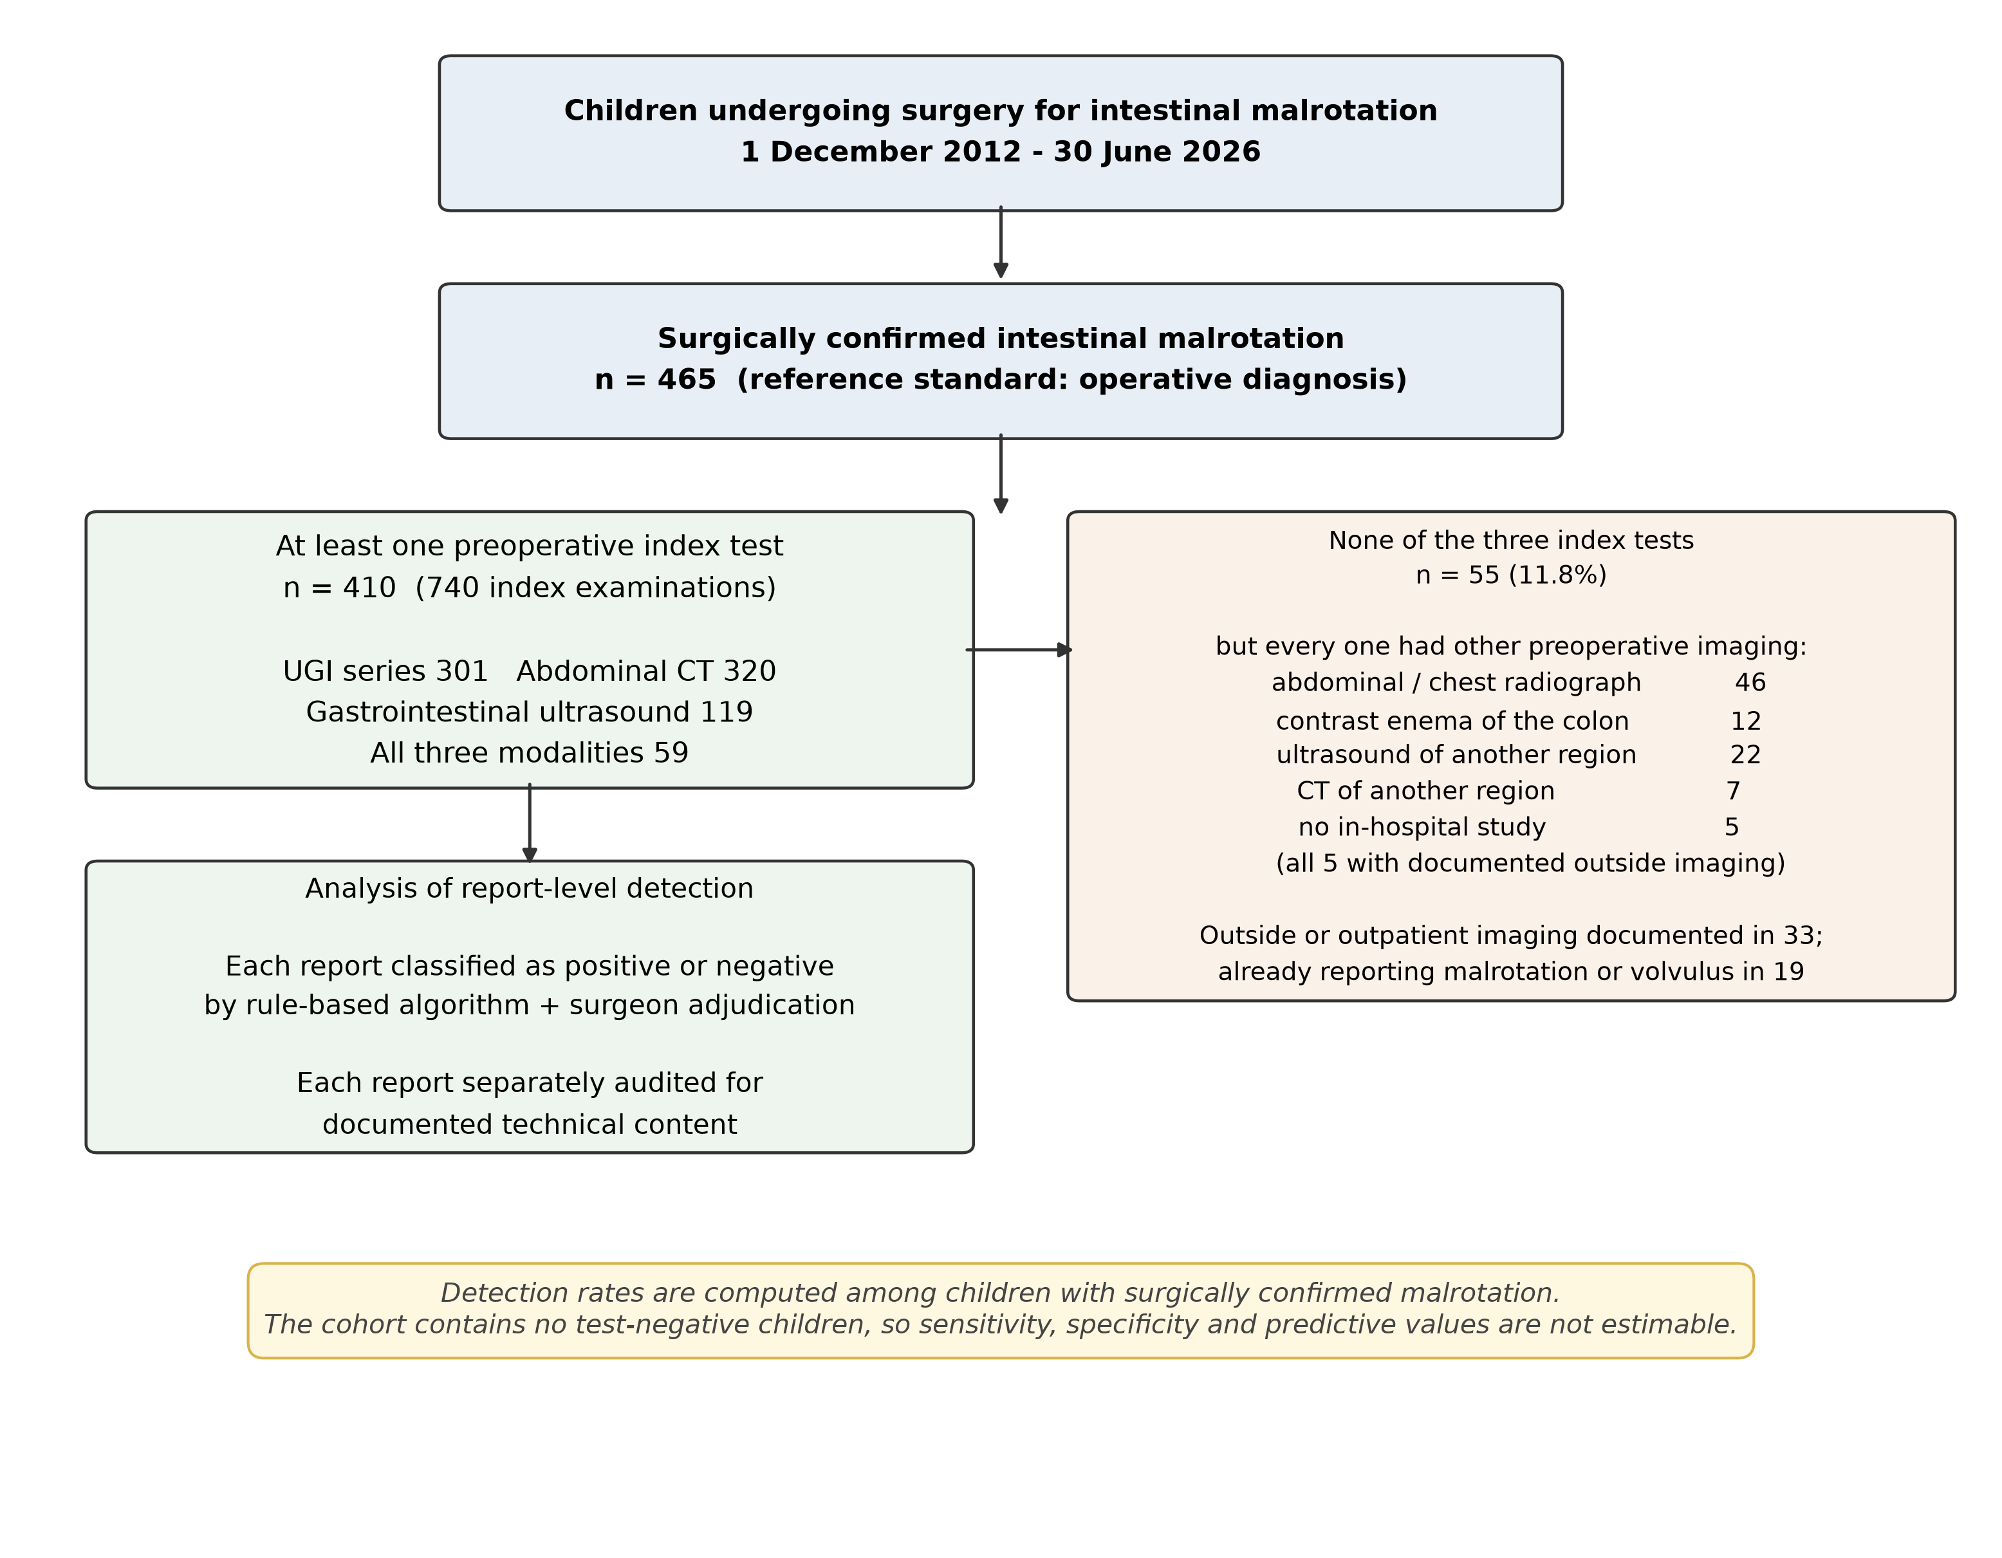
Fig. 1 Study flow diagram showing assembly of the surgically confirmed malrotation cohort, availability of each preoperative index test, and the imaging actually received by the 55 children who had none of the three index examinations
Fifty-five children (11.8%) had none of the three index examinations. This does not mean that they were operated on without imaging: every one of them had preoperative imaging of some kind (Fig. 1). Forty-six had radiographs (44 including the abdomen), 12 had a contrast enema of the colon, 22 had ultrasound of another region and 7 had CT of another region. Only 5 had no in-hospital preoperative study of any type, and the admission record of each of those 5 documented imaging performed before transfer, three of which had already reported malrotation or volvulus. Across all 55, the admission record documented prior outside or outpatient imaging in 33, and that imaging had already reported malrotation or volvulus in 19. These children were operated on after the diagnosis had been made or strongly suggested elsewhere, or after a radiograph and contrast enema in an era when that combination was more often considered sufficient. They differed systematically from the imaged children (Table 1): older (median 63 vs 12 days), less often neonates (41.8% vs 68.0%), less often with documented bilious vomiting (21.8% vs 50.5%) and less often with volvulus (76.4% vs 88.0%). Their exclusion from the index-test denominators is informative missingness, not random loss.

The three modalities were used in different children
The three modality groups were broadly similar in age and sex but were not interchangeable (Table 1). Children who underwent ultrasound had volvulus more often (95.0%, vs 89.0% for the UGI series and 87.8% for CT) and were concentrated in the second era: 67.2% of ultrasound examinations were performed in 2019–2026, against 31.9% of UGI series and 32.8% of CT examinations. Ultrasound utilisation among operated children rose from 13% (39/299) in 2012–2018 to 48% (80/166) in 2019–2026, and no gastrointestinal ultrasound in this cohort predated 2016.
Test sequence also differed systematically. Among the 271 children who received more than one modality, CT was the first index test in 183 (67.5%) and the UGI series the last before operation in 184 (67.9%). Per modality, the UGI series was the final preoperative test in 184 of 245 children who received it (75.1%), against 48 of 250 (19.2%) for CT and 39 of 106 (36.8%) for ultrasound; its detection was higher in that position (80.4%) than when another examination followed (70.5%), with no comparable gradient for CT (47.9% vs 54.0%) or ultrasound (53.8% vs 58.2%). The UGI series thus functioned as the confirmatory study immediately preceding operation — a feature of the diagnostic pathway, not a property of the test.

Report-level detection, and the certainty of the wording
Report-level detection among surgically confirmed children was 237/301 (78.7%, 95% CI 73.8–83.0) for the UGI series, 171/320 (53.4%, 48.0–58.8) for abdominal CT and 65/119 (54.6%, 45.7–63.3) for ultrasound (Table 2, Fig. 3). These three proportions are computed on different, indication-selected denominators drawn from overlapping groups of children, and Fig. 3 is annotated accordingly; they should not be read as a ranking of the tests.
Table 2. Report-level detection of intestinal malrotation among surgically confirmed children, with the certainty of the wording used in positive conclusions
Index test | Positive/total | Detection rate, % (95% CI) | Definite wording, n (%) | Probable wording, n (%) | Possible wording, n (%) | Detection excluding possible wording, %
UGI contrast series | 237/301 | 78.7 (73.8–83.0) | 78 (32.9) | 76 (32.1) | 83 (35.0) | 51.2
Abdominal CT (all) | 171/320 | 53.4 (48.0–58.8) | 34 (19.9) | 75 (43.9) | 62 (36.3) | 34.1
Gastrointestinal ultrasound | 65/119 | 54.6 (45.7–63.3) | 16 (24.6) | 17 (26.2) | 32 (49.2) | 27.7
CT, contrast-enhanced | 44/52 | 84.6 (72.5–92.0) | – | – | – | –
CT, unenhanced | 127/268 | 47.4 (41.5–53.4) | – | – | – | –
Ultrasound, whirlpool sign recorded | 59/119 | 49.6 (40.8–58.4) | – | – | – | –
Wilson 95% confidence intervals. Denominators differ between modalities and are drawn from overlapping but non-identical, indication-selected groups of children; the rates are not directly comparable between modalities and are not sensitivities. Certainty tiers were assigned from the conclusion text: definite (unqualified statement), probable ("most likely", "first consideration"), possible ("suspected", "cannot be excluded", "?"). The final column repeats the detection rate after reclassifying all possible-tier conclusions as negative. Percentages for certainty tiers are of positive reports; detection rates are of all index reports of that modality. Contrast-enhanced and unenhanced CT were performed for different indications and in children of different ages, so their comparison is confounded and is presented as an exploratory subgroup only.
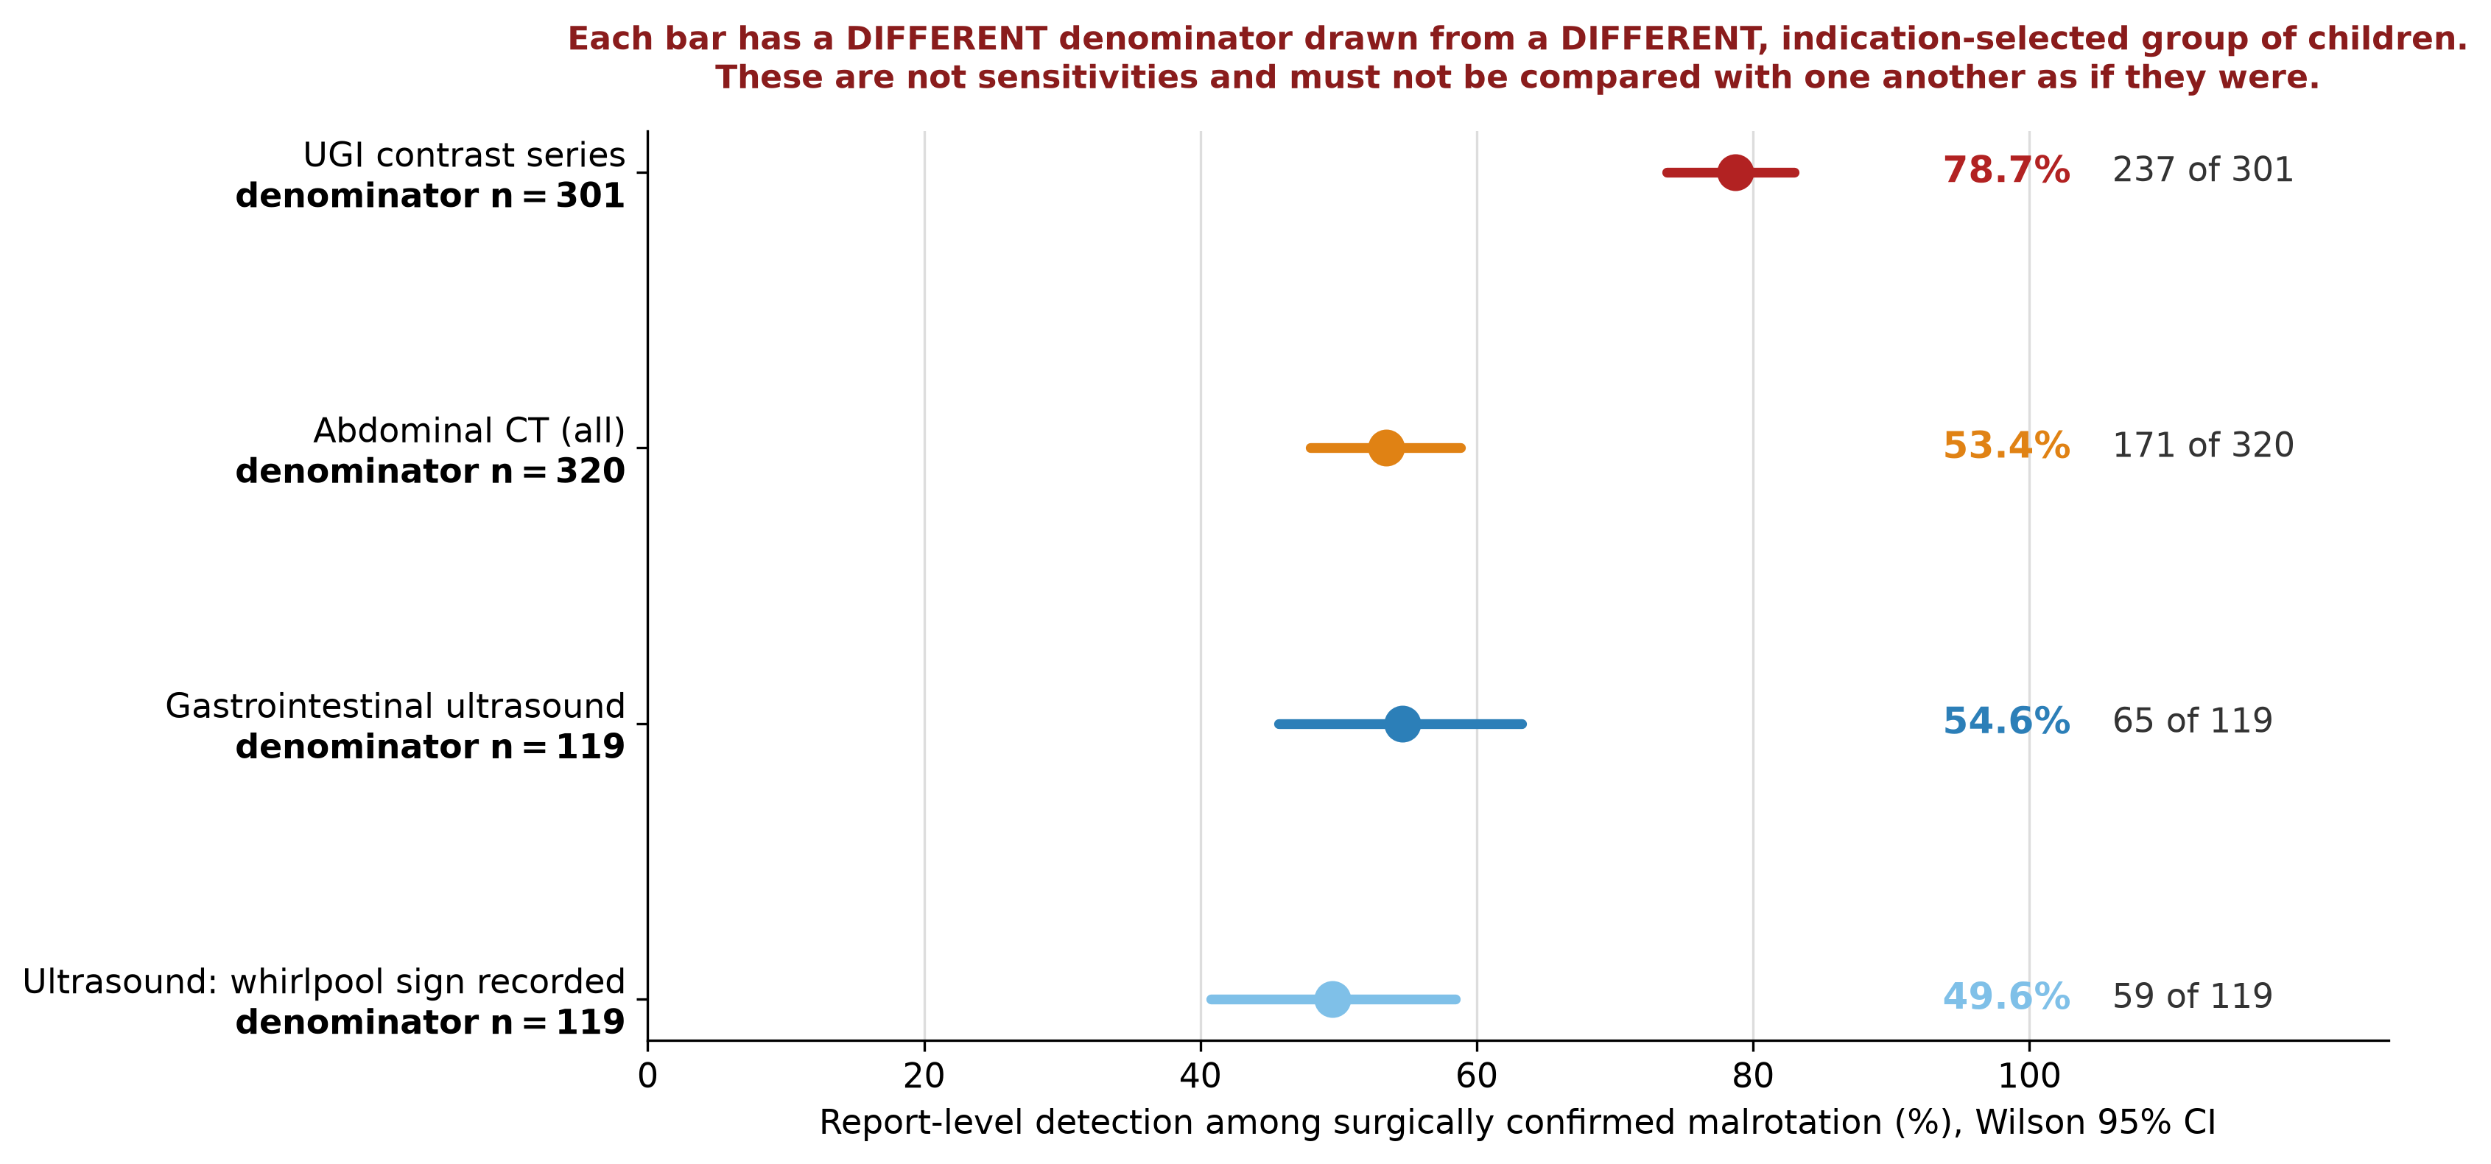
Fig. 3 Report-level detection of malrotation by each modality among children with a preoperative index examination (Wilson 95% confidence intervals). Each estimate has its own denominator, drawn from a different, indication-selected group of children; the rates are not directly comparable between modalities and do not constitute sensitivity
Tentative phrasing was common and differed by modality (Table 2). Of positive conclusions, 78 of 237 (32.9%) UGI, 34 of 171 (19.9%) CT and 16 of 65 (24.6%) ultrasound reports used unqualified wording; a further 32.1%, 43.9% and 26.2% used probable wording, and 35.0%, 36.3% and 49.2% used possible wording ("suspected", "cannot be excluded", "?"). Because every child had surgically confirmed malrotation, none of these tentative conclusions was a false positive: they were correct diagnoses expressed with hedging. Reclassifying all possible-tier conclusions as negative reduced detection to 51.2% (154/301) for the UGI series, 34.1% (109/320) for CT and 27.7% (33/119) for ultrasound, without changing the ordering; the largest proportional reduction fell on ultrasound.

What the ultrasound reports contained
The central finding concerns the content of the 119 ultrasound index reports (Table 3, Fig. 4). Not one documented the third portion of the duodenum or the duodenojejunal junction (0/119, 0%; 95% CI 0–3.1); six (5.0%) mentioned the duodenum at all. Ten (8.4%) described the superior mesenteric artery–vein relationship, and only one (0.8%) stated explicitly that the vessels were inverted, although vessel inversion was one of the two criteria defining a positive ultrasound. One report (0.8%) recorded enteric fluid and four (3.4%) the caecal position. By contrast, 59 (49.6%) recorded a whirlpool, swirl or spiral appearance, and bowel gas was reported as limiting the examination in 26 (21.8%).
Detection followed this content almost deterministically. Ultrasound reported malrotation in 59 of the 59 examinations documenting a whirlpool sign (100%, 95% CI 93.9–100) and in 6 of the 60 without one (10.0%, 4.7–20.1); where the mesenteric-vessel relationship was described, 10 of 10 were positive. Detection was 70.5% (43/61) for examinations recorded as abdominal great-vessel studies, 47.1% (32/68) for those recorded as gastrointestinal ultrasound and 22.2% for the nine bedside examinations. In this cohort, ultrasound diagnosed malrotation when, and essentially only when, it saw the twisted pedicle of an active volvulus; the anatomical assessment on which contemporary ultrasound accuracy rests was absent from the record of every examination.
The audits of CT and the UGI series show the same principle with different content (Online Resource 3). A mesenteric whirl was described in 116 of 320 CT reports (36.2%), of which 98.3% were positive, against 27.9% of those without. For the UGI series the duodenojejunal junction was described in 164 of 301 reports (54.5%), of which 98.2% were positive, against 55.5% of those without; jejunal position was described in 70.4% and a corkscrew appearance in 46.5%. Detection in each modality was governed by whether the diagnostic landmark was sought and recorded, and the UGI series was the only modality whose routine reports documented the landmark that defines malrotation itself in the majority of examinations.
Table 3. Documented content of the 119 routine gastrointestinal ultrasound index reports, and report-level detection conditional on that content
Documented content of the ultrasound report | n (%) of 119 reports | 2012–2018 (n=39), % | 2019–2026 (n=80), % | Detection when documented, % | Detection when not documented, %
Third portion of duodenum or duodenojejunal junction | 0 (0.0) | 0.0 | 0.0 | – | 54.6
Duodenum mentioned in any form | 6 (5.0) | 7.7 | 3.8 | 33.3 | 55.8
Superior mesenteric artery–vein relationship | 10 (8.4) | 5.1 | 10.0 | 100.0 | 50.5
Explicit statement of vessel inversion | 1 (0.8) | 0.0 | 1.2 | 100.0 | 54.2
Enteric fluid administered | 1 (0.8) | 0.0 | 1.2 | 0.0 | 55.1
Caecal position | 4 (3.4) | 2.6 | 3.8 | 75.0 | 53.9
Whirlpool, swirl or spiral appearance | 57 (47.9) | 41.0 | 51.2 | 98.2 | 14.5
Bowel gas explicitly limiting the study | 26 (21.8) | 20.5 | 22.5 | 46.2 | 57.0
Recorded as abdominal great-vessel study | 61 (51.3) | 28.2 | 62.5 | 70.5 | 37.9
Recorded as gastrointestinal ultrasound | 68 (57.1) | 74.4 | 48.8 | 47.1 | 64.7
Performed at the bedside | 9 (7.6) | 0.0 | 11.2 | 22.2 | 57.3
Whirlpool sign (adjudicated variable) | 59 (49.6) | 41.0 | 53.8 | 100.0 | 10.0
Content was coded from the findings and conclusion text of each index report by pre-specified patterns (Online Resource 1). This is an audit of what was recorded, and is a lower bound on what was performed: an element assessed but not documented cannot be distinguished here from one never assessed. The whirlpool sign appears twice because the adjudicated study variable and the text-pattern variable differ slightly (59 vs 57 reports); both are shown for transparency. Examination-type categories are not mutually exclusive.
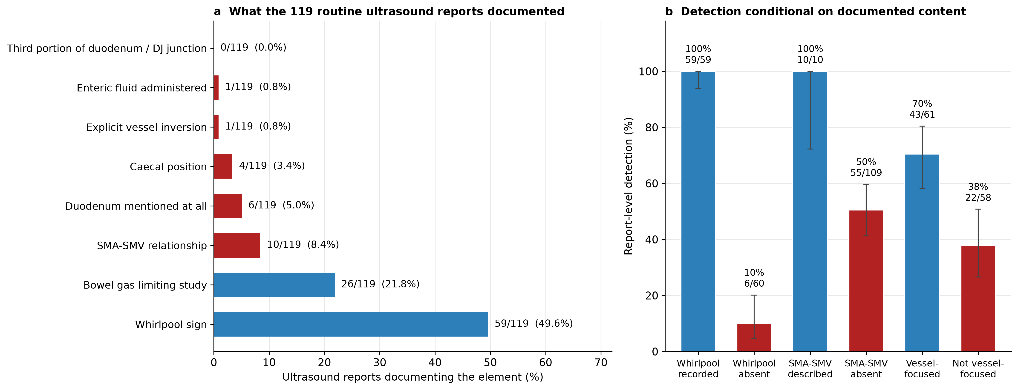
Fig. 4 Content of the 119 routine ultrasound index reports (a) and report-level detection conditional on that content (b). No report documented the third portion of the duodenum or the duodenojejunal junction; detection was 100% when a whirlpool sign was recorded and 10% when it was not

Between-modality models, presented as descriptions of practice
In the GEE model using all 410 children with at least one index test (740 examinations; Table 4), CT and ultrasound had lower odds of a positive report than the UGI series (odds ratio [OR] 0.31 [95% CI 0.22–0.44] and 0.33 [0.21–0.50]; both p<0.001), essentially unchanged after adjustment for era and age category (CT OR 0.29 [0.21–0.42]; ultrasound OR 0.27 [0.17–0.43]). Detection was higher in the later era (OR 1.79 [1.20–2.68], p=0.004) and in children older than 1 year relative to neonates (OR 3.14 [1.71–5.75], p<0.001), with no difference between infants aged 29 days to 1 year and neonates (OR 1.09 [0.69–1.73]). These coefficients absorb the indication for the test, its position in the diagnostic pathway and the content of the examination, and cannot be separated from them in these data.
Table 4. Between-modality comparison of report-level detection (generalised estimating equation)
Effect | Unadjusted OR (95% CI) | Adjusted OR (95% CI) | p (adjusted)
Abdominal CT vs UGI series | 0.31 (0.22–0.44) | 0.29 (0.21–0.42) | <0.001
Gastrointestinal ultrasound vs UGI series | 0.33 (0.21–0.50) | 0.27 (0.17–0.43) | <0.001
Operated 2019–2026 vs 2012–2018 | – | 1.79 (1.20–2.68) | 0.004
Age 29 days–1 year vs neonate | – | 1.09 (0.69–1.73) | 0.699
Age >1 year vs neonate | – | 3.14 (1.71–5.75) | <0.001
GEE logistic model with exchangeable working correlation and patient-level clustering (cluster-robust standard errors); 410 children, 740 preoperative index examinations. An odds ratio (OR) below 1 indicates lower report-level detection than the UGI series. These estimates describe indication-driven detection under routine test selection and are not estimates of comparative diagnostic accuracy; the modality coefficients absorb the indication for the test, its position in the diagnostic pathway and the content of the examination. The pre-specified modality-by-volvulus interaction could not be estimated across all three modalities because no ultrasound examination was positive among the six children without volvulus (complete separation, model non-convergence); for the estimable UGI-versus-CT comparison the interaction OR was 0.90 (95% CI 0.33-2.43, p=0.84).
The pre-specified modality-by-volvulus interaction could not be estimated across all three modalities: no ultrasound examination was positive among the six children without volvulus, causing complete separation and non-convergence. In the estimable comparison the CT-versus-UGI difference did not vary with volvulus (interaction OR 0.90 [0.33–2.43], p=0.84). Detection by the UGI series was similar with and without volvulus (79.1% [212/268] vs 75.8% [25/33]), as was CT (53.0% [149/281] vs 56.4% [22/39]); ultrasound detected 57.5% (65/113) of children with volvulus and none of the six without (0%, 95% CI 0–39.0) (Online Resource 2). We draw no directional conclusion from that last cell: six children cannot support one, ultrasound was chosen in only 6 of the 62 children without volvulus, and the model does not converge.

The selected subgroup who received all three examinations
Fifty-nine children underwent all three modalities preoperatively (Table 5, Fig. 2). This subgroup is not a random sample and is not a head-to-head accuracy comparison: these were children in whom the diagnosis remained uncertain after the first and second examinations, and they were more severely and more recently affected than the rest (96.6% volvulus vs 86.6% of the other imaged children; 83.1% neonates vs 65.5%; 62.7% operated in the later era vs 31.3%). The question they answer is narrow — among children investigated intensively enough to receive all three tests, which examination named the diagnosis most often — and we do not present it as confirmation of a population-level ordering.
Within the subgroup, the UGI series was positive in 45/59 (76.3%), ultrasound in 31/59 (52.5%) and CT in 28/59 (47.5%) (Cochran's Q p=0.001; exact McNemar UGI vs CT p=0.002, UGI vs ultrasound p=0.009, CT vs ultrasound p=0.65). The three examinations were separated by a median of 0.9 days (IQR 0.6–1.6); 47 children (79.7%) had all three within 48 h and 31 (52.5%) within 24 h. Because active volvulus and its imaging signs can evolve over such an interval, the analysis was repeated in these tighter windows: within 48 h detection was 83.0%, 59.6% and 48.9% for the UGI series, ultrasound and CT (Q p<0.001; UGI vs CT p=0.002, UGI vs ultrasound p=0.013), and within 24 h 87.1%, 64.5% and 51.6% (Q p=0.002; UGI vs CT p=0.003, UGI vs ultrasound p=0.039). Restricting to near-simultaneous examinations did not weaken the pattern, but it does not remove the selection that defines the subgroup.
Table 5. Report-level detection in the selected subgroup of children who underwent all three examinations, overall and restricted to examinations performed close together in time
Measure | All (n=59) | All three within 48 h (n=47) | All three within 24 h (n=31)
UGI contrast series, n/N (%; 95% CI) | 45/59 (76.3; 64.0–85.3) | 39/47 (83.0; 69.9–91.1) | 27/31 (87.1; 71.1–94.9)
Gastrointestinal ultrasound, n/N (%; 95% CI) | 31/59 (52.5; 40.0–64.7) | 28/47 (59.6; 45.3–72.4) | 20/31 (64.5; 46.9–78.9)
Abdominal CT, n/N (%; 95% CI) | 28/59 (47.5; 35.3–60.0) | 23/47 (48.9; 35.3–62.8) | 16/31 (51.6; 34.8–68.0)
Ultrasound whirlpool sign, n/N (%; 95% CI) | 30/59 (50.8; 38.4–63.2) | 27/47 (57.4; 43.3–70.5) | 19/31 (61.3; 43.8–76.3)
Cochran's Q, p | 0.001 | <0.001 | 0.002
Exact McNemar UGI vs CT: discordant pairs, p | 23/6, p=0.002 | 20/4, p=0.002 | 12/1, p=0.003
Exact McNemar UGI vs US: discordant pairs, p | 20/6, p=0.009 | 14/3, p=0.013 | 8/1, p=0.039
Exact McNemar CT vs US: discordant pairs, p | 8/11, p=0.648 | 4/9, p=0.267 | 2/6, p=0.289
This subgroup was assembled by diagnostic uncertainty, not by sampling: 96.6% had midgut volvulus, 83.1% were neonates and 62.7% were operated on in 2019-2026, compared with 86.6%, 65.5% and 31.3% of the other imaged children. It answers the question of which examination named the diagnosis most often among children investigated intensively enough to receive all three, and is not a population-level comparison of test accuracy. The interval is that between the first and last of the three examinations (median 0.9 days, IQR 0.6-1.6). Discordant pairs are shown as first-positive/second-positive.
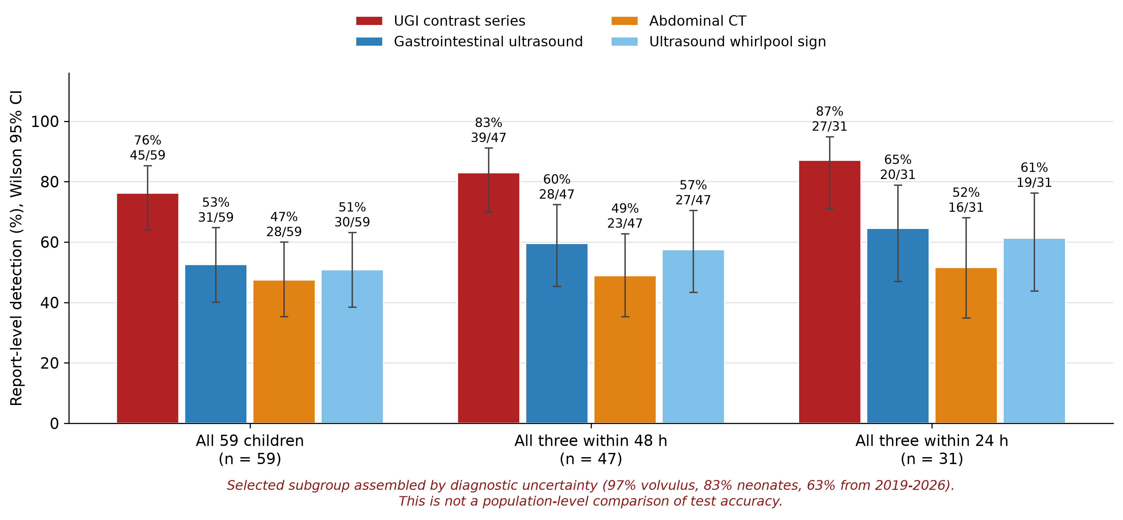
Fig. 2 Report-level detection in the selected subgroup of 59 children who underwent all three examinations preoperatively, shown for the whole subgroup and for the subsets in which all three examinations fell within 48 h and within 24 h. Error bars are Wilson 95% confidence intervals. This subgroup was assembled by diagnostic uncertainty and is not a population-level comparison of test accuracy

Detection changed over time, and the change tracked examination content
Detection rose across the study period for the two modalities whose technique changed. Ultrasound detection was 41.0% (16/39) in 2012–2018 and 61.3% (49/80) in 2019–2026; CT detection was 47.0% (101/215) and 66.7% (70/105); UGI detection was 77.1% (158/205) and 82.3% (79/96) (Table 6).
For ultrasound, this temporal change was accounted for by a shift in what the examination was. The proportion of ultrasound index examinations recorded as abdominal great-vessel studies rose from 28.2% to 62.5% (Fisher p<0.001), while the proportion recorded as gastrointestinal ultrasound fell from 74.4% to 48.8%; documentation of a whirlpool rose from 41.0% to 53.8% and of the mesenteric-vessel relationship from 5.1% to 10.0%. In a logistic model, later era was associated with detection (OR 2.27 [1.04–4.96], p=0.039); adding the vessel-focused examination indicator reduced the era term to 1.56 (0.67–3.62, p=0.30) while the examination indicator itself carried an OR of 3.46 (1.56–7.67, p=0.002). Detection when a vessel-focused examination was performed was similar in both eras (72.7% early, 70.0% late), whereas detection without it was 28.6% and 46.7%. The improvement over time is therefore better described as a change in what was done than as a change in when it was done.
For CT, the proportion of contrast-enhanced studies rose from 12.1% to 24.8%, and enhancement was strongly associated with detection (84.6% [44/52] enhanced vs 47.4% [127/268] unenhanced; Fisher OR 6.11, p<0.001; note that this comparison is confounded by indication, because enhanced studies were obtained for selected clinical reasons and in older children). Adjustment for enhancement attenuated the era term only partially (OR 2.26 falling to 1.98). For the UGI series, whose technique did not change materially, there was no era effect (OR 1.38 [0.75–2.56], p=0.30).
Table 6. Change in report-level detection between eras, and the examination-content variables that account for it
Modality | Detection 2012–2018 | Detection 2019–2026 | Era OR (95% CI) | Era OR after adjustment for examination content | Content variable OR (95% CI)
UGI contrast series | 158/205 (77.1%) | 79/96 (82.3%) | 1.38 (0.75–2.56) (p=0.304) | Not applicable (technique unchanged) | –
Abdominal CT | 101/215 (47.0%) | 70/105 (66.7%) | 2.26 (1.39–3.67) (p=0.001) | 1.98 (1.20–3.28) (p=0.008) | Contrast enhancement 5.53 (2.49–12.27) (p=<0.001)
Gastrointestinal ultrasound | 16/39 (41.0%) | 49/80 (61.3%) | 2.27 (1.04–4.96) (p=0.039) | 1.56 (0.67–3.62) (p=0.303) | Vessel-focused examination 3.46 (1.56–7.67) (p=0.002)
Modality-specific logistic models. For ultrasound the content variable is whether the examination was recorded as an abdominal great-vessel study rather than as gastrointestinal ultrasound; for CT it is intravenous contrast enhancement. Attenuation of the era odds ratio after the content variable is added indicates that the temporal change operated through what the examination was rather than through calendar time. The content variables were not randomly assigned and are themselves confounded by indication; these models are explanatory rather than causal.

Age, and the populations this cohort does not describe
Detection rose with age for the UGI series (75.9% of neonates, 80.0% of infants, 91.1% of children older than 1 year) and for CT (46.4%, 50.0%, 85.2%) but not for ultrasound (56.7%, 50.0%, 46.7%) (Online Resource 2). The cohort nonetheless remains heavily weighted toward severe neonatal disease: 302 children (64.9%) were neonates, 403 (86.7%) had volvulus, and only 62 (13.3%) had malrotation without volvulus, of whom 6 underwent ultrasound. It therefore contains very little information about the children in whom the ultrasound-first debate is most active — older children with intermittent vomiting, incidental or non-volvulus malrotation, equivocal presentations and stable outpatients — and we make no claims about them.

Discussion
In 13.5 years of routine practice, ultrasound reports for children who proved to have intestinal malrotation almost never contained the findings on which modern ultrasound accuracy depends. The third portion of the duodenum and the duodenojejunal junction were documented in none of 119 examinations, the mesenteric-vessel relationship in 8.4%, enteric fluid in one. What the reports did contain was the whirlpool sign, in about half, and detection followed it almost perfectly — 100% when a whirlpool was recorded, 10% when it was not. At this institution, ultrasound for malrotation functioned as a test for midgut volvulus: a child with malrotation whose midgut was not actively twisted at the moment of scanning was very unlikely to be identified.
This reframes the most-cited number in our data. Ultrasound named malrotation in 54.6% of surgically confirmed children who underwent it, against published sensitivities of 93–97% in protocolised series and a pooled 94% in meta-analysis [8, 9, 12, 19]. It would be wrong to read that contrast as evidence that ultrasound performs poorly. The published figures were obtained by examinations that assessed D3 and the duodenojejunal junction, often with enteric fluid, by readers alert to the diagnosis [12, 18, 20, 21]; ours were obtained by examinations that, on the evidence of their own reports, did not. The 2021 systematic review anticipated exactly this, finding substantial heterogeneity between studies and better performance where the mesenteric vessels and enteric fluid were used [8]. Our data are a quantified instance of that heterogeneity, with the mechanism visible in the record. An element assessed but not recorded cannot be identified in report text; but a diagnostic element absent from all 119 reports is unlikely to have been routine, and it was certainly not available to the clinician reading the report.
The temporal analysis points the same way. Ultrasound detection improved from 41% to 61% between eras, and the improvement was not a property of calendar time: once the shift toward a mesenteric-vessel-focused examination was taken into account, the era effect fell to a non-significant OR of 1.56, while the examination type itself carried an OR of 3.46, and detection with a vessel-focused study was about 70% in both eras. The institution improved because the examination changed, not because time passed. This is the most actionable finding here, because it identifies a modifiable cause, and it suggests that the remaining gap to 93–97% is plausibly attributable to the elements that still never appeared in the reports — D3, the duodenojejunal junction and enteric fluid [20, 21]. Whether adding them would close the gap is a hypothesis this design cannot test, and the counter-argument that D3 position alone cannot support a confident diagnosis deserves weight [22].
The same content-dependence held for the other modalities. CT reports describing a mesenteric whirl were positive in 98.3% of cases and those without in 27.9%; the association of contrast enhancement with detection (84.6% vs 47.4%) is consistent with vascular opacification being what makes the whirl visible, although enhanced studies were selected by indication and were more common in older children, so this contrast is confounded and hypothesis-generating. For that reason we have removed the enhanced-CT comparison from the abstract: a confounded subgroup contrast does not belong among a study's headline results. For the UGI series, the duodenojejunal junction was described in 54.5% of reports and jejunal position in 70.4% — the only modality whose routine reports documented the landmark that defines malrotation in the majority of examinations. That, rather than any intrinsic superiority demonstrated here, is the most economical explanation of its higher detection rate.
Three features of the design constrain how the between-modality differences may be read, and we regard them as decisive rather than as caveats. First, the reference standard is not independent of the index tests. The operating surgeon knew the preoperative imaging, and a positive UGI series often precipitated the operation that then confirmed the diagnosis, whereas an incidental CT or ultrasound finding was less determinative. This incorporation bias is asymmetrical between modalities and inflates the apparent advantage of whichever test drove the decision to operate; whether surgeons could have been influenced toward operating by a positive UGI series is, in our view, answered in the affirmative — that is how a confirmatory test functions in a diagnostic pathway — and it is a reason why these data cannot rank the tests. Second, position in the pathway differed: the UGI series was the last examination before operation in 75% of children who received it, and its detection was higher in that position (80.4% vs 70.5%). Third, the modalities were used in different children for different reasons (Table 1), and adjustment for the few variables recoverable from records cannot substitute for randomisation. Clinical indications were not recorded prospectively in a form permitting full adjustment, so we have displayed the differences between the groups rather than claiming to have controlled them. For the same reasons the 59 children who received all three examinations are presented as a selected subgroup — 97% with volvulus, 83% neonates, 63% from the later era, assembled by the very diagnostic uncertainty that led to repeated testing — and no longer as confirmation of a population-level ordering of sensitivity, even though restricting to examinations within 48 h or 24 h, which addresses evolution of volvulus between studies, did not weaken the pattern.
What, then, is this study for? Not for ranking modalities, and not for resolving the ultrasound-first debate. Its value is that it measures something rarely measured: the distance between diagnostic performance as established in the literature and as delivered by a real department's reports over more than a decade, together with a mechanism for that distance that is visible in the record and open to correction. Departments considering an ultrasound-first pathway on the strength of sensitivities of 93–97% should first establish that their own examinations resemble the examinations that produced those figures — that D3 and the duodenojejunal junction are sought and reported, that enteric fluid is used when needed, and that reports say so. A structured malrotation ultrasound report requiring explicit statements about D3, the duodenojejunal junction, the vessel relationship and study adequacy is a low-cost intervention that would make such a deficit visible prospectively rather than 13 years later. Where such an examination cannot be delivered, a negative ultrasound should not be taken to exclude malrotation in a child with persistent clinical suspicion, and a UGI series remains appropriate. A positive whirlpool sign, highly specific for volvulus in prior work [7, 12] rather than in this cohort, should prompt urgent surgical consultation; our data speak to what was reported, not to the outcome of acting on it.

Limitations
This is not a diagnostic accuracy study and must not be read as one. The cohort was assembled on surgically confirmed disease, so there are no test-negative children and specificity, predictive values and any accuracy-based ranking cannot be estimated; the detection rates apply to children who proved to have malrotation and do not transfer to children investigated for suspected malrotation, in whom contemporary studies report far higher ultrasound performance [8, 12, 19].
The cohort is heavily skewed toward severe neonatal disease (65% neonates, 87% volvulus, all operated) and therefore says very little about older children with intermittent symptoms, incidental or non-volvulus malrotation, equivocal presentations or stable outpatients. The six children without volvulus who underwent ultrasound cannot support any inference about ultrasound in uncomplicated malrotation, and the corresponding interaction model does not converge.
The reference standard was not independent of the index tests, and modality choice, test sequence and the decision to operate were clinically entangled. Single-modality rates were computed on different, indication-selected denominators; the paired subgroup mitigates but does not remove this, being itself selected for diagnostic uncertainty. The 55 children without any index test were excluded from those denominators; they had been imaged in other ways and often diagnosed elsewhere, but differed systematically from the rest, so their exclusion is informative missingness of unknown direction.
Index tests were classified from routine report text by a rule-based algorithm rather than blinded image review. Agreement with a blinded surgeon adjudicator was 92% (kappa 0.83) in a 24-report random sample, but validation rested on one adjudicator and a limited sample, so interobserver agreement could not be estimated; the algorithm and its failure modes are given in Online Resource 1. Correspondingly, this study measures reported detection, not achievable image-based accuracy: a finding seen but not written, and an inadequate examination reported as normal, are indistinguishable here. We regard this as the boundary of the question rather than a defect in answering it, since the report is what the clinician acts on, but it means our figures cannot be attributed to the imaging examination alone.
Tentative wording was counted as positive. Because every child had confirmed malrotation no such report was a false positive, and the surgical author team confirmed each individually; the frequency is now tabulated by modality and certainty tier (Table 2), and the principal analyses repeated with possible-tier conclusions reclassified as negative, without change to the pattern.
Technique and reporting evolved over 13.5 years, so pooled estimates blend two practice eras; we have therefore reported the eras separately and modelled the change. Comparisons were not adjusted for multiplicity, and the content and subgroup analyses are exploratory. Case ascertainment and the reference standard derived from operative-record text rather than independent re-adjudication, and the operative diagnosis was a clinical label rather than standardised anatomical criteria, so thresholds for borderline anomalies may have varied between surgeons.
Because CT was ascertained from archived report text rather than a structured dose registry, per-examination CTDIvol, dose–length product and acquisition parameters could not be captured; this precludes any assessment of radiation burden and falls short of current expectations for reporting CT dose in paediatric imaging research. Prospective comparative studies should capture these metrics.
Finally, this is a single-centre experience, and the report-content deficit we describe is a finding about one department's practice. Whether it generalises is unknown and is, in our view, the question most worth asking next: the same audit is inexpensive to repeat wherever routine reports are stored electronically.

Conclusion
In a 13.5-year single-centre cohort of children with surgically confirmed intestinal malrotation, routine ultrasound reports essentially never documented the duodenal landmarks that underpin contemporary ultrasound accuracy, and detection tracked the presence of a whirlpool sign almost perfectly — ultrasound in this department was, in practice, a test for midgut volvulus rather than for malrotation. The improvement in ultrasound detection over time was explained by a shift toward mesenteric-vessel-focused examination rather than by the passage of time. These are report-level detection rates in children with confirmed disease; they do not establish sensitivity, specificity or any ranking of ultrasound, CT and the upper gastrointestinal series, and they should not be used to argue against ultrasound-first pathways. They argue instead that a department's own examination technique and reporting content determine whether published ultrasound performance is achievable locally, and that this is measurable, and correctable, by audit.

Statements and Declarations
Funding: Provided on the separate title page.
Competing interests: The authors declare no competing interests.
Ethics approval: This study was approved by the institutional review board of the participating institution (approval number provided on the title page). All procedures were in accordance with the 1964 Declaration of Helsinki and its later amendments.
Consent to participate: The requirement for informed consent was waived by the institutional review board because of the retrospective, de-identified nature of the study.
Consent for publication: Not applicable. This manuscript does not contain any individual person's data, images, or other identifiable material.
Data availability: The de-identified analysis dataset used pseudonymised research identifiers rather than patient names or other direct identifiers; it is nonetheless not publicly available because of institutional and ethical restrictions on sharing patient-level clinical data and the potential for re-identification within this small, single-centre disease cohort. The original institutional clinical records from which it was derived remain identifiable within the hospital medical record system. The complete text-classification rule set and the report-content audit patterns are provided in Online Resource 1. De-identified data may be made available by the corresponding author upon reasonable request and with permission of the institutional review board of the participating institution.
Author contributions: Provided on the separate title page.

References
1. Marine MB, Karmazyn B (2014) Imaging of malrotation in the neonate. Semin Ultrasound CT MR 35:555–570 https://doi.org/10.1053/j.sult.2014.08.004
2. Martinez SA, Fligor SC, Tsikis S, et al (2023) IMPOWER: a national patient-generated registry for intestinal malrotation exploring diagnosis, treatment, and surgical outcomes. Orphanet J Rare Dis 18:113 https://doi.org/10.1186/s13023-023-02722-5
3. Yang X, Wang W, Wang K, et al (2024) Identification and treatment of intestinal malrotation with midgut volvulus in childhood: a multicenter retrospective study. Front Pediatr 12:1390856 https://doi.org/10.3389/fped.2024.1390856
4. Menghwani H, Piplani R, Yhoshu E, et al (2023) Delayed presentation of malrotation: case series and literature review. J Indian Assoc Pediatr Surg 28:271–277 https://doi.org/10.4103/jiaps.jiaps_2_23
5. Mattioli G, Gallo E, Wong MCY, et al (2024) Diagnostic accuracy of upper gastrointestinal series in children with suspected intestinal malrotation. Updates Surg 76:201–208 https://doi.org/10.1007/s13304-023-01559-8
6. Sizemore AW, Rabbani KZ, Ladd A, Applegate KE (2008) Diagnostic performance of the upper gastrointestinal series in the evaluation of children with clinically suspected malrotation. Pediatr Radiol 38:518–528 https://doi.org/10.1007/s00247-008-0762-8
7. Shimanuki Y, Aihara T, Takano H, et al (1996) Clockwise whirlpool sign at color Doppler US: an objective and definite sign of midgut volvulus. Radiology 199:261–264 https://doi.org/10.1148/radiology.199.1.8633156
8. Nguyen HN, Kulkarni M, Jose J, et al (2021) Ultrasound for the diagnosis of malrotation and volvulus in children and adolescents: a systematic review and meta-analysis. Arch Dis Child 106:1171–1178 https://doi.org/10.1136/archdischild-2020-321082
9. Nguyen HN, Navarro OM, Bloom DA, et al (2022) Ultrasound for midgut malrotation and midgut volvulus: AJR expert panel narrative review. AJR Am J Roentgenol 218:931–939 https://doi.org/10.2214/AJR.21.27242
10. Taylor GA (2011) CT appearance of the duodenum and mesenteric vessels in children with normal and abnormal bowel rotation. Pediatr Radiol 41:1378–1383 https://doi.org/10.1007/s00247-011-2118-z
11. Sodhi KS, Bhatia A, Saxena AK, et al (2014) Anticlockwise swirl of mesenteric vessels: a normal CT appearance, retrospective analysis of 200 pediatric patients. Eur J Radiol 83:710–714 https://doi.org/10.1016/j.ejrad.2013.12.026
12. Nguyen HN, El-Ali AM, Van Tassel D, et al (2025) Diagnostic performance of ultrasound for diagnosing midgut malrotation and volvulus in children: a multiinstitutional retrospective review. AJR Am J Roentgenol 225:e2532660 https://doi.org/10.2214/AJR.25.32660
13. Applegate KE, Anderson JM, Klatte EC (2006) Intestinal malrotation in children: a problem-solving approach to the upper gastrointestinal series. Radiographics 26:1485–1500 https://doi.org/10.1148/rg.265055167
14. von Elm E, Altman DG, Egger M, et al (2007) The Strengthening the Reporting of Observational Studies in Epidemiology (STROBE) statement: guidelines for reporting observational studies. Ann Intern Med 147:573–577 https://doi.org/10.7326/0003-4819-147-8-200710160-00010
15. López-Úbeda P, Martín-Noguerol T, Juluru K, Luna A (2022) Natural language processing in radiology: update on clinical applications. J Am Coll Radiol 19:1271–1285 https://doi.org/10.1016/j.jacr.2022.06.016
16. Zeger SL, Liang KY (1986) Longitudinal data analysis for discrete and continuous outcomes. Biometrics 42:121–130 https://doi.org/10.2307/2531248
17. Smitthimedhin A, Suarez A, Webb RL, Otero HJ (2018) Mimics of malrotation on pediatric upper gastrointestinal series: a pictorial review. Abdom Radiol (NY) 43:2246–2254 https://doi.org/10.1007/s00261-018-1537-9
18. McCurdie FK, Meshaka R, Leung G, et al (2024) Ultrasound for infantile midgut malrotation: techniques, pearls, and pitfalls. Pediatr Radiol 54:2099–2111 https://doi.org/10.1007/s00247-024-06067-4
19. Binu V, Nicholson C, Cundy T, et al (2021) Ultrasound imaging as the first line of investigation to diagnose intestinal malrotation in children: safety and efficacy. J Pediatr Surg 56:2224–2228 https://doi.org/10.1016/j.jpedsurg.2021.04.009
20. Menten R, Reding R, Godding V, et al (2012) Sonographic assessment of the retroperitoneal position of the third portion of the duodenum: an indicator of normal intestinal rotation. Pediatr Radiol 42:941–945 https://doi.org/10.1007/s00247-012-2403-5
21. Hennessey I, John R, Gent R, Goh DW (2014) Utility of sonographic assessment of the position of the third part of the duodenum using water instillation in intestinal malrotation: a single-center retrospective audit. Pediatr Radiol 44:387–391 https://doi.org/10.1007/s00247-013-2839-2
22. Karmazyn B, Cohen MD (2015) Based on the position of the third portion of the duodenum at sonography, it is not possible to confidently diagnose malrotation. Pediatr Radiol 45:138–139 https://doi.org/10.1007/s00247-014-3068-z

Figure legends
Fig. 1 Study flow diagram showing assembly of the surgically confirmed malrotation cohort, availability of each preoperative index test, and the imaging actually received by the 55 children who had none of the three index examinations
Fig. 2 Report-level detection in the selected subgroup of 59 children who underwent all three examinations preoperatively, shown for the whole subgroup and for the subsets in which all three examinations fell within 48 h and within 24 h. This subgroup was assembled by diagnostic uncertainty and is not a population-level comparison of test accuracy. Cochran's Q and exact McNemar comparisons refer to the three modalities only and do not include the whirlpool-sign bar
Fig. 3 Report-level detection of malrotation by each modality among children with a preoperative index examination (Wilson 95% confidence intervals). Each bar has its own denominator, drawn from a different, indication-selected group of children; the rates are not directly comparable between modalities and do not constitute sensitivity
Fig. 4 Content of the 119 routine ultrasound index reports (left) and report-level detection conditional on that content (right). No report documented the third portion of the duodenum or the duodenojejunal junction; detection was 100% when a whirlpool sign was recorded and 10% when it was not

Supplementary material
Online Resource 1. Text-classification algorithm and report-content audit: full rule dictionary, negation and scope handling, priority rules, worked examples of misclassification, and the per-modality distribution of positive, negative and tentative labels.
Online Resource 2. Report-level detection stratified by midgut volvulus and by age category, and detection of a volvulus-specific sign among children with surgically confirmed volvulus.
Online Resource 3. Content audit of the 320 CT and 301 upper gastrointestinal series index reports, with detection conditional on documented content.

