Real-world detection rates of gastrointestinal ultrasound, abdominal CT, and the upper gastrointestinal contrast series for intestinal malrotation in children: a 13.5-year single-center cohort
[Author names, affiliations, and corresponding-author details have been removed for double-blind peer review and are provided on the separate title page.]
Word count: 3686 (main text, excluding title, abstract, references, tables, and figure legends); Tables: 6; Figures: 3; Supplementary: 1 figure

Abstract
Background: Intestinal malrotation with midgut volvulus is a pediatric surgical emergency, yet ultrasound, computed tomography (CT), and the upper gastrointestinal (UGI) series have rarely been compared.
Objective: To compare the real-world detection rate of ultrasound, CT, and the UGI series for malrotation in surgically confirmed cases, and to assess how midgut volvulus affects each.
Materials and methods: We retrospectively studied children with surgically confirmed malrotation at a tertiary children's hospital (2012–2026). Preoperative reports were classified by a rule-based algorithm validated against surgeon review (92% agreement, kappa 0.83). Modalities were compared with a generalized estimating equation (GEE) model, with a paired confirmatory analysis (exact McNemar test) in those undergoing all three.
Results: Of 465 children (352 [75.7%] male; median age 11 days; volvulus in 400 [86%]), 410 had preoperative imaging. CT and ultrasound had lower odds of detecting malrotation than the UGI series (adjusted odds ratio [OR] 0.29 and 0.27; both p<0.001), confirmed in 59 undergoing all three (McNemar p≤0.009). Contrast-enhanced CT (82.7%) approached the UGI series (78.7%) in a small subgroup. Detection was lower in neonates, rose over time, and showed no modality-by-volvulus interaction.
Conclusion: The UGI series had the highest detection rate; CT and ultrasound had similarly lower detection without differing from each other, although contrast-enhanced CT approached the UGI series in a small, non-comparable subgroup. Prior literature, not this study, supports the whirlpool sign as a rule-in finding for volvulus. These are detection rates, not full accuracy; prospective studies with test-negative children are needed.
Keywords: Intestinal malrotation; Intestinal volvulus; Infant, Newborn; Ultrasonography; Tomography, X-Ray Computed; Upper gastrointestinal series

Introduction
Intestinal malrotation results from incomplete rotation and fixation of the midgut during fetal development and predisposes to midgut volvulus, in which the small bowel twists around a narrow mesenteric pedicle and can rapidly progress to bowel ischemia, necrosis, and short-bowel syndrome or death if untreated [1–2]. Bilious vomiting in a neonate is the classic presenting symptom and constitutes a surgical emergency until malrotation with volvulus has been excluded, although older infants and children may present with intermittent or atypical symptoms, which can delay diagnosis [3–4].
Because clinical findings alone cannot reliably distinguish malrotation from other causes of bilious vomiting, imaging plays a central role in diagnosis. The upper gastrointestinal (UGI) contrast series has long been regarded as the reference imaging test, based on identification of an abnormally positioned duodenojejunal junction and abnormal course of the proximal small bowel [5–6]. Gastrointestinal ultrasound has gained wide acceptance because it is fast, radiation-free, and can demonstrate an abnormal relationship between the superior mesenteric artery and vein or a whirlpool sign produced by a twisted mesenteric pedicle, a sign originally described as highly specific for volvulus [7–9]. Abdominal CT is used increasingly, particularly in older children or when malrotation is an incidental consideration during evaluation for another indication. CT can delineate duodenal position and the relationship between the superior mesenteric artery and vein—findings that differ between children with normal and abnormal bowel rotation [10]—and can show the same whirl sign when contrast-enhanced, although a counterclockwise or incomplete swirl of mesenteric vessels is a recognized normal variant that may be misinterpreted as pathological [11].
Despite the frequent use of all three modalities, direct within-cohort comparisons of their real-world diagnostic yield remain limited, and reported sensitivities vary considerably across single-modality series, study designs, and reference standards [5–6, 12–13]. In particular, it remains unclear how detection rates for ultrasound, CT, and the UGI series compare when applied to the same patients in routine clinical practice, and how the presence of midgut volvulus itself affects the detection rate of each modality. In addition, most published estimates derive from dedicated re-review by expert readers, whereas the performance of routine clinical reports—what actually informs bedside decisions—is less well characterized [8–9]. Clarifying these questions could help guide imaging strategy when malrotation is suspected, including whether a negative study of one modality should prompt a second test before malrotation is excluded.
We therefore performed a retrospective cohort study comparing the real-world detection rate of gastrointestinal ultrasound, abdominal CT, and the UGI contrast series for intestinal malrotation, using surgical findings as the reference standard, in a 13.5-year single-center pediatric surgical cohort. We further examined whether the detection rate differed according to the presence of midgut volvulus. Because the cohort comprised operated, predominantly symptomatic neonates, the findings apply to acute presentations rather than to elective screening.

Materials and methods

Study design and setting
We performed a retrospective, single-center cohort study at a tertiary academic children's hospital. The study was approved by the institutional review board, and the requirement for informed consent was waived given the retrospective, de-identified design. Because the cohort was assembled from surgically confirmed cases, the study estimates detection rates (sensitivity) rather than complete diagnostic accuracy; reporting follows the STROBE guidance for observational studies [14], and the participant flow is shown in Fig. 1.

Participants and reference standard
We identified consecutive children who underwent surgery for intestinal malrotation at our institution between December 2012 and June 2026, ascertained from the institutional clinical and surgical records database using the diagnosis of intestinal malrotation; inclusion required an operative diagnosis of malrotation. The intraoperative diagnosis served as the reference standard: malrotation was defined by an operative diagnosis of intestinal malrotation, and midgut volvulus by a keyword-based rule applied to the operative record: an explicit operative statement of volvulus or a documented degree of midgut/mesenteric rotation (e.g., clockwise rotation 360°–720°). This keyword-based volvulus definition is used throughout, including the primary analysis and the modality-by-volvulus interaction test. This was a consecutive, non-preselected sample of all children meeting this diagnostic criterion during the study period, without a prior sample size calculation; because cases were ascertained directly by operative diagnosis of malrotation, no cases meeting this criterion were excluded from the analysis cohort. A total of 465 children with surgically confirmed malrotation constituted the analysis cohort. Age at operation ranged from 0 to 14.2 years (median 11 days).

Index tests
Three preoperative imaging modalities, performed and reported during routine clinical care by pediatric radiologists unaware of the eventual operative findings, were evaluated: (1) gastrointestinal and mesenteric-vessel ultrasound; (2) abdominal CT, analyzed both overall and restricted to contrast-enhanced studies; and (3) the UGI contrast series (water-soluble contrast or barium). For each patient and modality, the preoperative examination closest to the operation was designated the index test; examinations performed after the operation were excluded by examination date. Consistent with current recommendations that CT-based studies report radiation dose, we sought per-examination CTDIvol, dose-length product, scan acquisition parameters (tube voltage, tube current-time product, slice thickness), and intravenous contrast dose and phase timing for this cohort; however, because CT was ascertained from archived radiology report text rather than a structured dose registry spanning this 13.5-year period, these metrics could not be retrieved and are not reported (see Limitations). Studies were classified as contrast-enhanced or unenhanced from the report text alone.
An examination was classified as positive when its report conclusion raised malrotation—including equivocal phrasing (suspected, possible, considered, cannot be excluded, or recommended to be ruled out) or a modality-appropriate diagnostic sign: on ultrasound, a whirlpool sign or inversion of the superior mesenteric artery and vein; on the UGI series, an abnormally positioned duodenojejunal junction or a corkscrew course of the proximal small bowel; and on CT, a mesenteric whirl or an abnormal duodenal position. Explicit negation (e.g., no sign of malrotation identified, normal rotation) was classified as negative, and isolated benign gastric volvulus was not counted. The ultrasound whirlpool sign was additionally recorded as a separate variable. Report text was classified with a rule-based, clause-level natural-language algorithm with explicit negation handling, developed for this study and informed by general natural language processing approaches in radiology [15]; the algorithm's full rule dictionary, negation-handling logic, priority rules, and code are not included in this manuscript and are not currently available as supplementary material. Technically non-diagnostic studies were not separately coded as indeterminate but were classified by their stated conclusion. To validate the algorithm, a pediatric surgeon blinded to the operative findings adjudicated 32 reports of the core cohort in two samples. In a stratified random sample of 24 reports (positive and negative machine labels balanced across the three modalities), algorithm-adjudicator agreement was 92% (22 of 24; Cohen kappa 0.83; per-modality agreement 88%, 88%, and 100% for the UGI series, CT, and ultrasound). A separate targeted review of the 8 reports in which a malrotation sign co-occurred with a negative machine label identified 5 additional machine under-calls, which were corrected. All discordances in both samples were machine under-calls, indicating that the reported detection rates are conservative. Adjudicated labels superseded algorithmic labels in the final analysis.

Statistical analysis
Per-modality detection rate (sensitivity) for malrotation was calculated with Wilson 95% CIs. The primary between-modality comparison used a generalized estimating equation (GEE) logistic model [16], with detection as the outcome, imaging modality as the predictor (UGI series as reference), a patient-level cluster and an exchangeable working correlation to account for the correlation between a patient's multiple examinations, and cluster-robust standard errors; this model used all patients with at least one preoperative index test, rather than only the subset undergoing all three. The model was refitted with adjustment for era of operation (2012–2018 vs 2019–2026) and neonatal status (≤28 days), and a modality-by-volvulus interaction tested whether the modality effect differed by the presence of volvulus. Because imaging modality was not randomly assigned, these odds ratios reflect real-world, indication-driven detection under routine test selection rather than a randomized or otherwise controlled comparison of intrinsic test performance; adjustment for era and neonatal status cannot fully remove confounding by indication. As a confirmatory sensitivity analysis, detection rates in the subset undergoing all three modalities were compared with the exact McNemar test and Cochran's Q. Single-modality rates, computed on differing denominators, are descriptive; a prespecified subgroup compared unenhanced with contrast-enhanced CT, and detection rates were stratified by volvulus. Because the cohort was assembled on confirmed disease, specificity was not estimable (see Limitations). Given the exploratory nature of the subgroup comparisons, p values were not adjusted for multiplicity. Analyses used Python 3.12 (statsmodels 0.14, SciPy 1.18).

Results
Between December 2012 and June 2026, 465 children with surgically confirmed intestinal malrotation were included; 352 (75.7%) were male. The median age was 11 days (IQR 4 days to 2.8 months); 304 (65%) were neonates (≤28 days) and 80% were ≤1 year of age. Midgut volvulus was documented at operation in 400 (86%). A preoperative examination was available in 301 patients for the UGI series, 320 for abdominal CT, and 119 for ultrasound; 59 patients underwent all three preoperatively (paired cohort). The study flow is shown in Fig. 1; 55 children (12%) had no preoperative imaging of any modality and contributed only to the reference standard.

Table 1. Characteristics of the surgically confirmed malrotation cohort.
Characteristic | Value
Confirmed malrotation, n | 465
Median age (IQR) | 11 days (4 days to 2.8 months)
Age range (min-max) | 0–14.2 years
Male sex, n (%) | 352 (75.7%)
Neonates (≤28 days), n (%) | 304 (65%)
Era of operation, 2012–2018, n (%) | 298 (64.1%)
Era of operation, 2019–2026, n (%) | 167 (35.9%)
Midgut volvulus, n (%) | 400 (86%)
Preoperative UGI, n | 301
Preoperative abdominal CT, n | 320
Preoperative ultrasound, n | 119
No preoperative imaging of any modality, n (%) | 55 (12%)
Paired cohort (all three), n | 59

Fig. 1 Study flow diagram showing assembly of the surgically confirmed malrotation cohort and availability of each preoperative index test
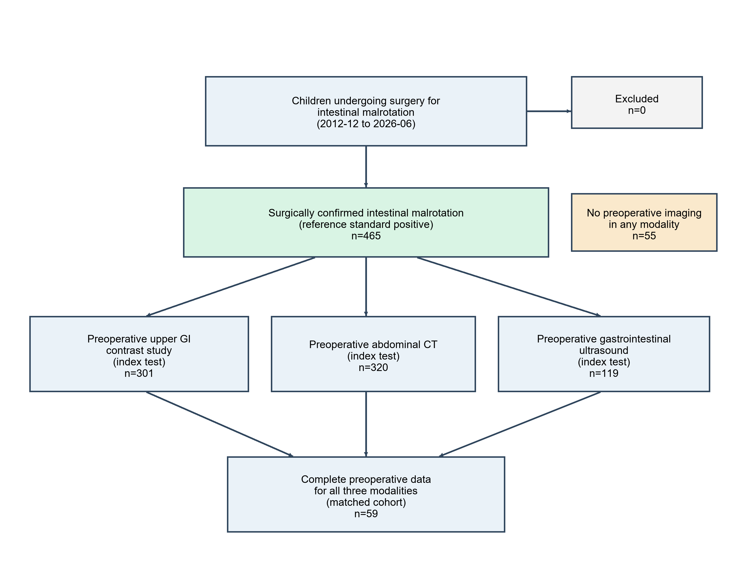
In the primary GEE analysis, which used all 410 patients with at least one preoperative index test (740 examinations; Table 2), both abdominal CT and ultrasound had markedly lower odds of detecting malrotation than the UGI series (odds ratio [OR] 0.31 [95% CI 0.22–0.44] and 0.33 [0.21–0.50], respectively; both p<0.001). After adjustment for era and neonatal status the estimates were similar (CT OR 0.29 [0.21–0.42]; ultrasound OR 0.27 [0.17–0.43]); detection was higher in the later era (OR 1.86 [1.25–2.76], p=0.002) and lower in neonates (OR 0.48 [0.32–0.72], p<0.001). The ultrasound-by-volvulus interaction term specifically was not significant (p=0.580), reflecting a near-zero cell for that term because no ultrasound examination was positive among volvulus-negative children under the keyword-based volvulus definition; the CT-by-volvulus term and a global (joint) Wald test for the modality-by-volvulus interaction are not reported, and this finding should not be read as a comprehensive test of interaction across all modalities.

Table 2. Between-modality comparison of malrotation detection (primary analysis, generalized estimating equation).
Effect | Unadjusted OR (95% CI) | Adjusted OR (95% CI) | p (adjusted)
Abdominal CT vs UGI series | 0.31 (0.22–0.44) | 0.29 (0.21–0.42) | <0.001
Ultrasound vs UGI series | 0.33 (0.21–0.50) | 0.27 (0.17–0.43) | <0.001
Later era (2019–2026) | - | 1.86 (1.25–2.76) | 0.002
Neonate (≤28 days) | - | 0.48 (0.32–0.72) | <0.001
GEE logistic model with exchangeable working correlation and patient-level clustering (robust standard errors); 410 patients, 740 preoperative examinations. Odds ratio (OR) < 1 indicates lower detection than the UGI series. The ultrasound-by-volvulus interaction term specifically was not significant (p=0.580), reflecting a near-zero cell under the keyword-based volvulus definition; the CT-by-volvulus term and a global interaction test are not reported.
This ordering was confirmed in the subset undergoing all three tests (n=59; Table 3, Fig. 2), with the UGI series detecting malrotation significantly more often than both CT and ultrasound, which did not differ from each other. For most patients in this subset the three tests were obtained close in time (median 0 days, 51 of 59 [86%] within 2 days), although the remaining 8 (14%) were separated by more than 2 days, during which active volvulus and its imaging signs could evolve.

Table 3. Paired detection rates in patients undergoing all three modalities (n=59), confirmatory analysis.
Index test | Detected/Total | Detection rate % (95% CI)
UGI contrast series | 45/59 | 76.3 (64.0–85.3)
Ultrasound | 31/59 | 52.5 (40.0–64.7)
Abdominal CT | 28/59 | 47.5 (35.3–60.0)
Cochran's Q p=0.001. Exact McNemar (discordant pairs, first-positive/second-positive): UGI vs CT 23/6, p=0.002; UGI vs ultrasound 20/6, p=0.009; CT vs ultrasound 8/11, p=0.648. The CT-versus-ultrasound comparison was not significant but was underpowered.

Fig. 2 Paired detection rates in the 59 patients undergoing all three modalities preoperatively: the UGI contrast series, abdominal CT, and gastrointestinal ultrasound, with the ultrasound whirlpool sign shown as an additional secondary indicator. Cochran's Q (p=0.001) and the exact McNemar pairwise comparisons (UGI vs CT p=0.002; UGI vs ultrasound p=0.009) refer to the three modalities only and do not include the whirlpool-sign bar
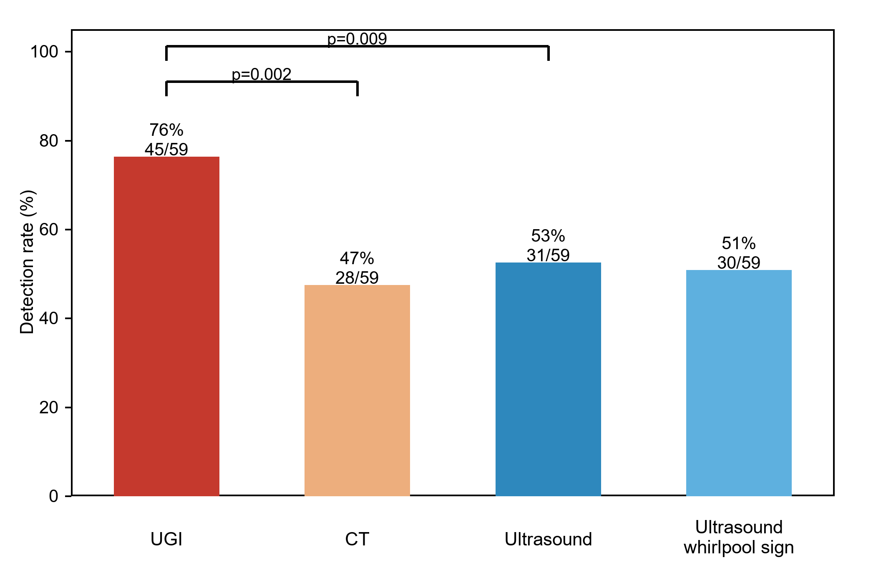
Single-modality detection rates, each computed on a different denominator and therefore not directly comparable, are shown in Table 4 and Fig. 3, and were highest for the UGI series, intermediate for ultrasound, and lowest for abdominal CT overall. In an exploratory subgroup, contrast-enhanced CT reached 82.7% (95% CI 70.3–90.6, n=52) versus 47.8% (95% CI 41.9–53.7, n=268) for unenhanced CT (Fisher's exact OR 5.23 [95% CI 2.45–11.14], p<0.001); because enhanced CT was obtained for selected indications rather than by randomization, this large difference is confounded by indication and should be read as hypothesis-generating rather than a controlled comparison of technique.

Table 4. Detection rate (sensitivity) of each modality for intestinal malrotation (reference standard: surgery).
Index test | Positive/Total | Detection rate % (95% CI)
UGI contrast series | 237/301 | 78.7 (73.8–83.0)
Abdominal CT (all) | 171/320 | 53.4 (48.0–58.8)
Abdominal CT (contrast-enhanced) | 43/52 | 82.7 (70.3–90.6)
Ultrasound (any sign) | 65/119 | 54.6 (45.7–63.3)
Ultrasound—whirlpool sign | 59/119 | 49.6 (40.8–58.4)
Wilson 95% CI. Denominators differ across modalities; rates are not directly comparable between modalities. UGI, upper gastrointestinal.

Fig. 3 Detection rate of each modality for intestinal malrotation among patients with a preoperative examination (Wilson 95% CI). Denominators differ across modalities and rates are not directly comparable between modalities (see Table 3 for the paired comparison)
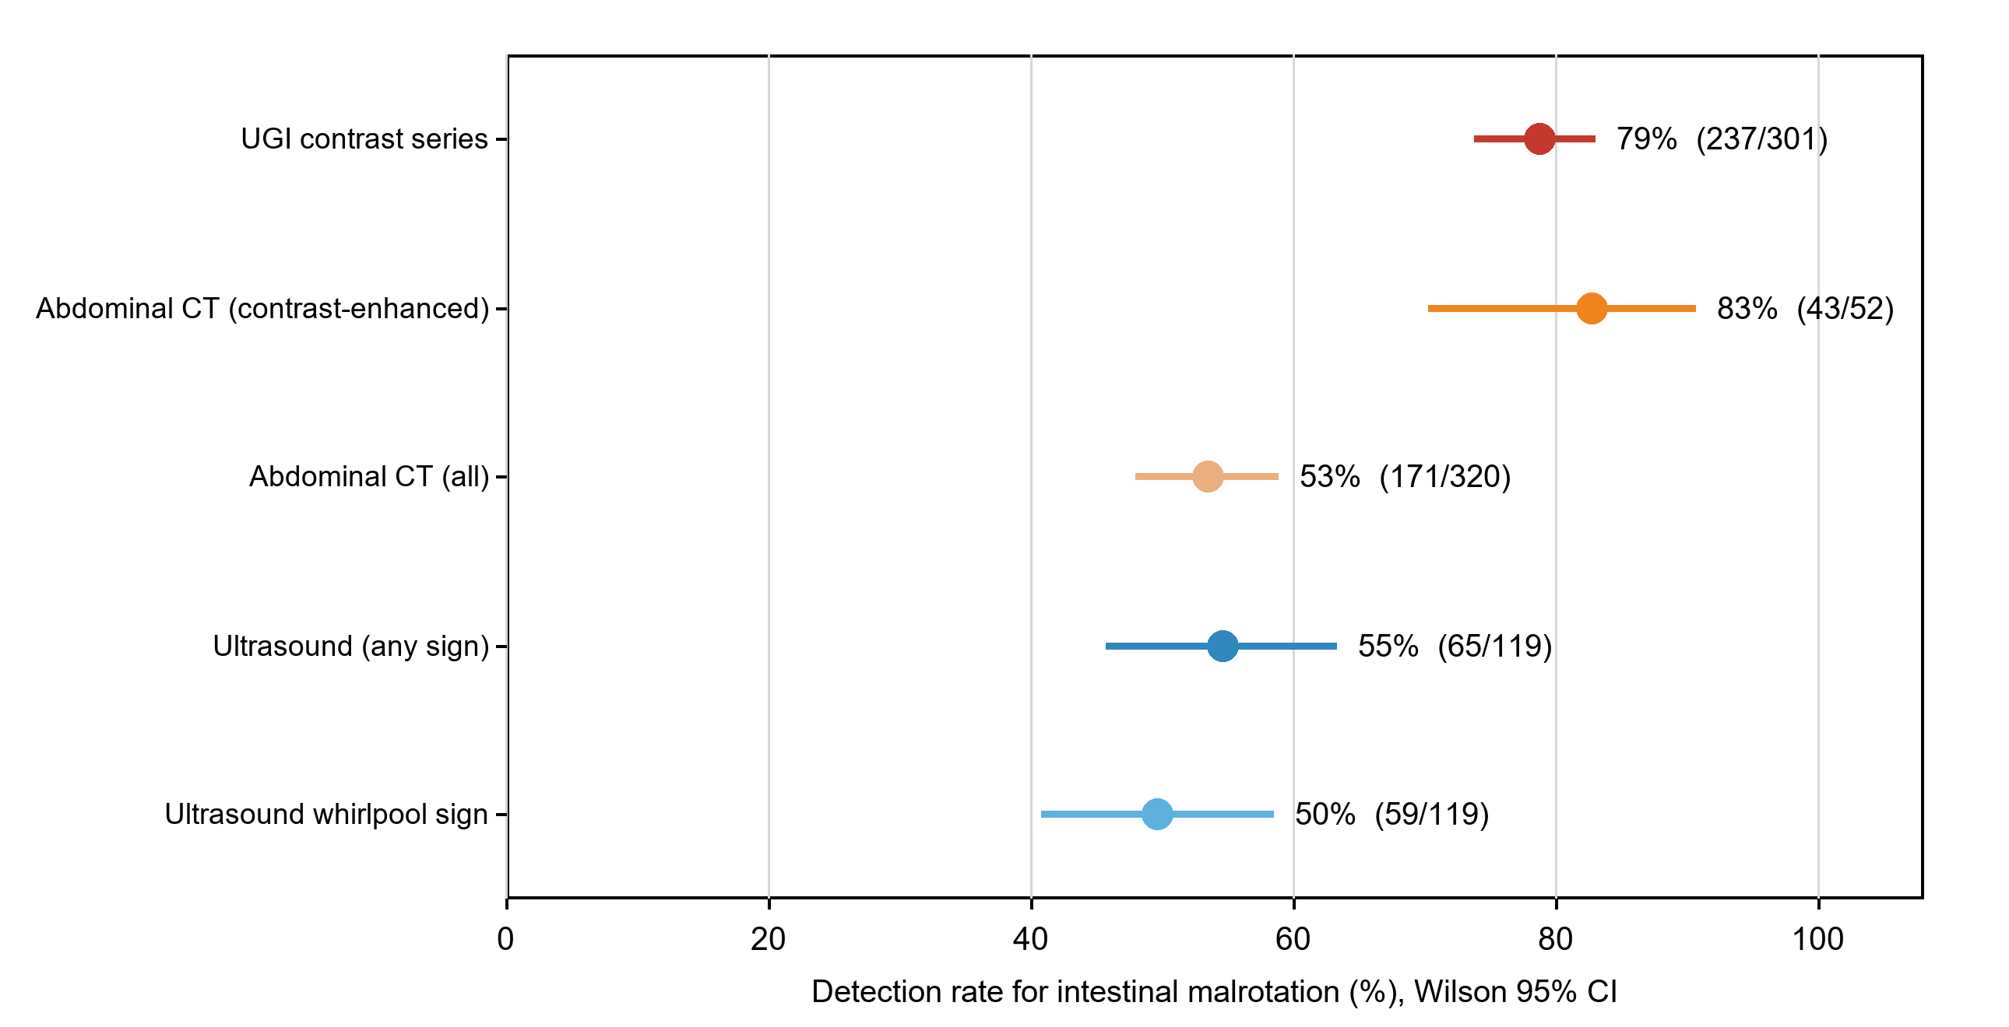
The effect of volvulus is shown in Table 5. UGI detection was essentially independent of volvulus, whereas ultrasound detected malrotation in the majority of children with volvulus but in none of the few without volvulus. This latter estimate is both imprecise and subject to selection, because ultrasound was performed in only 6 of the 65 volvulus-negative children (versus 33 for the UGI series and 39 for CT), reflecting that ultrasound was seldom the chosen test in stable presentations; the finding is nonetheless consistent with the dependence of the whirlpool sign on active midgut volvulus, and no directional claim about ultrasound in volvulus-negative malrotation can be drawn from these numbers.

Table 5. Detection rate stratified by midgut volvulus.
Index test | Volvulus | Detected/Total | Detection rate % (95% CI)
UGI | Present | 212/268 | 79.1 (73.8–83.5)
UGI | Absent | 25/33 | 75.8 (59.0–87.2)
Abdominal CT | Present | 149/281 | 53.0 (47.2–58.8)
Abdominal CT | Absent | 22/39 | 56.4 (41.0–70.7)
Ultrasound | Present | 65/113 | 57.5 (48.3–66.2)
Ultrasound | Absent | 0/6 | 0.0 (0.0–39.0)
Detection rates rose over the study period. Ultrasound detected malrotation in 41% of confirmed patients operated in 2012–2018 versus 61% in 2019–2026, CT in 47% versus 67%, and the UGI series in 77% versus 82%, indicating that the pooled figures partly reflect earlier, less sensitive imaging and reporting.
Detection of a volvulus-specific sign (a whirlpool/corkscrew appearance or an explicit report of volvulus) among children with surgically confirmed midgut volvulus is shown in Table 6 and Online Resource 1. Here the pattern differed from that for malrotation overall: ultrasound and the UGI series performed similarly, both numerically exceeding CT, with ultrasound reporting a volvulus-specific sign significantly more often than CT in the paired volvulus cohort (n=57).

Table 6. Detection of a volvulus-specific sign among children with surgically confirmed midgut volvulus.
Index test | Detected/Total | Detection rate % (95% CI)
UGI contrast series | 131/268 | 48.9 (43.0–54.8)
Ultrasound | 59/113 | 52.2 (43.1–61.2)
Abdominal CT | 116/281 | 41.3 (35.7–47.1)
Volvulus-specific sign = whirlpool/corkscrew appearance or an explicit report of volvulus. Paired volvulus cohort (n=57): ultrasound vs CT p=0.041; UGI vs ultrasound p=1.000; Cochran's Q p=0.053.

Discussion
In this 13.5-year single-center cohort of children with surgically confirmed intestinal malrotation, the UGI contrast series detected malrotation most often, both in the primary full-sample model and in the confirmatory paired comparison. In the non-randomized single-modality comparison, contrast-enhanced CT was numerically similar to the UGI series, whereas unenhanced CT was considerably less sensitive—a difference confounded by indication rather than evidence that the two tests perform comparably. Ultrasound likewise had significantly lower detection than the UGI series, comparable in magnitude to CT and not significantly different from it in the paired cohort; its detection rate was numerically higher in children with volvulus, although the formal modality-by-volvulus interaction was not significant. Because each modality was ordered for different indications, only the paired comparison is free of confounding by indication, and even there the 59 children who underwent all three tests were a diagnostically uncertain subgroup; the single-modality figures, including the enhanced-versus-unenhanced CT comparison, should be read as descriptive detection rates rather than as a ranking of test accuracy or technique. Few prior studies have compared all three modalities within the same children. By doing so, and by characterizing their yield as reflected in routine reports rather than optimized expert re-review, this study complements single-modality accuracy series [6, 12] and reveals a gap between research-grade and everyday performance that was most marked for ultrasound.
These findings align with the anatomic basis of each test. The UGI series directly opacifies the duodenojejunal junction and proximal jejunum, the anatomic hallmark of malrotation regardless of whether volvulus has occurred, which likely explains why its sensitivity was similar with and without volvulus in our cohort. This mirrors prior work in which an abnormally positioned duodenojejunal junction was the most reliable sign of malrotation on the UGI series (reported sensitivity approximately 88%) [5]. Its overall sensitivity for surgically confirmed malrotation has been reported to reach 96% [6], in keeping with its long-standing role as the reference imaging test, although several conditions can displace the duodenojejunal junction and mimic malrotation [17]. Contrast-enhanced CT can similarly delineate duodenal position and, additionally, visualize the relationship between the superior mesenteric artery and vein, including a whirl sign when volvulus is present. The markedly lower detection rate of unenhanced CT in our cohort raises the possibility that vascular opacification, rather than CT as a modality per se, drives detection; because enhanced and unenhanced studies were performed in different children for different indications, however, this remains hypothesis-generating and would require a controlled, within-patient comparison to confirm. Cautious interpretation of CT is warranted regardless, given that a counterclockwise or incomplete mesenteric swirl can be a normal variant mistaken for volvulus [11].
The detection rate of ultrasound was concentrated in children with volvulus, consistent with the pathophysiology of the whirlpool sign, which is produced by the twisted mesenteric pedicle itself and therefore signals volvulus more directly than malrotation in isolation [7, 12]. This apparent dependence should, however, be regarded as hypothesis-generating rather than established: the ultrasound-by-volvulus interaction term was not statistically significant, reflecting a near-zero cell because no ultrasound examination was positive among the few (n=6) volvulus-negative children under the keyword-based volvulus definition; the CT-by-volvulus term and a global interaction test are not available, so this should not be read as a comprehensive test of interaction across modalities. Published estimates are considerably higher: the original description of the clockwise whirlpool sign reported sensitivity and specificity of approximately 92% and 100% for volvulus [7], a recent multi-institutional review reported ultrasound sensitivity of 93–97% for malrotation and 97% for volvulus when interpreted by dedicated reviewers [12], and a systematic review and meta-analysis of 17 studies estimated a pooled sensitivity of 94% and specificity of 100% [8]. Our substantially lower figures for routine clinical reports, together with the low detection in the small volvulus-negative subgroup, suggest that real-world ultrasound yield for malrotation without volvulus may fall short of that achieved under optimized or blinded research conditions, and that a negative ultrasound should not be considered sufficient to exclude uncomplicated malrotation.
This volvulus-dependence of ultrasound was reinforced by the volvulus-specific analysis: when the endpoint was reporting of a whirlpool/corkscrew appearance or an explicit twist among children with confirmed volvulus, ultrasound performed on par with the UGI series and numerically better than CT, in contrast to its inferiority for malrotation overall. In other words, the relative strength of ultrasound lies specifically in detecting the twisted mesenteric pedicle of active volvulus rather than the underlying rotational anomaly, which is coherent with the whirlpool sign being fundamentally a sign of volvulus [7, 12]. The comparatively lower rate of a documented volvulus-specific sign on CT is consistent with the observation that this sign is best appreciated on contrast-enhanced acquisitions and can be mimicked by a normal mesenteric swirl [11].
These observations carry practical implications for imaging strategy, although they follow from detection rates alone rather than from formal predictive values or clinical outcomes, which this design cannot provide. A positive ultrasound whirlpool sign, highly specific for volvulus in prior work [7, 12] rather than in this cohort, may heighten clinical suspicion and prompt expedited surgical consultation alongside clinical assessment and institutional protocols, rather than independently dictating emergent exploration. Conversely, because ultrasound detected only a minority of malrotation cases in the absence of established volvulus, a negative ultrasound in a stable child with persistent clinical suspicion should not be taken to exclude malrotation, and a UGI series remains appropriate. When CT is performed for this question, contrast enhancement was associated with a substantially higher detection rate than an unenhanced study in this cohort, although this comparison was not randomized. These considerations should be weighed against the growing move toward ultrasound-first pathways at experienced centers [9, 18], which our real-world data suggest depends heavily on operator expertise and reporting.
This study has several limitations. First, the cohort comprised only surgically confirmed cases, so the analysis estimates detection rates rather than complete diagnostic accuracy; specificity and predictive values could not be validly estimated and are not reported. Second, the reference standard—the intraoperative diagnosis—was not independent of the index tests, since the operating surgeon knew the preoperative imaging; this incorporation bias likely inflated detection differentially, as a positive UGI series often prompted operation and shaped the recorded diagnosis, whereas an incidental ultrasound or CT was less determinative, so the apparent UGI advantage may partly reflect this asymmetry. Third, single-modality rates were computed on different, indication-selected subsets and are not directly comparable; the paired cohort mitigates but does not eliminate this selection, as those 59 children were themselves a diagnostically uncertain group. Fourth, 55 children (12% of the cohort) went directly to operation without preoperative imaging and were excluded from the relevant denominators, an informative missingness that may bias the estimates. Fifth, index tests were classified from routine report text by a rule-based algorithm rather than blinded image review; although algorithm-adjudicator agreement was high (92%, kappa 0.83), validation rested on one adjudicator and a limited sample, and the results reflect real-world reporting rather than maximal achievable accuracy, likely explaining why our figures—particularly for ultrasound—were lower than in dedicated diagnostic-accuracy studies [8, 12]. Relatedly, reports using equivocal language (e.g., suspected, possible, cannot be excluded, or recommended to be ruled out) were counted as positive under the classification rule; because every patient in this cohort had surgically confirmed malrotation, the surgical author team individually reviewed these equivocal-language reports and confirmed that each represented a genuine positive finding rather than an overcall, supporting their classification as positive. The frequency of such phrasing was not separately tabulated by modality, so a differential contribution to between-modality comparisons cannot be entirely excluded. Sixth, imaging technique and reporting evolved over the 13.5-year period and detection rates rose accordingly (e.g., ultrasound from 41% to 61%), so pooled estimates partly reflect this temporal drift. Seventh, comparisons were not adjusted for multiplicity. Eighth, case ascertainment and the reference standard were derived from operative-record text rather than independent re-adjudication, so misclassification cannot be excluded, and the operative diagnosis was a clinical label rather than standardized anatomic criteria, with thresholds for borderline anomalies possibly varying between surgeons. Ninth, because CT was ascertained from archived report text rather than structured radiation dose reports, per-examination CTDIvol, dose-length product, and detailed acquisition parameters were not captured for this cohort and could not be reported; this precludes assessment of the radiation burden associated with each modality and falls short of current recommendations for reporting CT dose in pediatric imaging studies, and future comparative studies of these modalities should capture these metrics prospectively. Prospective, multicenter studies with blinded image review and a denominator including children in whom malrotation was suspected but excluded are needed to establish specificity, predictive values, and any ranking of modalities.

Conclusion
In this real-world cohort, the upper gastrointestinal contrast series detected intestinal malrotation more often than computed tomography or ultrasound, which had similarly lower and statistically indistinguishable detection rates. Because these findings reflect detection rates in children with confirmed disease rather than complete diagnostic accuracy, prospective studies that include children without malrotation are needed before firm recommendations on imaging strategy can be made.

Statements and Declarations
Funding: Provided on the separate title page.
Competing interests: The authors declare no competing interests.
Ethics approval: This study was approved by the institutional review board of the participating institution (approval number provided on the title page). All procedures were in accordance with the 1964 Declaration of Helsinki and its later amendments.
Consent to participate: The requirement for informed consent was waived by the institutional review board because of the retrospective, de-identified nature of the study.
Consent for publication: Not applicable. This manuscript does not contain any individual person's data, images, or other identifiable material.
Data availability: The de-identified analysis dataset used pseudonymized research identifiers rather than patient names or other direct identifiers; it is nonetheless not publicly available because of institutional and ethical restrictions on sharing patient-level clinical data and the potential for re-identification within this small, single-center disease cohort. The original institutional clinical records from which it was derived remain identifiable within the hospital medical record system. De-identified data may be made available by the corresponding author upon reasonable request and with permission of the institutional review board of the participating institution.
Author contributions: Provided on the separate title page.

References
1. Marine MB, Karmazyn B (2014) Imaging of malrotation in the neonate. Semin Ultrasound CT MR 35:555–570 https://doi.org/10.1053/j.sult.2014.08.004
2. Martinez SA, Fligor SC, Tsikis S, et al (2023) IMPOWER: a national patient-generated registry for intestinal malrotation exploring diagnosis, treatment, and surgical outcomes. Orphanet J Rare Dis 18:113 https://doi.org/10.1186/s13023-023-02722-5
3. Yang X, Wang W, Wang K, et al (2024) Identification and treatment of intestinal malrotation with midgut volvulus in childhood: a multicenter retrospective study. Front Pediatr 12:1390856 https://doi.org/10.3389/fped.2024.1390856
4. Menghwani H, Piplani R, Yhoshu E, et al (2023) Delayed presentation of malrotation: case series and literature review. J Indian Assoc Pediatr Surg 28:271–277 https://doi.org/10.4103/jiaps.jiaps_2_23
5. Mattioli G, Gallo E, Wong MCY, et al (2024) Diagnostic accuracy of upper gastrointestinal series in children with suspected intestinal malrotation. Updates Surg 76:201–208 https://doi.org/10.1007/s13304-023-01559-8
6. Sizemore AW, Rabbani KZ, Ladd A, Applegate KE (2008) Diagnostic performance of the upper gastrointestinal series in the evaluation of children with clinically suspected malrotation. Pediatr Radiol 38:518–528 https://doi.org/10.1007/s00247-008-0762-8
7. Shimanuki Y, Aihara T, Takano H, et al (1996) Clockwise whirlpool sign at color Doppler US: an objective and definite sign of midgut volvulus. Radiology 199:261–264 https://doi.org/10.1148/radiology.199.1.8633156
8. Nguyen HN, Kulkarni M, Jose J, et al (2021) Ultrasound for the diagnosis of malrotation and volvulus in children and adolescents: a systematic review and meta-analysis. Arch Dis Child 106:1171–1178 https://doi.org/10.1136/archdischild-2020-321082
9. Nguyen HN, Navarro OM, Bloom DA, et al (2022) Ultrasound for midgut malrotation and midgut volvulus: AJR expert panel narrative review. AJR Am J Roentgenol 218:931–939 https://doi.org/10.2214/AJR.21.27242
10. Taylor GA (2011) CT appearance of the duodenum and mesenteric vessels in children with normal and abnormal bowel rotation. Pediatr Radiol 41:1378–1383 https://doi.org/10.1007/s00247-011-2118-z
11. Sodhi KS, Bhatia A, Saxena AK, et al (2014) Anticlockwise swirl of mesenteric vessels: a normal CT appearance, retrospective analysis of 200 pediatric patients. Eur J Radiol 83:710–714 https://doi.org/10.1016/j.ejrad.2013.12.026
12. Nguyen HN, El-Ali AM, Van Tassel D, et al (2025) Diagnostic performance of ultrasound for diagnosing midgut malrotation and volvulus in children: a multiinstitutional retrospective review. AJR Am J Roentgenol 225:e2532660 https://doi.org/10.2214/AJR.25.32660
13. Applegate KE, Anderson JM, Klatte EC (2006) Intestinal malrotation in children: a problem-solving approach to the upper gastrointestinal series. Radiographics 26:1485–1500 https://doi.org/10.1148/rg.265055167
14. von Elm E, Altman DG, Egger M, et al (2007) The Strengthening the Reporting of Observational Studies in Epidemiology (STROBE) statement: guidelines for reporting observational studies. Ann Intern Med 147:573–577 https://doi.org/10.7326/0003-4819-147-8-200710160-00010
15. López-Úbeda P, Martín-Noguerol T, Juluru K, Luna A (2022) Natural language processing in radiology: update on clinical applications. J Am Coll Radiol 19:1271–1285 https://doi.org/10.1016/j.jacr.2022.06.016
16. Zeger SL, Liang KY (1986) Longitudinal data analysis for discrete and continuous outcomes. Biometrics 42:121–130 https://doi.org/10.2307/2531248
17. Smitthimedhin A, Suarez A, Webb RL, Otero HJ (2018) Mimics of malrotation on pediatric upper gastrointestinal series: a pictorial review. Abdom Radiol (NY) 43:2246–2254 https://doi.org/10.1007/s00261-018-1537-9
18. McCurdie FK, Meshaka R, Leung G, et al (2024) Ultrasound for infantile midgut malrotation: techniques, pearls, and pitfalls. Pediatr Radiol 54:2099–2111 https://doi.org/10.1007/s00247-024-06067-4

Supplementary material
Online Resource 1. Detection of a volvulus-specific sign by each modality among children with surgically confirmed midgut volvulus (Wilson 95% CI).

