LAB 1
REPORT
Course: Web Application Development
Student Name: Hứa Thụy Hồng Ngọc
Student ID: ITDSIU24035

1. Exercise 1 – Personal CV Website
1.1 Objective
The objective of Exercise 1 is to design a single-page Curriculum Vitae (CV) using only HTML. The webpage must use semantic HTML structure, include a favicon, and be ready for future styling.

1.2 Implementation
<!DOCTYPE html>
<html>
<head>
<title>CV-Hứa Thụy Hồng Ngọc-ITDSIU24035</title>
<meta http-equiv="Content-Type" content="text/html; charset=UTF-8">
<link rel="icon" type="image/png" href="favicon.png">
</head>
<body>
<header>
<h1>Hứa Thụy Hồng Ngọc</h1>
<h2><font color = "green">Junior Frontend Developer</font></h2>

<address>
<p>815 Huong Lo 2</p>
<p>Ho Chi Minh City, Vietnam </p>
<p>(84)924151080</p>
<p><a href="itdsiu24035@student.hcmiu.edu.vn"> itdsiu24035@student.hcmiu.edu.vn</a></p>
</address>
</header>

<main>
<section>
<h2><font color = "green">Skills</font></h2>
<ul>
<li>HTML</li>
<li>CSS</li>
<li>JavaScript</li>
<li>Accessibility</li>
<li>Figma to Design</li>
<li>Responsive Web Design</li>
<li>Technical Writing</li>
<li>Presentation</li>
</ul>
</section>

<section>
<h2><font color = "green">Education</font></h2>
<h3><font color = "blue">Ho Chi Minh City International University – Data Science</font></h3>
<p><time datetime="2024-09">September 2024</time> – <time datetime="2028-09">September 2028</time></p>
<ul>
<li>Member of GDGoC</li>
<li>Complete the course of Data Analysis</li>
</ul>
</section>

<section>
<h2><font color = "green">Experience</font></h2>
<h3><font color = "blue">Company Name, Location - Job Title</font></h3>
<p><time datetime="2024-09">Month 20xx</time> – <time datetime="2028-09">Month 20xx</time></p>
<ul>
<li>List of achievements</li>
<li>List of achievements</li>
<li>List of achievements</li>
</ul>
<p><strong>Skills:</strong> HTML, CSS, JavaScript</p>
</section>

<section>
<h2><font color = "green">Across the Internet</font></h2>
<ul>
<li><a href="https://github.com/hthngoc059">GitHub</a></li>
<li><a href="https://www.linkedin.com/in/th%E1%BB%A5y-h%E1%BB%93ng-ng%E1%BB%8Dc-h%E1%BB%A9a-645115354/">LinkedIn</a></li>
</ul>
</section>
</main>

<footer>
<p>&copy; 2026 Hua Thuy Hong Ngoc</p>
</footer>
</body>
</html>

The CV webpage is implemented using semantic HTML elements to ensure clarity, accessibility, and maintainability. The structure of the webpage includes the following sections:
- Header: Displays the personal information such as name, job title, address, phone number, and email.
- Skills: Lists technical and soft skills using an unordered list.
- Education: Presents academic background, including degree, institution, and study duration.
- Experience: Describes work experience and achievements.
- Across the Internet: Provides links to online profiles such as GitHub and LinkedIn.
- Footer: Displays copyright information.
Semantic HTML tags such as <header>, <main>, <section>, <address>, <time>, and <footer> are used to clearly define the structure of the CV.
A favicon is added to the webpage using the <link rel="icon"> tag inside the <head> section. This favicon represents the website visually on the browser tab and improves user experience.
1.3 Result
The result is a clean and well-structured single-page CV website that meets all the requirements of the assignment.

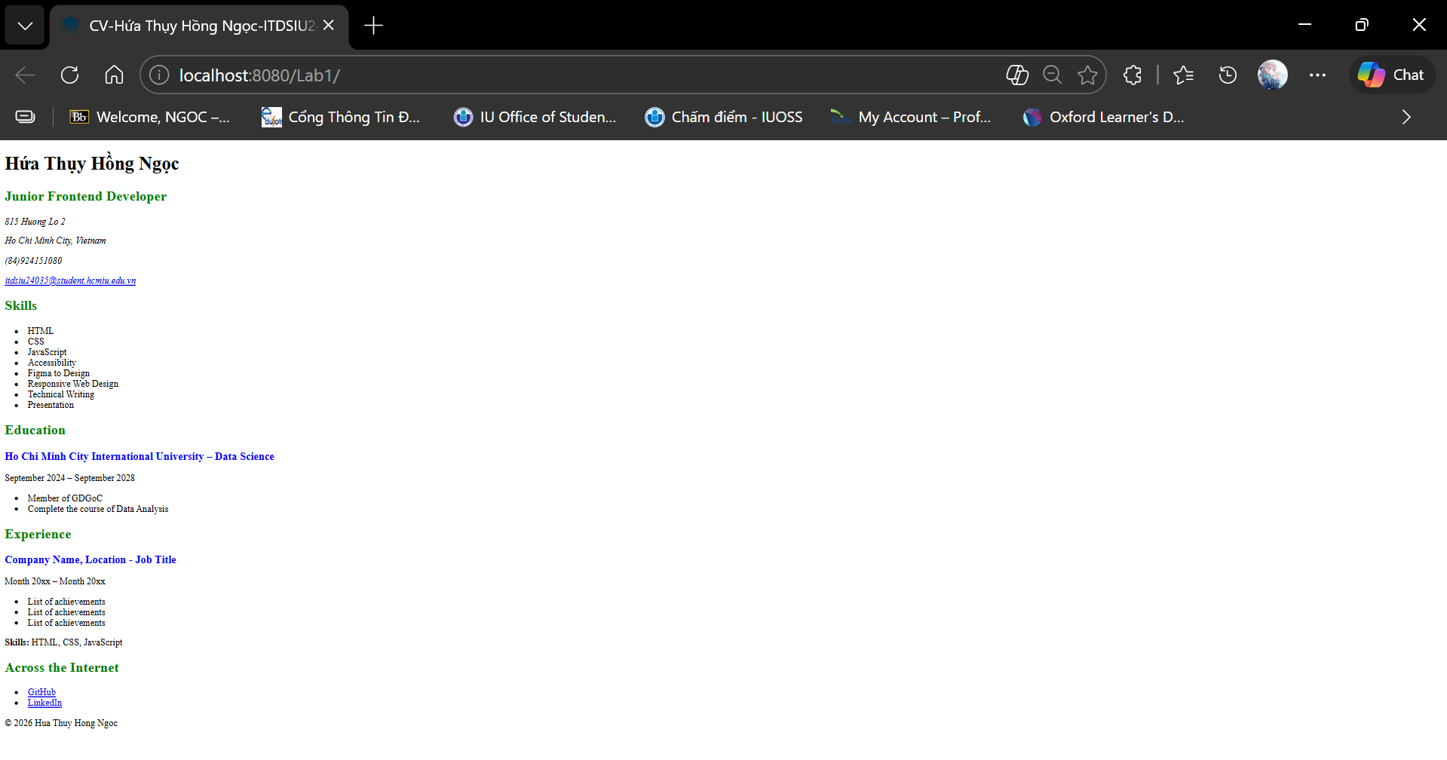
2. Exercise 2 – Database Design Using MySQL
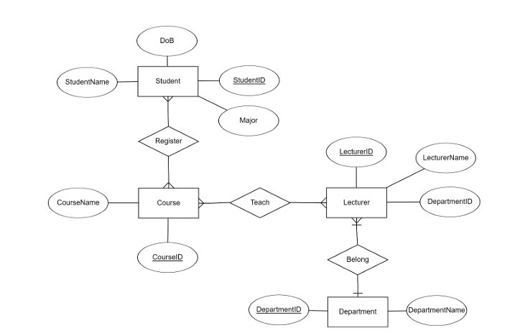
2.1 Database Design
The database is named:
WEB_Lab01_ITDSIU24035_HuaThuyHongNgoc
The database consists of the following tables:
- Student: Stores student information such as student ID, name, date of birth, and major.
- Course: Stores course information.
- Lecturer: Stores lecturer information and references the Department table.
- Department: Stores department details.
- Register: Represents a many-to-many relationship between Student and Course.
- Teach: Represents a many-to-many relationship between Lecturer and Course.
Primary keys are defined for all main tables, and foreign keys are used to enforce referential integrity between related tables.
2.2 Relationships
- A student can register for multiple courses, and a course can have multiple students. This many-to-many relationship is implemented using the Register table.
- A lecturer can teach multiple courses, and a course can be taught by multiple lecturers. This many-to-many relationship is implemented using the Teach table.
- Each lecturer belongs to one department, which is implemented using a foreign key in the Lecturer table.
2.3 Data Insertion
Sample data is inserted into all tables to demonstrate database functionality. The data insertion order follows the foreign key constraints to avoid integrity violations.
3.5 Result
The database is successfully created with all required tables and relationships. Sample data is inserted correctly, and the database can be exported into a single SQL file as required.

CREATE DATABASE IF NOT EXISTS WEB_Lab01_ITDSIU24035_HuaThuyHongNgoc;
USE WEB_Lab01_ITDSIU24035_HuaThuyHongNgoc;

CREATE TABLE IF NOT EXISTS Student (
StudentID INT PRIMARY KEY,
StudentName VARCHAR(100),
DoB DATE,
Major VARCHAR(100)
);

CREATE TABLE IF NOT EXISTS Course (
CourseID INT PRIMARY KEY,
CourseName VARCHAR(100)
);

CREATE TABLE IF NOT EXISTS Department (
DepartmentID INT PRIMARY KEY,
DepartmentName VARCHAR(100)
);

CREATE TABLE IF NOT EXISTS Lecturer (
LecturerID INT PRIMARY KEY,
LecturerName VARCHAR(100),
DepartmentID INT,
FOREIGN KEY (DepartmentID) REFERENCES Department(DepartmentID)
);

CREATE TABLE IF NOT EXISTS Register (
StudentID INT,
CourseID INT,
PRIMARY KEY (StudentID, CourseID),
FOREIGN KEY (StudentID) REFERENCES Student(StudentID),
FOREIGN KEY (CourseID) REFERENCES Course(CourseID)
);

CREATE TABLE IF NOT EXISTS Teach (
LecturerID INT,
CourseID INT,
PRIMARY KEY (LecturerID, CourseID),
FOREIGN KEY (LecturerID) REFERENCES Lecturer(LecturerID),
FOREIGN KEY (CourseID) REFERENCES Course(CourseID)
);

INSERT INTO Department VALUES
(1, 'Computer Science'),
(2, 'Information Technology'),
(3, 'Data Science');

INSERT INTO Lecturer VALUES
(101, 'Dr. Smith', 1),
(102, 'Dr. John', 2),
(103, 'Dr. Tom', 3);

INSERT INTO Course VALUES
(201, 'Database Management'),
(202, 'Web Application Development'),
(203, 'Object-Oriented Programming');

INSERT INTO Student VALUES
(301, 'Alice', '2003-05-10', 'IT'),
(302, 'Bob', '2002-09-21', 'CS'),
(303, 'Hanna', '2003-05-10', 'DS');

INSERT INTO Register VALUES
(301, 201),
(301, 202),
(303, 201);

INSERT INTO Teach VALUES
(101, 203),
(101, 201),
(102, 202),
(103, 203);

Link to Github: https://github.com/hthngoc059/WEB_Lab01.git

