**Adulting 101: Exploring Developmental Gene Expression Profiles in the Tobacco Hornworm, *Manduca sexta***

             The life history of insects is structured into stages by molting, the shedding of their exoskeleton (Chapman 2013). As insects grow, they have to molt and develop new exoskeleton to accommodate their larger body size until they reach adulthood.  This stage structure is especially pronounced in holometabolous insects (such as moths and beetles), which have morphologically distinct larvae and adults with a transitional pupal stage. For example, lepidopterans are caterpillars as larvae, which then pupate into cocoons before emerging as adult butterflies or moths.

Not only are larvae and adults morphologically distinct, they often occupy different ecological niches and have different life history specializations (Chapman 2013; Truman 2019). Larvae are specialized for feeding and resource acquisition, and adults for reproduction and dispersal. Life history theory predicts that animals should allocate resources to functions that would maximize fitness because they are often resource limited (Stearns 1992). The stage-structured life history of insects should lead to stage-specific physiological adaptations that maximize fitness, reflected in differential gene expression across different life stages. For instance, genes involved in reproduction should be expressed in adults but not in larvae, because larvae are not capable of reproducing (e.g. vitellogenin; Zhao et al. 2016).

This project aims to explore how the tobacco hornworm *Manduca sexta* regulates its physiology through gene expression at different life stages. To the best of our knowledge, this study is the first to screen for inter-stage gene expression differences using transcriptomic data. We will examine what genes have the largest change in expression after the transition from larvae to adult using transcriptomic data from different tissues of *M. sexta* at different life stages. Consequently, we can determine what physiological functions undergo the most reconfiguration during the transition to adulthood. The results can reveal important and novel physiological trade-offs that occur between larvae and adults.

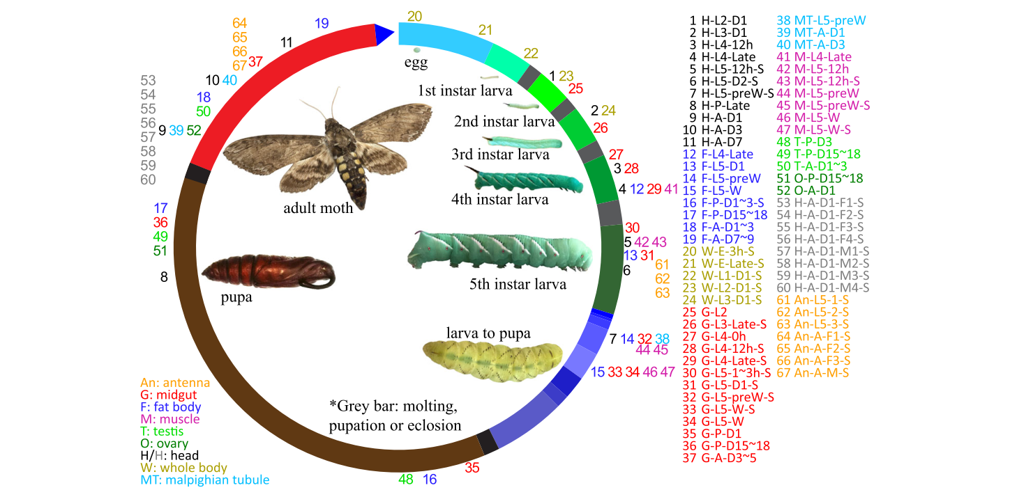

**Figure 1.** *Manduca sexta* life cycle and the 67 Illumina RNA-seq datasets. Library numbers placed outside the circle at corresponding life stage; colour of number corresponds to tissue type. Bars in circle correspond to life stages. Figure copied from Cao & Jiang 2017.

Data:

The data is sourced from a study examining 67 RNA-seq datasets from 8 tissues across 9 life stages of the tobacco hornworm, *Manduca sexta* (Cao & Jiang 2017; Fig 1). Each row is a different gene (*n* = 15 544 rows) and each column is a different transcript (*n* = 67 columns). Most genes also have a “gene description”. Each transcript is from a different tissue-life stage combination. Each cell of data is the FPKM (fragments per kilobase per million mapped reads) which is a representation of the level of gene expression in a given transcript, ranging from 0 (no expression) to > 500 000 (total *n* = 1 042 118 cells).

Question: What genes undergo the largest difference in expression in specific tissues between larval and adult stages? How do these genes change across tissues and developmental stages?

Pipeline:

To wrangle the data, we will use R and dplyr. We will melt the dataset so that each row is a unique tissue-life stage-gene combination (i.e. our columns will be gene ID, life stage, tissue type, and gene expression level; See Appendix 1). We will separate the data so we only have the fifth instar and adult stages in just the head, midgut, and fat body tissues. Then we will subtract the gene expression level from adult and 5th instar larva. We will select the three genes with the largest differences in each of the three tissue types (for a total of 9 genes). We will run NCBI BLAST to identify the function of each focal gene. We will then plot and model gene expressions of all 9 genes in all 3 tissue types across all life stages.

We will have weekly sessions for working together to wrangle the data. Marco will run NCBI BLAST, Regan will plot and model gene expressions, Hana will prepare figures, and Hayden will write background information for the poster. We will use Github to share scripts, data, and an R-project.

Predicted results:

Between the 5th instar and adult stages of the tobacco hornworm’s life cycle, we expect the largest change in gene expression to be associated with genes that regulate reproductive processes. There is likely to be a sudden increase in the activity of these genes between the 5th instar and the adult stage as only the adult stage of this species exhibits any reproductive processes. We do not expect there to be much activity or increase in expression levels for these genes until the moth reaches its adult stage.

Significance:

Complete metamorphosis occurs in 10 insect orders, and the oldest fossils of holometabolous insects are around 315 million years old, indicating that this is an important and evolutionarily stable trait for many insect species (Nel et al. 2013). We will help answer questions about the genetic mechanisms behind metamorphosis and potential developmental trade-offs by identifying genes that are highly differentially expressed between two important life stages and may play a key role during metamorphosis. Furthermore, *M. sexta* larvae feed on solanaceous plants, such as tobacco and tomato, and are important agricultural pests. This study, and future studies on *M. sexta* genetics could aid in the development of specific pesticides to help mitigate the agricultural impacts of *M. sexta.*

Literature cited:

Cao, X., & H. Jiang. 2017. An analysis of 67 RNA-seq datasets from various tissues at different

stages of a model insect, *Manduca sexta*. *BMC Genomics* 18:796.

Chapman RF. 2013. The insects: Structure and function. Simpson SJ, Douglas AE, editors.

Cambridge University Press.

Nel, A., P. Roques, P. Nel, A. A. Prokin, T. Bourgoin, K. Prokop, J. Szwedo, D. Azar, L.

Desutter-Grandcolas, T. Wappler, R. Garrouste, D. Coty, D. Huang, M. S. Engel, & A. G. Kirejtshuk. 2013. The earliest known holometabolous insects. *Nature* 503:257–261.

Truman JW. 2019. The evolution of insect metamorphosis. *Curr Biol*. 29(23):R1252-R1268.

Stearns S. 1992. The evolution of life histories. Oxford University Press.

Zhao J, Sun Y, Xiao LB, Tan YA, Bai LX. 2016. Molecular characterization and expression of

vitellogenin gene from spodoptera exigua exposed to cadmium stress. *Gene*. 593(1):179-184.

**Appendix 1:** Example of post-wrangled dataset.

|  |  |  |  |
| --- | --- | --- | --- |
| **Gene ID** | **Tissue type** | **Life Stage** | **Gene expression level** |
| Msex2.00001 | head | Larva, second instar | 11.29 |
| Msex2.00001 | head | Larva, third instar | 11.92 |
| Msex2.00001 | head | Larva, fourth instar | 11.83 |
| Msex2.00001 | head | Larva, fifth instar | 1.39 |
| Msex2.00001 | head | Pupa | 3.92 |
| Msex2.00001 | head | Adult | 13.58 |
| Msex2.00001 | Fat body | Larva, fourth instar | 7.68 |
| Msex2.00001 | Fat body | Larva, fifth instar | 7.04 |
| Msex2.00002 | head | Larva, second instar | 4.04 |