Analysis results -

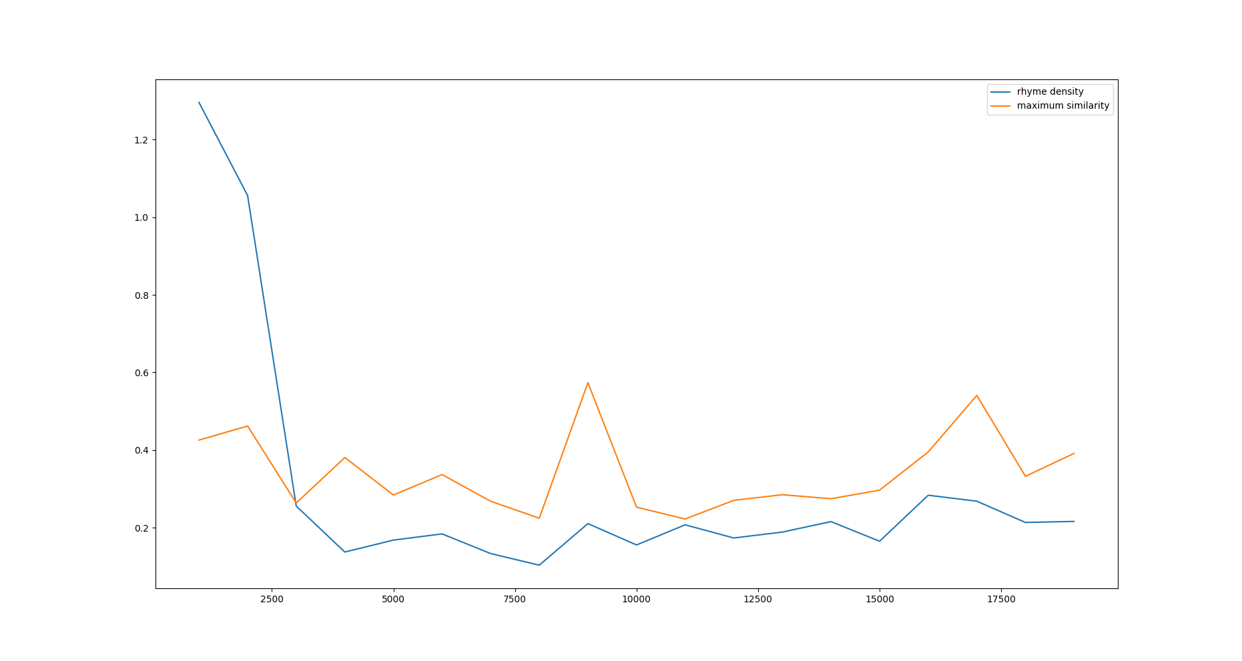

The above graph is different than the above one.

correlation between rhyme density and maximum similarity - [2.1560899]

correlation between rhyme density and maximum similarity (ignoring peaks at epoch 1000 and 2000 since they generated useless verses composed of single repeating line )- [1.11641268]

Both above values are greater than given values in the paper.

Using rhyme density of artist as 0.34 (as given in the paper).

Then estimated epoch where such rhyme density will be achieved by the model – 45188

Max similarity score at that epoch – 0.515 ( less than what is given in the paper).