|  |
| --- |
| NetSpeed ATS  Integration Specification |

NetSpeed ATS Integration Specification

About This Document

This document describes the guidelines for integration of NetSpeed ATS VIP. This includes instructions on how to integrate Netspeed Checkers and Scoreboard into customer’s Testbench.

Audience

* Design and Verification Engineers

Customer Support

For technical support about this product, please contact [support@netspeedsystems.com](mailto:support@netspeedsystems.com)

For general information about NetSpeed products refer to: [www.netspeedsystems.com](http://www.netspeedsystems.com)

Revision History

|  |  |  |
| --- | --- | --- |
| Revision | Date | Updates |
| 0.0 | June 1, 2018 | Initial Release |
| 0.1 | June 22, 2018 | SV checkers |
|  |  |  |

# ATS Verification Overview

## Files included

* ns_ats_checkers.f
* Compilation file, contains list of files to be compiled.
* ns_bind_checkers.svh
* Bind file for all checkers.
* sv_checkers

|  |  |
| --- | --- |
| **NAME OF FILE** | **FUNCTIONALITY** |
| netspeed_idi_prot_checker.sv | Enforces IDI protocol correctness and sends packets to E2E checker. |
| netspeed_cmi_prot_checker.sv | Enforces CMI protocol correctness and sends packets to E2E checker. |
| netspeed_spk_prot_checker.sv | Enforces SPK protocol correctness and sends packets to E2E checker. |
| netspeed_sbe_prot_checker.sv | Enforces SBE protocol correctness. |
| ns_ats_noc_e2e_checker.sv | Checks for data transfer / routing (hashing) correctness. |
| ns_s_fifo_checker.sv | Checks synchronous fifo functionality. |
| ns_a_fifo_checker.sv | Checks asynchronous fifo functionality between register bus and fabric. |
| ns_fifo_2in_checker.sv | Checks 2-input port fifo functionaility |
| ns_a_fifo_tracker.sv | Collects packets and sends to ns_noc_async_fifo_checker. |
| ns_fifo_structure.sv | Contains structs being used in fifo checker files. |
| ns_noc_async_fifo_checker.sv | Transport checker for fifos. |
| ns_cmn_cfgstsreg_checker.sv | Checks configuration state register functionality. |
| ns_regbus_ring_slv_native_core_checker.sv | Checks regbus ring slave functionality. |

* Header files

These files are “included” in checker files as necessary. These need NOT be compiled, hence they are not part of compile file list in ns_ats_checkers.f.

* + ns_ats_pkg.svh
  + ns_checker_functions.svh
  + ns_message_defines.vh
  + ns_common_func.vh
  + ns_global_defines.vh
* Configuration file – **TO BE EDITED** as per customer preferences.

## Integration of Verification Checkers

Each checker binds to the corresponding RTL module / instance.

To integrate NetSpeed verification checkers into your environment, please follow the below steps.

1. Add the following line to your testbench:

`include "ns_bind_checkers.svh”

1. Adjust paths in ns_ats_checker.f for compilation.
2. Adjust the `defines settings in sv_checkers/ns_global_defines.vh. Below is the explanation for each of the defines.

|  |  |  |
| --- | --- | --- |
| `define | EXAMPLE VALUES | DETAILS |
| NS_NOC_TOP | top.ns_soc_ip.u_ns_fabric | Top level wrapper for NS fabric |
| NS_RESET_RESPONDER | top.external_reset | Cmi slave reset used by CMI protocol checker for proper credit initialization. |
| NS_NUM_ATS_SLICES | 8 | Number of slices being instantiated |
| NS_NUM_ATS_DIS | 1 | Number of display instances |
| NS_NUM_ATS_SPK | 1 | Number of SPK instances |
| NS_IDI_PROT_CHECKER_EN | 1 | Enable / Disable IDI protocol checker |
| NS_CMI_PROT_CHECKER_EN | 1 | Enable / Disable CMI protocol checker |
| NS_SPK_PROT_CHECKER_EN | 1 | Enable / Disable SPK protocol checker |
| NS_SBE_PROT_CHECKER_EN | 1 | Enable / Disable SBE protocol checker |
| NS_NOC_END2END_CHECKER_EN | 1 | Enable / Disable E2E checker (To enable E2E checker, all the protocol checkers must also be enabled, but it can be disabled independently.) |
| NS_ASYNC_FIFO_CHECKER_EN | 1 | Enable / Disable asynchronous fifo checker |
| NS_REGBUS_RING_SLV_CHECKER_EN | 1 | Enable / Disable regbus ring slave checker |
| NS_ASYNC_FIFO_LOG_EN | 0 | Enable log file generation from fifo checkers. |
| INT_LOG | 0 | Enable / Disable ATS interface logs. |
| NS_E2E_LOG | 1 | Enable / Disable ATS End2End logs. |
| NS_E2E_CHECKER_TOP | `NS_NOC_TOP.ns_ats_noc_e2e_checker | Path to E2E checker instantiation. |
| NS_ASYNC_FIFO_CHECKER_TOP | NS_NOC_TOP.ns_noc_async_fifo_checker | Path to Async fifo checker instance. |

# NetSpeed Ats testbench architecture

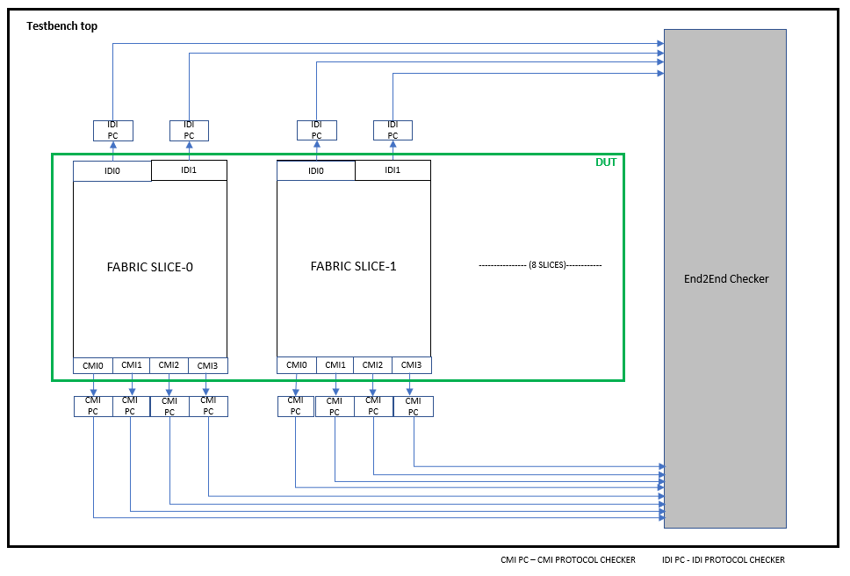

**Figure: Testbench architecture**

2870 Zanker Road,

Suite 210,

San Jose, CA 95134

(408) 617-5209

<http://www.netspeedsystems.com>