Moodboard und Links
Farbpaletten:

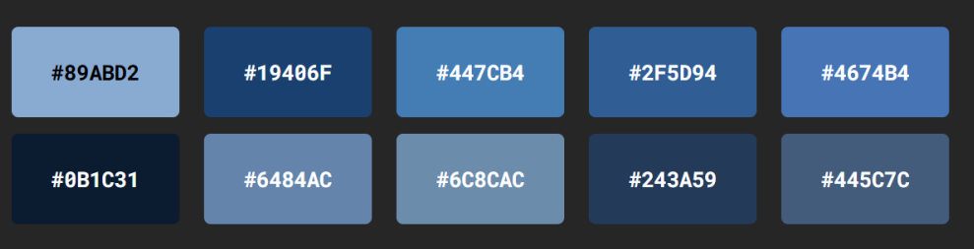

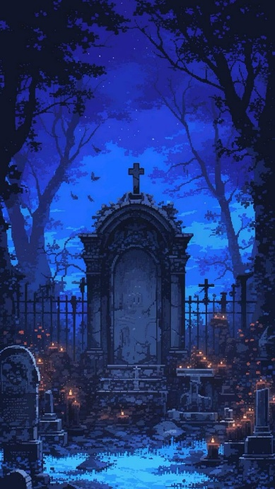
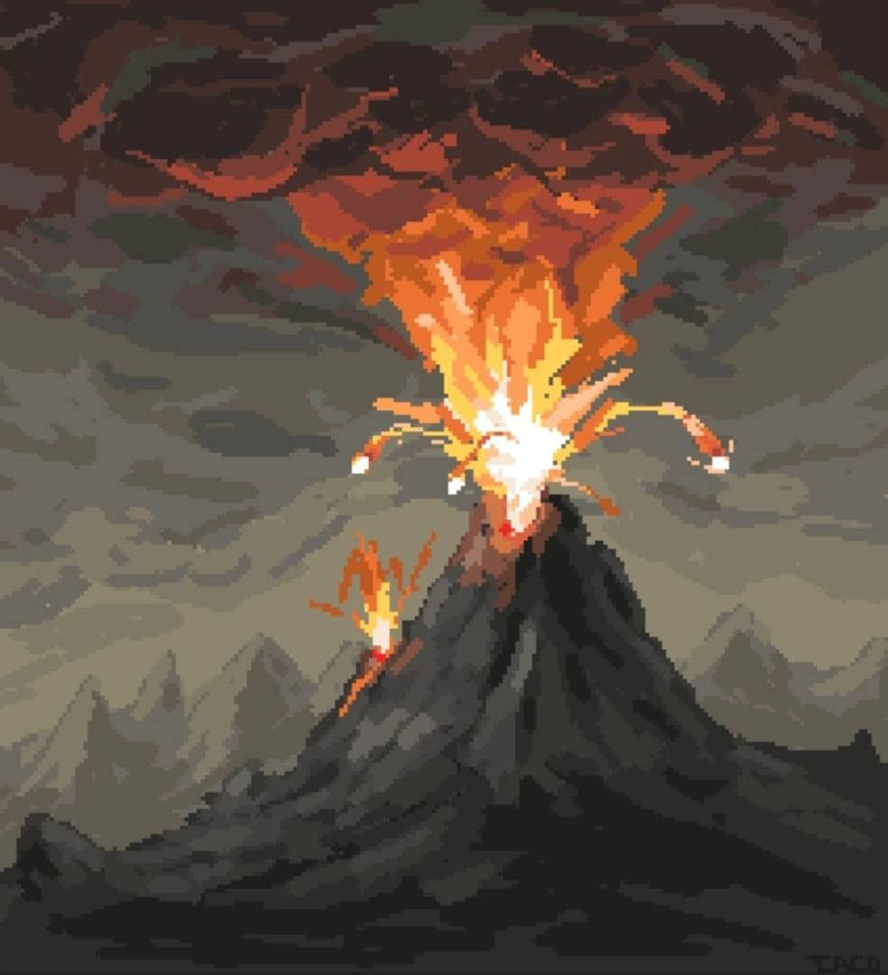

Prototype Link:
https://www.figma.com/proto/BfbzAc64ZYVYPSsSAj6iot/Sommerprojekt?node-id=2-2&t=dnSY0pdvY0a7vjGQ-1&starting-point-node-id=2%3A2
Projekt Link:
https://www.figma.com/design/BfbzAc64ZYVYPSsSAj6iot/Sommerprojekt?m=auto&t=ekJbq2i2NZJlZdg5-6

