Supplementary Material
Neoadjuvant Chemotherapy with Trastuzumab plus Pertuzumab versus Trastuzumab Alone in Early HER2-Positive Breast Cancer: A Single-Center Retrospective Cohort Study
SYNTHETIC DATA FOR TEACHING — NOT A REAL STUDY. Patients, investigators and institution are fictional.
This demonstration manuscript was written by AI (Claude Opus 5.5). In a real submission, the text must be written by the authors.

Table S1a. Baseline characteristics, all categories (part 1 of 3)
Characteristic | Overall N = 615 | Trastuzumab + pertuzumab N = 416 | Trastuzumab alone N = 199 | SMD
Age at diagnosis, years | 50.9 (43.5–58.4) | 50.7 (43.8–59.1) | 51.5 (42.6–57.7) | 0.05
Missing | 1 | 1 | 0
Menopausal status |  |  |  | 0.05
Premenopausal | 267 (43.4%) | 184 (44.2%) | 83 (41.7%)
Postmenopausal | 348 (56.6%) | 232 (55.8%) | 116 (58.3%)
ECOG performance status |  |  |  | 0.10
0 | 450 (73.2%) | 309 (74.3%) | 141 (70.9%)
1 | 154 (25.0%) | 101 (24.3%) | 53 (26.6%)
2 | 11 (1.8%) | 6 (1.4%) | 5 (2.5%)
BMI, kg/m² | 24.1 (21.3–26.7) | 24.1 (21.5–26.9) | 24.0 (21.2–26.4) | 0.08
Baseline LVEF, % | 65.0 (61.0–68.0) | 65.0 (61.0–68.0) | 65.0 (62.0–68.0) | -0.08
Clinical T category |  |  |  | 0.09
T1 | 49 (8.0%) | 32 (7.7%) | 17 (8.5%)
T2 | 348 (56.6%) | 237 (57.0%) | 111 (55.8%)
T3 | 139 (22.6%) | 97 (23.3%) | 42 (21.1%)
T4 | 79 (12.8%) | 50 (12.0%) | 29 (14.6%)
Clinical N category |  |  |  | 0.00
N0 | 180 (29.3%) | 122 (29.3%) | 58 (29.1%)
N1 | 290 (47.2%) | 196 (47.1%) | 94 (47.2%)
N2 | 83 (13.5%) | 56 (13.5%) | 27 (13.6%)
N3 | 62 (10.1%) | 42 (10.1%) | 20 (10.1%)
Values are n (%) or median (IQR); missing values are shown and excluded from percentages. SMD, standardized mean difference before weighting.

Table S1b. Baseline characteristics, all categories (part 2 of 3)
Characteristic | Overall N = 615 | Trastuzumab + pertuzumab N = 416 | Trastuzumab alone N = 199 | SMD
Clinical stage (AJCC 8th, anatomic) |  |  |  | 0.10
IIA | 139 (22.6%) | 94 (22.6%) | 45 (22.6%)
IIB | 208 (33.8%) | 141 (33.9%) | 67 (33.7%)
IIIA | 134 (21.8%) | 94 (22.6%) | 40 (20.1%)
IIIB | 72 (11.7%) | 45 (10.8%) | 27 (13.6%)
IIIC | 62 (10.1%) | 42 (10.1%) | 20 (10.1%)
Hormone receptor (ER or PR ≥1%) |  |  |  | 0.01
Positive | 356 (57.9%) | 240 (57.7%) | 116 (58.3%)
Negative | 259 (42.1%) | 176 (42.3%) | 83 (41.7%)
HER2 status |  |  |  | 0.02
IHC 3+ | 475 (77.2%) | 320 (76.9%) | 155 (77.9%)
IHC 2+, ISH amplified | 140 (22.8%) | 96 (23.1%) | 44 (22.1%)
Histologic grade |  |  |  | 0.07
1 | 22 (3.9%) | 15 (3.9%) | 7 (3.9%)
2 | 257 (45.2%) | 171 (44.2%) | 86 (47.5%)
3 | 289 (50.9%) | 201 (51.9%) | 88 (48.6%)
Missing | 47 | 29 | 18
Ki-67, % | 43.5 (31.0–56.0) | 43.5 (31.0–56.0) | 43.5 (30.0–57.0) | -0.05
Missing | 71 | 54 | 17
Neoadjuvant chemotherapy backbone |  |  |  | 0.55
Anthracycline-based | 223 (36.3%) | 116 (27.9%) | 107 (53.8%)
Carboplatin-based | 392 (63.7%) | 300 (72.1%) | 92 (46.2%)
Values are n (%) or median (IQR); missing values are shown and excluded from percentages. SMD, standardized mean difference before weighting.

Table S1c. Baseline characteristics, all categories (part 3 of 3)
Characteristic | Overall N = 615 | Trastuzumab + pertuzumab N = 416 | Trastuzumab alone N = 199 | SMD
Year of neoadjuvant therapy start |  |  |  | 2.80
2012–2015 | 162 (26.3%) | 6 (1.4%) | 156 (78.4%)
2016–2019 | 209 (34.0%) | 171 (41.1%) | 38 (19.1%)
2020–2023 | 244 (39.7%) | 239 (57.5%) | 5 (2.5%)
Values are n (%) or median (IQR); missing values are shown and excluded from percentages. SMD, standardized mean difference before weighting.

Table S2. Pathologic complete response by hormone receptor status (exploratory)
Subgroup | Patients, n (T+P/T) | pCR, T+P* | pCR, T* | Odds ratio (95% CI)
Hormone receptor negative | 176/83 | 64.4% | 40.8% | 2.63 (0.79–8.71)
Hormone receptor positive | 240/116 | 50.5% | 33.5% | 2.03 (0.94–4.37)
Overlap-weighted proportions with propensity scores re-estimated within each subgroup, averaged over 20 imputations. P* = 0.552 for interaction (overall weights). pCR, pathologic complete response; T, trastuzumab; T+P, trastuzumab plus pertuzumab.

Table S3. E-values for unmeasured confounding
Endpoint | E-value, point estimate | E-value, confidence limit
pCR (OR) | 2.19 | 1.31
EFS (HR) | 1.39 | 1.00
The E-value is the minimum strength of association, on the risk-ratio scale, that an unmeasured confounder would need to have with both treatment and outcome to explain away the observed estimate. †The confidence interval includes the null value.

Figure S1. Covariate balance before and after overlap weighting
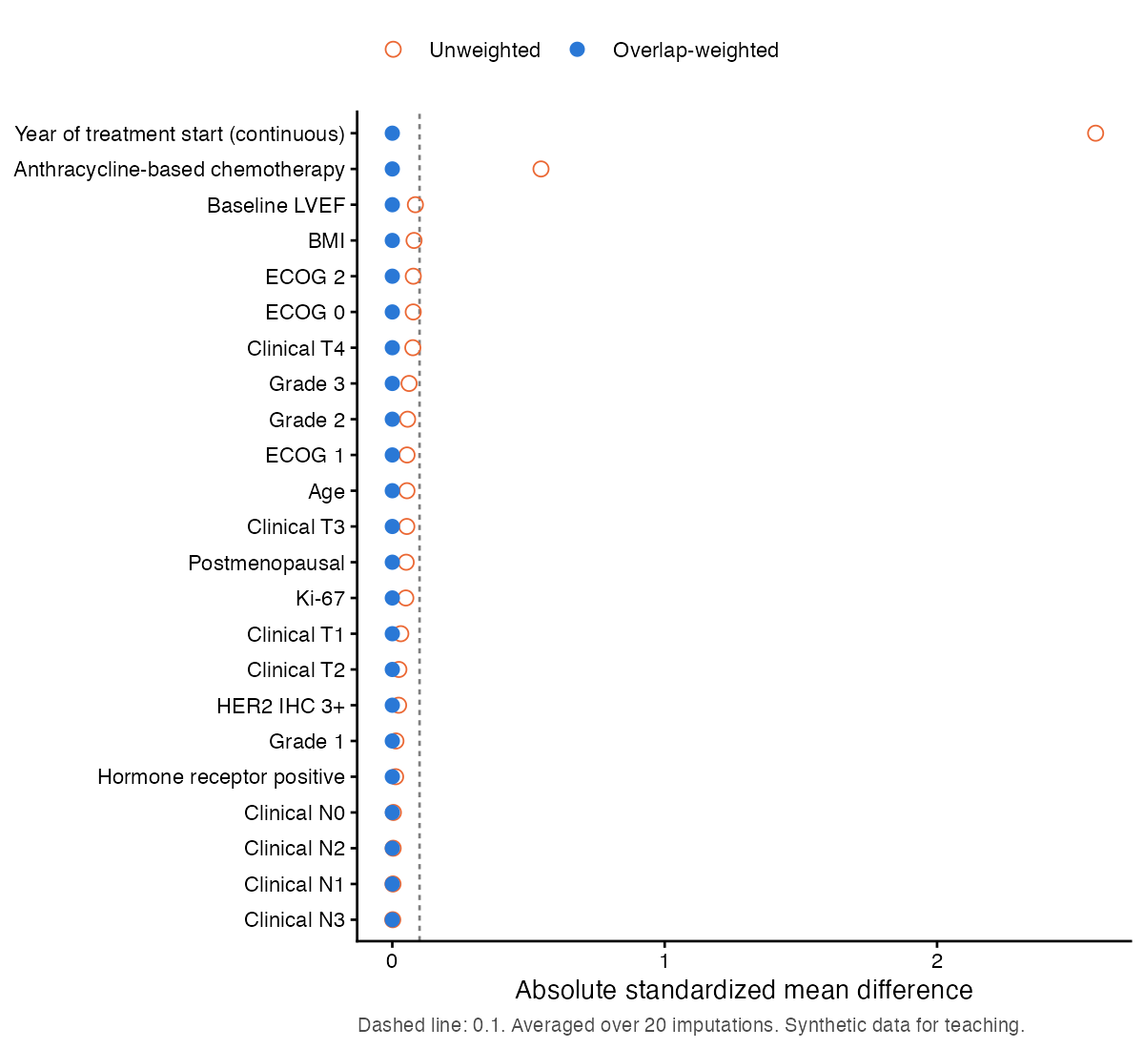
Absolute standardized mean differences of the propensity-score covariates; dashed line, 0.1. Year of treatment start is shown as a continuous variable.
Supplementary File S1. Analysis code (JCRP_supplementary_code.zip): the statistical analysis plan, analysis code, shared definitions with automated tests, analysis parameters, drug-name map, and records of data queries and decisions. No patient data are included. The code was written with the assistance of Claude Opus 5.5 (see the Use of Generative AI statement).

