Supplementary Material
Neoadjuvant Chemotherapy with Trastuzumab plus Pertuzumab versus Trastuzumab Alone in Early HER2-Positive Breast Cancer: A Single-Center Retrospective Cohort Study
SYNTHETIC DATA FOR TEACHING — NOT A REAL STUDY. Patients, investigators and institution are fictional.
This demonstration manuscript was written by AI (Claude Opus 5.5). In a real submission, the text must be written by the authors.

Table S1a. Baseline characteristics, all categories (part 1 of 3)
Characteristic | Overall N = 615 | Trastuzumab + pertuzumab N = 416 | Trastuzumab alone N = 199 | SMD
Age at diagnosis, years | 50.9 (43.5–58.4) | 50.7 (43.8–59.1) | 51.5 (42.6–57.7) | 0.05
Missing | 1 | 1 | 0
Menopausal status |  |  |  | 0.05
Premenopausal | 267 (43.4%) | 184 (44.2%) | 83 (41.7%)
Postmenopausal | 348 (56.6%) | 232 (55.8%) | 116 (58.3%)
ECOG performance status |  |  |  | 0.10
0 | 450 (73.2%) | 309 (74.3%) | 141 (70.9%)
1 | 154 (25.0%) | 101 (24.3%) | 53 (26.6%)
2 | 11 (1.8%) | 6 (1.4%) | 5 (2.5%)
BMI, kg/m² | 24.1 (21.3–26.7) | 24.1 (21.5–26.9) | 24.0 (21.2–26.4) | 0.08
Baseline LVEF, % | 65.0 (61.0–68.0) | 65.0 (61.0–68.0) | 65.0 (62.0–68.0) | -0.08
Clinical T category |  |  |  | 0.09
T1 | 49 (8.0%) | 32 (7.7%) | 17 (8.5%)
T2 | 348 (56.6%) | 237 (57.0%) | 111 (55.8%)
T3 | 139 (22.6%) | 97 (23.3%) | 42 (21.1%)
T4 | 79 (12.8%) | 50 (12.0%) | 29 (14.6%)
Clinical N category |  |  |  | 0.00
N0 | 180 (29.3%) | 122 (29.3%) | 58 (29.1%)
N1 | 290 (47.2%) | 196 (47.1%) | 94 (47.2%)
N2 | 83 (13.5%) | 56 (13.5%) | 27 (13.6%)
N3 | 62 (10.1%) | 42 (10.1%) | 20 (10.1%)
Values are n (%) or median (IQR); missing values are shown and excluded from percentages. SMD, standardized mean difference before weighting.

Table S1b. Baseline characteristics, all categories (part 2 of 3)
Characteristic | Overall N = 615 | Trastuzumab + pertuzumab N = 416 | Trastuzumab alone N = 199 | SMD
Clinical stage (AJCC 8th, anatomic) |  |  |  | 0.10
IIA | 139 (22.6%) | 94 (22.6%) | 45 (22.6%)
IIB | 208 (33.8%) | 141 (33.9%) | 67 (33.7%)
IIIA | 134 (21.8%) | 94 (22.6%) | 40 (20.1%)
IIIB | 72 (11.7%) | 45 (10.8%) | 27 (13.6%)
IIIC | 62 (10.1%) | 42 (10.1%) | 20 (10.1%)
Hormone receptor (ER or PR ≥1%) |  |  |  | 0.01
Positive | 356 (57.9%) | 240 (57.7%) | 116 (58.3%)
Negative | 259 (42.1%) | 176 (42.3%) | 83 (41.7%)
HER2 status |  |  |  | 0.02
IHC 3+ | 475 (77.2%) | 320 (76.9%) | 155 (77.9%)
IHC 2+, ISH amplified | 140 (22.8%) | 96 (23.1%) | 44 (22.1%)
Histologic grade |  |  |  | 0.07
1 | 22 (3.9%) | 15 (3.9%) | 7 (3.9%)
2 | 257 (45.2%) | 171 (44.2%) | 86 (47.5%)
3 | 289 (50.9%) | 201 (51.9%) | 88 (48.6%)
Missing | 47 | 29 | 18
Ki-67, % | 43.5 (31.0–56.0) | 43.5 (31.0–56.0) | 43.5 (30.0–57.0) | -0.05
Missing | 71 | 54 | 17
Neoadjuvant chemotherapy backbone |  |  |  | 0.55
Anthracycline-based | 223 (36.3%) | 116 (27.9%) | 107 (53.8%)
Carboplatin-based | 392 (63.7%) | 300 (72.1%) | 92 (46.2%)
Values are n (%) or median (IQR); missing values are shown and excluded from percentages. SMD, standardized mean difference before weighting.

Table S1c. Baseline characteristics, all categories (part 3 of 3)
Characteristic | Overall N = 615 | Trastuzumab + pertuzumab N = 416 | Trastuzumab alone N = 199 | SMD
Year of neoadjuvant therapy start |  |  |  | 2.80
2012–2015 | 162 (26.3%) | 6 (1.4%) | 156 (78.4%)
2016–2019 | 209 (34.0%) | 171 (41.1%) | 38 (19.1%)
2020–2023 | 244 (39.7%) | 239 (57.5%) | 5 (2.5%)
Values are n (%) or median (IQR); missing values are shown and excluded from percentages. SMD, standardized mean difference before weighting.

Table S2. Pathologic complete response by hormone receptor status (exploratory)
Subgroup | Patients, n (T+P/T) | pCR, T+P* | pCR, T* | Odds ratio (95% CI)
Hormone receptor negative | 176/83 | 64.4% | 40.8% | 2.63 (0.79–8.71)
Hormone receptor positive | 240/116 | 50.5% | 33.5% | 2.03 (0.94–4.37)
Overlap-weighted proportions with propensity scores re-estimated within each subgroup, averaged over 20 imputations. P* = 0.552 for interaction (overall weights). pCR, pathologic complete response; T, trastuzumab; T+P, trastuzumab plus pertuzumab.

Table S3. E-values for unmeasured confounding
Endpoint | E-value, point estimate | E-value, confidence limit
pCR (OR) | 2.19 | 1.31
EFS (HR) | 1.39 | 1.00
The E-value is the minimum strength of association, on the risk-ratio scale, that an unmeasured confounder would need to have with both treatment and outcome to explain away the observed estimate. †The confidence interval includes the null value.

Table S4. Post hoc analyses performed in response to peer review
Analysis | Patients, n (T+P/T) | Measure | Estimate (95% CI) | P
Propensity score with natural spline for year (3 df) | 416/199 | OR for pCR | 2.00 (1.05–3.79) | 0.034
EFS, treatment start 2012-2019 (before adjuvant T-DM1 was used) | 177/194 | HR for EFS | 0.81 (0.39–1.70) | 0.584
pCR excluding patients with progression before surgery | 412/194 | OR for pCR | 2.01 (1.12–3.62) | 0.020
pCR including patients operated elsewhere, all assumed pCR | 422/209 | OR for pCR | 1.40 (0.77–2.53) | 0.271
pCR including patients operated elsewhere, all assumed no pCR | 422/209 | OR for pCR | 2.19 (1.27–3.77) | 0.005
EFS with follow-up truncated at 5 years | 416/199 | HR for EFS | 0.59 (0.26–1.36) | 0.216
OS with follow-up truncated at 5 years | 416/199 | HR for OS | 0.77 (0.30–1.99) | 0.584
These analyses were not prespecified in the statistical analysis plan. All used overlap weighting with the same 20 imputations as the primary analysis. Patients operated on elsewhere were assigned to groups by pertuzumab use within 180 days of the index date. CI, confidence interval; EFS, event-free survival; HR, hazard ratio; OR, odds ratio; OS, overall survival; pCR, pathologic complete response; T, trastuzumab; T+P, trastuzumab plus pertuzumab.

Figure S1. Covariate balance before and after overlap weighting
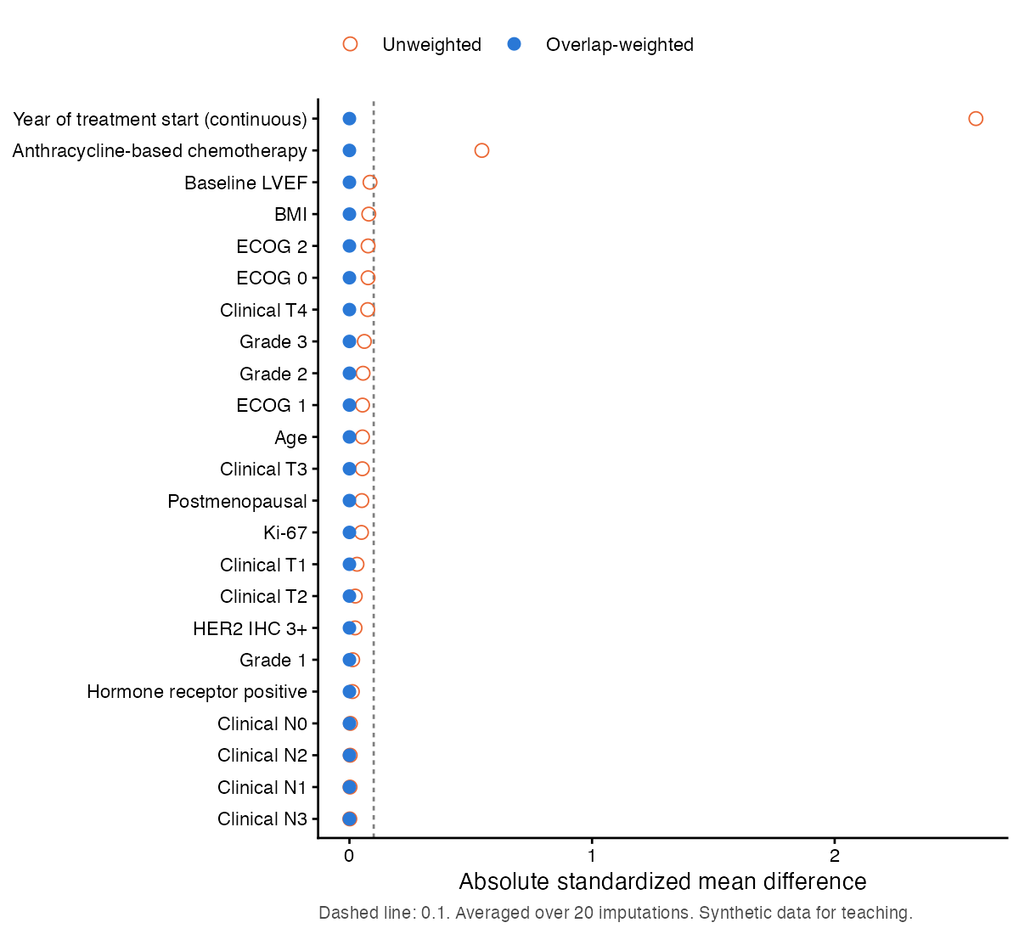
Absolute standardized mean differences of the propensity-score covariates; dashed line, 0.1. Year of treatment start is shown as a continuous variable.

Figure S2. Distribution of propensity scores by neoadjuvant regimen (post hoc)
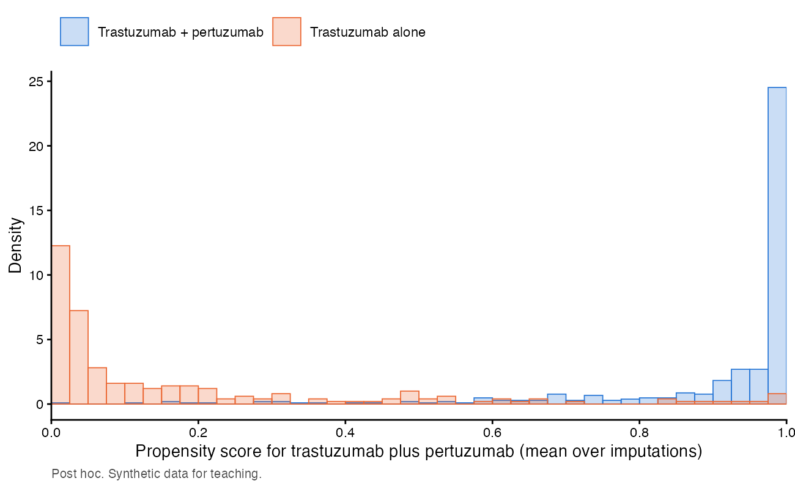
Propensity scores for receiving trastuzumab plus pertuzumab, averaged over imputations. The limited overlap reflects the different treatment periods of the two regimens; overlap weighting gives the greatest weight to patients in the region of overlap.
Supplementary File S1. Analysis code (JCRP_supplementary_code.zip): the statistical analysis plan, analysis code, shared definitions with automated tests, analysis parameters, drug-name map, and records of data queries and decisions. No patient data are included. The code was written with the assistance of Claude Opus 5.5 (see the Use of Generative AI statement).
Supplementary File S2. STROBE checklist (JCRP_STROBE_checklist.docx): the completed STROBE checklist for cohort studies, with the page on which each item is reported.

