**Another Day at SkyJ**

**Final Project**

**TW02**

**Submitted by:**

Balahadia, Geoffrie

Costinar, John Kenneth

Cotamco, Xyrus

Dela Cruz, Darryl Ace

**Submitted to:**

Sir. Jabez Mendoza

FOODPANDA APPLICATION

*User-Friendly, Visually Pleasing: Enhancing Foodpanda’s Interface*

**Introduction**

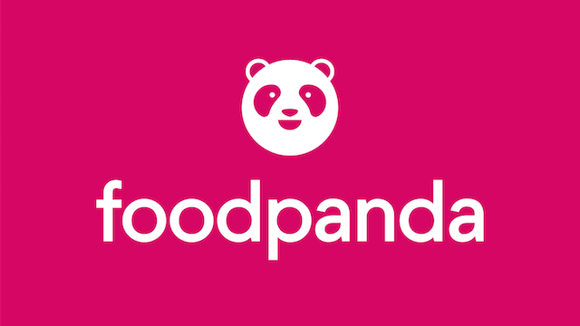

Foodpanda is one of the most popular food delivery applications, designed for ease and convenience as a go-to platform for users seeking meals, groceries, essentials, and more. Launched in Singapore in 2012, it quickly expanded to 11 markets across Asia, reaching the Philippines in 2014. With key features like real-time tracking, multiple payment options, and a user-friendly interface, Foodpanda has become an essential service for many Filipinos. Beyond food delivery, it offers Pandamart for groceries and Pandago for courier services. Its efficiency proved invaluable during the COVID-19 pandemic (2020-2022) when dining restrictions increased the demand for reliable delivery options.

Furthermore, Foodpanda continues to adapt to evolving consumer needs by introducing new services, expanding its market presence, and incorporating sustainability efforts. With over 10 million users globally as of 2023, the platform remains committed to enhancing speed, reliability, and overall user experience through continuous innovation.