# JQuery validate

## 简介

插件作者：Jorn Zeefferer

JQuery Validate是一个专门用来进行前端表单验证的JQuery插件，让表单验证变得更加简单和高效，同时提供了大量的定制选项，满足各种应用的需求。

插件自己内置了一整套的验证处理逻辑，包括URL和电子邮件验证等等，也提供了一个用来编写用户自定义方法的API，所有的函数方法默认使用英语作为错误信息，已经翻译成37种各种语言。

## 使用

### 引入JQuery Validate支持

|  |
| --- |
| <script type="text/javascript" src="js/jquery-1.12.4.min.js" ></script>  <script type="text/javascript" src="js/jquery.validate.js" ></script> |

### 默认验证规则

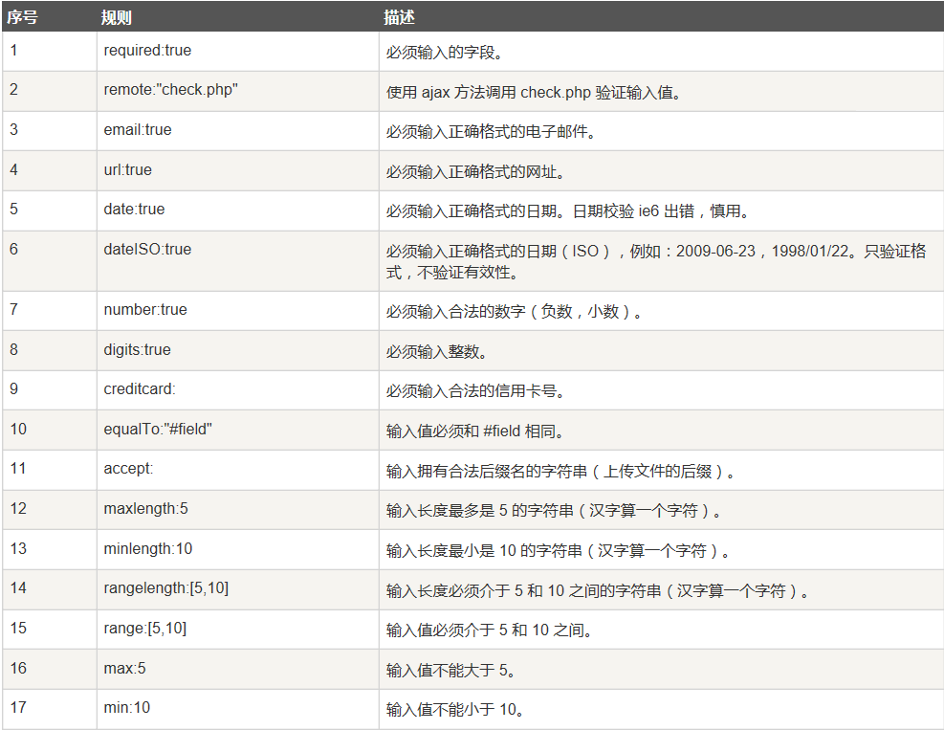

### 默认提示_英文

|  |
| --- |
|  |

### 使用中文提示

需要引入中文提示js文件：dist/localization/messages_zh.js

|  |
| --- |
|  |

### quick start

|  |
| --- |
| 处理效果图 |
|  |
| 在网页中，通过Jqeury validate插件进行表单验证 |
| <body>  <form class="cmxform" id="signupForm" method="get" action="">  <fieldset>  <legend>验证完整的表单</legend>  <p>  <label for="firstname">名字</label>  <input id="firstname" name="firstname" type="text">  </p>  <p>  <label for="lastname">姓氏</label>  <input id="lastname" name="lastname" type="text">  </p>  <p>  <label for="username">用户名</label>  <input id="username" name="username" type="text">  </p>  <p>  <label for="password">密码</label>  <input id="password" name="password" type="password">  </p>  <p>  <label for="confirm_password">验证密码</label>  <input id="confirm_password" name="confirm_password" type="password">  </p>  <p>  <label for="email">Email</label>  <input id="email" name="email" type="email">  </p>  <p>  <label for="agree">请同意我们的声明</label>  <input type="checkbox" class="checkbox" id="agree" name="agree">  </p>  <p>  <label for="newsletter">我乐意接收新信息</label>  <input type="checkbox" class="checkbox" id="newsletter" name="newsletter">  </p>  <fieldset id="newsletter_topics">  <legend>主题 (至少选择两个) - 注意：如果没有勾选“我乐意接收新信息”以下选项会隐藏，但我们这里作为演示让它可见</legend>  <label for="topic_marketflash">  <input type="checkbox" id="topic_marketflash" value="marketflash" name="topic">Marketflash  </label>  <label for="topic_fuzz">  <input type="checkbox" id="topic_fuzz" value="fuzz" name="topic">Latest fuzz  </label>  <label for="topic_digester">  <input type="checkbox" id="topic_digester" value="digester" name="topic">Mailing list digester  </label>  <label for="topic" class="error">Please select at least two topics you'd like to receive.</label>  </fieldset>  <p>  <input class="submit" type="submit" value="提交">  </p>  </fieldset>  </form>  </body> |
| **js验证过程** |
| <script>  $(function() {  // 在键盘按下并释放及提交后验证提交表单  $("#signupForm").**validate**({  **rules**: {  firstname: "required",  lastname: "required",    username: {  required: true,  minlength: 2  },    password: {  required: true,  minlength: 5  },    confirm_password: {  required: true,  minlength: 5,  equalTo: "#password"  },    email: {  required: true,  email: true  },    topic: {  required: "#newsletter:checked",  minlength: 2  },    agree: "required"  },    **messages**: {  firstname: "请输入您的名字",  lastname: "请输入您的姓氏",    username: {  required: "请输入用户名",  minlength: "用户名必需由两个字母组成"  },    password: {  required: "请输入密码",  minlength: "密码长度不能小于 5 个字母"  },    confirm_password: {  required: "请输入密码",  minlength: "密码长度不能小于 5 个字母",  equalTo: "两次密码输入不一致"  },    email: "请输入一个正确的邮箱",  agree: "请接受我们的声明",  topic: "请选择两个主题"  }  });  });  </script> |