***Name: Class:***

1. ***Match each item in Column A with its function in Column B***

|  |  |  |  |
| --- | --- | --- | --- |
| **A Item** |  |  | **B Function** |
| 1. RAM |  |  | controls the cursor |
| 1. processor |  |  | inputs data through keys like a typewriter |
| 1. mouse |  |  | displays the output from a computer on a screen |
| 1. clock |  |  | reads DVD-ROMs |
| 1. flash memory key |  |  | reads and writes to electronic chips on a card |
| 1. monitor |  |  | holds instructions which are needed to start up the computer |
| 1. keyboard |  |  | holds data read or written to it by the processor |
| 1. DVD-ROM drive |  |  | provides extremely fast access for sections of a program and its data |
| 1. cache |  |  | controls the timing of signals in the computer |
| 1. ROM |  |  | controls all the operations in a computer |

1. ***Complete this dialogue with the words in the box***

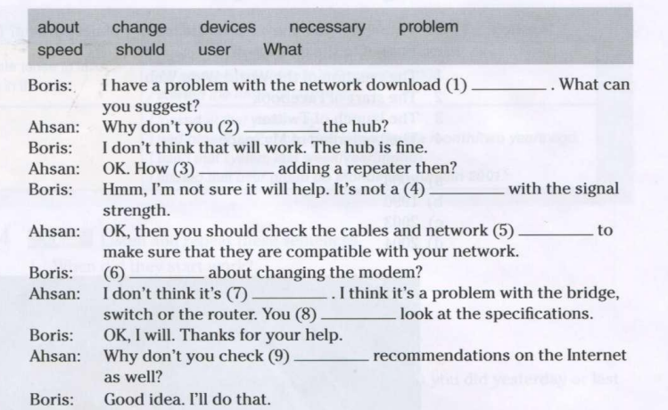

1. ***Choose the best verb***

1. To turn on the computer, …………the “Start” button.

a. touch b. press c. switch

2. The printer has ……………..of ink.

a. finished b. ended c. run out

3. Unfortunately, my scanner isn't…. at the moment

a. working b. going c. doing

4. Please ……………. the CD ROM.

a. Insert b. introduce c. inject

5. The projector isn't working because It isn't ………

a Plugged b. plugged in c plugged into

6. The batteries in my digital camera are nearly dead. They need ………..

a to change b. exchanging c changing

7. I have to …a computer screen for eight hours a day.

a. see b. look at c. watch

8. Switch off your computer, and ….it from the wall socket.

a de-plug b. unplug c. non-plug

9. I turned off the photocopier and ………..the plug.

a. pulled out b. extracted c. took away.

1. ***Reading***

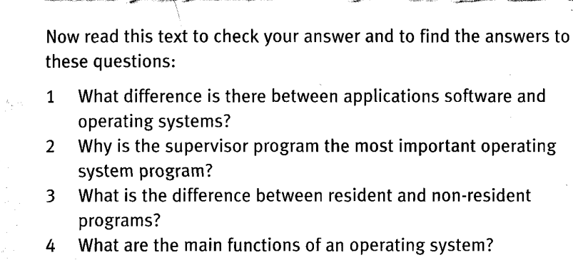

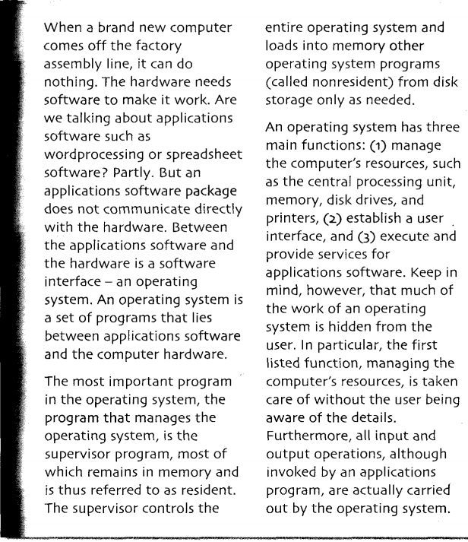

1. ***Writing***

