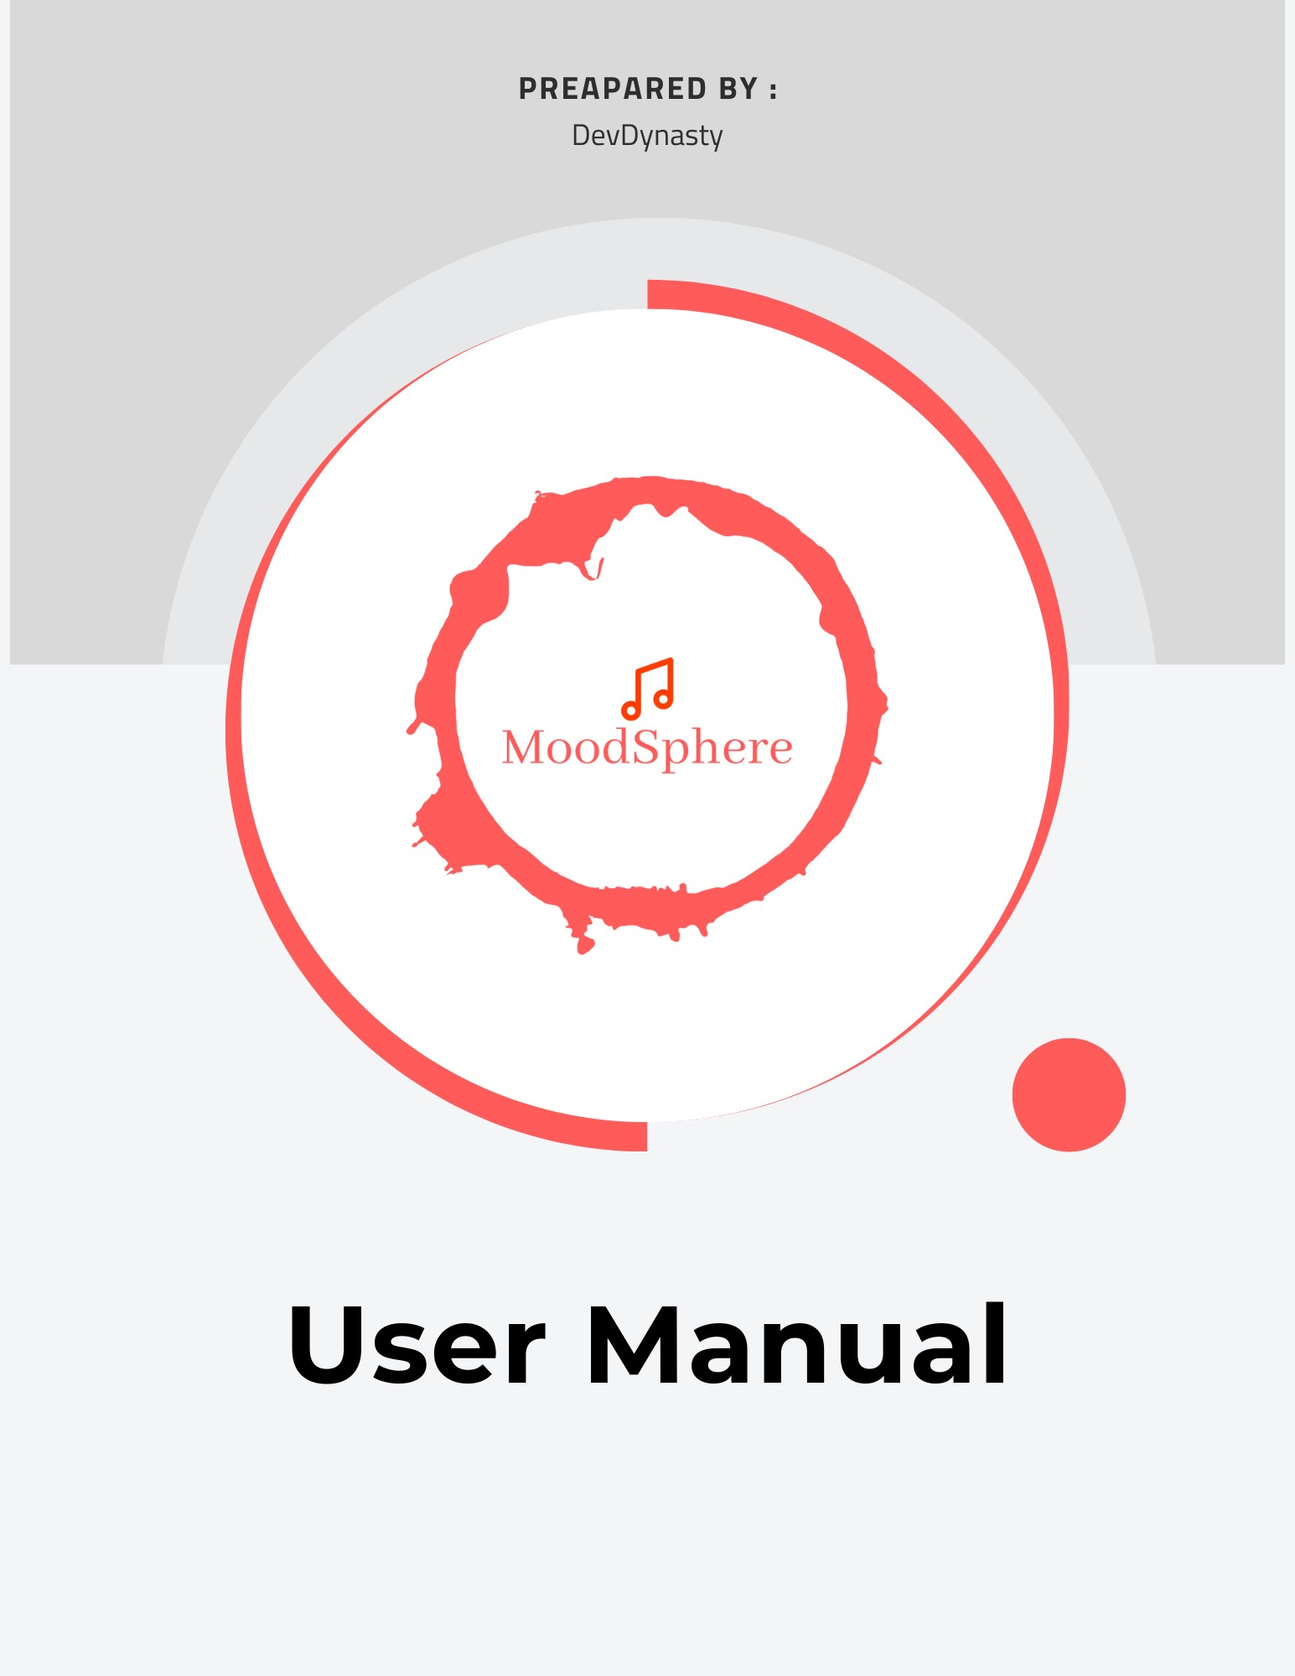

## CONTENT

1. **Introduction**

## Landing Page

* 1. **Get Started**

## User Register

* 1. **User Login**

## Guest Login

1. **Homepage**

## Sidebar

* 1. **Homepage Options**

## Find Artist by Genre

* + 1. **Find Music by Artist**

## Mood Status (MVP)

* + - 1. **Upload Your Image**

## Camera

* + - 1. **Browse Files**

## Upload from Saved Images

1. **Playlist**

## Library

* 1. **Search Song by Artist**

## Search Song by Genre

1. **Feedback**

# Introduction

Welcome to MoodSphere’s user manual, your way to a groundbreaking music discovery journey specifically for your mood. If you are a music enthusiast or seldom listener, are you desirous to catch up with your feelings tunes?

## MoodSphere is made for you!

MoodSphere uses cutting-edge Convolutional Neural Network technology to analyze your mood accurately. MoodSphere integrates complex deep-learning algorithms with the network to provide immediate music recommendations. Euphorically, in short, you’ll be preoccupied without stopping with the sounds associated with how you are perceived now.

# Getting Started

When you first visit [moodsphere.vervel.app](http://moodsphere.vervel.app/), you will be redirected to out Landing Page shown below.

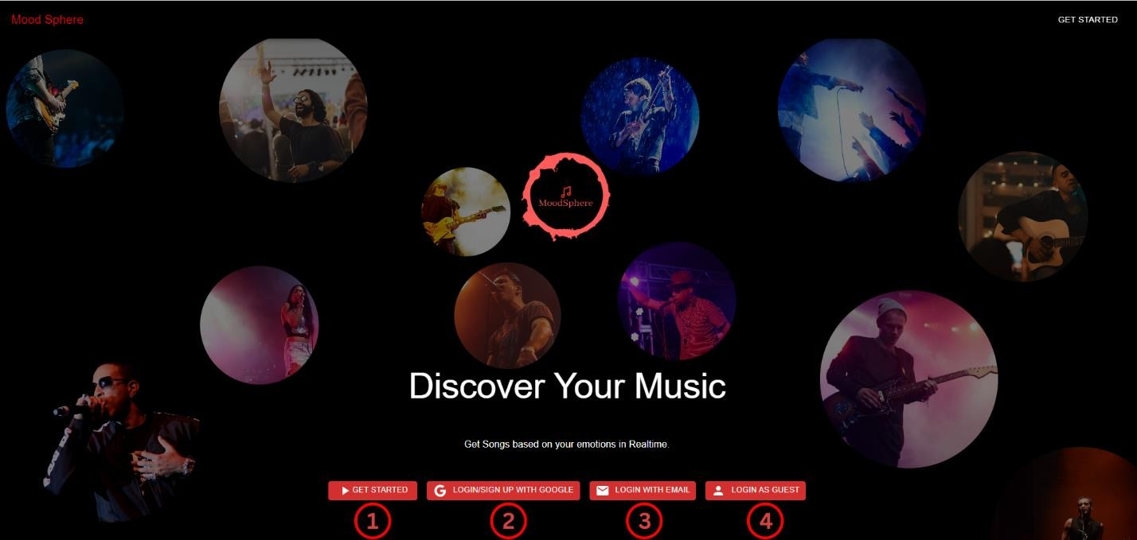

## Get Started:

When you hit on Get Started, it will take you to the User Register form which means you do not have an existing account and pull ups a form to fill.

## User Register*:*

* Access Registration: Click on "User Register" on the homepage.
* Fill Out Form: Enter your first name, last name, email, and create a password.
* Submit: Click the submit button to create your account

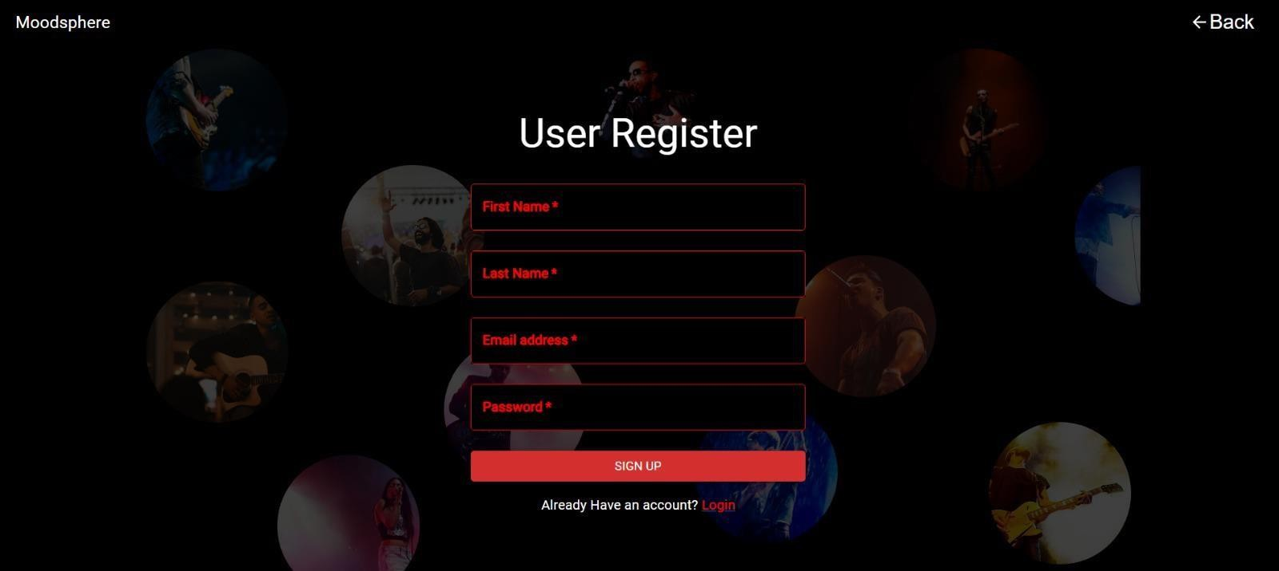

## User Login:

* Access Login Page: Click on "User Login" on the homepage.
* Enter Credentials: Type in your registered email and password.
* Log In: Click the login button to access your account

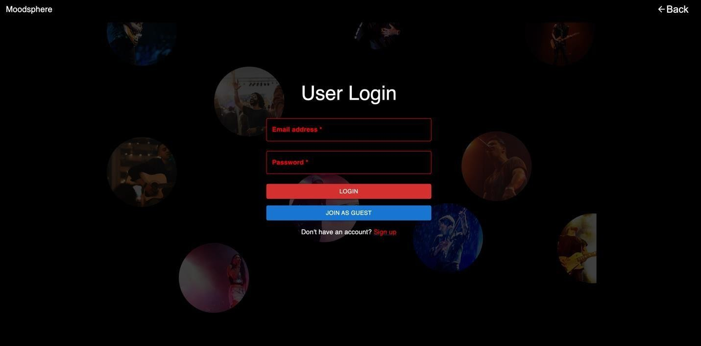

## Guest Login (For Quick Access)

When you hit Login as Guest, you will be only be able to access limited features of the site.

# A black background with a red border Description automatically generatedHomepage

After successful login, you will be redirected to the homepage (as seen in the screenshot). This is the primary page of our application; all the features are accessible here.

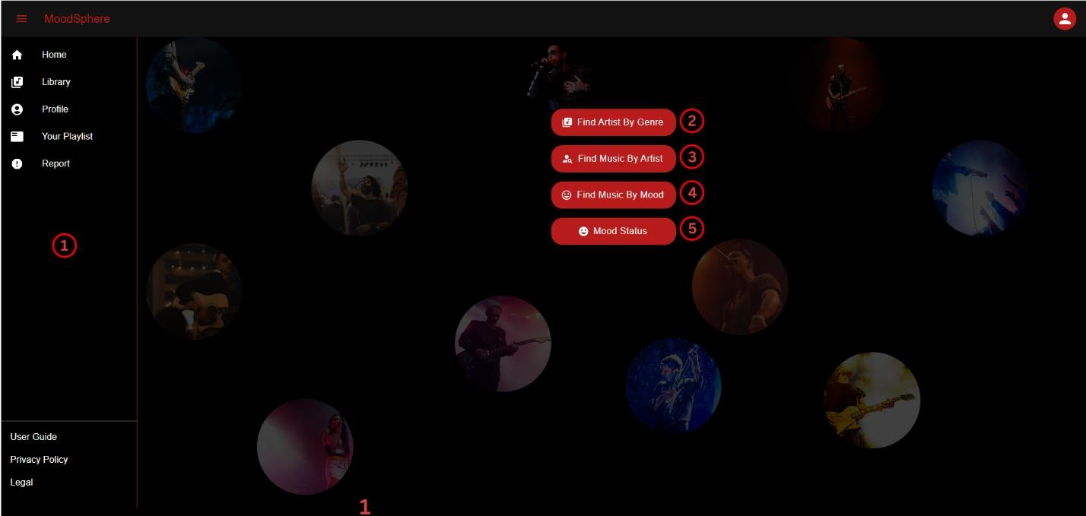

## Sidebar:

This sidebar is common in our application. Even if you are in any part of the application, you can access the following parts of the feature such as-

* + 1. Clicking on” Playlist” will directly take you

to your saved playlist page.

* + 1. Clicking on Library will redirect you to our search feature.
    2. The Profile button allows the user to

navigate to their profile page where they can see their information.

* + 1. If the user finds any issues, and they want to report it, the last button suffices this need.
    2. The lower area of the sidebar is for user’s security aids. Application provides” legal” and” Privacy policy” buttons which will open the application’s legal bindings and privacy policy.

## Home Page Options

* + 1. **Find Artist by Genre:**

As the button suggests. This section dives you into searching songs which are specific to your favorite genres. May it be pop, hip-hop, classical, or even Rock, users will be able to find all kinds of genres which are supported by the application. To use this feature simply

1. Click on any genre from the list provided OR
2. Users can manually search their genre, which filters from the list.
3. Once you find your genre, just click on it and voila! You will get top songs with your selected genre.

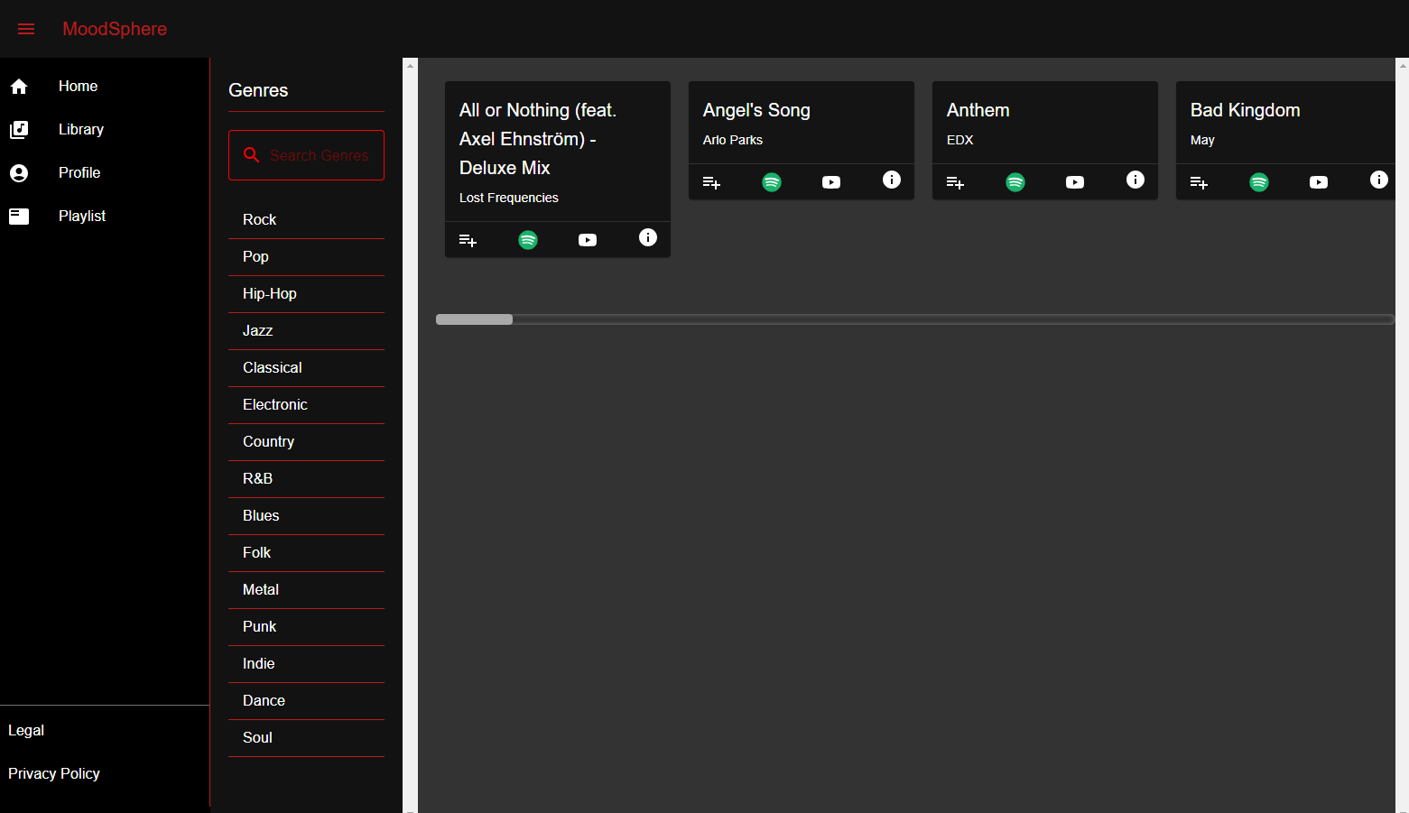

## Find Music by Artist:

This section is all about your artists. Users can make use of the same steps from section 3.2.1.

Steps to use:

* + - 1. Click on any artist from the list provided OR
      2. Users can manually search their artist, which filters from the list.
      3. Once you find your artist, just click on it and voila! You will get top songs with your selected genre.

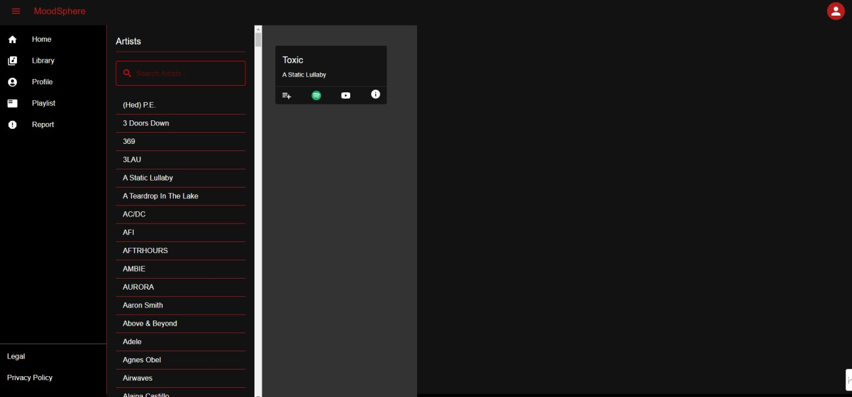

## Mood Status:

This is the MINIMUM VIABLE PRODUCT of our whole application. This section will cover the primary features of our application.

This feature allows users to upload an image and get song recommendations based on their mood predicted from the image.

To get started click on the “upload your image” button.

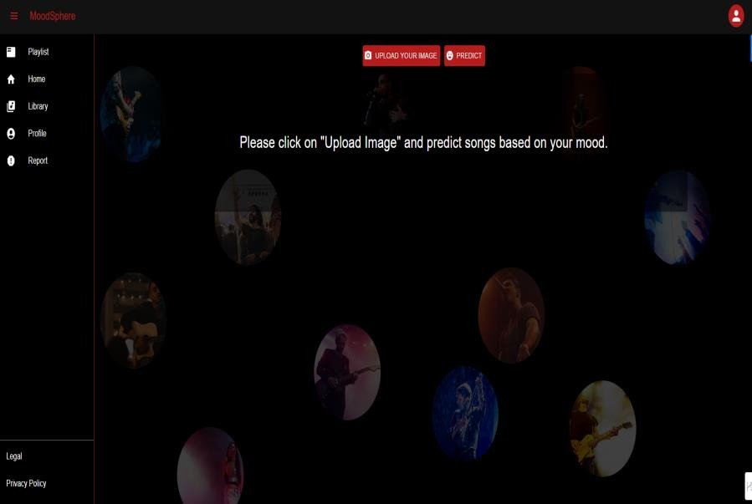

## Upload Your image-

After clicking on “upload your image”, The user will be prompted with three options.

Let’s go over this, one by one.

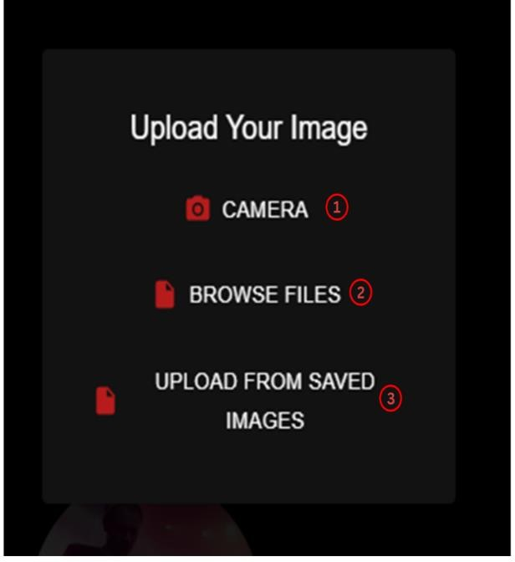

## Camera:

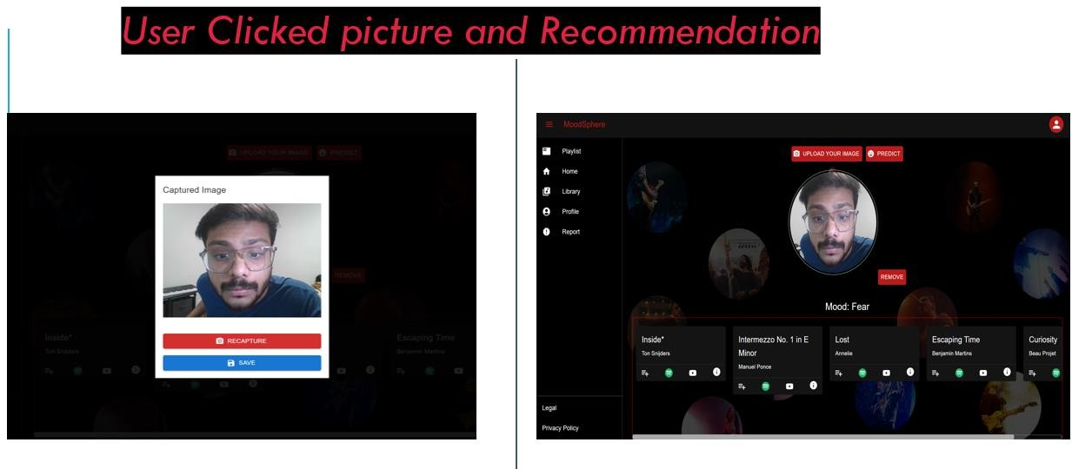

* + 1. Once you click on the camera, the system will ask the user to allow access to the user’s camera.
    2. Allowing it will Open the camera and user will be again prompted to capture the mood.
    3. Once clicked, if the user doesn’t like that picture or if he/she wants to recapture, then we allow users to either recapture or save.
    4. After clicking save, user needs to click “predict”, Once

clicked you will receive the list of recommended songs.

## Browse Files:

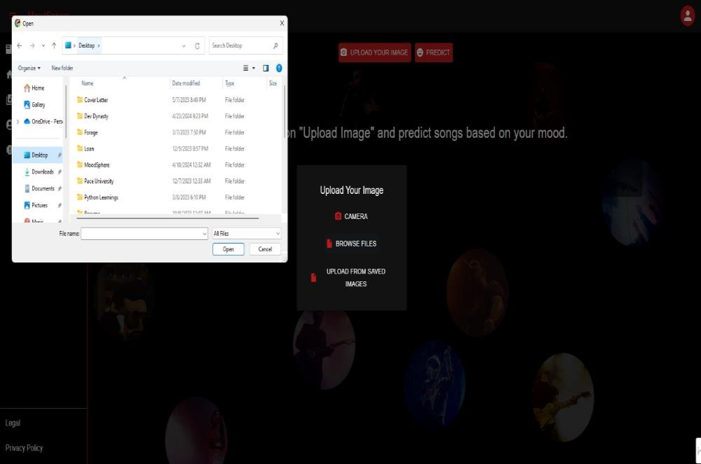

Steps to use mood status feature using local storage

1. Once you click on the browse files, the system will open

user’s local file storage

1. After browsing, the user can choose an image and hit save.
2. After saving that, the process is simple, if the user wants to get a list of songs, then hit predict.
3. Once you upload the image, it directly gets saved in our database.

## Upload from Saved Images:

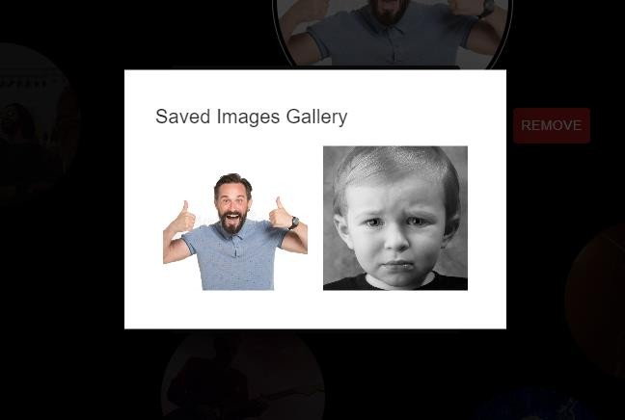

The last button, upload from saved images, pretty much has the same function as browse files, but here the catch is user can choose from the list of pre-uploaded images which were previously uploaded using the previous feature.

# Playlist

When your mood is predicted, you will be recommended music that resonates your mood, there will be a button where you get to add music to a playlist.

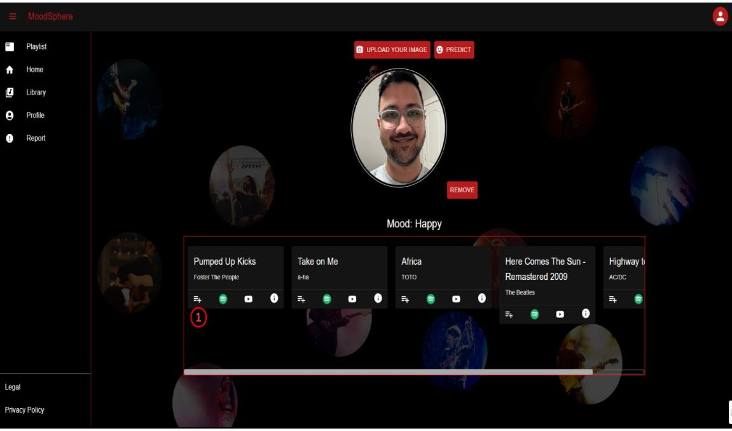

Once the prediction is complete, a music data card will be displayed with details about the suggested song.

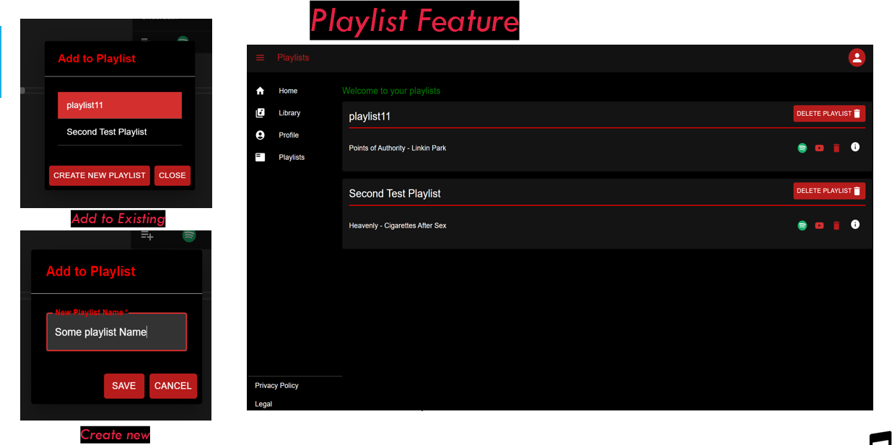

* + 1. On the music data card, there will be an "Add to Playlist" button.
    2. Click this button to open options for adding the song to an existing playlist or creating a new one.
    3. As soon as you hit on the add a playlist button, two options will be given
       - add to the existing playlist.
       - Create a new playlist and add that song.
    4. You can access and manage playlists from the playlist option from the sidebar.

# Library

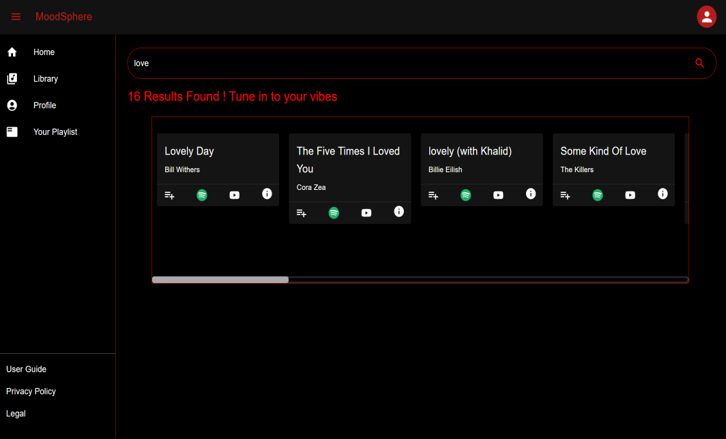

You get a feature where you can search your favorite genre from search bar-

* Search your favorite artist or song name
* Hit search to find the artist or song name

# Feedback

Feel free to reach out to us at [dynastydev23915@gmail.com](mailto:dynastydev23915@gmail.com).

Enjoy your music!