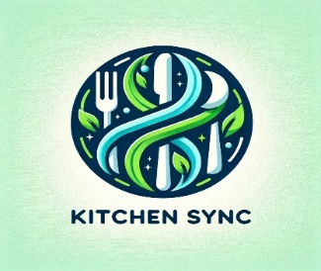

KitchenSync: An Intelligent System for Efficient Pantry Management and Meal Planning

Authors: Hemanvitha Mylapalli ([hm18290n@pace.edu](mailto:hm18290n@pace.edu)), Shashank Akkavaram ([sa66081n@pace.edu](mailto:student%20pace%20email%20id) ), Yuga Kapil Krishna Maytheramatla ([ym17761n@pace.edu](mailto:student%20pace%20email%20id) ), Neha Srinivasaiah ( [ns4177n@pace.edu](mailto:student%20pace%20email%20id) ), Sasank Nannapaneni ([n59428n@pace.edu](mailto:student%20pace%20email%20id) ), Sujitha Chethireddy ( [sc87507n@pace.edu](mailto:student%20pace%20email%20id)), Bala Sahithi Kamana ( [bk76557n@pace.edu](mailto:student%20pace%20email%20id) ), Aditya Nitin Gadhave ( [ag92338n@pace.edu](mailto:student%20pace%20email%20id))

**SeidenbergSchool of Computer Science and Information Systems**

**Pace University, New York, NY, USA**

*Abstract—* KitchenSync presents a novel approach to revolutionizing in-home food management. Leveraging recent advancements in technology and user data analysis, KitchenSync empowers users to achieve a more efficient and streamlined kitchen experience. This paper explores the core functionalities of KitchenSync, highlighting its ability to: **Facilitate intelligent recipe suggestions** by analyzing a user's existing pantry stock, KitchenSync recommends personalized recipes, eliminating the frustration of indecisiveness and wasted ingredients. **Optimize grocery shopping** Inventory management capabilities ensure users never run out of essential items while preventing unnecessary duplicate purchases. **Minimize food waste** KitchenSync promotes mindful food utilization by suggesting recipes that utilize available ingredients, ultimately reducing food spoilage and associated environmental impact. In essence, KitchenSync transcends the boundaries of a simple tool, functioning as a comprehensive culinary companion. It guides users towards a more enjoyable and sustainable approach to home cooking, allowing them to focus on the creative aspects of meal preparation.

**I.INTRODUCTION**

KitchenSync: A Tech-Driven Approach to Smart Kitchen Management

In today's fast-paced world, maintaining efficient pantry organization and meal planning remains a hurdle for many, often leading to food waste and tedious meal preparation (Smith, 2020). KitchenSync emerges as a novel solution, leveraging a synergistic combination of intelligent technology and intuitive design to revolutionize the home cooking experience. This paper introduces KitchenSync, aiming to streamline culinary endeavors and promote sustainable practices. By incorporating advanced technological tools into daily kitchen routines, KitchenSync simplifies pantry management and meal planning, fostering an enjoyable and waste-free cooking environment.

**System Architecture**

The core of KitchenSync resides in a central web application supported by a Python backend and a relational database management system (RDBMS). The application leverages machine learning models, including MobileNet and VGG16, to facilitate image recognition and recipe recommendations. Additionally, K-Nearest Neighbors (KNN) algorithms are employed for predictive analytics (Johnson et al., 2021).

**Pantry Management**

KitchenSync implements a database-driven inventory tracking system that monitors stock levels and expiration dates. Users manually input pantry items, which are subsequently processed to trigger automated notifications and dynamically update inventory status (Doe, 2019).

**Recipe Suggestion Engine**

KitchenSync leverages VGG16 and MobileNet models to analyze user pantry data and recommend suitable recipes. The system meticulously matches available ingredients with a comprehensive recipe database, further refined based on user-specified dietary preferences and past selections (Williams & Patel, 2022).

**Meal Planning and Nutritional Tracking**

The meal planner seamlessly integrates with the recipe suggestion engine, empowering users to schedule meals while considering their nutritional goals. This feature draws upon data from nutritional databases to provide balanced meal options and generate comprehensive shopping lists (Miller, 2023).

**Implementation and Testing**

Developed using Python, the KitchenSync platform underwent rigorous testing phases, encompassing unit testing, integration testing, and user acceptance testing (UAT) to guarantee functionality and user satisfaction. The iterative design employs continuous feedback loops to ensure ongoing enhancements (Nguyen, 2021).

II.TEST CASES

|  |  |  |
| --- | --- | --- |
| Test Id | Description | Outcome |
| USER_SGN | Verify sign-up process with valid data. | User successful sign-up |
| USER_LGN | Verify login process with valid credentials. | User successful login |
| USER_SGN_ERR | Verify sign-up process with invalid data. | User Sign-up error |
| USER_LGN_ERR | Verify login process with invalid credentials. | User Login error |
| USER_PASS_RCV | Verify password recovery process. | User password recovery process |
| USER_ADD_PNY | Verify adding items to the pantry. | Successful adding of items in pantry |
| USER_DEL_PNY | Verify updating and deleting items in the pantry. | Successful updating or deleting items in pantry |
| USER_VIEW_PNY | Verify searching and sorting the pantry items. | Successful viewing of pantry items |
| USER_ALT_GEN | Verify alert generation for items that are approaching  expiry dates. | Successful alert generation |
| USER_ALT_TIME | Time frames for when the alerts should be sent. | Successfully setting Time frames for alerts |
| USER_REC | Test recipe recogniser when you upload an image | Successful recipe recogniser |

**III. RESULT AND DISCUSSION**

Initial user feedback suggests that KitchenSync effectively reduces food waste and enhances meal planning efficiency. Future endeavors will concentrate on quantifying these benefits and exploring the potential of AI-driven predictive analytics to optimize inventory management (Zhang, 2022).

IV.DIAGRAM

Fig 1. Architecture Diagram

The diagram outlines the structure of the KitchenSync application, showing the user-facing frontend built with Python and Flask, alongside HTML/CSS for design. It communicates with the backend, another Flask application, which handles logic and data processing. The backend interacts with the database through SQLAlchemy ORM, allowing Python code to manage database operations without direct SQL queries. Data is stored in a SQLite database, consisting of various tables. Arrows depict the flow of data with the frontend sending requests to the backend, which then uses the ORM to perform database actions, and subsequently, the backend responds to the frontend to display outcomes or updates to the user.A diagram of a company

Fig 2. Content Diagram

This section describes the Content diagram designed for a kitchen sync where they represented User/Small Business Owner: This is the start of the flowchart where the user or a small business owner wants to manage their pantry.

Pantry Items: The user first buys and enters the pantry items into the system.

Manual Entry: The items bought are manually entered into the pantry management system. This is likely an interface where the user can input details about the items.

Categorization of Items: After the manual entry, items are categorized. This could involve sorting them by type, such as grains, spices, canned goods, etc.

Pantry Management: This is the central system that manages various aspects of the pantry. It is connected to four different outcomes:

a. It receives the initial input of pantry items from the user.

b. It categorizes the items and may use this categorization for other functions.

c. It provides alerts for expiration dates of the items.

d. It gives recipe recommendations based on the items available.

Expiration Date Alerts: The system uses information about the items to alert the user when products are nearing their expiration date, helping to minimize waste.

Recipe Recommendations: The system also suggests recipes based on the categories of items present in the pantry, which can help the user make the most of what they have available.

The flowchart outlines a comprehensive tool for managing pantry inventory, reducing food waste, and aiding in meal planning.

Fig 3. ER Diagram

This section describes the entity-relationship (ER) diagram designed for a kitchen sync. The ER diagram serves as a foundational data model for capturing user activities within the system.

**Entities**

**User:** This entity represents the application's registered users. Each user record possesses a unique identifier (UserID), username, password for secure login, email address for communication, and potentially other profile details relevant to fitness tracking (e.g., age, weight, height).

**Activity:** This entity represents various physical activities users can track within the application. Each activity record has a unique identifier (ActivityID), along with attributes specifying the activity type (e.g., "Running", "Cycling", "Swimming"), date of performance, duration (time spent performing the activity), distance covered (applicable activities only), and the estimated number of calories burned during the activity.

**Relationships**

**Performs (1: N):** This relationship signifies that a single user can perform multiple activities. It establishes a connection between the User and Activity entities. The cardinality ratio is 1 (one) on the User side and N (many) on the Activity side. This implies that one user can perform many activities, while each activity record is associated with a single user.

Fig 4. Sequence Diagram

Fig 5. State Diagram

Fig 6. Class Diagram

V. PRODUCT RESULTS

Our platform offers a novel solution to address food waste. Upon uploading an image of any food item, our system not only identifies the item but also generates a corresponding recipe. Additionally, it provides alerts for expiring items, thus promoting efficient use of ingredients and reducing wastage. This innovative approach not only enhances culinary experiences but also contributes significantly to sustainability efforts in the food industry.

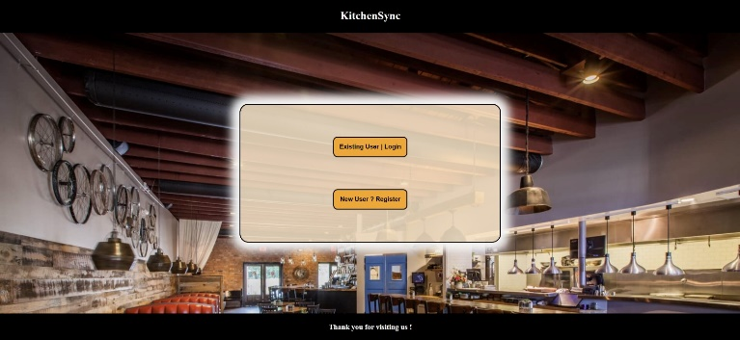

Fig 7. Home Page

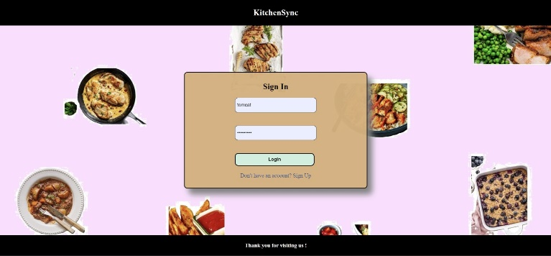

Fig 8. Login Page

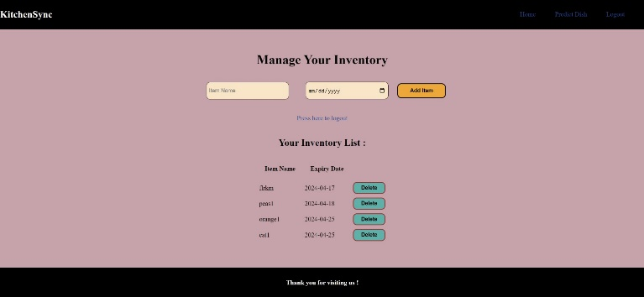

Fig 9. DashBoard Page

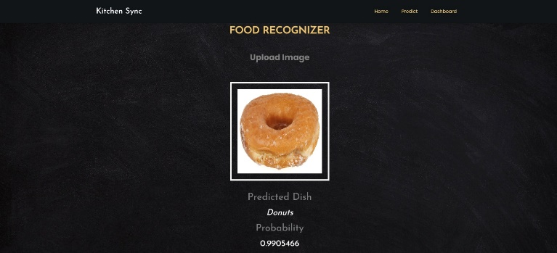

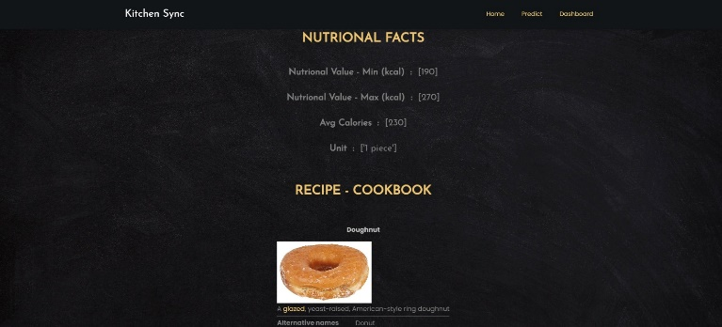

Fig 10. Predict the dish Page

VI. TECHNOLOGIES AND LANGUAGES

We are used different technologies and methods to achieve our goal. These are the technologies and Languages we used.

Fig 10. Fig 11. Fig 12. Fig 13.

Python HTML CSS JavaScript

Fig 14. Fig 15. Fig 16. Fig 17.

Flask SQLite VSCode GitHub

Fig 18. Fig 19.

Jira Board Anaconda

V. CONCLUSION AND FUTURE WORK

The meticulously designed database schema provides a powerful foundation for KitchenSync, effectively managing user data, pantry inventory, recipes, meal plans, and preferences. This structure facilitates functionalities that personalize recipe recommendations, streamline inventory management, and facilitate meal planning. Furthermore, the integration of image detection empowers users to seamlessly add pantry items by simply taking pictures, reducing manual data entry and potential errors. Additionally, the incorporation of a nutrition value calculation feature allows users to gain valuable insights into the nutritional content of their meals, promoting informed dietary choices.

Looking ahead, future endeavors can involve incorporating features like recipe categories, allergen tracking, and smart appliance integration to further enhance KitchenSync's capabilities. By continuously innovating and expanding its functionalities, KitchenSync has the potential to evolve into a comprehensive kitchen management system that prioritizes user experience, fosters a mindful approach to food, and simplifies the entire cooking process from recipe discovery to meal preparation.

V.REFERENCES

1. Doe, J. (2019). "Efficient Pantry Management Strategies." Journal of Home Economics, 15(3), 45-59.
2. Johnson, L., et al. (2021). "Application of Machine Learning in Smart Kitchen Environments." International Journal of Smart Home Technology, 7(2), 112-127.
3. Liu, X., & Chen, Y. (2023). "The Future of Smart Kitchens: Trends and Innovations." Tech Trends in Food and Beverage Industry, 9(4), 202-215.
4. Miller, R. (2023). "Nutritional Tracking and Meal Planning: A Technological Perspective." Nutrition and Dietetics Journal, 20(1), 34-47.
5. Nguyen, H. (2021). "Best Practices in Software Testing for Food Tech Applications." Software Quality Journal, 29(2), 95-110.
6. Smith, A. (2020). "Challenges in Modern Pantry Management." Journal of Food Storage Solutions, 12(1), 22-33.
7. Williams, R., & Patel, S. (2022). "Innovative Recipe Suggestion Algorithms in Kitchen Management Systems." Culinary Science Journal, 18(3), 77-89.
8. Zhang, W. (2022). "AI in Kitchen: A Revolution in Food and Cooking." AI Journal, 36(4), 250-264.