**GuideSense: API Documentation**

1. **Authentication APIs**
   1. Registration API

Purpose: Creates a new user account with email, password, and additional user details via Clerk.

Method: POST using Clerk via Full stack SDK

Process:

1. Input: User having two options to sign-up their account. Either manual enter the username, email, and password; or sign up by link to their Google account.
2. Output: A new user account is created in Clerk Authentication, and corresponding user details are stored in Clerk

Key Code: [Users: Create users](https://clerk.com/docs/users/creating-users)

* 1. Login API

Purpose: User able to login their accounts on two options.

Method: Enable the login options on Clerk API

Process:

1. Login with their username or email with password.

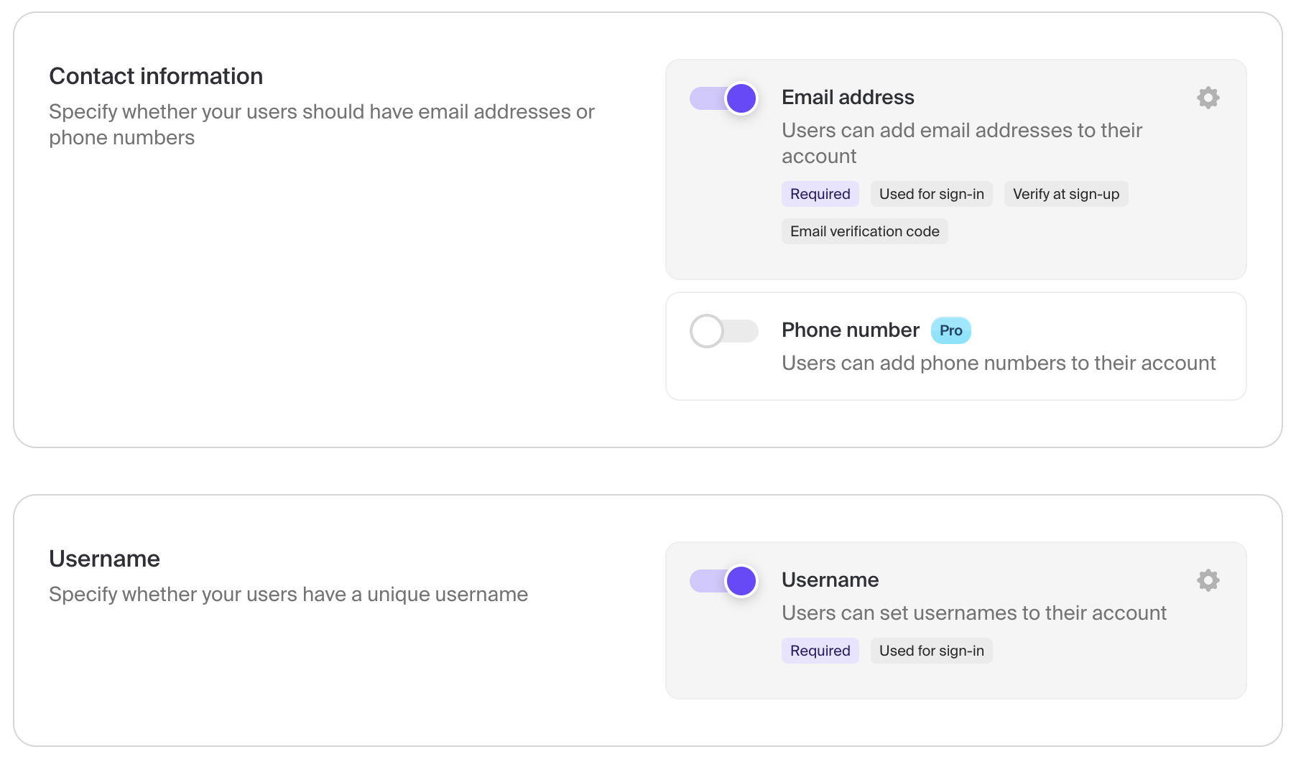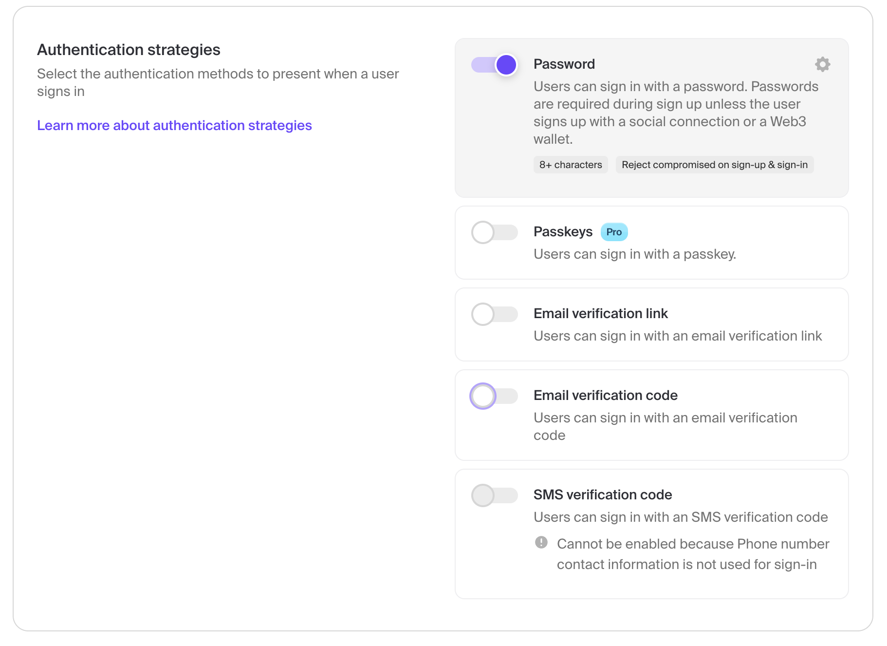

1. Login with “Continue with Google”, which requires user to login to their Google account.

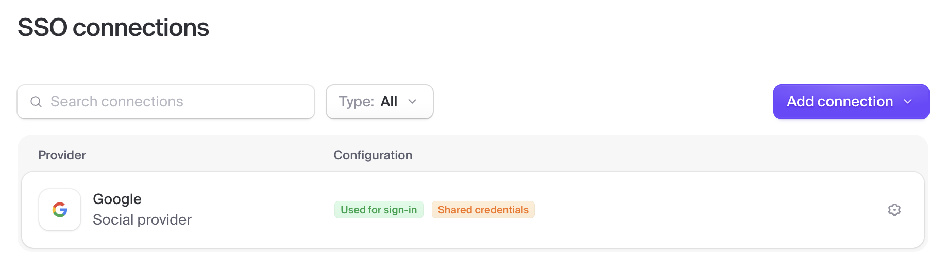

2. **FastAPI**

<https://fastapi.tiangolo.com/reference/openapi/docs/>

To see documentation in Swagger UI, add /docs to the end of the URL.

To see documentation in ReDoc, add /redoc to the end of the URL.

3. **Google Maps**

* Go to the Google Cloud Console.
* Click the project dropdown (top bar) → "New Project".
* Name your project and click **"Create"**.
* Go to the API Library
* Search for and enable the following APIs depending on your needs:

Maps JavaScript API Geocoding API, Directions API, Places API

4. **Google Text to Speech**

* Go to the Google Cloud Console.
* Visit the API Library.
* Search for “Text-to-Speech API”.
* Click Enable.
* Go to Credentials.
* Click **"Create Credentials" → "Service Account"**.
* Fill in name/description and click **Create and Continue**.
* Grant the **"Project → Editor"** role (or more specific roles if needed).
* Click **Done**.
* In the credentials list, click your new service account → **"Keys" tab** → **Add Key → Create new key → JSON**.
* A .json key file will download. **Save this securely** — it's your authentication token,