1️‍ Farmer – Rajesh Kumar

Age: 45

Location: Andhra Pradesh, India

Background: Rajesh has a 5-acre farm and grows wheat and paddy. He faces problems with plant diseases but doesn't have access to the latest technology in agriculture.

Needs: A simple mobile solution for plant disease identification and treatment.

Challenges:

Limited access to lab testing.

Lack of technical knowledge in AI-based tool usage.

Requires an offline mode when working in the field remotely.

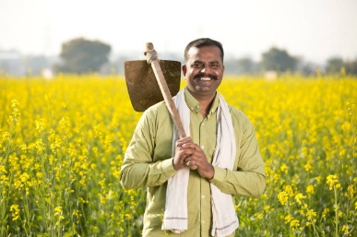

2️ Agricultural Consultant – Anna Mule

Age: 32

Location: Newyork, USA

Background: Anna is an agronomist with an experience of more than 12 years. She consults for multiple farms and promotes organic and sustainable farming and Director of Slow food USA.

Needs: A scalable diagnostic tool to assess multiple farms and suggest treatment strategies.

Challenges:

Manual inspections take too much time.

Needs high-accuracy AI predictions.

Prefers a web-based dashboard to analyze disease trends.

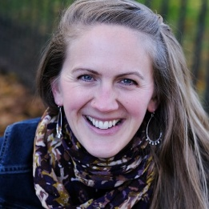

3️ Government Researcher – Dr. Mankombu Sambasivan Swaminathan

Age: 78

Location: Chennai, India

Background: Swaminathan is a government agricultural researcher working on food security and disease prediction models. He works with ICAR and policymakers.

Needs: Large-scale data of plant diseases for scientific research & policy making.

Challenges:

Wants real-time data across multiple states.

Disease trend analytics along with historical data.

API preference for data to integrate into projects.

