ResuMind
Eric Lantz¹, Sarah Wierzbicki², Joseph Indriolo³, Anika Bushra⁴
Seidenberg School of Computer Science and Information Systems, Pace University
One Pace Plaza, New York, NY 10038
¹el60794n@pace.edu, ²sw21410n@pace.edu, ³ji66549p@pace.edu, ⁴ab45375n@pace.edu

Abstract— ResuMind is an AI-powered tool that helps job seekers efficiently find relevant job opportunities by reading and interpreting the content in their resumes. By utilizing natural language processing (NLP) techniques like named entity recognition (NER), and the RoBERTa model, the system identifies a user’s career category and connects it to job postings that match their skills and experience. Unlike traditional job boards that require manual filtering, ResuMind automatically parses resumes, classifies users and recommends jobs through an intuitive interface. This approach has the potential to make the job search process faster, easier, and more personalized for job seekers.

Keywords— Job recommendation systems, natural language processing (NLP), named entity recognition (NER), machine learning, resume parsing
- Introduction
Whether you are actively or passively looking for a job, finding good opportunities can be an overwhelming process. There is often a high volume of job listings across different sites such as Indeed, LinkedIn, or Monster, however, they can be irrelevant for a job seeker’s current skillset, outdated, or even fraudulent. Users are expected to manually filter through large amounts of job listings and match their resumes to find suitable opportunities. The lack of personalized guidance combined with lengthy applications makes the job searching process challenging.
This study presents ResuMind, an AI-powered job assistant that personalizes the job search experience for users by leveraging natural language processing (NLP) to extract information from resumes and our machine learning module determines relevant job opportunities and matches them. Unlike traditional platforms that require filtering or manual searches, ResuMind automates the process. Users directly upload their resumes onto the platform, the resume is parsed to determine a relevant job category, and a curated list of jobs is generated. To create a more interactive experience, users can swipe right to like or swipe left to dismiss a job, similar to a dating app interface - but for job searching instead. The liked jobs are then saved to a Matched Jobs page where users can view a match percentage and the option to apply for the role.
The goal of this study is to create a seamless solution for job seekers to efficiently find relevant job opportunities whether they are returning to the workforce, switching industries, or simply looking for a more aligned fit within their current industry. This paper outlines the design our team has come up with, the methodologies employed, and results of the ResuMind platform to demonstrate how the job search process can be streamlined and personalized.
- Literature review
Resume screening and job matching systems have evolved significantly due to the rise in technologies such as natural language processing (NLP) and machine learning. These tools offer faster ways to review resumes and match job seekers with opportunities, which replaces the manual candidate screening methods. This section reviews recent research in these areas and positions ResuMind within this landscape.

- HrFlow.ai
An example of a modern AI-powered hiring platform is HrFlow.ai which helps companies automatically read and interpret resumes. It uses a combination of NLP and artificial intelligence (AI) to extract key details from an applicant’s resume such as names, skills, education, and work history. HrFlow can also analyze resumes in multiple languages, making it useful for larger companies with global applicants [1]. This platform is designed for recruiters and companies to quickly identify qualified candidates and job seekers do not directly interact with the platform. By comparison, ResuMind is made for job seekers. While it also uses NLP techniques to extract key resume details and match candidates to roles, ResuMind provides job seekers with a more personalized experience.

- NLP and Named Entity Recognition (NER)
A key aspect of automating resume analysis is Named Entity Recognition (NER), a technique used in NLP to find important information in text. In the context of resumes, NER can be used to detect skills and experience. Modern NER systems are powered by deep learning models that understand various contexts and syntax. Tools like spaCy use efficient statistical or neural models to identify entities even when resumes vary in structure or formatting [2]. Accurate entity recognition ensures that the system can interpret resumes consistently, regardless of how they are written.

- Machine Learning Models in Resume Matching
Once a resume is parsed, the next step is to determine what type of candidate the user is. Traditional platforms like LinkedIn or Indeed rely on manual searching and filtering which can lead to generic job suggestions. By applying the RoBERTa language model to convert resumes and job descriptions into data representations that capture what words mean, ResuMind is able to process the resumes and provide match scores with the user’s job category. For example, a user may be matched as software engineering versus advertising based on their listed skills or experience. This classification model uses deeper language understanding capabilities of RoBERTa to group users more accurately based on context and content [3]. LinkedIn, on the other hand, uses learning-to-rank models that includes user behavior and engagement history to recommend jobs, which can be both repetitive or biased [4]. ResuMind focuses on what is actually written in the resume to provide skill-based job suggestions.

- Positioning ResuMind
The majority of AI tools used for hiring are built for employers to quickly filter for qualified candidates, but they don’t offer guidance to job seekers. Our study takes an alternative approach by using similar NLP and machine learning models to analyze a user’s resume and recommend relevant jobs. ResuMind also shows users how well they match each role, and gives them control through the swipe-based interface, where the main “profile” of each card is high level information such as title, salary, and location so that users can easily decide whether they want to swipe right or left. ResuMind proves how AI can be used not just to automate hiring, but to also support and provide clearer direction to job seekers.

III. Methodologies

- System Overview
ResuMind helps job seekers discover relevant opportunities by matching the content on their resumes to different job opportunities. The multi-stage process begins with a user uploading their resume and ends with interactively exploring jobs. The four key components that it consists of are: resume parsing, user classification, job matching, and an interactive frontend interface. React.js frontend is used to collect user input and display results. The backend is built using Python with Flask to handle the resume processing and model communication. MongoDB is used to store the user data, resume content, along with the matched job listings. Lastly, the model is deployed using Amazon SageMaker, allowing it to respond to API requests in real time. A high-level overview of the system architecture is shown in Fig. 1. In addition to the system architecture, the context diagram in Fig. 2 illustrates the external entities that interact with the system, highlighting how data flows from uploading the resume to displaying the matched job listings.

- Cloud Deployment
Along with MongoDB, Amazon EC2 (Elastic Cloud Computing) that acts as a virtual machine was used to deploy the system. The EC2 instance runs both the frontend and backend services, along with MongoDB. The platform can be accessed over the web while maintaining scalability and reliability, due to the components being centralized on Amazon EC2. Hosting on EC2 allowed us to manage updates to the frontend, backend APIs, and database in a single environment.
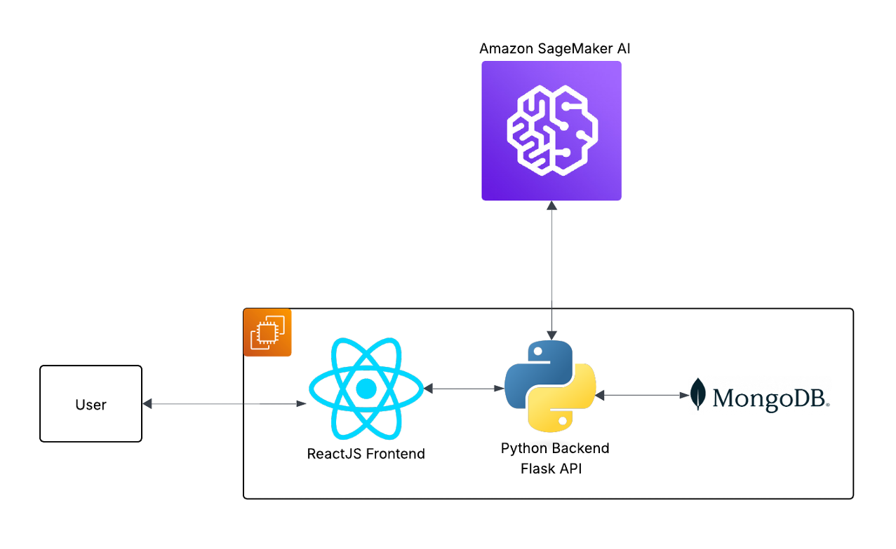
Fig. 1 System architecture diagram representing the flow of data between the frontend and backend, along with the machine learning model and database components used to create ResuMind.

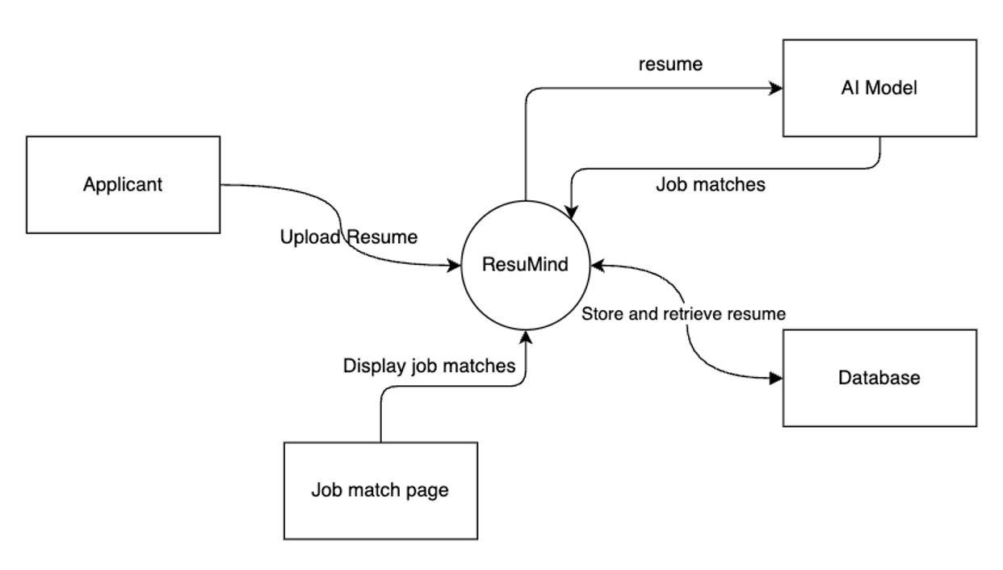

Fig. 2 Context diagram illustrating the external interactions between the applicant, ResuMind platform, AI model, database, and job match page, including the flow of resumes, job matches, and stored data.

- Resume Parsing
After a user uploads their resume, information needs to be extracted by parsing. Since resumes are written in a diverse range of styles and formats, parsing is necessary so that there is a structured and consistent format. For this study, ResuMind uses spaCy for NLP [5]. Within it, we use the Named Entity Recognition feature to allow the system to scan the resume and find key details like skills, job titles, education, etc. These details are labeled and organized in a way so that even if a resume has unique wording or layout, it can still be interpreted correctly. Afterward, the structured output is stored in a structured format in MongoDB. The parsing process happens entirely in the backend using Python and it is triggered as soon as the resume is uploaded.

- User Classification
After the resume is parsed and the key information is extracted, the system must determine the kind of job the user is suited for, and our work uses RoBERTa to do so. The model was trained on a dataset of 2,500 resumes, each labeled with specific career categories like “Agriculture” or “Finance”. Once a resume is uploaded, the information is interpreted and the model makes a prediction on the extracted text and creates a user category based on their skills and experience. This step helps build personalized job recommendations based on the overall context of a user’s background and not just isolated keyword matching. Once the user’s job category is determined, it is stored in the database and used to filter relevant job listings at the next stage. The classification process is deployed using Amazon SageMaker, which allows the model to respond to user inputs in real time. The entire process from resume upload to classification and job match preparation is illustrated in Fig. 3, which outlines the sequence of steps performed by the system.

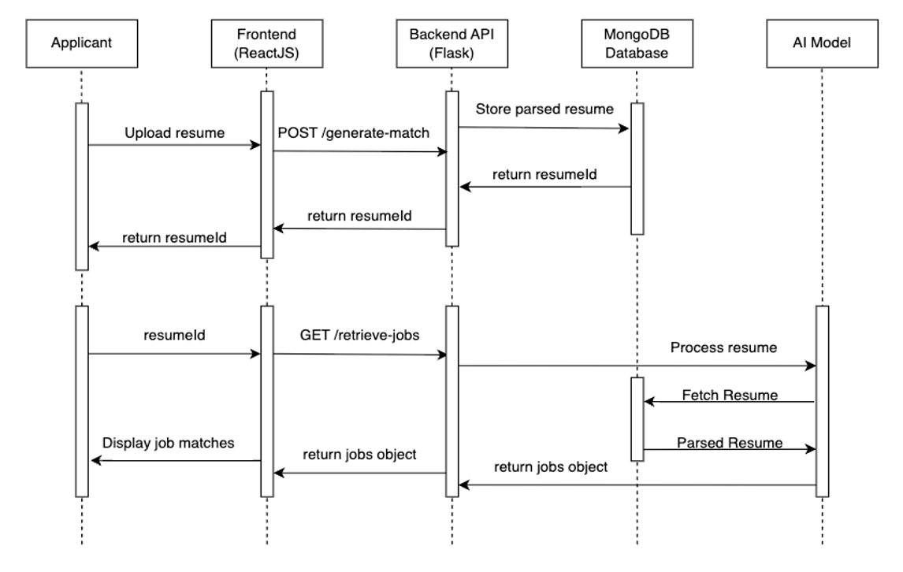
Fig. 3 Sequence diagram displaying the interactions between the user, frontend, backend API, MongoDB database, and AI model during resume processing (POST) and job retrieval (GET). The diagram highlights data exchanges for storing, fetching, and parsing resume content to generate the matched job listings.

- Job Matching
Once a user’s resume has been classified into a specific job category, ResuMind uses this prediction to filter a set of relevant job postings. The jobs are pulled from a curated database and aligned with the predicted category. The goal is to provide roles specific to the user's skills and experience, even if the words on their resume differ from the job listing. The matching logic takes both the assigned category and specific entities from the resume into consideration. For example, a resume that contains words like “data visualization” or “SQL” would likely trigger matches in roles like being a data analyst. This approach is more personalized and provides better recommendations compared to platforms that solely rely on job titles or filters.

- User Interface and Interaction
Once the job matches are generated, they are displayed through an interactive, web-based interface designed for clarity and ease of use. The frontend was built using React.js and styled with JavaScript. User interactions such as swiping through cards are managed by client side logic, while the server side interactions are handled by Node.js, which connects the frontend and backend API endpoints. The user interface is structured across three main pages:
- Home page: The home page is designed to welcome users to ResuMind by offering an overview of what the platform does, and allows users to upload their resumes.
- Job Search page: This page presents matched jobs in a swipe-based format, with cards displaying high-level information such as company name, job title, and brief descriptions. Similar to a dating app interface, users can swipe right to save a job or swipe left to pass on a job.
- Matched Jobs page: When a user swipes right on a job, it automatically saves and is displayed in the “Matched Jobs” page. This page also includes a search bar for filtering results by the job titles.
This three-page structure was designed to simplify the job search process and align with our brand strategy for maintaining a modern and intuitive interface. Samples of the actual interface are shown in Figs. 4-7, including the Home Page (Fig. 4), the Job Search Page (Fig. 5), the Job Search Page with swipe functionality (Fig. 6), and the Matched Jobs page (Fig. 7).
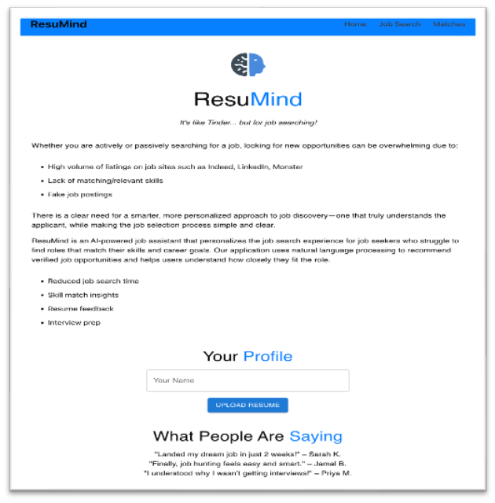
Fig. 4 Home Page

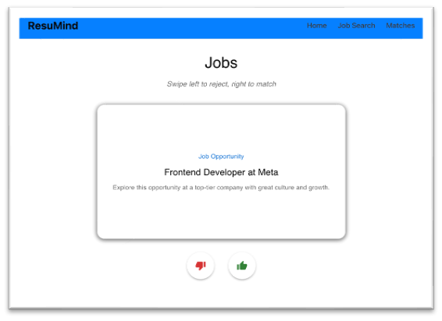
Fig. 5 Job Search Page

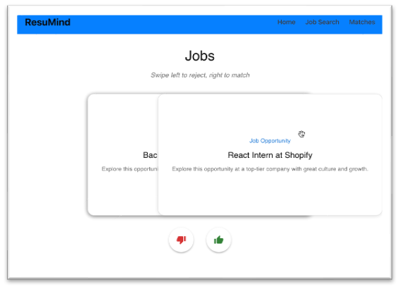
Fig. 6 Job Search Page showcasing swipe functionality

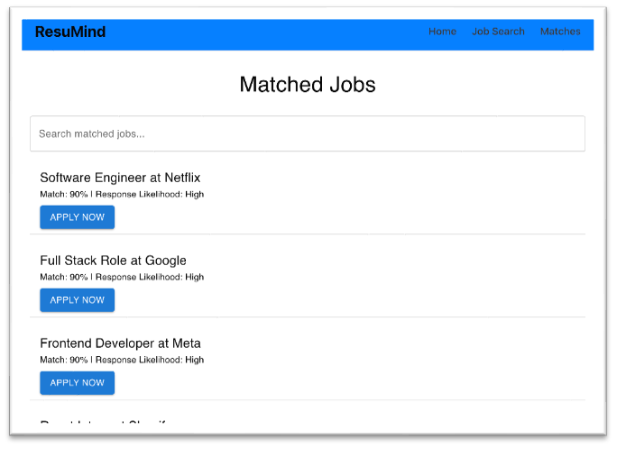
Fig. 7 Matched Jobs Page

- Summary of Technologies
The ResuMind platform was built using a full-stack architecture that combines machine learning libraries, a cloud-based deployment pipeline, and interactive web technologies. Below, Table I provides a summary of the tools and frameworks used across our study.

Table I. ResuMind Technology Stack

Component | Technologies Used
Frontend | React.js, JavaScript, Node.js
Backend | Python, Flask, MongoDB
Natural Language Processing | spaCy (Named Entity Recognition)
Machine Learning Framework | HuggingFace Transformers, PyTorch
Model Deployment | Amazon SageMaker
Data Preprocessing | Scikit-learn, RESTful APIs, JSON format

Table I. Technology stack used in the development of ResuMind which includes the frontend tools, backend services, NLP libraries, and the machine learning infrastructure.

IV. Results

- Overview
To ensure that ResuMind works as intended from reading resumes to matching jobs, we tested the functionality in various ways. Our main objective was to confirm that the system could handle different resumes, make accurate recommendations, and display them in an engaging way.

- Functional Outcomes
- Resume Parsing
ResuMind is able to read and process resumes in different file formats such as PDF and Word. By utilizing spaCy’s NER tool, it could pull out important details such as skills, previous job titles, and education.
- User Classification
Our RoBERTa-based model was able to group users into specific job categories that suited their background. For example, a resume with strong software developer experience would be classified in Engineering.

- Job Matching
The suggested jobs were relevant to both the user’s category and the skills listed on their resumes. If a resume mentioned “SQL”, it would likely result in data analyst job recommendations. Since the system scans for skills and context instead of just job titles, more personalized recommendations were found.
- User Interface Performance
The swipe-based job search page worked seamlessly and let users decide whether to save or skip a job. The three main pages - Home, Job Search, and Matched Jobs loaded quickly and the search bar on the Matched Jobs page made it easy to find specific saved jobs.

- Observations
- Resumes with clear formatting and a detailed skill section gives the most accurate results.
- The job classification model worked best when job titles and skill descriptions were specific.
- The swipe interface felt fast and was an intuitive feature that made the job search process more exciting.

V. conclusions, implications, and future work

- Conclusion
This study introduced ResuMind, an AI-powered platform designed to help job seekers discover relevant opportunities by analyzing the content of their resumes and generating personalized job matches. It integrates natural language processing, machine learning, and a modern swipe-based interface to make the job search process feel faster and more intuitive.
Testing the functional MVP proved that ResuMind can successfully parse resumes in multiple formats, classify users into matching job categories, and provide recommendations that align with their skills and experience. These results highlight the platform’s potential to enhance the job search experience for users by offering more relevant and personalized job suggestions compared to traditional keyword-based systems.

- Implications
The results have important implications for both job seekers and recruiters. For job seekers, the platform streamlines the search process by providing targeted matches rather than general listings which saves applicants time in job hunting. On the other hand, for recruiters, similar technology such as this or HrFlow.ai could be used to identify qualified candidates to potentially improve hiring efficiency.

- Recommendations for Future Work
While ResuMind has strong overall functionality, there are some areas that could use improvement. These include integrating live job feeds from platforms like LinkedIn, adding more features to the platform such as location, salary range, and type of employment. For the model it would also be good to incorporate a feature so that factors such as years of experience or preferred industries could make the recommendations more personalized.

- Summary and Projections
With technological advancements, ResuMind demonstrates well-combined AI-driven resume analysis with a modern interactive interface to create a more efficient and engaging job search experience. With continued development, it could become a valuable tool for both job seekers and employers.

Acknowledgment
We would like to thank Professor Henry Wong and Pace University for providing the resources, guidance, and opportunity to develop the ResuMind study.

references

[1] HrFlow.ai, “HrFlow API Documentation,” [Online]. Available: https://hrflow.ai/api. Accessed: Aug. 11, 2025.

[2] D. Jurafsky and J. H. Martin, Speech and Language Processing: An Introduction to Natural Language Processing, Computational Linguistics, and Speech Recognition, 3rd ed. Draft, 2023.

[3] Y. Liu, M. Ott, N. Goyal, J. Du, M. Joshi, D. Chen, O. Levy, M. Lewis, L. Zettlemoyer, and V. Stoyanov, “RoBERTa: A Robustly Optimized BERT Pretraining Approach,” arXiv preprint arXiv:1907.11692, Jul. 2019. [Online]. Available: https://arxiv.org/abs/1907.11692.

[4] R. Zhang, S. Jain, M. Malhotra, J. Xu, and Y. Wang, “Designing LinkedIn’s job recommender system,” in Proc. 14th ACM Conf. Recommender Systems (RecSys), 2020, pp. 400–409.

[5] Explosion AI, “spaCy: Industrial-Strength Natural Language Processing in Python,” [Online]. Available: https://spacy.io/. Accessed: Aug. 11, 2025.

