Adaptive Arena: Adaptive Difficulty Fighting Game
Anthony Piombino, Inna Ivashchenko, Shariah Allen, Johnny Brayman, Gabrielle Schwan
Seidenberg School of Computer Science and Information Systems
Pace University, New York, NY, USA

Abstract— The increasing complexity and diversity of player skill levels in video games have created a growing demand for adaptive AI systems that can provide engaging and challenging gameplay experiences. Adaptive Arena is a web-based fighting game developed by QuestKeepers that utilizes multiple AI strategies to provide dynamic difficulty levels tailored to individual players. The system incorporates rule-based AI for easy and medium difficulties and reinforcement learning for hard difficulty, enabling responsive and intelligent opponent behavior. The game also features a user-friendly interface, health-tracking HUDs, and smooth camera systems to enhance player engagement and immersion. By integrating adaptive AI and carefully designed gameplay mechanics, Adaptive Arena aims to maintain player motivation, reduce frustration, and improve skill progression. This paper presents the design, methodology, and implementation of Adaptive Arena, exploring the underlying AI frameworks, game architecture, and user interaction features.

Keywords— Adaptive AI, Unity, ML-Agents, Reinforcement Learning, State Machine, Decision Tree, Fighting Game, Difficulty Scaling, Player Engagement, Procedural Content Generation, Dynamic Difficulty Adjustment
- Introduction
Video games, particularly competitive fighting games, require precise control, quick reaction times, and strategic decision-making. However, players vary significantly in skill level, and a fixed-difficulty AI often leads to frustration for novice players or boredom for experts. Adaptive Arena is designed to address this problem by offering a web-based platform where players can select from three difficulty levels: Easy, Medium, and Hard. Each level represents a distinct AI behavior paradigm. The easy level primarily relies on random or suboptimal decision-making, the medium level incorporates basic strategic choices with some randomness, and the hard level employs reinforcement learning techniques to simulate intelligent, adaptive combat. Unlike traditional fighting games with fixed AI behaviors, Adaptive Arena combines rule-based and reinforcement learning agents to create scalable difficulty and responsive combat strategies
The game interface provides a seamless experience from the main menu to combat sequences, displaying vital in-game information such as health bars, combat animations, and match outcomes. The camera system ensures both fighters remain visible throughout the match, enhancing player situational awareness. Additionally, the game supports multiple control schemes, including keyboard/mouse and gamepad input, allowing players to use their preferred method of interaction. Adaptive Arena emphasizes not only skill-based competition but also the psychological factors that contribute to player engagement, such as challenge, skill progression, and satisfaction from overcoming dynamic opponents.
- BACKGROUND AND AI TECHNIQUES
- State Machines and Decision Trees
State Machines and Decision Trees are widely used in game AI to model behavior and decision-making [4][5]. A State Machine represents AI behavior as a set of states and transitions [1]. Each state defines a particular action or behavior, such as attacking, defending, or idling, and transitions occur based on conditions or triggers, such as player proximity or health levels [1]. For example, in Adaptive Arena, the Easy AI might have states like “Idle,” “Move Toward Player,” “Attack,” and “Block,” with transitions determined by random timers or basic proximity checks. State Machines provide a clear and modular way to encode predictable AI behavior while maintaining flexibility.
Decision Trees, on the other hand, allow the AI to evaluate conditions in a hierarchical structure to select actions. Nodes in the tree represent conditional checks, such as “Is the player within attack range?” or “Is my health below 50%?” Leaf nodes indicate the corresponding action, such as “Jump Attack” or “Defend” [1][5]. Decision Trees are particularly effective for rule-based AI in the Medium difficulty, allowing for more nuanced responses than purely random behavior. Combined, State Machines and Decision Trees enable AI that is responsive, predictable, and scalable across different difficulty levels while keeping computation efficient for real-time gameplay.
- Reinforcement Learning and ML-Agents
For the Hard difficulty, Adaptive Arena employs Reinforcement Learning (RL) using Unity ML-Agents [2][6][9]. RL allows the AI agent to learn optimal strategies by interacting with the game environment through training episodes [7]. Each episode represents a single match where the AI receives observations of the game state, such as player position, health, and available actions. Actions are selected according to a learned policy, and the agent receives rewards or penalties based on outcomes, such as successfully landing an attack, avoiding damage, or winning a match [7].
Exploration versus exploitation is a key aspect of RL. Initially, the agent explores different actions to gather knowledge about effective strategies. Over time, the learned policy favors actions with higher expected rewards, representing exploitation. The training process is iterative, using thousands of episodes to gradually refine the AI’s combat effectiveness [6][10]. Once trained, the neural network is integrated into the Unity game, allowing the Hard AI to respond dynamically to the player’s actions with a high degree of strategic sophistication [2][6].
- Adaptive Difficulty and Game Psychology
Adaptive difficulty is crucial in maintaining player engagement and retention. Games that are too easy lead to boredom, whereas games that are too difficult create frustration. By scaling AI behavior to match player skill levels, Adaptive Arena promotes flow, a psychological state in which players are fully engaged and challenged appropriately. Prior research highlights that adaptive AI improves learning curves, keeps players motivated to continue gameplay, and enhances overall satisfaction [3][8]. Studies in procedural content generation and difficulty scaling demonstrate that adaptive systems not only improve retention but also encourage repeated play sessions, making them a valuable design consideration in modern game development [1][11]. By integrating adaptive AI and carefully designed gameplay mechanics, Adaptive Arena aims to maintain player motivation, reduce frustration, improve skill progression, and enhance player engagement.
- system architecture
The architecture of Adaptive Arena consists of four main components: Frontend/User Interface, Backend/Game Logic, Game Objects/Entities, and Data Storage.
- Frontend/User Interface – The UI consists of a main menu where players select difficulty and settings, a HUD displaying player and AI health bars during combat, and win/lose screens with options to restart or return to the main menu. Player input is captured through keyboard/mouse or gamepad controllers, ensuring flexible gameplay.
- Backend/Game Logic – The backend handles game progression and decision-making. The Game Manager oversees the match, health management, and win/lose conditions. State Machines and Decision Trees drive Easy and Medium AI behaviors, while the Difficulty Manager loads the appropriate AI controller based on the player’s selection. The Combat System processes attacks, blocks, and collisions in real-time.
- Game Objects/Entities – This includes the player character, the AI opponent, and the camera system. The camera dynamically adjusts to keep both fighters visible, zooming or panning smoothly without cutting off important gameplay elements. Invisible walls prevent players from leaving the playable area, while physics-based locomotion and animations ensure a realistic combat experience.
- Data Storage – Unity Engine 6.3 is used for the core development environment, while Git LFS handles large file storage for assets and models. Python and ML-Agents manage neural network training for Hard difficulty AI.
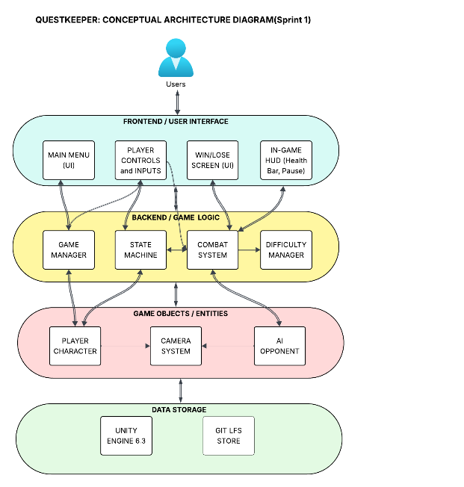
Fig. 1. Architecture Diagram
- methodology
- User Interaction and Controls
Players enter the game via the main menu, selecting a difficulty level before entering combat. Core actions include locomotion, attack, and block, with optional advanced mechanics like combos, countering, and throwing for future updates. Health bars for both players are displayed and updated in real-time, providing immediate feedback on damage received. Match conclusion occurs when one player’s health reaches zero, triggering win or lose screens with navigation options to replay or return to the main menu. Preliminary playtests with users of varying skill levels indicated that the AI appropriately scales difficulty, sustaining engagement without excessive frustration.
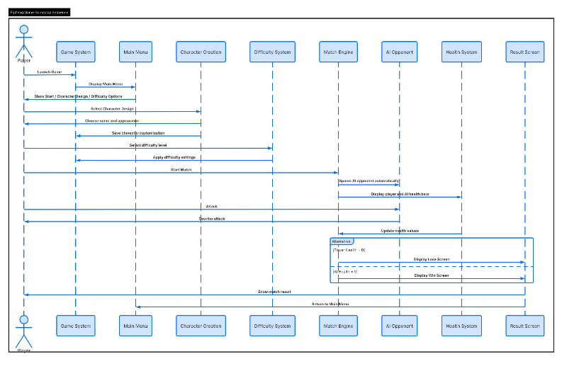
Fig. 2. Sequence Diagram
Below figures shows the functionality mentioned:

Fig. 1. Launch image
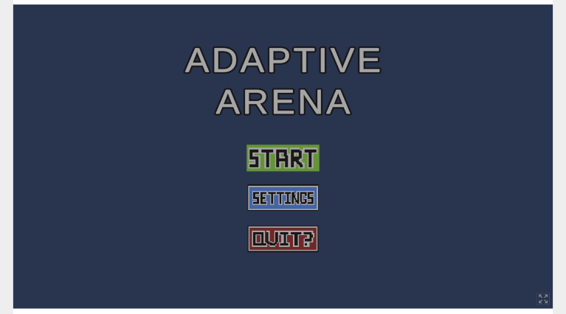
Fig. 2. Initial menu
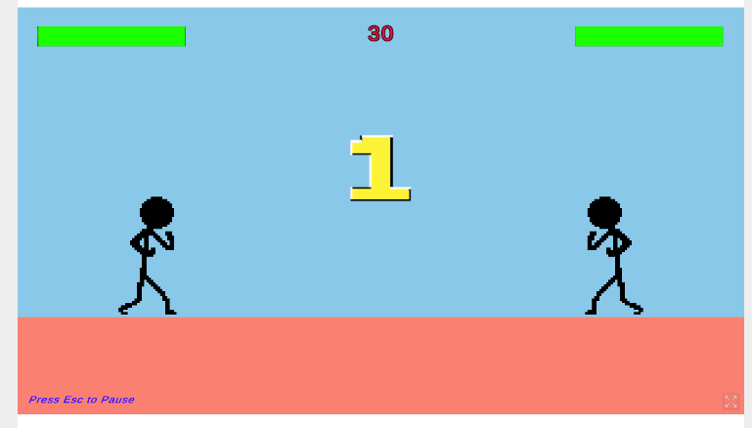
Fig. 3. Countdown begins after start is selected

Fig. 4. Damage is recorded in health bar in real time
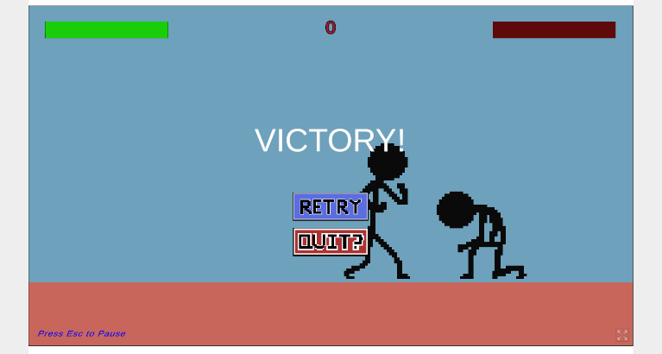
Fig. 5. Victory screen

- AI Controllers
- Easy AI uses a simple randomized State Machine, reacting slowly and selecting actions like attack, block, or move with random timers.
- Medium AI combines Decision Trees and State Machines for moderately strategic responses, making it faster and less predictable than Easy AI.
- Hard AI is trained using ML-Agents. Neural networks learn optimal strategies through repeated training episodes, with rewards for effective attacks and penalties for mistakes. The trained model is integrated into the game, providing adaptive, intelligent combat behavior.
- RESULTS
Adaptive Arena demonstrates the value of adaptive AI in fighting games, integrating multiple AI paradigms to create a dynamic and engaging experience. The combination of State Machines, Decision Trees, and Reinforcement Learning allows the game to accommodate a broad spectrum of player abilities, maintaining challenge and motivation.
Future work includes extending the AI’s action repertoire with advanced combos and counterattacks, adding multiplayer functionality, and refining the neural network with larger datasets to improve Hard AI performance. Additional research will explore personalized difficulty scaling, where AI adapts in real-time to the player’s performance, further optimizing engagement and retention. Finally, integrating analytics to track player behavior could inform dynamic adjustments, providing a fully responsive and immersive fighting game experience.
References
- Almeida, P., Carvalho, V., & Simões, A., "Reinforcement Learning Applied to AI Bots in First-Person Shooters: A Systematic Review," Algorithms, MDPI, 2023, 16(7):323, https://www.mdpi.com/1999-4893/16/7/323/html, accessed April 2026.
- Cook, M., Smith, G., & Colton, S., "Procedural Content Generation in Games: A Survey," IEEE Transactions on Computational Intelligence and AI in Games, IEEE, 2016, pp. 1‑18.
- Entertainment Computing, "A Framework for Designing Reinforcement Learning Agents with Dynamic Difficulty Adjustment in Single-Player Action Video Games," Elsevier, 2024, https://www.sciencedirect.com/science/article/pii/S187595212400054, accessed April 2026.
- Entertainment Computing, "Leveraging Deep Reinforcement Learning for Dynamic NPC Behavior and Enhanced Player Experience in Unity3D," Elsevier, 2025, https://www.sciencedirect.com/science/article/abs/pii/S1875952125000874, accessed April 2026.
- Juliani, A., Berges, V.P., Teng, E., et al., "Unity ML-Agents Toolkit: Enabling Reinforcement Learning in Games," arXiv Preprint, 2018, pp. 1‑15.
- MDPI Applied Sciences, "Survey of Planning and Learning in Games," MDPI, 2019, 10(13):4529, https://www.mdpi.com/2076-3417/10/13/4529, accessed April 2026.
- Mekni, S., Jayaramireddy, C. S., & Naraharisetti, S. V. V., "Reinforcement Learning Toolkits for Gaming: A Comparative Analysis," Journal of Software Engineering and Applications, Scientific Research Publishing, 2022, 15(12), pp. 563‑585, https://www.scirp.org/journal/doi.aspx?doi=10.4236/jsea.2022.1512024, accessed April 2026.
- Sweetser, P., & Wyeth, P., "GameFlow: A Model for Evaluating Player Enjoyment in Games," Computers in Entertainment, ACM, 2005, pp. 1‑24.
- Togelius, J., Yannakakis, G. N., Stanley, K. O., & Browne, C., "What Is AI in Games?," AI Magazine, AAAI, 2011, pp. 3‑12.
- Wang, Y., Wang, Y., Tian, F., & Ma, J., "Intelligent Games Meeting with Multi-Agent Deep Reinforcement Learning: A Comprehensive Review," Artificial Intelligence Review, Springer, 2025, https://link.springer.com/article/10.1007/s10462-025-11166-1, accessed April 2026.
- Yannakakis, G. N., & Togelius, J., Artificial Intelligence and Games, Springer, 2018.

