Adaptive Arena: Adaptive Difficulty Fighting Game
Anthony Piombino, Inna Ivashchenko, Shariah Allen, Johnny Brayman, Gabrielle Schwan
Seidenberg School of Computer Science and Information Systems
Pace University, New York, NY, USA

Abstract— The increasing complexity and diversity of player skill levels in video games have created a growing demand for adaptive AI systems that can provide engaging and challenging gameplay experiences. Adaptive Arena is a web-based fighting game developed by QuestKeepers that utilizes multiple AI strategies to provide dynamic difficulty levels tailored to individual players. The system incorporates rule-based AI for easy and medium difficulties and reinforcement learning for hard difficulty, enabling responsive and intelligent opponent behavior. The game also features a user-friendly interface, health-tracking HUDs, and smooth camera systems to enhance player engagement and immersion. By integrating adaptive AI and carefully designed gameplay mechanics, Adaptive Arena aims to maintain player motivation, reduce frustration, and improve skill progression. This paper presents the design, methodology, and implementation of Adaptive Arena, exploring the underlying AI frameworks, game architecture, and user interaction features.

Keywords— Adaptive AI, Unity, ML-Agents, Reinforcement Learning, State Machine, Decision Tree, Fighting Game, Difficulty Scaling, Player Engagement, Procedural Content Generation, Dynamic Difficulty Adjustment
- Introduction
Videogames, particularly competitive fighting games, require precise control, quick reaction times, and strategic decision-making. However, players vary significantly in skill level, and a fixed-difficulty AI often leads to frustration for novice players or boredom for experts. Adaptive Arena is designed to address this problem by offering a web-based platform where players can select from three difficulty levels: Easy, Medium, and Hard. Each level represents a distinct AI behavior paradigm. The easy level primarily relies on random or suboptimal decision-making, the medium level incorporates basic strategic choices with some randomness, and the hard level employs reinforcement learning techniques to simulate intelligent, adaptive combat. Unlike traditional fighting games with fixed AI behaviors, Adaptive Arena combines rule-based and reinforcement learning agents to create scalable difficulty and responsive combat strategies [9].
The game interface provides a seamless experience from the main menu to combat sequences, displaying vital in-game information such as health bars, combat animations, and match outcomes. The camera system ensures both fighters remain visible throughout the match, enhancing player situational awareness. Adaptive Arena emphasizes not only skill-based competition but also the psychological factors that contribute to player engagement, such as challenge, skill progression, and satisfaction from overcoming dynamic opponents [16].
- BACKGROUND AND AI TECHNIQUES
- State Machines and Decision Trees
State Machines and Decision Trees are widely used in game AI to model behavior and decision-making [4][5]. A State Machine represents AI behavior as a set of states and transitions [1]. Each state defines a particular action or behavior, such as attacking, defending, or idling, and transitions occur based on conditions or triggers, such as player proximity or health levels [1]. For example, in Adaptive Arena, the Easy AI might have states like “Idle,” “Move Toward Player,” “Attack,” and “Block,” with transitions determined by random timers or basic proximity checks. State Machines provide a clear and modular way to encode predictable AI behavior while maintaining flexibility.
Decision Trees, on the other hand, allow the AI to evaluate conditions in a hierarchical structure to select actions. Nodes in the tree represent conditional checks, such as “Is the player within attack range?” or “Is my health below 50%?” Leaf nodes indicate the corresponding action, such as “Jump Attack” or “Defend” [1][5]. Decision Trees are particularly effective for rule-based AI in the Medium difficulty, allowing for more nuanced responses than purely random behavior. Combined, State Machines and Decision Trees enable AI that is responsive, predictable, and scalable across different difficulty levels while keeping computation efficient for real-time gameplay.
- Reinforcement Learning and ML-Agents
For the Hard difficulty, Adaptive Arena employs Reinforcement Learning (RL) using Unity ML-Agents [2]. RL allows the AI agent to learn optimal strategies by interacting with the game environment through training episodes [7]. Each episode represents a single match where the AI receives observations of the game state, such as player position, health, and available actions. Actions are selected according to a learned policy, and the agent receives rewards or penalties based on outcomes, such as successfully landing an attack, avoiding damage, or winning a match [7].
Exploration versus exploitation is a key aspect of RL. Initially, the agent explores different actions to gather knowledge about effective strategies. Over time, the learned policy favors actions with higher expected rewards, representing exploitation. The training process is iterative, using thousands of episodes to gradually refine the AI’s combat effectiveness [10]. Once trained, the neural network is integrated into the Unity game, allowing the Hard AI to respond dynamically to the player’s actions with a high degree of strategic sophistication [2].
- Adaptive Difficulty and Game Psychology
Adaptive difficulty is crucial in maintaining player engagement and retention. Games that are too easy lead to boredom, whereas games that are too difficult create frustration. By scaling AI behavior to match player skill levels, Adaptive Arena promotes flow, a psychological state in which players are fully engaged and challenged appropriately. Prior research highlights that adaptive AI improves learning curves, keeps players motivated to continue gameplay, and enhances overall satisfaction [3][8]. Studies in procedural content generation and difficulty scaling demonstrate that adaptive systems not only improve retention but also encourage repeated play sessions, making them a valuable design consideration in modern game development [1][11]. By integrating adaptive AI and carefully designed gameplay mechanics, Adaptive Arena aims to maintain player motivation, reduce frustration, improve skill progression, and enhance player engagement.
- system architecture
The architecture of Adaptive Arena consists of four main components: Frontend/User Interface, Backend/Game Logic, Game Objects/Entities, and Data Storage.
- Frontend/User Interface – The UI consists of a main menu where players select difficulty and settings, a HUD displaying player and AI health bars during combat, and win/lose screens with options to restart or return to the main menu. Player input is captured through keyboard/mouse or gamepad controllers, ensuring flexible gameplay.
- Backend/Game Logic – The backend handles game progression and decision-making. The Game Manager oversees the match, health management, and win/lose conditions. State Machines and Decision Trees drive Easy and Medium AI behaviors, while the Difficulty Manager loads the appropriate AI controller based on the player’s selection. The Combat System processes attacks, blocks, and collisions in real-time.
- Game Objects/Entities – This includes the player character, the AI opponent, and the camera system. The camera dynamically adjusts to keep both fighters visible, zooming or panning smoothly without cutting off important gameplay elements. Invisible walls prevent players from leaving the playable area, while physics-based locomotion and animations ensure a realistic combat experience.
- Data Storage – Unity Engine 6.3 is used for the core development environment, while Git LFS handles large file storage for assets and models. Python and ML-Agents manage neural network training for Hard difficulty AI.
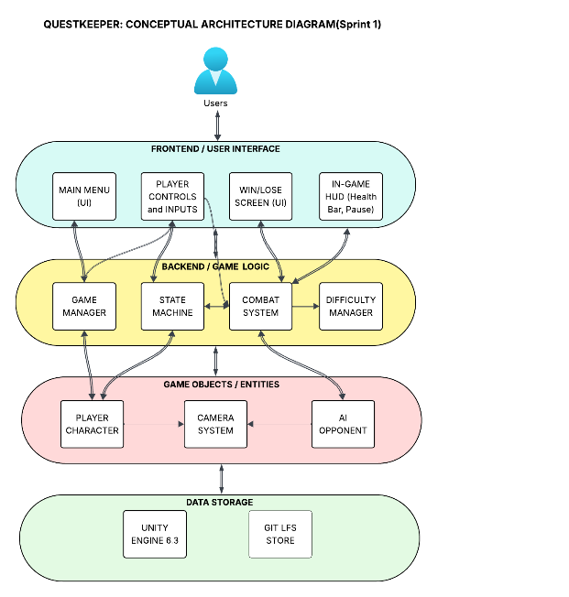
Fig. 1. Architecture Diagram
- methodology
- User Interaction and Controls
Players enter Adaptive Arena through a main menu interface where they select a difficulty level before initiating combat. This design ensures that players can immediately tailor the gameplay experience to their preferred skill level, allowing both beginners and experienced players to engage with appropriately balanced challenges.
Core gameplay actions include locomotion, attacking, and blocking. These foundational mechanics were designed to be simple enough for new players to learn quickly while still providing depth through timing and positioning. Locomotion allows horizontal movement across the arena, enabling players to control spacing and avoid incoming attacks. The attack mechanic is used to initiate offensive actions, while blocking provides a defensive option for mitigating damage and creating opportunities for counterplay.
In addition to these core mechanics, the system was designed with extensibility in mind. Advanced features such as combo systems, counterattacks, and throwable objects were considered for future implementation to further deepen gameplay complexity and skill expression. These mechanics would allow for more advanced strategic play while preserving accessibility for new users.
The user interface plays a critical role in supporting gameplay clarity and responsiveness. Health bars for both the player and AI opponent are displayed prominently on screen and are updated in real time to reflect damage received during combat. This immediate visual feedback allows players to make quick strategic decisions based on match conditions. At the conclusion of each match, a win or loss screen is displayed, providing clear outcome feedback and navigation options to either replay the match or return to the main menu.
Preliminary playtesting with users of varying skill levels indicated that the system successfully supports adaptive engagement. Players reported that the game effectively scaled difficulty in a way that maintained challenge without overwhelming new users. Beginner players benefited from the simplified controls and slower-paced AI behavior, while more experienced players found higher difficulty levels sufficiently challenging to remain engaged [8].
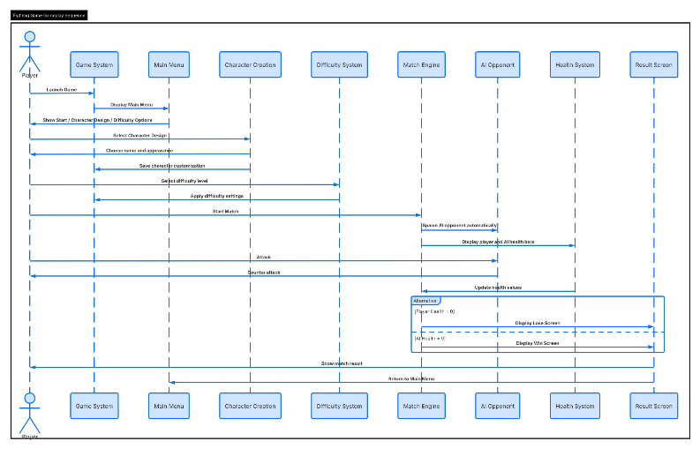
Fig. 2. Sequence Diagram
Below figures shows the functionality mentioned:

Fig. 1. Launch image
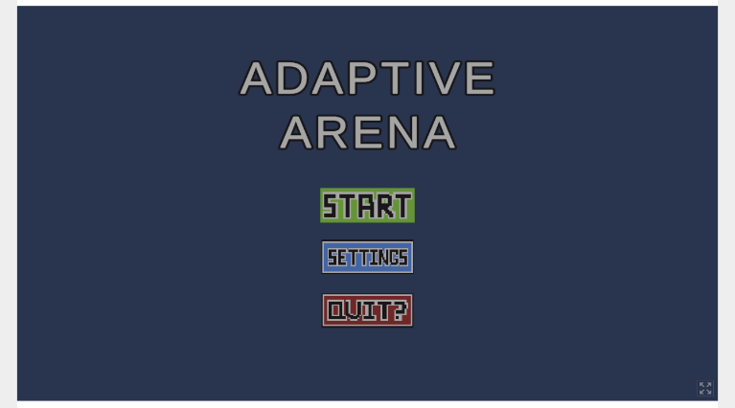
Fig. 2. Initial menu
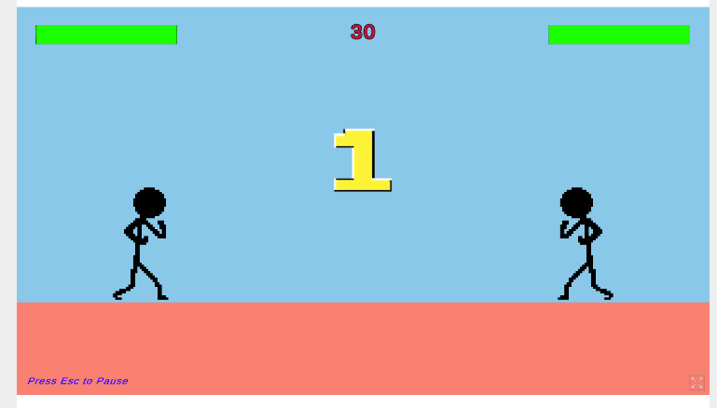
Fig. 3. Countdown begins after start is selected

Fig. 4. Damage is recorded in health bar in real time
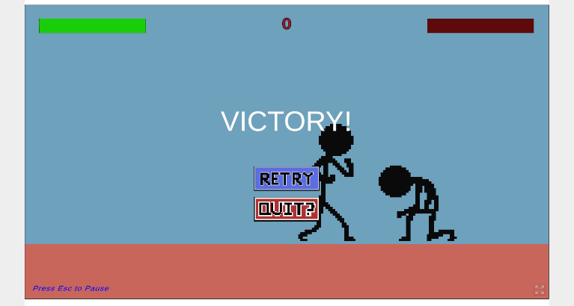
Fig. 5. Victory screen

- AI Controllers
Adaptive Arena introduces three distinct AI difficulty levels designed to accommodate players with varying skill levels and gameplay experience. Each difficulty level utilizes a different approach to artificial intelligence behavior, allowing the game to gradually increase challenge and strategic complexity as players improve.
The Easy difficulty mode is implemented using a rule-based State Machine designed to produce simple and predictable behavior patterns. This AI operates using a limited set of states such as idle, approach, attack, and defend. Transitions between these states are triggered by basic conditions such as player proximity, random timers, or simple cooldown logic.
To ensure accessibility for beginner players, the Easy AI incorporates intentionally delayed reaction times and randomized decision-making. This results in slower responses to player actions and occasional suboptimal behavior, creating a forgiving environment for learning core mechanics. The primary goal of this AI is not to provide competitive challenge, but rather to introduce players to movement, timing, and basic combat interaction in a low-pressure setting.
The Medium difficulty mode builds upon the State Machine architecture by integrating Decision Tree logic to improve decision-making complexity and situational awareness. While still grounded in predefined behavioral states, the AI evaluates additional environmental and combat conditions before selecting actions.
Decision Tree nodes evaluate factors such as player distance, current health percentage, attack cooldown status, and positional advantage. Based on these evaluations, the AI selects more appropriate combat responses such as initiating attacks, blocking incoming damage, or repositioning for better engagement.
This hybrid approach results in a more balanced and competitive opponent. Unlike the Easy AI, the Medium AI reacts more quickly and demonstrates improved tactical behavior, including defensive timing and opportunistic attacks. However, controlled randomness is still incorporated to prevent the AI from becoming overly deterministic, ensuring that gameplay remains engaging and varied.
The Hard difficulty mode utilizes reinforcement learning implemented through Unity ML-Agents to produce an adaptive and data-driven AI opponent [5]. Unlike rule-based systems, this AI learns optimal behavior strategies through repeated interaction with the game environment during training episodes.
Each training episode represents a full match simulation in which the AI agent observes key environmental inputs, including player position, relative distance, health values, and combat state information. Based on these observations, the agent selects from a discrete action space that includes movement, attacking, blocking, and defensive positioning.
A reward system is used to guide learning. Positive rewards are assigned for successful behaviors such as landing attacks, successfully blocking incoming damage, maintaining advantageous positioning, and winning matches. Conversely, penalties are applied for ineffective actions such as taking damage, missing attacks, or remaining idle during critical combat situations. Over time, this reward structure encourages the agent to optimize its behavior toward more effective combat strategies.
The reinforcement learning process relies on a balance between exploration and exploitation. During early training stages, the AI explores a wide range of actions to discover effective strategies. As training progresses, the policy gradually shifts toward exploitation of high-reward behaviors, resulting in more consistent and strategic decision-making.
Once training is complete, the learned neural network model is integrated into the Unity game environment, allowing the Hard AI to operate in real time [5]. This enables the AI to respond dynamically to player actions, producing less predictable and more adaptive combat behavior compared to traditional scripted systems.
- Methodological Integration and System Design Rationale
By implementing three distinct AI paradigms within a unified system, Adaptive Arena demonstrates a structured approach to scalable difficulty design in fighting games. The progression from rule-based State Machines to hybrid Decision Tree systems, and finally to reinforcement learning-based AI reflects a deliberate increase in complexity and adaptability.
This layered architecture ensures that each difficulty level provides a distinct gameplay experience while maintaining consistency in core mechanics. The modular design of the system also supports future expansion, allowing additional AI behaviors or difficulty tiers to be integrated without significant restructuring of the existing framework.
Overall, this methodology enables Adaptive Arena to balance accessibility, challenge, and long-term engagement while showcasing multiple artificial intelligence techniques within a single interactive application.
- RESULTS
Adaptive Arena demonstrates the effectiveness of adaptive artificial intelligence in modern fighting games by integrating multiple AI paradigms into a single scalable gameplay experience. With State Machines, Decision Trees, and Reinforcement Learning, the system successfully accommodates players with varying skill levels while maintaining challenge, engagement, and replayability. Each difficulty level provides a noticeably distinct gameplay experience, allowing players to progress naturally from beginner-friendly encounters to more advanced and adaptive combat scenarios. This layered difficulty structure reinforces a sense of progression, where players can gradually build skill and confidence before facing more complex AI behavior [3].
- Playtesting Observations and Behavioral Differences
Preliminary playtesting showed that players were consistently able to distinguish between the behavioral patterns of the three AI difficulty settings. Across participants with varying levels of gaming experience, clear differences in perceived intelligence, reaction speed, and strategic depth were observed.
The Easy AI was widely regarded as approachable and forgiving due to its delayed reaction time and intentionally simplified decision-making process. A beginner player reported that this difficulty level reduced cognitive overload, allowing them to focus on understanding fundamental mechanics such as movement, blocking, and timing attacks. Because the AI occasionally made suboptimal decisions or paused between actions, players were given sufficient time to experiment with strategies without experiencing significant pressure. This made the Easy difficulty particularly effective as an onboarding tool for new players unfamiliar with fighting game mechanics.
The Medium AI produced a noticeably more balanced and engaging experience. By combining Decision Trees with State Machines, the AI demonstrated improved situational awareness and more consistent combat responses. Play testers observed that the Medium AI adapted more effectively to player positioning and attack patterns, resulting in more dynamic and less predictable matches. The inclusion of structured decision-making logic allowed the AI to execute defensive maneuvers, reposition strategically, and time attacks more effectively than the Easy AI. As a result, players reported that Medium difficulty required greater focus and reaction speed while still remaining fair and achievable.
The Hard AI represented the most advanced gameplay experience due to the integration of reinforcement learning through Unity ML-Agents. Unlike rule-based systems, this AI demonstrated emergent behavior that was not explicitly programmed. During gameplay, the Hard AI responded dynamically to player actions, creating a more adaptive and competitive opponent. Players noted that the AI exhibited aggressive yet strategic behavior, often punishing repeated mistakes and adjusting its actions based on combat flow. This resulted in a more human-like opponent behavior, increasing perceived realism and challenge intensity. Reinforcement learning in game agents has been shown to produce emergent and adaptive behaviors that differ significantly from scripted AI systems [1].
- Impact on Player Engagement and Replayability
The results indicate that adaptive difficulty significantly improves player engagement and replay value. By allowing players to select or progress through difficulty levels that match their skill, Adaptive Arena reduces both frustration and boredom—two common issues in fixed-difficulty game systems. Adaptive difficulty systems have been widely shown to improve player retention by balancing challenge and frustration [3].
Players demonstrated higher willingness to replay matches across Medium and Hard difficulties compared to Easy mode, suggesting that increased challenge correlates with higher engagement once basic mechanics are understood. The variability introduced by AI behavior differences also contributed to replayability, as no two matches felt identical. This aligns with established game design principles that emphasize variability and optimal challenge pacing as key drivers of long-term retention.
Additionally, the presence of reinforcement learning in the Hard AI introduced an element of unpredictability that further increased replay value. Because the AI does not rely solely on scripted behavior, players encountered varied responses even when repeating similar actions, preventing gameplay from becoming repetitive.
- Technical Performance and System Effectiveness
From a technical standpoint, the integration of multiple AI systems within the Unity environment was successful in maintaining stable performance during real-time gameplay. State Machines and Decision Trees provided lightweight and computationally efficient solutions for Easy and Medium AI behaviors, ensuring consistent frame rates and responsive interactions.
In contrast, the reinforcement learning model introduced higher computational complexity during training but remained efficient during inference in gameplay. Once deployed, the trained neural network operated smoothly within the game environment, allowing real-time decision-making without noticeable latency. This separation between training complexity and runtime efficiency proved effective for maintaining both performance and AI sophistication.
The modular architecture of the system also contributed significantly to development efficiency. Each AI system was implemented as a distinct module, enabling independent testing, debugging, and iteration. This design choice reduced integration issues and allowed for future scalability without requiring major structural changes to the core game architecture.
- Limitations Identified
Despite positive results, several limitations were identified during development and testing. Reinforcement learning required extensive tuning of reward and penalty structures to ensure balanced and fair AI behavior. In some training iterations, the Hard AI developed overly aggressive or repetitive strategies that reduced gameplay variety and fairness. These issues highlight the sensitivity of reward shaping in reinforcement learning systems. Reward design sensitivity and instability are well-known challenges in reinforcement learning applications [1].
Additionally, the current version of Adaptive Arena is limited by a relatively small set of combat mechanics. The restricted move set limits the complexity of both player strategies and AI decision-making. As a result, the depth of possible interactions between players and AI opponents is constrained.
Another limitation relates to the scale of playtesting. While initial feedback was positive, the sample size of testers was limited, which may affect the generalizability of the observed results. Larger-scale testing would provide more reliable insights into long-term engagement and difficulty balancing.
- Summary of Findings
Overall, the results demonstrate that combining multiple AI paradigms within a single system is an effective approach for creating scalable difficulty in fighting games. The progression from rule-based behavior to decision-tree logic and finally to reinforcement learning provides a clear and meaningful increase in AI sophistication.
This multi-layered approach successfully enhances player experience by supporting gradual skill development, maintaining engagement, and increasing replayability. The findings suggest that adaptive AI systems can play a significant role in improving both accessibility for new players and challenge for experienced users in competitive game environments.
- CHALLENGES AND LIMITATIONS
During the development of Adaptive Arena, several technical, design, and machine learning challenges were encountered. These challenges were instrumental in shaping the final system and provided important insights into the practical constraints of implementing adaptive artificial intelligence in real-time game environments.
- Reinforcement Learning Stability and Reward Design
One of the primary challenges involved designing and tuning the reinforcement learning system used for the Hard AI. Reinforcement learning models are highly sensitive to reward structures, and small adjustments in reward or penalty values often resulted in significantly different AI behaviors. Reinforcement learning systems are highly sensitive to reward shaping, often requiring extensive tuning to achieve stable learning behavior [1].
During early training iterations, the AI exhibited unintended behaviors such as excessive aggression, repetitive attack loops, or avoidance of engagement altogether. In some cases, the agent learned to prioritize survival over winning, resulting in overly defensive strategies that reduced gameplay excitement. These issues required extensive experimentation with reward shaping to ensure that the AI learned balanced combat behavior that aligned with intended gameplay design. Reward shaping and instability are widely recognized challenges in reinforcement learning systems [1].
Additionally, stabilizing training across thousands of episodes presented computational and time-related constraints. Training sessions required significant processing time, and achieving consistent convergence of the learning model required multiple iterations of parameter tuning and retraining. Reinforcement learning in game environments often requires large numbers of training episodes and significant computational resources to achieve stable convergence [7].
- Behavioral Balance Between Difficulty Levels
Another key challenge was ensuring clear but fair differentiation between the three AI difficulty levels. While each AI system was designed using a different architectural approach, balancing their relative difficulty required careful iteration.
In early builds, the gap between Medium and Hard difficulty was inconsistent, with some players reporting that Medium AI occasionally felt too similar to Easy AI, while others found Hard AI to be disproportionately difficult depending on its trained behavior state. This inconsistency highlighted the difficulty of aligning rule-based systems with a learned reinforcement learning model within a unified difficulty progression. Balancing AI difficulty across heterogeneous systems remains a common issue in adaptive game AI design [3].
To address this, adjustments were made to reaction timing, decision thresholds, and combat aggressiveness across all AI systems. However, maintaining a consistent difficulty curve remains an ongoing design challenge, particularly when integrating machine learning systems whose behavior evolves during training.
- Limited Action Space and Combat Complexity
The current version of Adaptive Arena is constrained by a relatively limited set of player and AI actions. The combat system primarily includes basic movement, attacking, and blocking mechanics, which restricts the complexity of possible strategies.
This limitation impacts both gameplay depth and AI expressiveness. For rule-based AI systems, the limited action space reduces the variety of decision branches in State Machines and Decision Trees. For the reinforcement learning model, it constrains the range of strategies the AI can discover during training, potentially limiting long-term behavioral diversity.
Expanding the action space with mechanics such as combo systems, directional attacks, grappling, and environmental interactions would significantly increase both player engagement and AI learning complexity.
- Real-Time Performance Constraints
Although the system performed well during testing, real-time performance considerations influenced several design decisions. Unity-based environments require careful optimization to maintain consistent frame rates during physics calculations, animation updates, and AI decision processing.
While State Machines and Decision Trees are computationally efficient, integrating reinforcement learning inference in real time required ensuring that neural network evaluation did not introduce noticeable latency. Although the trained model operates efficiently during gameplay, balancing performance with AI complexity remains an important constraint, particularly when scaling to more advanced AI models or additional game features.
- Playtesting Scope and Data Limitations

Another limitation of the project was the relatively small scale of playtesting. While initial feedback provided valuable insights into player experience and difficulty perception, the sample size was limited and may not fully represent a broader player population.
Additionally, most playtesting sessions were conducted in controlled environments rather than long-term gameplay scenarios. As a result, the data collected primarily reflects short-term engagement rather than extended player retention or progression behavior. Robust evaluation of game AI systems typically requires larger-scale and longer-duration player studies [8].
Future evaluations with larger and more diverse player groups would provide stronger statistical validity and deeper insights into long-term adaptive AI performance.
- Generalization of Reinforcement Learning Behavior
A final challenge relates to the generalization capability of the reinforcement learning model. While the Hard AI performed well against common player behaviors observed during training, its adaptability to entirely new or unexpected strategies remains uncertain.
Reinforcement learning models can sometimes overfit to the distribution of behaviors seen during training, leading to reduced effectiveness when encountering novel gameplay patterns. This limitation highlights the importance of expanding training diversity and incorporating broader simulation scenarios to improve robustness. Generalization limitations in reinforcement learning agents are a well-documented issue in game AI research [1].
- Summary of Challenges
Overall, the development of Adaptive Arena highlighted the complexity of integrating multiple AI paradigms within a unified real-time game system. Challenges related to reinforcement learning stability, difficulty balancing, limited action space, performance constraints, and evaluation scope all influenced system design decisions.
Despite these limitations, the project successfully demonstrates the feasibility of combining rule-based AI and machine learning techniques to create scalable and engaging adaptive gameplay systems. These challenges also provide clear directions for future improvements and research expansion.
References
- Almeida, P., Carvalho, V., & Simões, A., "Reinforcement Learning Applied to AI Bots in First-Person Shooters: A Systematic Review," Algorithms, MDPI, 2023, 16(7):323, https://www.mdpi.com/1999-4893/16/7/323/html, accessed April 2026.
- Cook, M., Smith, G., & Colton, S., "Procedural Content Generation in Games: A Survey," IEEE Transactions on Computational Intelligence and AI in Games, IEEE, 2016, pp. 1‑18.
- Entertainment Computing, "A Framework for Designing Reinforcement Learning Agents with Dynamic Difficulty Adjustment in Single-Player Action Video Games," Elsevier, 2024, https://www.sciencedirect.com/science/article/pii/S187595212400054, accessed April 2026.
- Entertainment Computing, "Leveraging Deep Reinforcement Learning for Dynamic NPC Behavior and Enhanced Player Experience in Unity3D," Elsevier, 2025, https://www.sciencedirect.com/science/article/abs/pii/S1875952125000874, accessed April 2026.
- Juliani, A., Berges, V.P., Teng, E., et al., "Unity ML-Agents Toolkit: Enabling Reinforcement Learning in Games," arXiv Preprint, 2018, pp. 1‑15.
- MDPI Applied Sciences, "Survey of Planning and Learning in Games," MDPI, 2019, 10(13):4529, https://www.mdpi.com/2076-3417/10/13/4529, accessed April 2026.
- Mekni, S., Jayaramireddy, C. S., & Naraharisetti, S. V. V., "Reinforcement Learning Toolkits for Gaming: A Comparative Analysis," Journal of Software Engineering and Applications, Scientific Research Publishing, 2022, 15(12), pp. 563‑585, https://www.scirp.org/journal/doi.aspx?doi=10.4236/jsea.2022.1512024, accessed April 2026.
- Sweetser, P., & Wyeth, P., "GameFlow: A Model for Evaluating Player Enjoyment in Games," Computers in Entertainment, ACM, 2005, pp. 1‑24.
- Togelius, J., Yannakakis, G. N., Stanley, K. O., & Browne, C., "What Is AI in Games?," AI Magazine, AAAI, 2011, pp. 3‑12.
- Wang, Y., Wang, Y., Tian, F., & Ma, J., "Intelligent Games Meeting with Multi-Agent Deep Reinforcement Learning: A Comprehensive Review," Artificial Intelligence Review, Springer, 2025, https://link.springer.com/article/10.1007/s10462-025-11166-1, accessed April 2026.
- Yannakakis, G. N., & Togelius, J., Artificial Intelligence and Games, Springer, 2018.

