Adaptive Arena

User Manual
May 2026
Team QuestKeepers



Table of Contents

Introduction…………………………………………………………………………….…….3
Launching the Game……………………………………………………………………….3
Main Menu Navigation……………………………………………………………………3
Settings Menu……………………………………………………………………………..….4
Difficulty Selection………………………………………………………………………….5
Gameplay Controls………………………………………………………………………….6
Pause Menu…………………………………………………………………………………….7
Victory and Defeat Screens…………………………………………………..………….8
Credits…………………………………………………………………………………...……….9
Contact Information………………………………………………………………..……….10

Introduction
Welcome to the Adaptive Arena User Manual. Adaptive Arena is a retro-inspired 2D fighting game created in Unity. Players battle AI-controlled opponents across multiple difficulty levels using movement, combat, defensive mechanics, and advanced mobility options.
This manual provides instructions on how to launch the game, navigate menus, configure settings, and play Adaptive Arena successfully.

Launching the Game
When the game launches, the player will first see the game page with a Run Game button.
1. Click the Run Game button to launch Adaptive Arena.
2. To improve the gameplay experience, click the Full Screen button located in the bottom-right corner of the screen.
3. Once the game launches, the Main Menu will appear.


Main Menu Navigation
The Main Menu provides access to the core game features.
Start:
Selecting Start opens the difficulty selection menu.
Settings:
Selecting Settings allows the player to configure audio settings.
Credits:
Selecting Credits displays the developers and contributors of Adaptive Arena.
Quit:
Selecting Quit closes the game application completely.
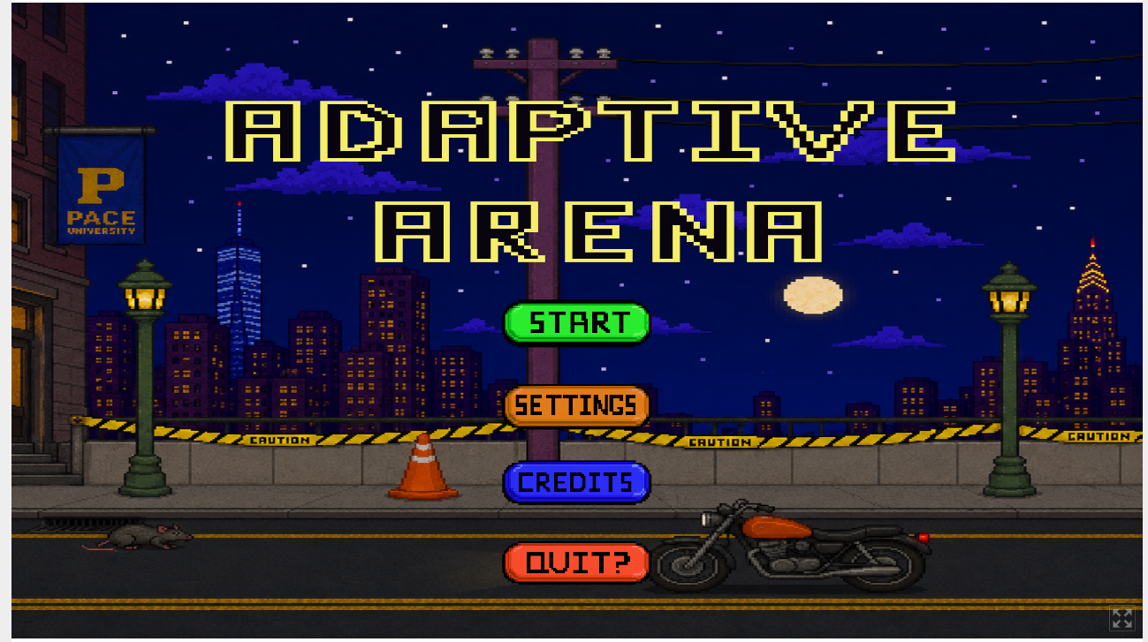

Settings Menu
The Settings menu allows players to customize the sound of the game.
Both the combat and music are controlled by the volume bar.
Press the X button on the right tower to leave Settings.
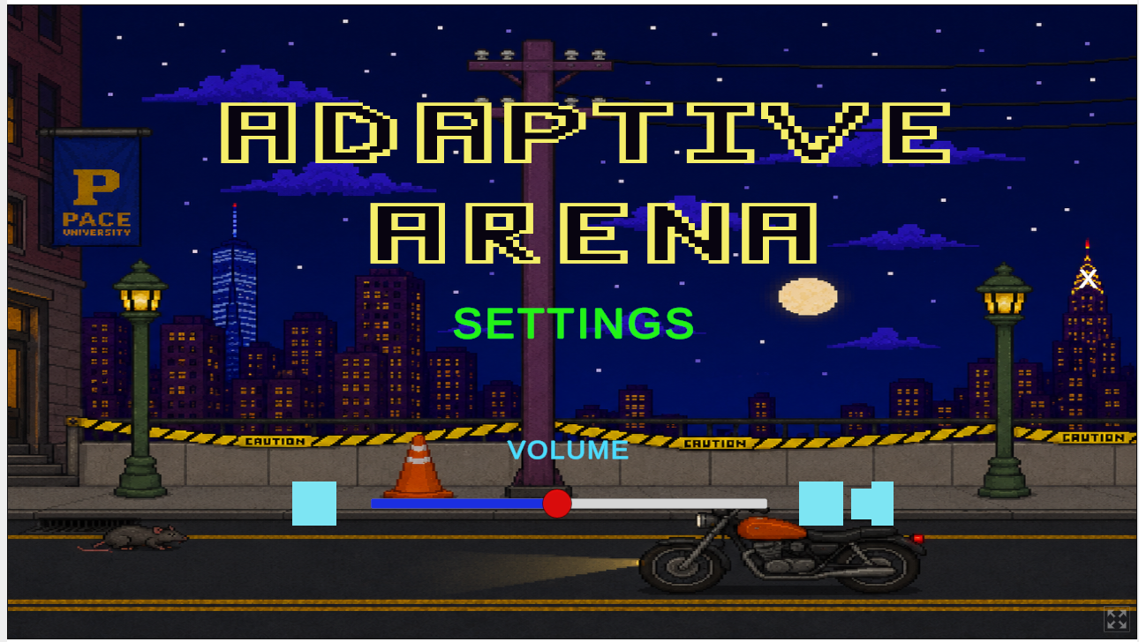

Difficulty Selection
Selecting Start from the Main Menu opens the difficulty selection screen.
Easy:
Recommended for beginner players.
Medium:
Provides a balanced combat experience.
Hard:
Provides a challenging AI opponent with advanced reactions.
Back:
Returns the player to the Main Menu.
After selecting a difficulty, the game begins a countdown from 3 before the match starts.
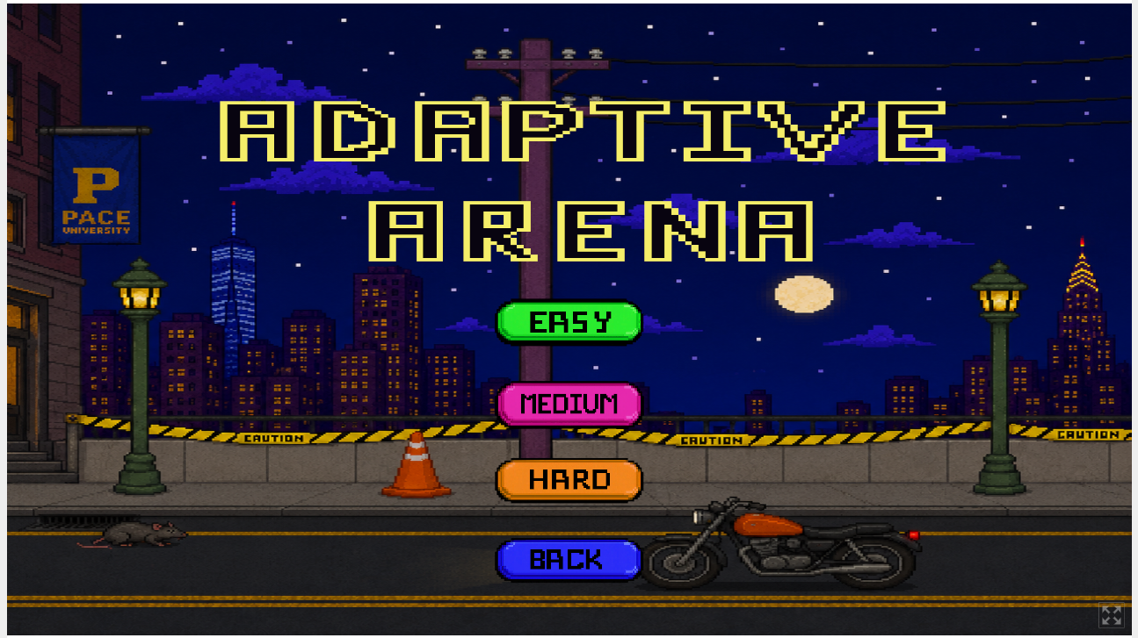

Gameplay Controls
Movement:
Left Arrow Key moves the player left. You can also use the A button.
Right Arrow Key moves the player right. You can also use the D button.
Combat:
Left Mouse Button performs a punch attack.
Right Mouse Button performs a kick attack.

Defense:
Shift Button activates block.
S button ducks the player.
Jumping:
Press the Space Bar to jump.
Press the Space Bar a second time while airborne to perform a double jump.
Gameplay Objective:
Defeat the AI opponent before your health reaches zero.
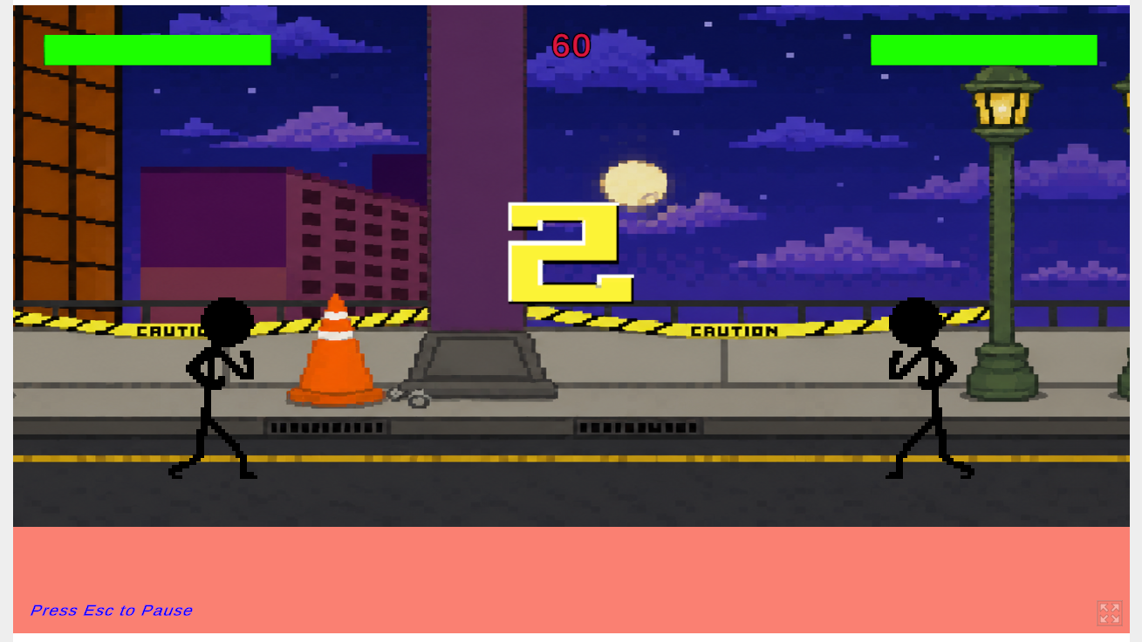

Pause Menu
During gameplay, pressing the Escape key pauses the game.
Retry:
Restarts the current match using the same selected difficulty.
Quit:
Returns the player to the Main Menu.
Resume:
Pressing Escape again resumes gameplay.
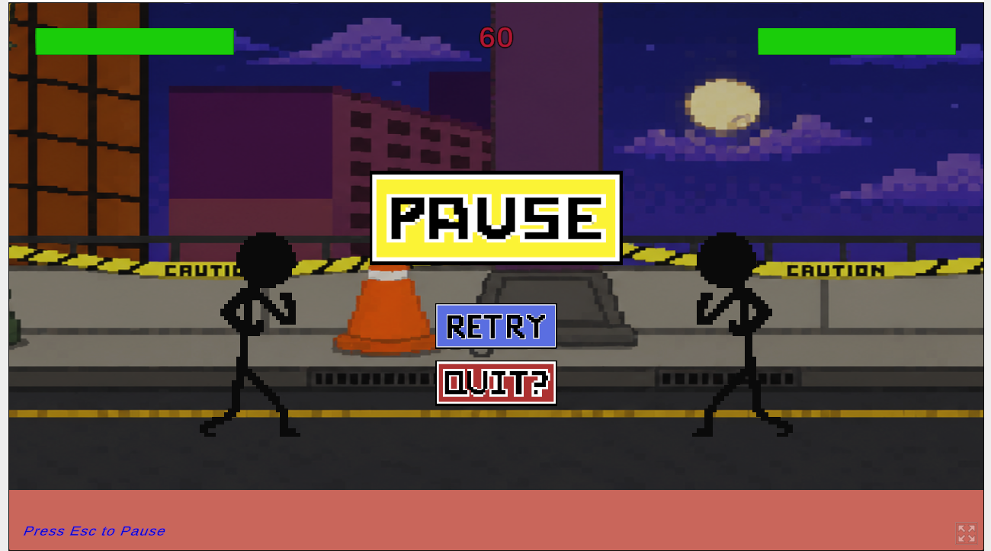

Victory and Defeat Screens
At the end of a match, either a Victory or Lose screen appears depending on the outcome.
Victory:
Appears when the player defeats the AI opponent.
Lose:
Appears when the player is defeated.
Retry:
Restarts the match at the same difficulty.
Quit:
Returns the player to the Main Menu to select another difficulty.
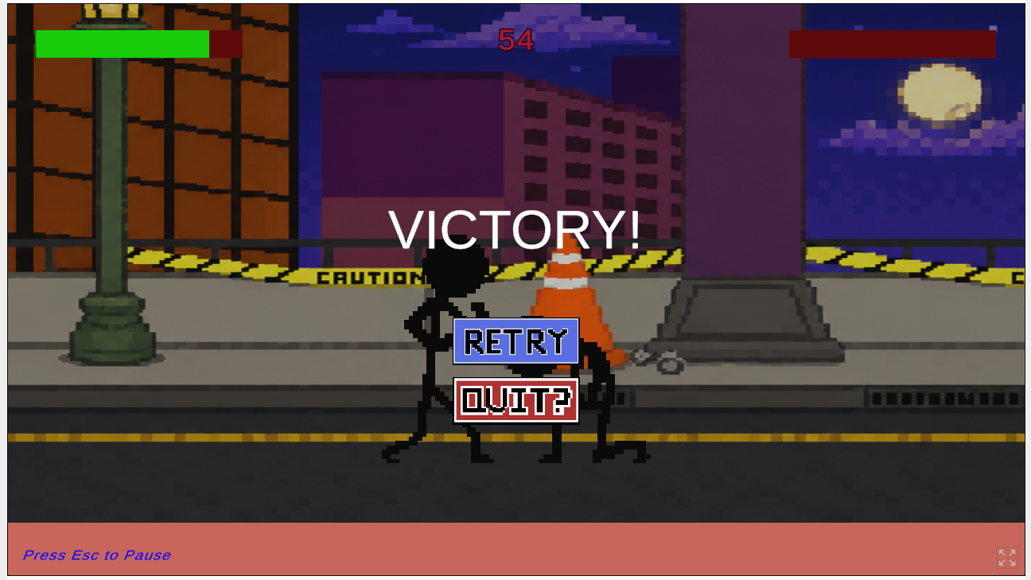

Credits
The Credits page lists the developers and contributors responsible for creating Adaptive Arena.
To access the Credits page:
1. Open the Main Menu.
2. Select Credits.
3. View the developer information displayed on screen.
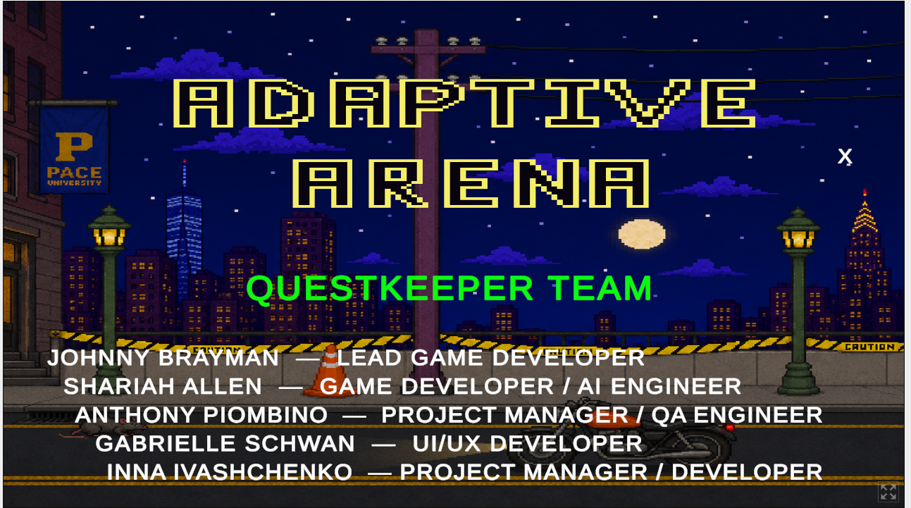

Contact Information
Thank you for playing Adaptive Arena.
For questions, bug reports, or feedback, please contact the Adaptive Arena development team.
Email: questkeeperteam@gmail.com
Game link: https://jhbrayman.itch.io/adaptive-arena

