Adaptive Arena Deployment Manual

May 2026
Team QuestKeepers

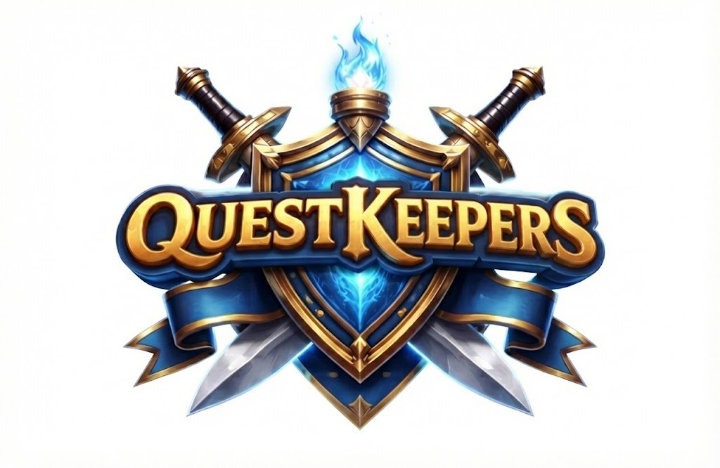

Table of Contents

Introduction………………………………………………………….3
System Requirements…………………………………………....3
Installation Procedures………………………………………….4
Cloning the GitHub Repository…………………………….…4
Setting Up Unity…………………………………………………....4
Installing Git LFS…………………………………………………..4
Launching the Game Project………………………………….5
Building and Running Adaptive Arena…………….……..5
Testing the Game………………………………………….….…..5
Contact Information………………………………………..……5

Introduction
Welcome to the Adaptive Arena Deployment Manual. Adaptive Arena is a 2D fighting game developed entirely in Unity. The project features AI-controlled opponents with multiple difficulty levels, retro-inspired pixel art visuals, combat mechanics, and controller support.
This manual explains how to deploy, configure, and run the Adaptive Arena project in a development environment. The guide is intended for developers, instructors, testers, and technical users who need to set up the game locally using Unity and GitHub.

System Requirements
Hardware Requirements
Processor:
Minimum: Intel Core i5 or AMD Ryzen 5
Recommended: Intel Core i7 or AMD Ryzen 7
Memory:
Minimum: 8 GB RAM
Recommended: 16 GB RAM
Graphics:
Minimum: Integrated Graphics
Recommended: NVIDIA GTX 1660 or higher
Storage:
Minimum: 10 GB free space
Recommended: 20 GB free space
Software Requirements
Operating System:
Windows 10/11
macOS 12+
Ubuntu 20.04+
Required Software:
Unity Hub
Unity Editor 2022+
Git
Git LFS
GitHub Desktop (optional)
Supported Browsers for GitHub:
Google Chrome
Mozilla Firefox
Microsoft Edge

Installation Procedures
1. Download Unity Hub from the official Unity website.
2. Install Unity Hub by following the installer instructions.
3. Open Unity Hub and install Unity Editor version 2022 or later.
4. Ensure that the Windows Build Support module is installed during setup.

Cloning the GitHub Repository
1. Open Git Bash or a terminal window.
2. Navigate to the folder where the project will be stored.
3. Use the following command:
git clone <repository-url>
4. Navigate into the repository folder after cloning completes.

Setting Up Unity
1. Open Unity Hub.
2. Select Open Project.
3. Navigate to the cloned Adaptive Arena folder.
4. Allow Unity to import all project files and packages.
5. Wait for the editor to finish compiling scripts and assets.

Installing Git LFS
Adaptive Arena uses Git Large File Storage (Git LFS) to manage large Unity assets.
1. Download Git LFS from the official Git website.
2. Install Git LFS on your system.
3. Open a terminal and run:
git lfs install
4. Pull all LFS files using:
git lfs pull

Launching the Game Project
1. Open the project inside Unity.
2. Navigate to the MainMenu scene in the Assets/Scenes folder.
3. Double-click the scene to load it.
4. Press the Play button at the top of the Unity editor to launch the game.

Building and Running Adaptive Arena
1. In Unity, open File > Build Settings.
2. Select the target platform.
3. Click Add Open Scenes to include the active scene.
4. Press Build and choose an output directory.
5. Launch the generated executable to run the game outside the editor.

Testing the Game
Manual testing should include the following systems:
- Main menu navigation
- Character movement and combat
- AI difficulty selection
- Blocking, grabbing, and kicking
- Sound effects and music
- Controller support
- Camera tracking behavior
- Settings menu and volume controls

Contact Information
For questions, bug reports, or additional support regarding Adaptive Arena, please contact the development team.
Email: questkeeperteam@gmail.com
GitHub Repository: https://github.com/htmw/2026SA-QuestKeeper/tree/main

