NutriAI

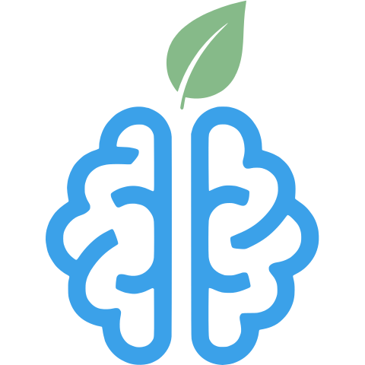

Deployment Manual

Table of Contents
Table of Contents 2
Running NutriAI Locally 3
Prerequisites 3
Building and Starting Server 4
Starting the AI Recommender Server 4
Starting the NutriAI Application 4
Running on Vercel 5
Fork NutriAI 5
Setting up AI Recommender 5
Setting up NutriAI Project 5

Running NutriAI Locally

Prerequisites
- Node.js
  - Open a web browser and navigate to https://nodejs.org/en/download
  - Either follow the on-screen commands or download the prebuilt binary and follow the on-screen instructions
  - Once installed, open terminal/command prompt and verify it is installed by running the command
    - node -v
      - Should print the version of Node.js. If not ensure that you properly installed Node.js
- npm
  - This comes preinstalled with Node.js. To verify npm is installed run the command
    - npm -v
      - Should print the version of npm. If not ensure that you properly installed Node.js
- MongoDB
  - You can either setup your database with MongoDB Atlas, which is a cloud based Mongo Database managed by MongoDB, or you can install the MongoDB Community Server locally on your machine by following the instructions here:
https://www.mongodb.com/try/download/community
- Python
  - Navigate to https://www.python.org/downloads/ and download the latest version of Python and follow the instructions in the installer
  - Once installed, open terminal/command prompt and verify that it is installed by running the command
    - python3 --version # Use this for unix systems
    - py --version # Use this for windows
- OpenAPI
  - You will need to setup an OpenAI account at https://www.openai.com and login to the API platform
  - Create a project, add funds and obtain your API key.

Building and Starting Server

Starting the AI Recommender Server
- Clone the repository using:
  - git clone https://github.com/htmw/2026SA-TechDocs.git
- First start the AI recommender server
- Navigate to python-api folder
- Run the command python -m venv .venv to create a virtual environment
  - For mac/Unix: python3 -m venv .venv
- Once the environment has been created run the command .venv\Scripts\activate to enter the virtual environment
  - For mac/Unix: source .venv\bin\activate
- Run pip install -r requirements.txt to install the Python dependencies
- Run uvicorn main:app to start the Python Server
- The AI Recommender Server will now be running on port 8000
  - The port can be changed using the --port option
    - uvicorn main:app --port <PORT>

Starting the NutriAI Application
- Now navigate back to the root folder of the project
- Navigate to the code directory
- Make a copy of the env.example file and remove the copy to .env
- Enter your MongoDB URI into the MONGODB_URL field
  - Make sure the URL includes the database name
- Enter the url of AI Recommender Server into the AI_RECOMMENDER_URL field
  - Since the server is running locally, it will be http://127.0.0.1:8000
    - Note: if you changed the port in the previous step, please change 8000 with the custom port
- Enter your OpenAI API Key into the OPENAI_API_KEY field
- Run npm install to install of the dependencies
- Run npm run build to build the project
- Run npm run start to start the server
- The server should now be running on port 3000
  - Note: to change the port, modify the start command in package.json
  - Modify this line
    - "start": "next start" -> "start": "next start -p <PORT>",
  - Change port to whatever you need

Running on Vercel

Fork NutriAI
- Login/Create a Github Account
- Navigate to https://github.com/htmw/2026SA-TechDocs.git
- Fork the Github Repo

Setting up AI Recommender
- Login/Create a Vercel account
- Start a new Vercel Project
- On the New Project screen, connect your Github account where you forked the NutriAI repository
- Once your Github account is connected, make sure Vercel has permission to view the repository.
- Once everything is connected and Vercel can see the repository, click Import next to the repository.
- You will now be presented with a page to setup the project
  - Change the Application Preset to FastAPI
  - Change the Root Directory to python-api
- Once complete, click Deploy
- Once the deployment has finished you will be brought to a Congratulations page where it will show you a preview of the AI Recommender service.
  - If the preview shows a json with a message that says
NutriAI FastAPI Recommender is running.
You are good to go, if not please try setting up again.

Setting up NutriAI Project
- Navigate to vercel.com and create an account
- Click Add New -> Project
- On the New Project screen, connect your Github account where you forked the NutriAI repository
- Once connected select the forked repository and click Import
- You will now be presented with a page to setup the project
  - Change the Application Preset to Next.js
  - Change the Root Directory to code
  - Add the Environment Variables
    - MONGODB_URL - this is the url of the MongoDB, this must include the database name
    - APP_NAME - this should be the name of the app, NutriAI
    - AI_RECOMMENDER_URL - the url of the AI Recommender that was setup in the previous step
    - OPENAI_API_KEY - this can be obtained from your OpenAI account.
- Once complete, click Deploy
- Once the deployment has finished you will be brought to a Congratulations page where it will show you a preview of NutriAI
  - If the preview shows the frontpage of NutriAI then NutriAI has been successfully deployed otherwise try the setup again.

