NutriAI



User Manual

Table of Contents
Table of Contents 2
Getting Started 4
Creating an Account 4
Logging In 6
Navigation 8
Sidebar 8
Dashboard 10
Meal Journal 11
Daily Log 13
Goals 15
Chat 16
Settings 17
Profile 18
Guide 19
General 19
Navigating Home 19
Navigating to Dashboard 19
Logging Out 19
Daily Log 19
Checking In 19
Checking In For a Missed Day 20
Logging a Hunger Event 21
Logging a Craving Event 22
Adding Suggested Hunger Event Recipe to Meal Log 23
Adding Suggested Craving Event Recipe to Meal Log 24
Deleting Hunger Event 25
Deleting Craving Event 26
Meal Journal 27
Adding Meal to Food Log 27
Removing Meal From Meal Logs 28
Chat 29
Asking NutriAI a Question 29
Managing/Viewing Past Conversations 30
Adding Chat Rules 30
Deleting Chat Rules 30
Profile 31
Updating Profile Information 31
Goals 32
Setting a Goal 32
Settings 32
Enable/Disable Daily Check-In Reminder 32

Getting Started

Creating an Account
- Click Sign Up in the top right corner of the screen.
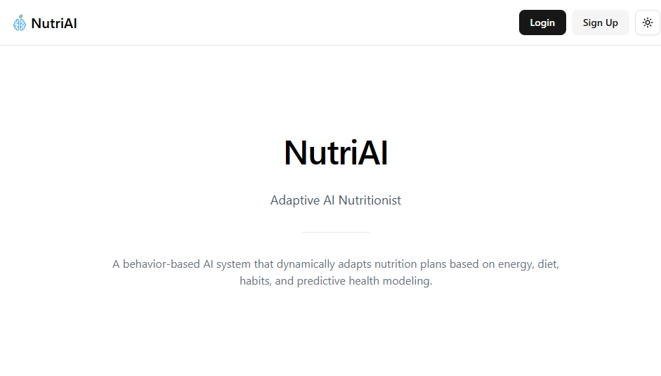
- Enter your name, email, and password, then click Sign Up.
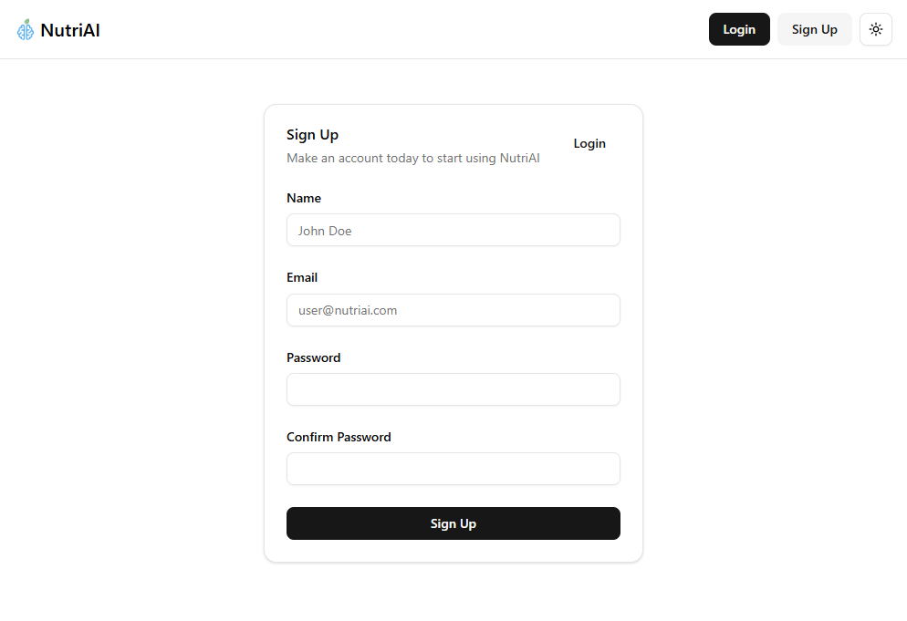
- Complete the setup form by filling out your basic information and following the setup prompts.
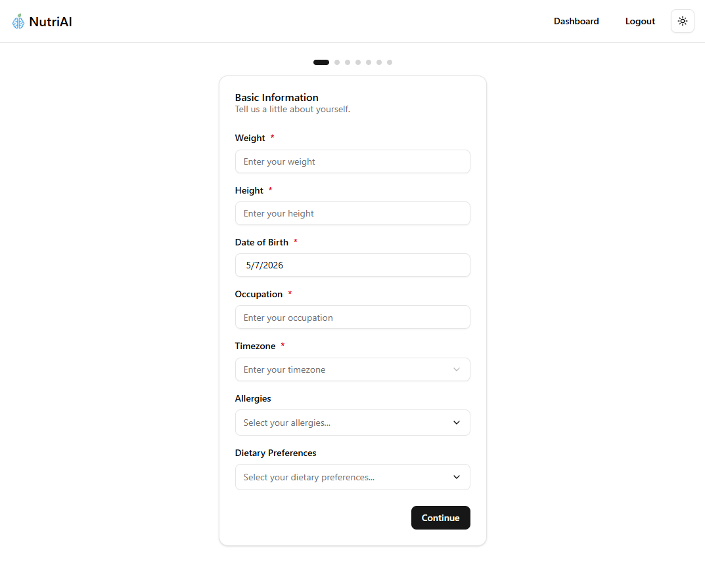
- Review your information, the click Finish Setup to complete account creation.
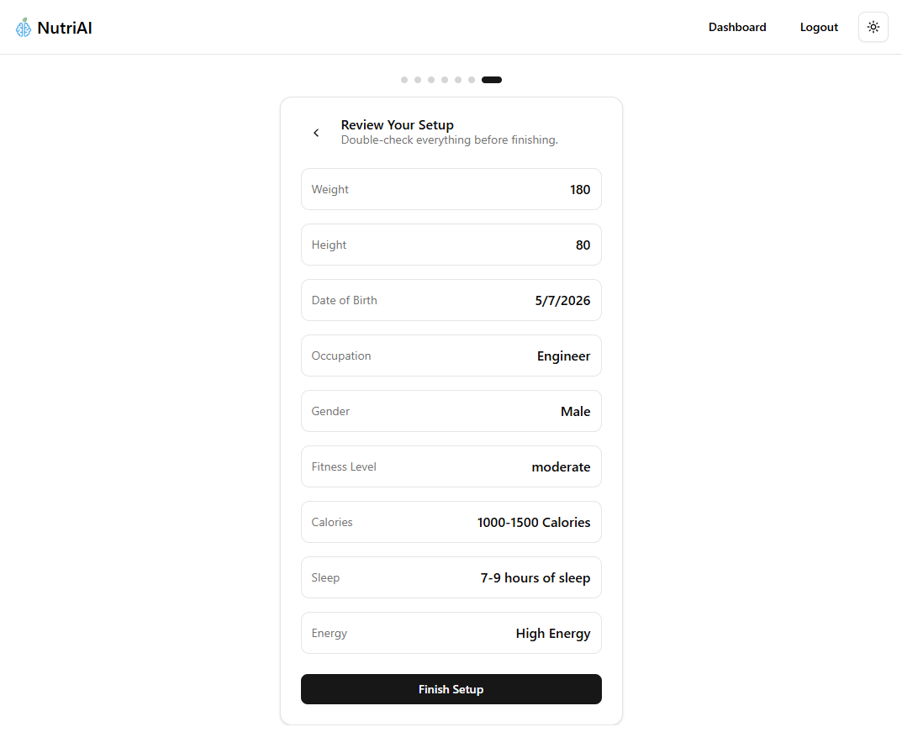

Logging In
- Click Login in the top left corner of the screen.

- Login with your Email and Password, then click login. If you do not already have an account, click Sign Up to create one.
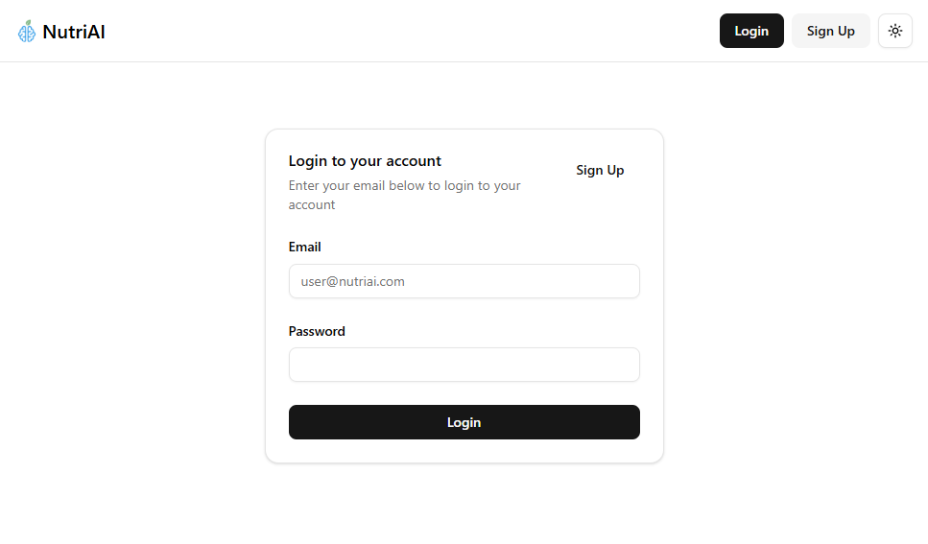
- Once logged in, you will be redirected to the dashboard.

Navigation

Sidebar

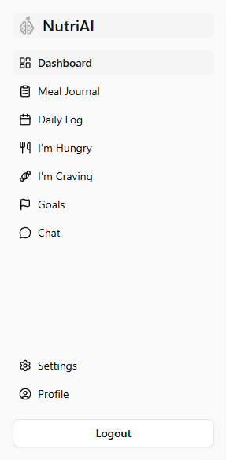
The Navigation Sidebar provides quick access to all major sections of the NutriAI application. The sidebar is displayed throughout the application and allows you to easily navigate between pages and wellness tools.

- Dashboard - The Dashboard provides an overview of your recent activity, health trends, and nutrition progress.
- Meal Journal - The Meal Journal allows you to search for foods and recipes, log meals, and track your daily nutritional intake.
- Daily Log - The Daily Log provides a detailed overview of your daily activity, including check-ins, hunger events, craving events, nutrition summaries, and meal history.
- I’m Hungry - The I’m Hungry page allows you to log hunger events and receive food or meal recommendations based on your nutrition goals and current intake.
- I’m Craving - The I’m Craving page allows you to log cravings and receive personalized meal or food recommendations that align with your wellness goals.
- Goals - The Goals page allows you to configure and manage your wellness and nutrition objectives.
- Chat - The Chat page allows you to interact directly with NutriAI through a chat-like interface.
- Settings - The Settings page allows you to manage your notification settings.
- Profile - The Profile page allows you to manage your personal health information, lifestyle details, and wellness profile settings.
- Logout - The Logout button securely signs you out NutriAI

Dashboard
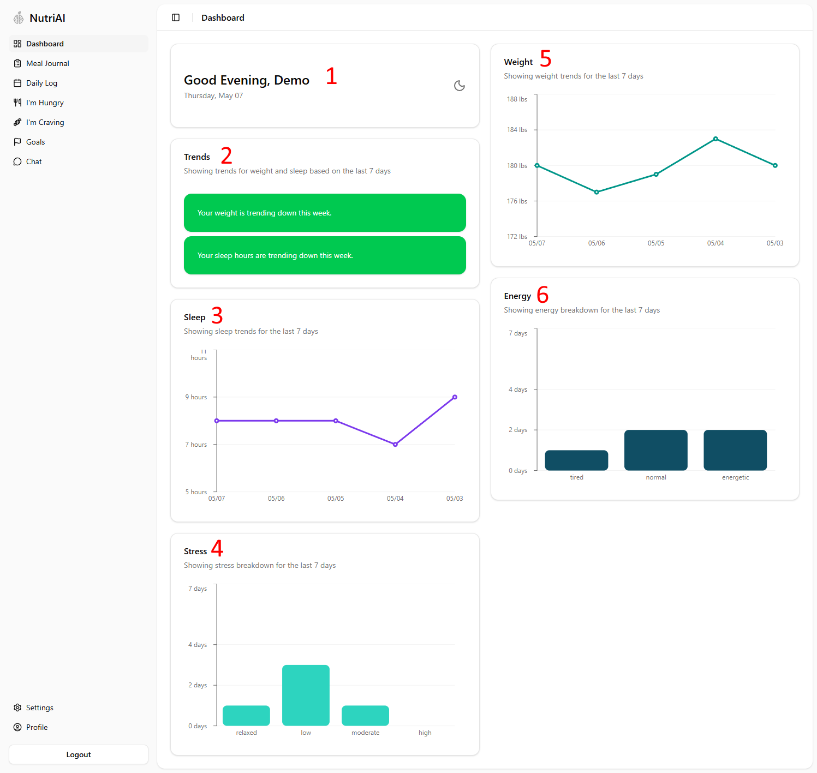
The Dashboard provides a centralized overview of your recent wellness activity and health trends within NutriAI. This page is designed to help you quickly monitor your progress, review wellness patterns, and identify changes in your daily habits over time.

- Greeting Card - The Greeting Card displays a simple greeting based on the time of day along with the current date
- Trends Card - The Trends Card provides a quick summary of your recent wellness trends based on your logged data from the past 7 days
- Sleep Graph - The Sleep Graph shows your recorded sleep hours over the last 7 days
- Stress Graph - The Stress graph displays a breakdown of your recorded stress levels over the last 7 days.
- Weight Graph - The Weight graph displays your recorded weight trends over the last 7 days.
- Energy Graph - The Energy graph displays a breakdown of your recorded energy levels over the last 7 days.

Meal Journal
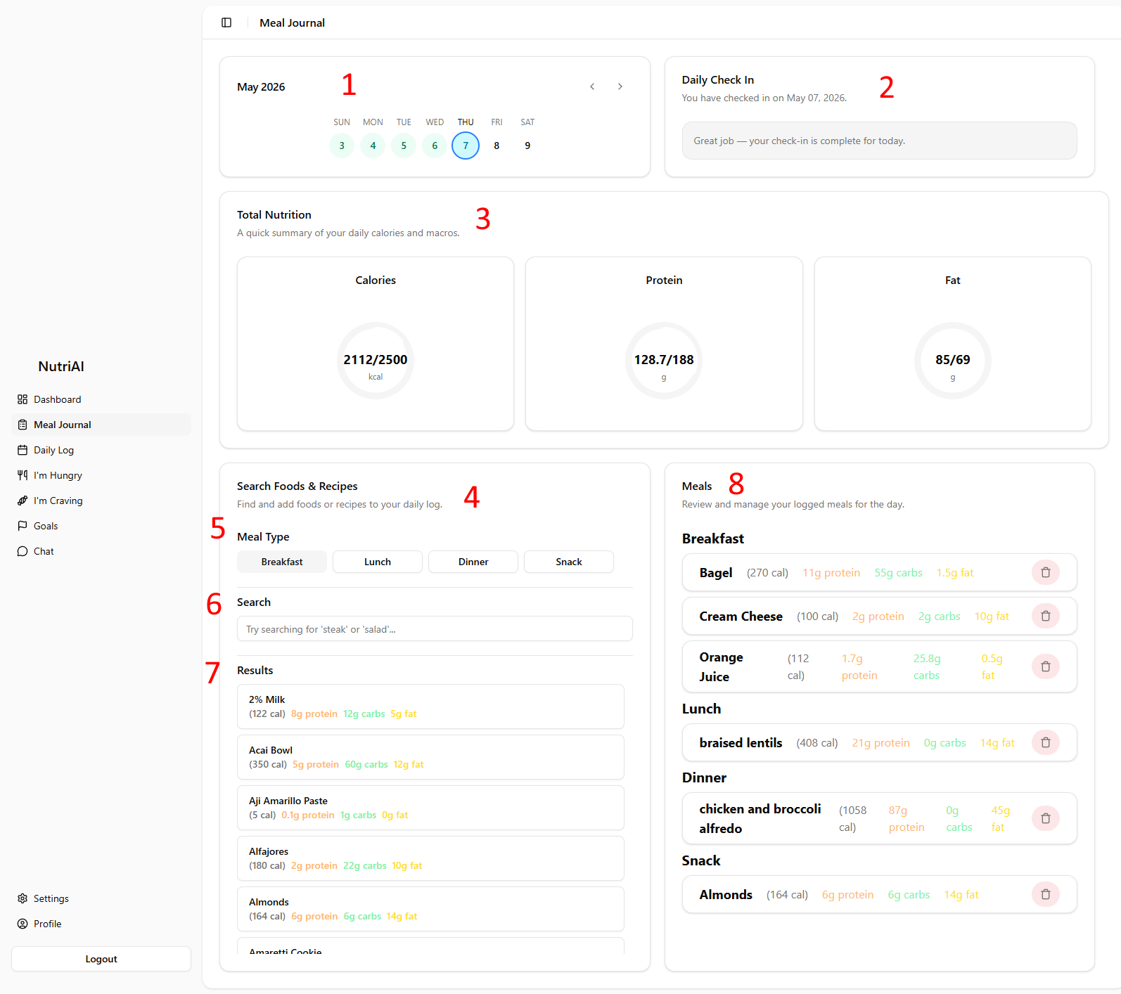
The Meal Journal page allows you to track your daily food intake, manage meals, and monitor nutritional progress throughout the day.

- Day Selector - The Day Selector allows you to navigate between different dates and manage nutrition logs for a specific day, You can switch between days to review previous entries or log meals for the current date.
- Check-In Card -The Daily Check In card displays your check in status for the selected date. Daily check-ins are required before any meal logging can begin and are used to record important health information such as, morning weight, sleep, energy, and stress.
- Total Nutrition Card - The Total Nutrition Card provides a summary of your nutritional intake for the selected day. This section displays progress toward daily nutrition goals, such as calories, protein, and fat
- Food & Recipe Lookup Card - The Food & Recipe Lookup card allows you to search for food and recipes to add to their meal log.
- Meal Type Selector - The Meal Type Selector determines which category the selected food or recipe will be added to.
- Search Bar - The Search Bar allows you to search for foods or recipes by name.
- Search Results - The Search Results section displays foods and recipes that match your search query
- Meal Log - The Meal Log displays all foods and recipes logged for the selected day. Entries are grouped by meal category, allowing you to review your daily meals.

Daily Log
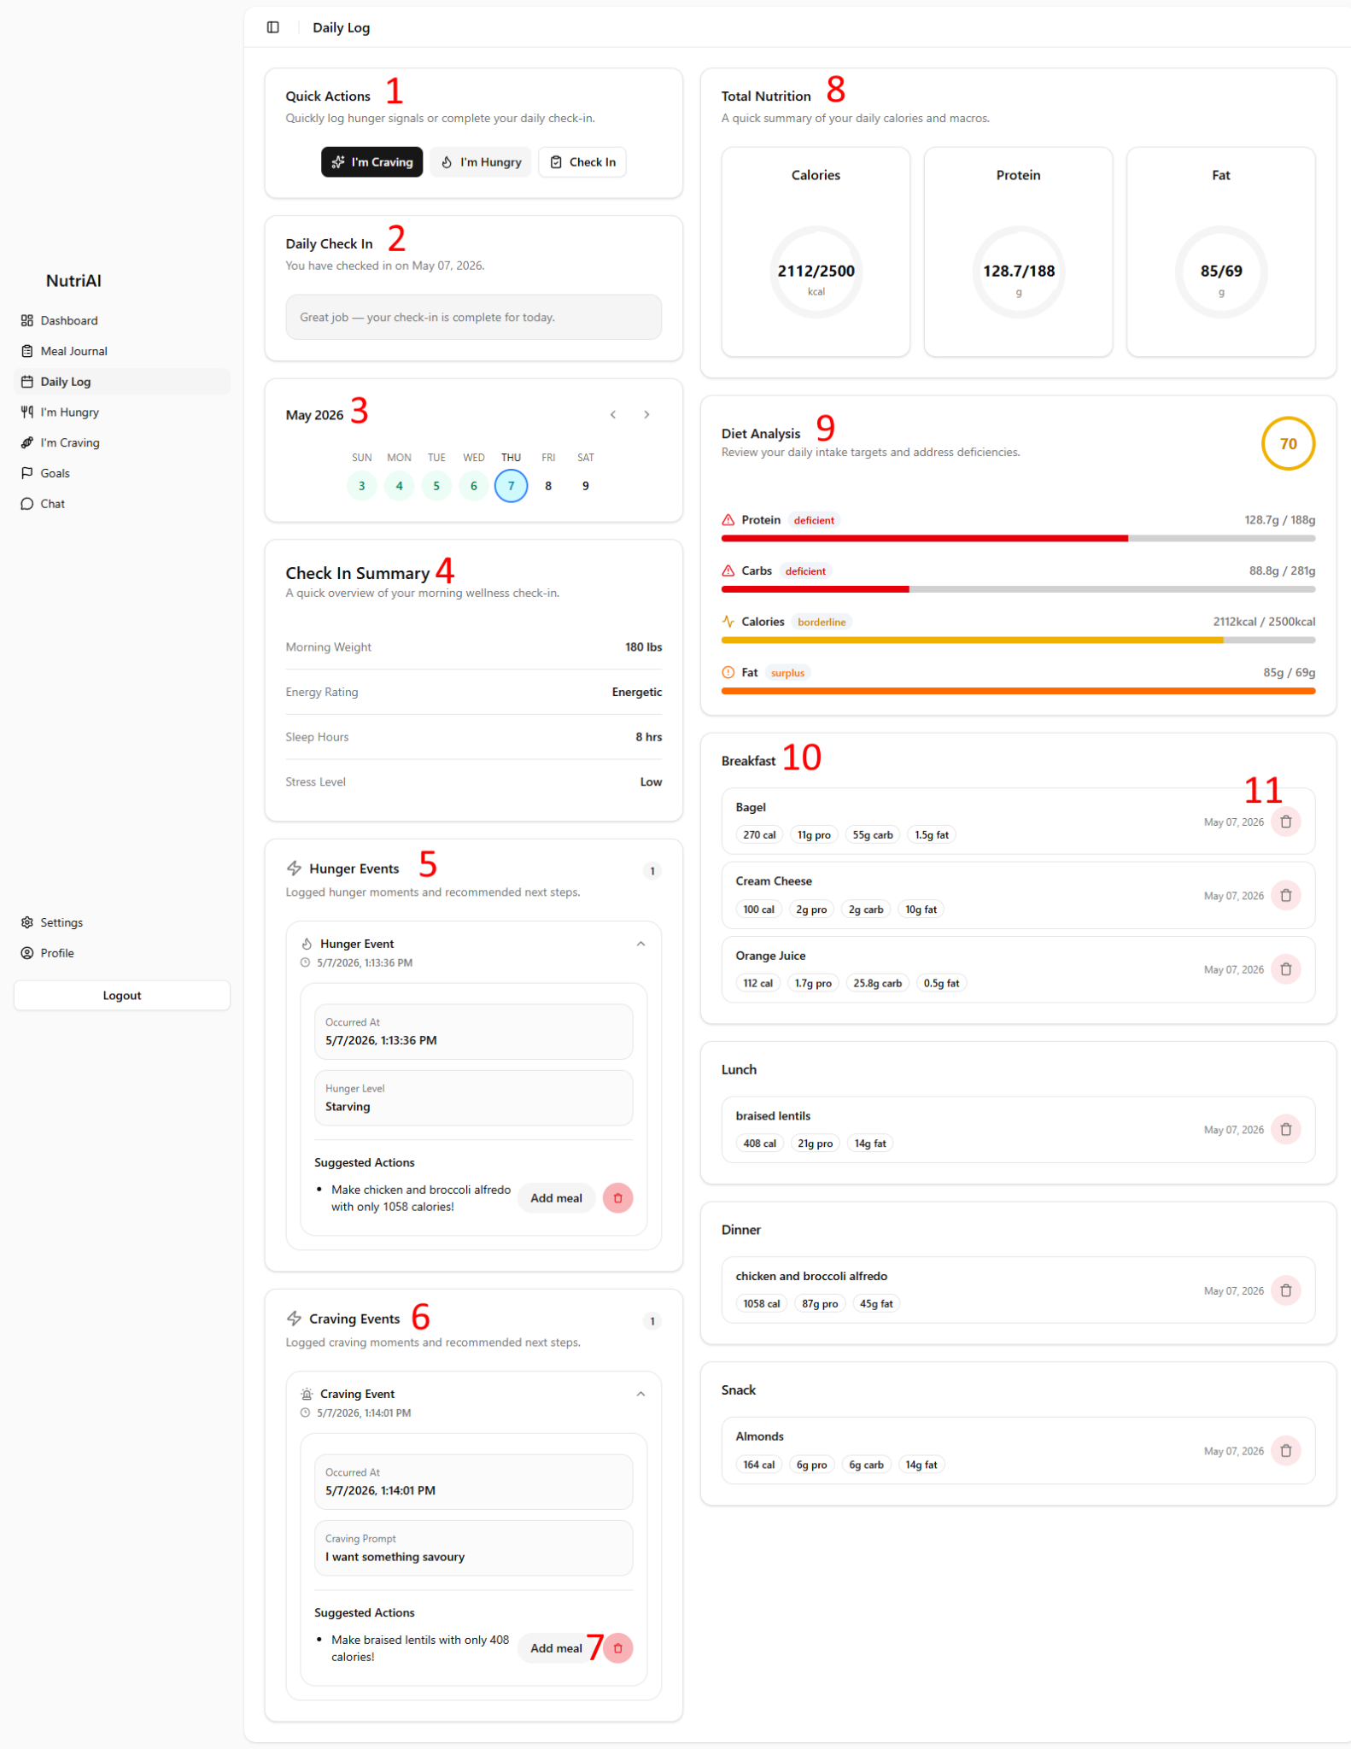

The Daily Log page provides a detailed overview of your daily activity, nutrition progress, hunger and craving events, and logged meals. This page is designed to help you monitor your daily habits and better understand your eating patterns throughout the day.

- Quick Actions Card - The Quick Actions card provides shortcuts to commonly used actions within NutriAI. With this card you can quickly
  - Log a craving event
  - Log a hunger event
  - Complete your daily check-in
- Check-In Card -The Daily Check In card displays your check in status for the selected date. Daily check-ins are required before any meal logging can begin and are used to record important health information such as, morning weight, sleep, energy, and stress.
- Day Selector - The Day Selector allows you to navigate between different dates and manage nutrition logs for a specific day, You can switch between days to review previous entries or log meals for the current date.
- Check-In Summary - The Check-In Summary card provides a quick overview of the information submitted during your daily check-in. This section displays your recorded wellness metric for the selected day
- Hunger Events - The Hunger Events section displays all hunger events you have logged for the selected day. Hunger events help track moments when you have felt hungry and provide recommendations based on your nutrition goals. Each hunger event includes:
  - The date and time you logged the event
  - Your hunger level
  - Suggested food recommendations
  - Quick actions to add recommended foods or delete the event
- Craving Events - The Craving Events section displays all craving events you have logged for the selected day. Craving events help track specific food cravings and provide meal recommendations that align with your nutrition goals. Each craving event includes:
  - The date and time you logged the event
  - Your craving prompt
  - Suggested food recommendations
  - Quick actions to add recommended foods or delete the event
- Event Quick Actions - All events include quick actions that allow you to add recommended foods or recipes to your Meal Log.
- Total Nutrition Card - The Total Nutrition Card provides a summary of your nutritional intake for the selected day. This section displays progress toward daily nutrition goals, such as calories, protein, and fat
- Diet Analysis - The Diet Analysis card provides a breakdown of how your current nutrition intake compares to your daily nutrition targets.
- Meal Log - The Meal Log displays all foods and recipes logged for the selected day. Entries are grouped by meal category, allowing you to review your daily meals.

Goals
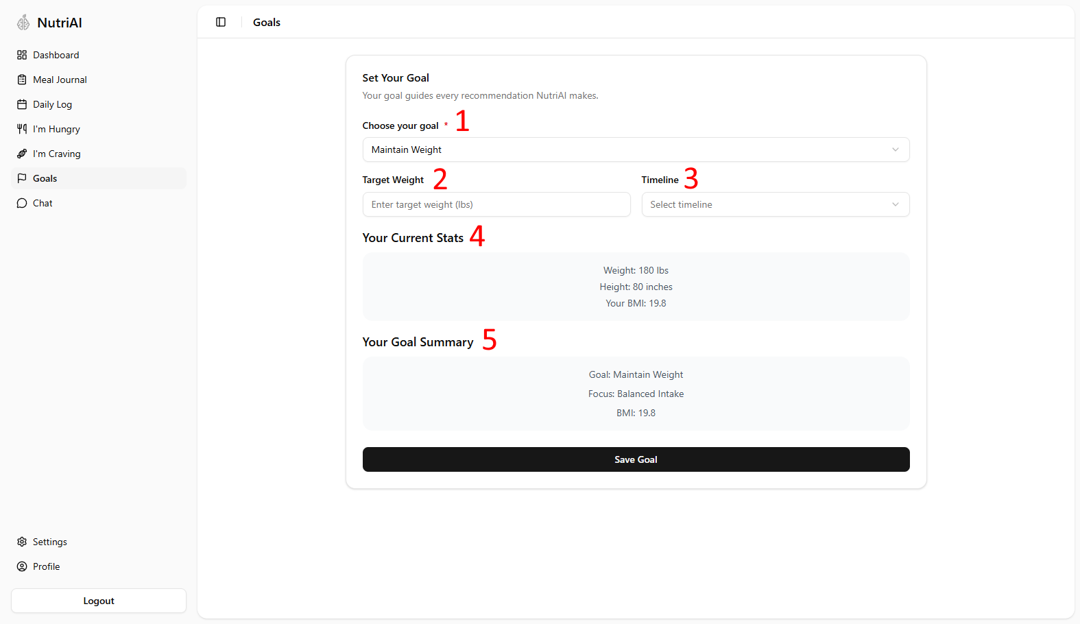
The Goals page allows you to configure your personal wellness and nutrition goals within NutriAI. Your selected goal helps guide the recommendations, meal suggestions, and nutrition analysis provided throughout the application.

- Goal Selection - The Goal Selection allows you to choose your primary wellness objective. Your selected goal is used by NutriAI to personalize recommendations and nutrition guidance.
- Target Weight - The Target Weight section allows you to enter your desired target weight.
- Timeline Selection - The Timeline section allows you to choose the timeframe for reaching your target goal.
- Current Stats - The Current Stats displays your current body measurements and health information based on your profile data.
- Goal Summary - The Goal Summary section provides a quick overview of your currently selected goal and wellness focus.

Chat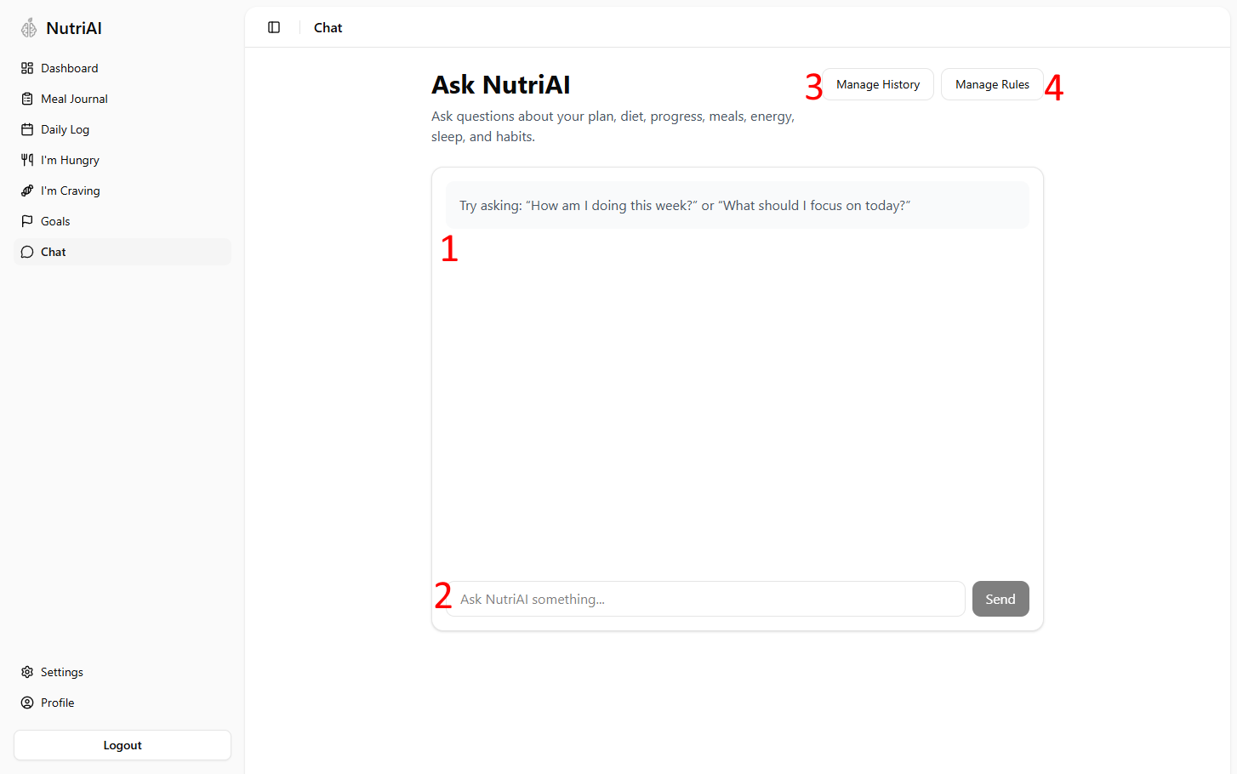
The Chat Page allows you to interact directly with NutriAI using a chat style interface. You can ask questions related to your nutrition plan, meals, wellness, process, etc.

- Chat History - The Chat History displays your active conversation with NutriAI
- Message Input - The Message Input allows you to enter questions or prompts for NutriAI. After entering your message, click Send to submit your question. You may ask questions about topics such as:
  - Nutrition goals
  - Meal recommendations
  - Energy levels
  - Sleep habits
- Manage History - The Manage History button allows you to manage your previous chat conversations.
- Manage Rules - The Manage Rules button allows you to manage personalized chat preferences.

Settings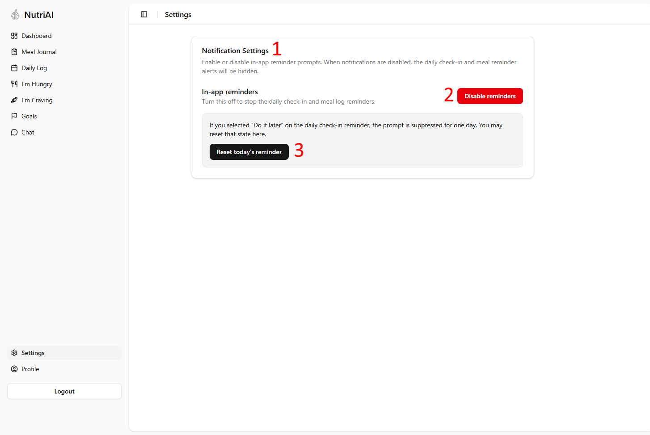
The Settings page allows you to manage notification and reminder preferences within NutriAI. These settings control how in-app reminders and prompts are displayed throughout the application.
- Notification Settings - The Notification Settings section allows you to configure how NutriAI displays in-app reminders and wellness prompts.
- Reminder Toggle - The Reminder Toggle allows you to enable or disable in-app reminders. When Reminders are disabled, daily check-in reminders will no longer appear and meal reminder prompts will be hidden
- Reset Reminder State - The Reset Reminder State action allows you to restore reminder prompts that were previously dismissed.
  - For example, if you selected a “Do it later” option on a reminder, NutriAI may temporarily suppress that notification for the remainder of the day. Using this option resets that state and allows reminders to appear again.

Profile

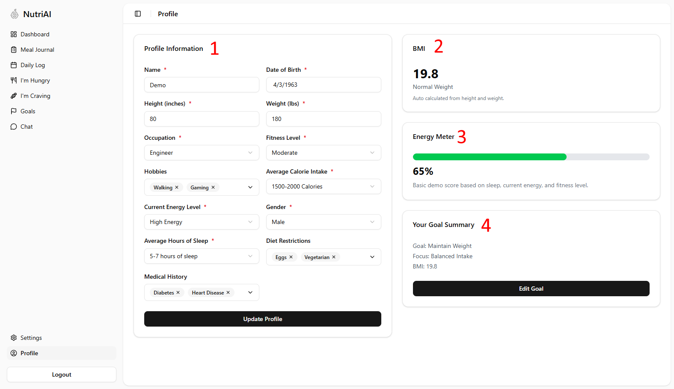
The Profile page allows you to manage your personal health and lifestyle information within NutriAI. The information entered on this page is used to personalize nutrition recommendations, wellness insights, energy analysis, and goal planning throughout the application.

- Profile Information - The Profile Information section allows you to enter and update your personal wellness and lifestyle details. This information helps NutriAI generate more accurate recommendations and health insights.
- BMI Summary - The BMI Summary section displays your calculated Body Mass Index (BMI) based on your height and weight information.
- Energy Meter - The Energy Meter provides an estimated overview of your current wellness and energy state based on your profile information.
- Goal Summary - The Goal Summary section displays information related to your currently selected wellness goal.

Guide

General

Navigating Home
- If you are currently on the dashboard, open the sidebar and click the NutriAI logo located at the top of the sidebar.
- If you are currently on the Login or Sign Up page, click the NutriAI logo located in the top-left corner of the screen.

Navigating to Dashboard
- Click the Dashboard button located in the top-right corner of the screen.
- If you are not currently signed in, you will need to sign in or create an account before accessing the dashboard.

Logging Out
- If you are on the Home page, click the Logout button located in the top-right corner of the screen.
- If you are on the dashboard, open the sidebar if it is not already open, then click the Logout button located at the bottom of the sidebar.

Daily Log

Checking In
- Navigate to either the Meal Journal page or the Daily Log page.
- Locate the Daily Check In card.
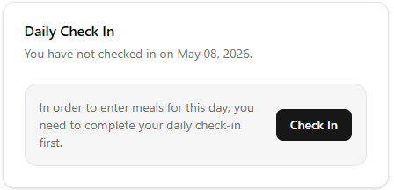
- Click Check In.
- Enter your morning weight, sleep hours, stress level, and energy rating in the check-in form.
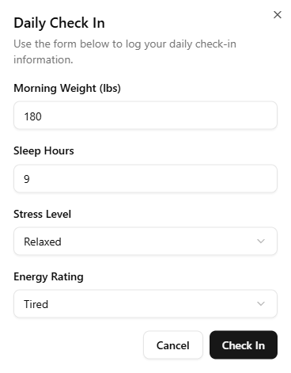
- Once all fields are completed, click Check In to save your daily check-in.

Checking In For a Missed Day
- Navigate to the Daily Log page
- Select the day you missed using the Day Selector card.
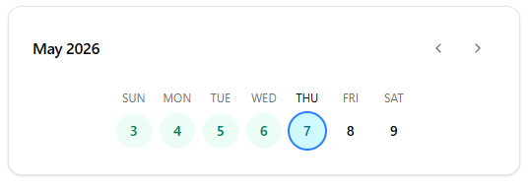
- Follow the instructions provided in the Checking In section to complete your daily check-in for that day.

Logging a Hunger Event
- Navigate to the Daily Log page.
- Locate the Quick Actions card.
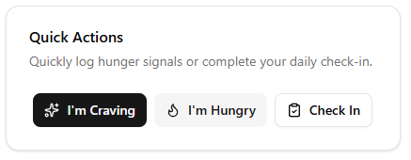
- Click the I’m Hungry button.
- Choose your hunger level, then click Submit Hunger.
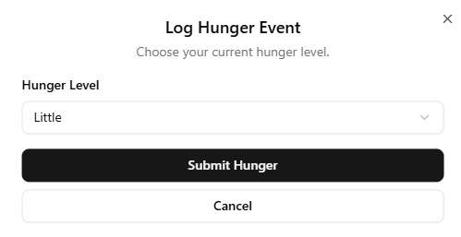
- Review the suggested recipe
  - If you would like to use the recipe, click Accept Recipe.
  - If you would like a different recommendation, click Request New Recipe.
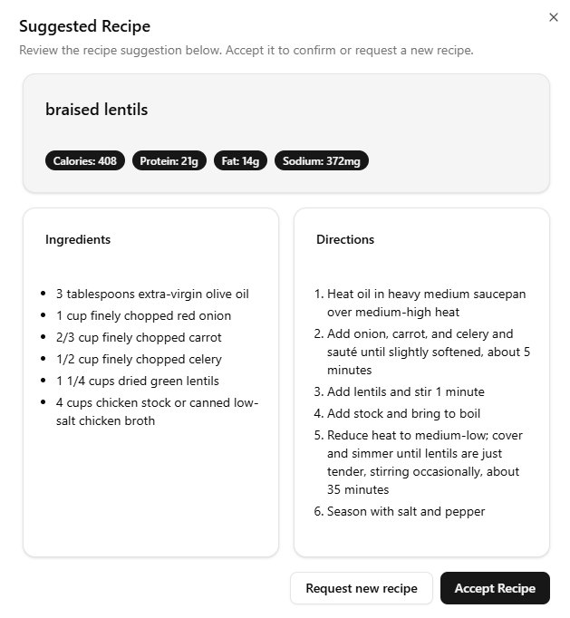
- Once a recipe is accepted, the hunger event will appear in the Hunger Events card.

Logging a Craving Event
- Navigate to the Daily Log page.
- Locate the Quick Actions card.

- Click the I’m Craving button.
- Describe your craving in the text field using a sentence or short description.
- Review the suggested recipe
  - If you would like to use the recipe, click Accept Recipe.
  - If you would like a different recommendation, click Request New Recipe.

- Once a recipe is accepted, the hunger event will appear in the Craving Events card.

Adding Suggested Hunger Event Recipe to Meal Log
- Navigate to the Daily Lo g page.
- Locate the Hunger Events card.
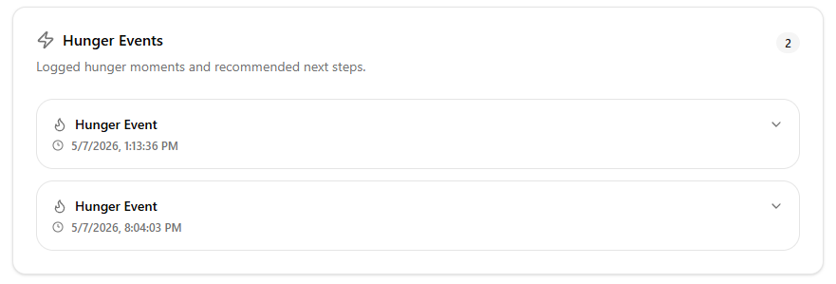
- Find the hunger event recipe you want to add to your meal log.
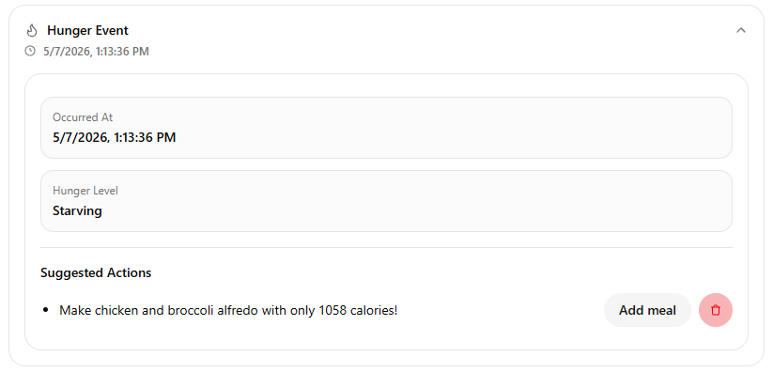
- Click Add Meal.
- Choose which meal category you want to add the recipe to.
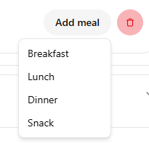
- Once added, the recipe will appear in the Meal Journal.

Adding Suggested Craving Event Recipe to Meal Log
- Navigate to the Daily Lo g page.
- Locate the Craving Events card.
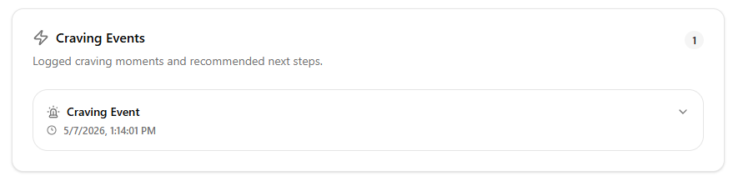
- Find the craving event recipe you want to add to your meal log.
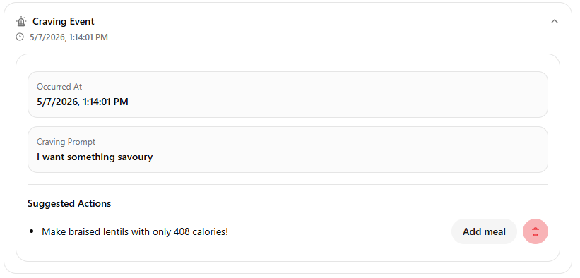
- Click Add Meal.
- Choose which meal category you want to add the recipe to.

- Once added, the recipe will appear in the Meal Journal.

Deleting Hunger Event
- Navigate to the Daily Log page.
- Locate the Hunger Events card.

- Find the hunger event you want to delete.

- Click the event to expand and view its details.
- Click the Trash icon located in the bottom-right corner of the event card.

Deleting Craving Event
- Navigate to the Daily Log page.
- Locate the Craving Events card.

- Find the craving event you want to delete.

- Click the event to expand and view its details.
- Click the Trash icon located in the bottom-right corner of the event card.

Meal Journal

Adding Meal to Food Log
- Navigate to the Meal Journal page.
- Complete your daily check-in if you have not already done so.
- Locate the Search Food & Recipes card.
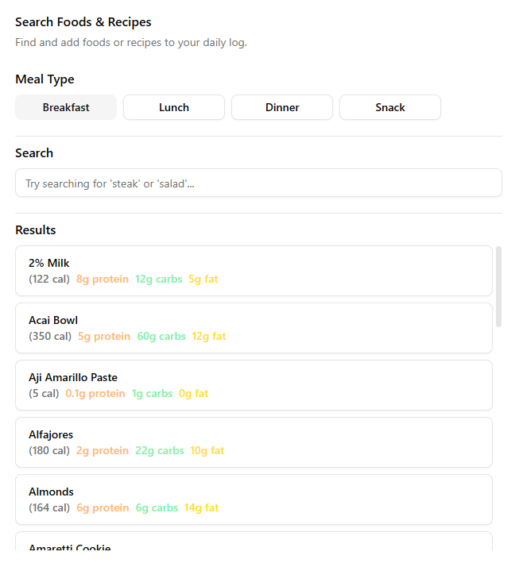
- Select which meal category you want to add food to.
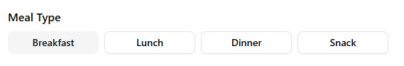
- Search for the food or recipe you want to log.
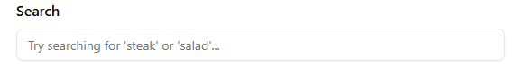

- Select the food from the search results.

Removing Meal From Meal Logs
- Navigate to the Meal Journal page.
- Select the day you want to remove the meal from using the Day Selector card.

- Locate the Meals card
- Find the meal you want to remove.
- Click the Trash icon located to the right of the meal entry.

Chat

Asking NutriAI a Question
- Navigate to the Chat page.
- Enter your question into the text field.
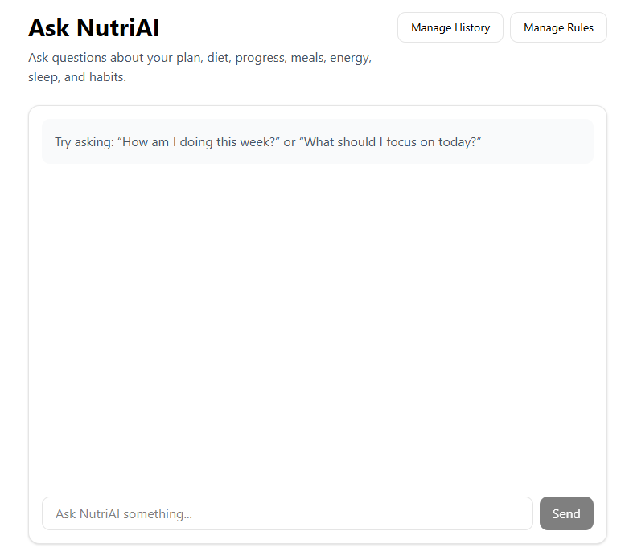
- Click Send.
- View NutriAI’s response in the chat window.

Managing/Viewing Past Conversations
- Navigate to the Chat page.
- Click Manage History in the top right corner of the screen.
- Select a time range you would like to view.
- To remove chat history, click the Delete button.

Adding Chat Rules
- Navigate to the Chat page
- Click Manage Rules in the top right corner of the screen.
- Locate the Add Rule card
- Enter a rule into the text field.
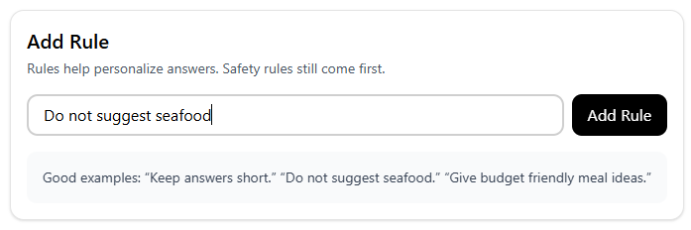
- Click Add Rule to save the rule.

Deleting Chat Rules
- Navigate to the Chat page.
- Click Manage Rules in the top right corner of the screen.
- Locate the Saved Rules card.
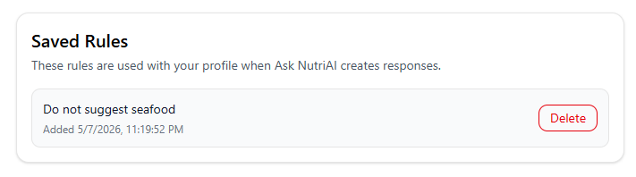
- Find the saved rule you would like to delete.
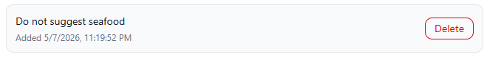
- Click Delete to remove the rule.

Profile

Updating Profile Information
- Navigate to the Profile page.
- Locate the Profile Information card.
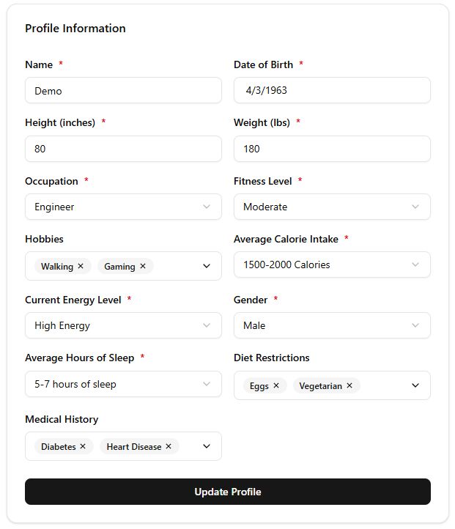
- Update the fields you would like to change.
- Click Update Profile to save your changes.

Goals

Setting a Goal
- Navigate to the Goals page.
- Select the goal you would like to set.
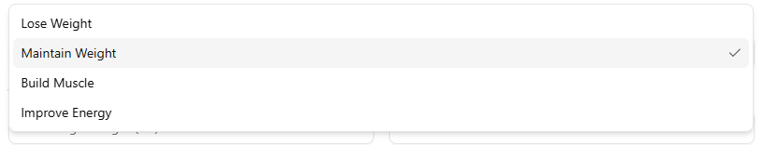
- Enter your target weight.
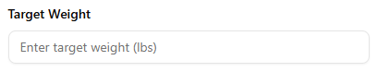
- Choose your desired timeline for achieving the goal.
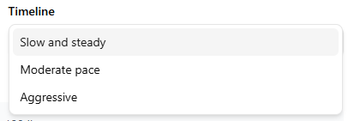
- Click Save Goal to save your goal settings.

Settings

Enable/Disable Daily Check-In Reminder
- Navigate to the Settings page
- Locate the Notification Settings card
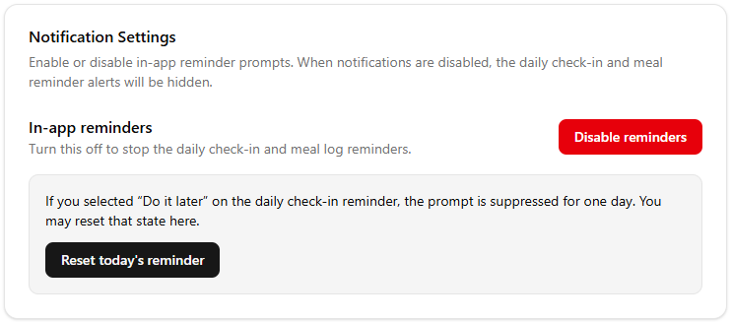
- Toggle the In-app reminders button
