Credit Card Fraud Detection App - User Manual
1. Introduction
The Credit Card Fraud Detection App is an iOS-based mobile application designed to help users monitor their credit card activity and quickly respond to suspicious transactions. The app provides an intuitive dashboard for viewing all cards, tracking transactions, and managing potential fraud alerts. With built-in reporting tools and real-time review actions, users maintain full control over their financial security. This application runs entirely on the device, ensuring privacy and a smooth offline experience.
This User Manual provides instructions for using the Credit Card Fraud Detection iOS App built in Swift/Xcode. The application runs fully on the user's device— local deployment needed before, and internet is not required.
Key Features:
- Real-Time Fraud Detection
- Interactive Transaction Review (Approve/Deny)
- Multi-Card Management
- Fraud Analytics & Reports
App Launch Screen
Below is the initial appearance of the app on the device:
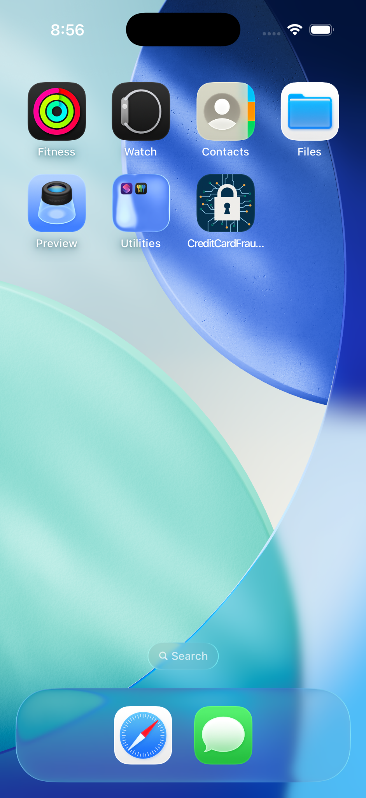
2. Getting Started
2.1 Signing Up
To create a new account:
1. Open the app.
2. Tap the Sign Up button.
3. Enter your name, email, and password.
4. Submit to create the account.
2.2 Logging In
Enter your registered credentials and tap Login to access your dashboard.
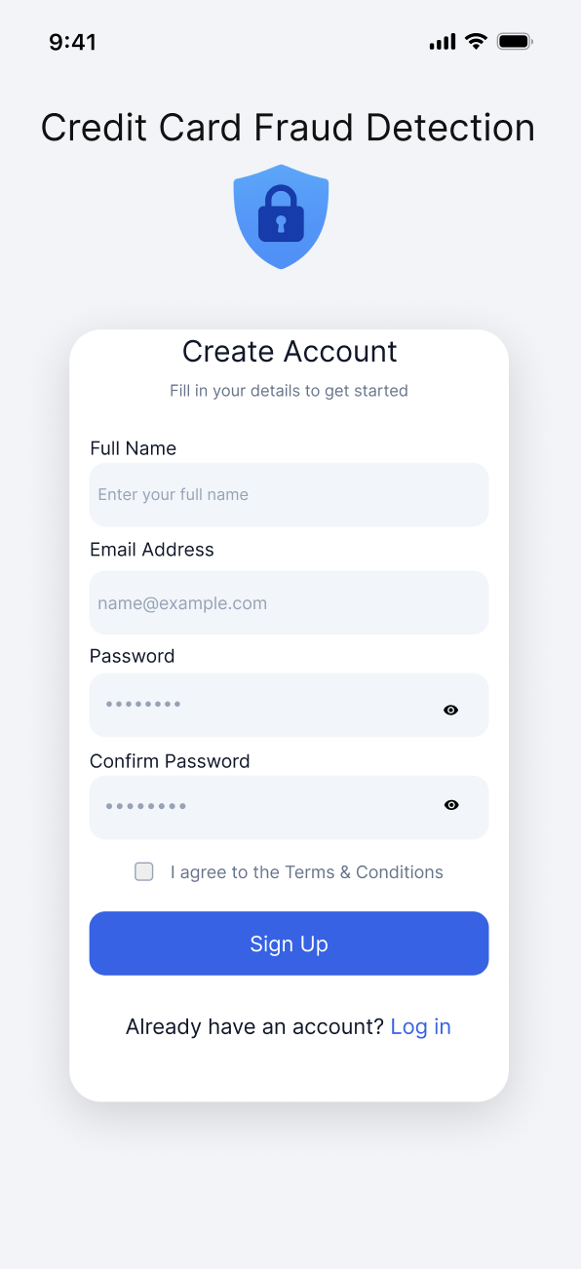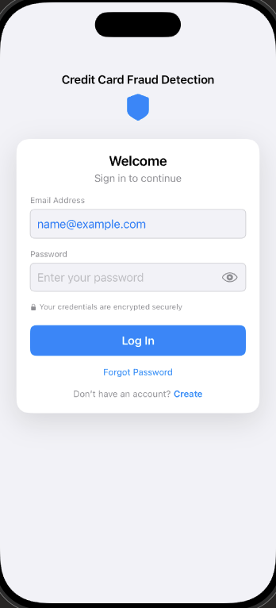
3. Adding a New Credit Card
Users can add a new credit card:
Steps to add a card:
1. On the home screen, tap the + icon.
2. Enter card number, expiration date, CVV, and issuer.
3. Tap Add Credit Card.
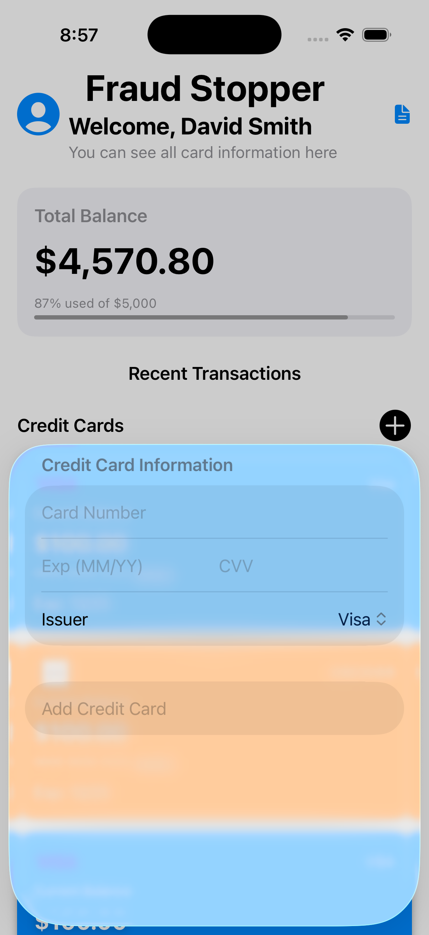

4. Home Screen Overview
After logging in, the home dashboard displays:
- Welcome message
- Total balance overview
- All saved credit cards
- Red fraud indicators on risky cards
- Report Icon for fraud analytics
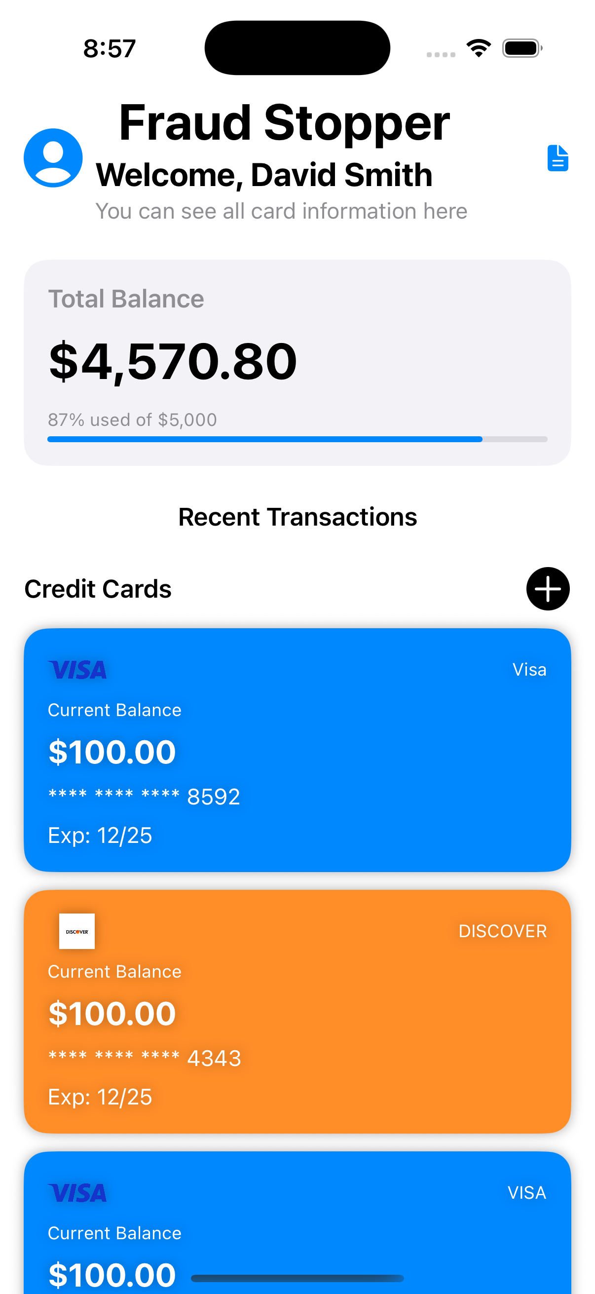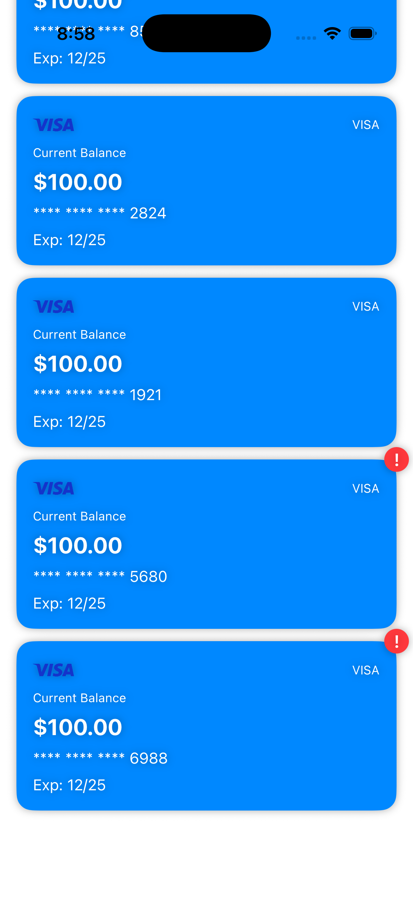

5. Viewing Credit Cards
Each card displays issuer, balance, last four digits, and expiration date.

6. Managing Transactions
Opening a card shows all its transactions. Fraudulent ones have a red warning icon.
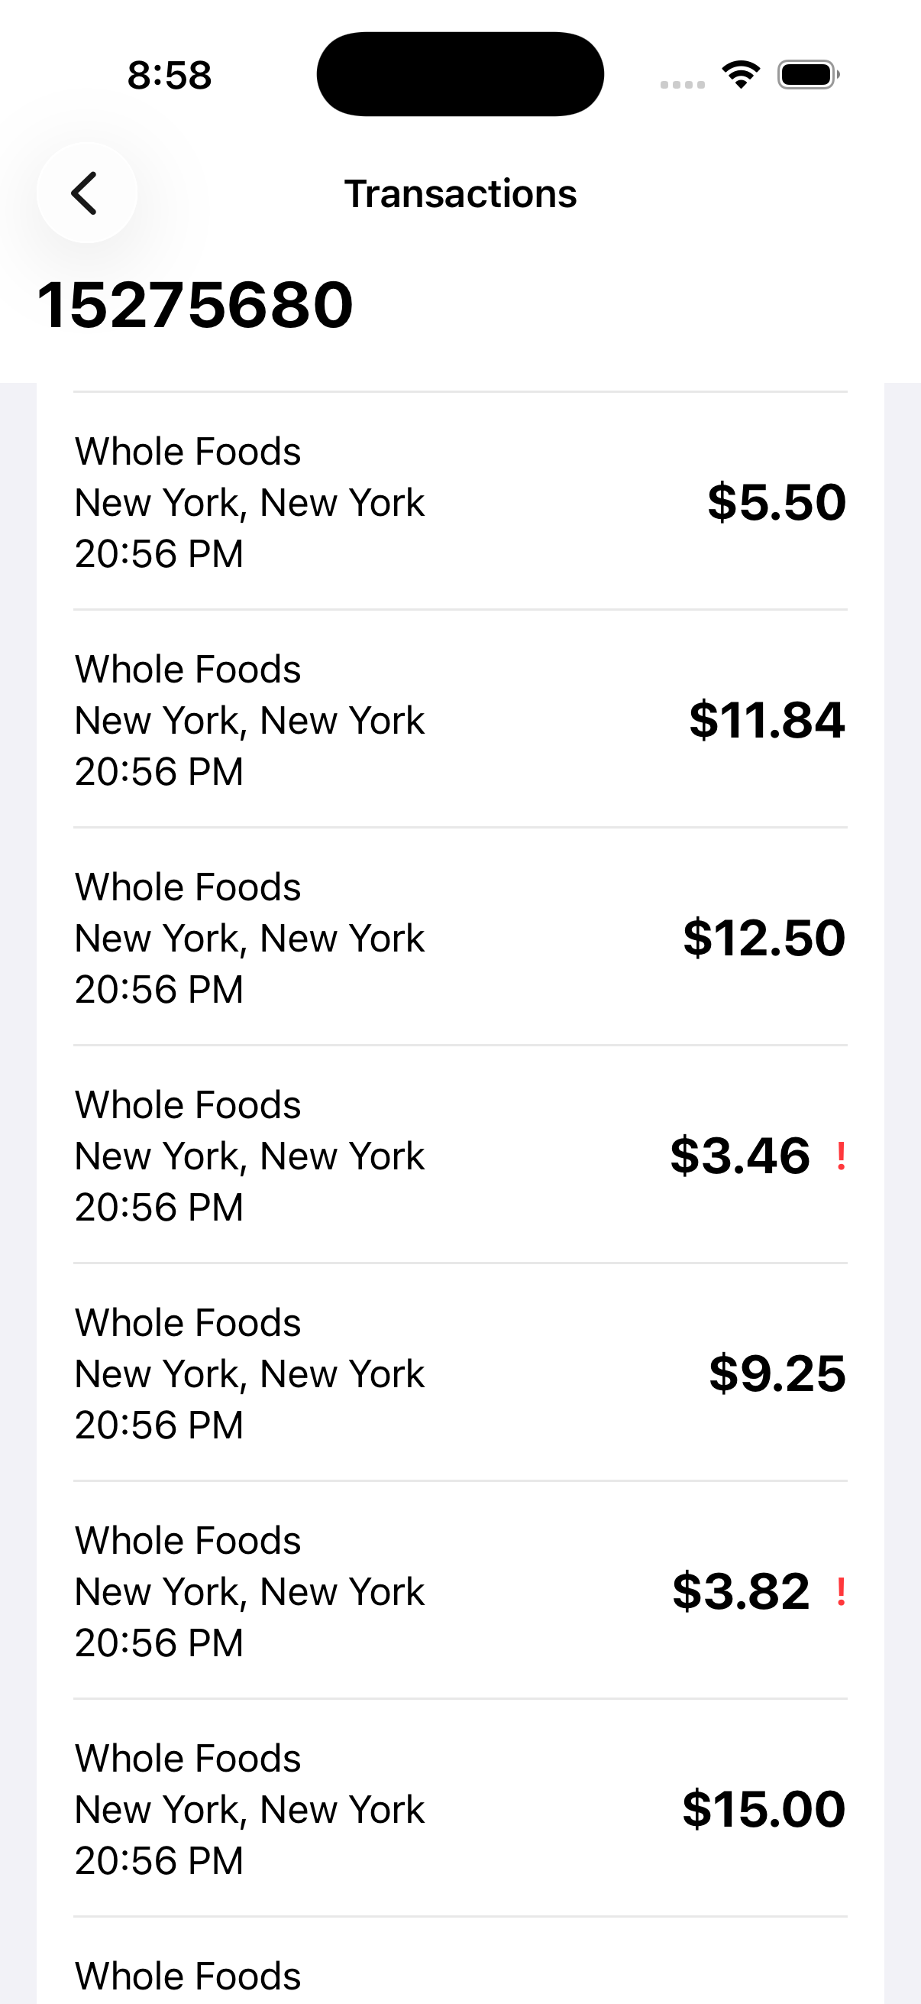
6.1 Approving Transactions
Swipe left on denied transaction → Tap green checkmark → Mark as Approved.
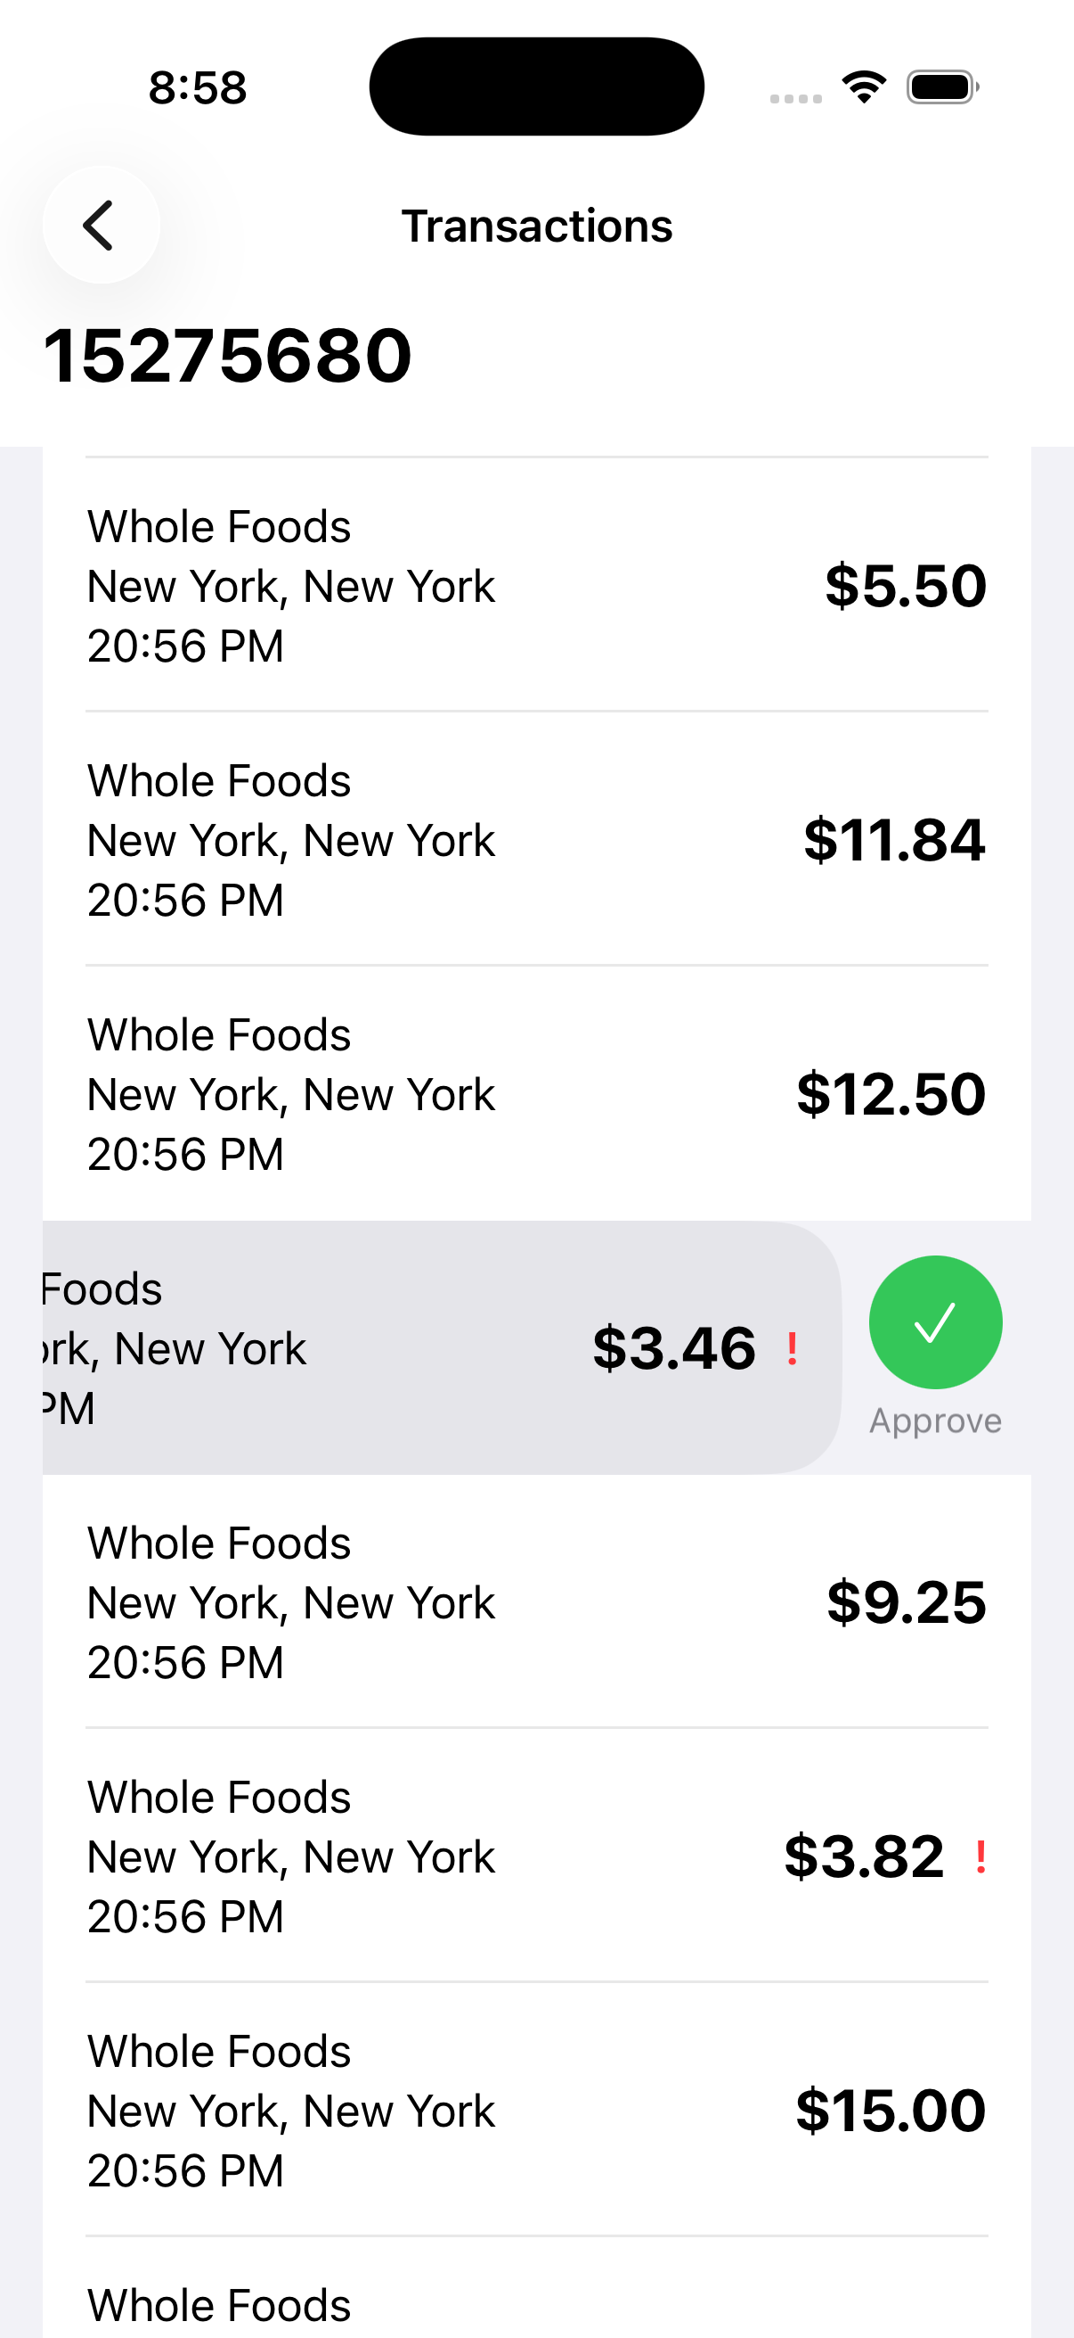
6.2 Denying Transactions
Swipe left → Tap red deny icon → Mark as Denied.
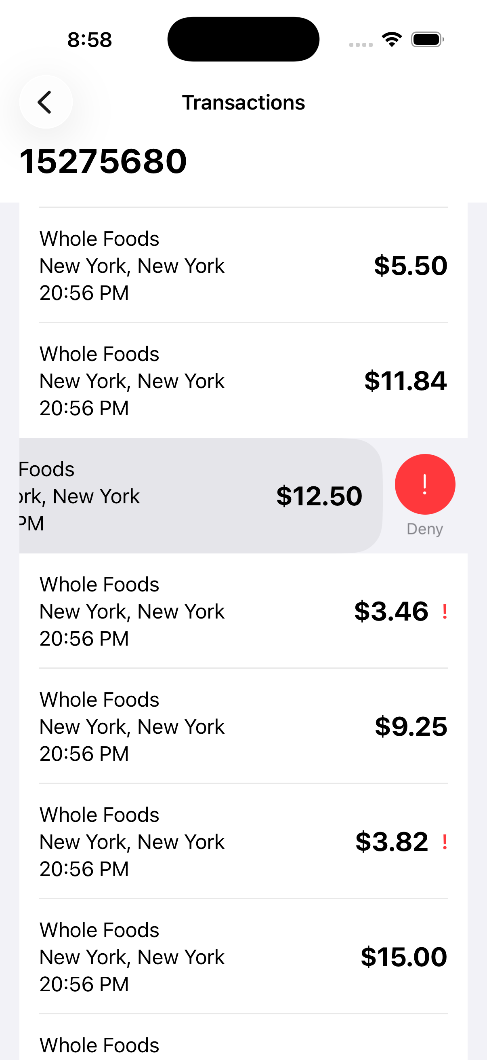
7. Fraud Reports
The Reports Section provides analytics across different periods (Today, Week, Month, Custom).
Metrics include:
- Total Transactions: All processed transactions.
- Flagged as Fraud: Transactions identified as suspicious.
- Confirmed Fraud: Fraudulent transactions denied by the user.
- Loss Prevented: The amount saved based on detected and denied fraud cases.
Charts show a comparison of fraudulent vs legitimate activity to help understand spending patterns and risk exposure.
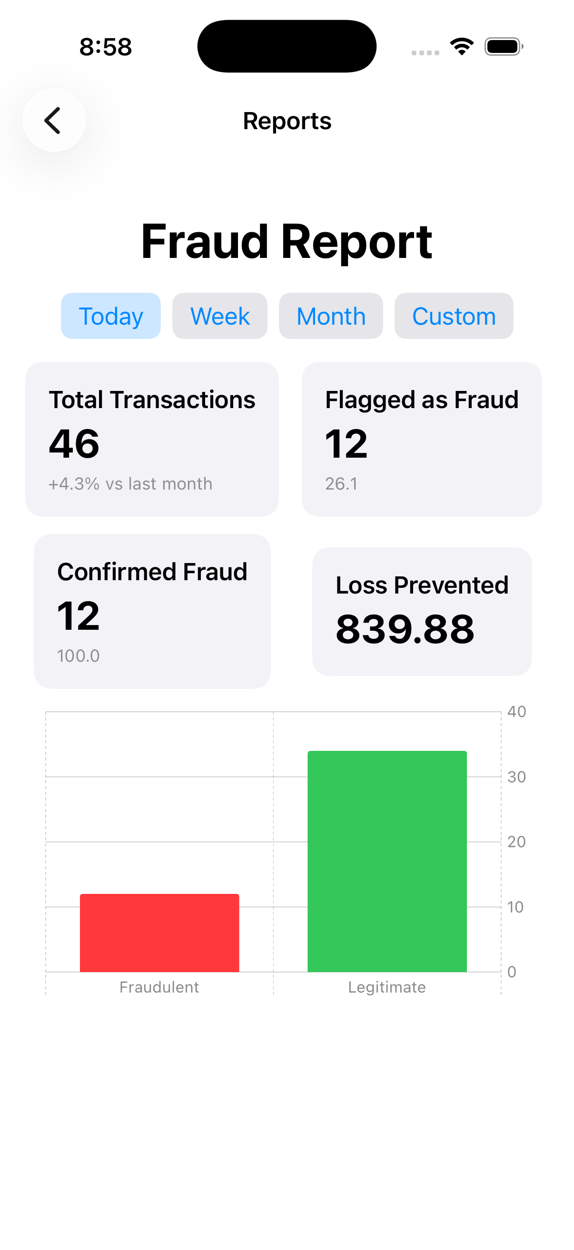
8. Troubleshooting
Common issues and solutions:
- Unable to log in → Check credentials and restart the app.
- Card not visible → Re-add or restart the app.
- Transactions not updating → Reopen the card screen.
9. Support
This is a local academic project. For assistance, refer to project documentation or make comment on GitHub.

