Crowdfunding: A Decentralized Transparent
Funding Platform
Nyi Nyi Lwin, Ashwitha Maram, Ashwanth Maram, Raj Mandaliya,
Vinukonda Yashwanth Reddy, Naveen Pesalabanda

Seidenberg School Of Computer Science and Information Systems, Pace University
One Pace Plaza, New York, NY 10038

nl55428n@pace.edu, am47139n@pace.edu, am381510n@pace.edu,
rm25003n@pace.edu, yv76986n@pace.edu, np21371n@pace.edu

Abstract— Crowdfunding platforms have become central tools for creators, entrepreneurs, and communities seeking financial support. Most traditional platforms suffer from high fees, limited transparency, and minimal governance for contributors. This study presents a decentralized crowdfunding system implemented with Ethereum smart contracts, providing transparent contribution tracking, automated refund mechanisms, and weighted governance voting. Contributors can track funds, vote on fund disbursement, and reclaim contributions if campaigns fail. Deployment on Ethereum test networks demonstrates feasibility, usability, and security considerations. This work contributes to blockchain literature by integrating fund management, contributor governance, and refund automation into a single framework, advancing transparency, trust, and user empowerment. The study also highlights challenges such as gas optimization, security vulnerabilities, and governance complexity, offering a roadmap for future research and real-world deployment.
Keywords— Crowdfunding, Blockchain, Smart Contracts, Governance, Transparency, Ethereum, DApps
- Introduction

Crowdfunding has emerged as a powerful mechanism for raising capital from distributed networks of individuals. Platforms such as Kickstarter (founded 2009) and Indiegogo (founded 2008) have transformed how individuals raise funds.
They enabled creators worldwide to bring ideas to life. Despite its success, traditional crowdfunding relies heavily on centralized intermediaries that introduce various friction points: high platform fees, lack of transparency in fund allocation, and limited governance by contributors. These limitations often erode trust and hinder the democratization of funding.
Blockchain technology — particularly public blockchains like Ethereum — offers a compelling alternative. Through smart contracts, financial logic can be enforced on-chain, rendering processes transparent, tamper-evident, and automated. Previous studies indicate that decentralized crowdfunding can lower costs and enhance trust among contributors [3], [5], [8]. Moreover, governance models based on contributor voting can empower funders to influence project decisions, creating a more democratic funding process.
In this study, we present a smart-contract-based crowdfunding system implemented in Solidity. Our approach integrates three major components: (1) contribution tracking to record exactly who contributed what amount; (2) automated refunds, where backers can reclaim their funds if the campaign fails; and (3) weighted governance, enabling contributors to vote on disbursement requests in proportion to their stakes. We deployed and tested the system on an Ethereum testnet to evaluate its feasibility, security, and efficiency.
The paper first reviews related work, then describes our methodology and smart contract design. We present the results, discuss implications, and conclude with suggestions for future research.
- LITERATURE REVIEW
Several works have explored the design of crowdfunding platforms built on Ethereum. For instance, Anavkar et al. proposed an Ethereum-based crowdfunding system to address the transparency and fraud issues of traditional platforms [1]. Similarly, Viju et al. described a blockchain crowdfunding mechanism where smart contracts track payments and disbursements, thereby improving efficiency and trust [2].
Tiganoaia and Alexandru (2023) developed a decentralized crowdfunding platform specifically for social and educational causes, emphasizing sustainable development goals. Their system enables donors to track exactly how their contributions are used, reflecting the transparency advantages of blockchain [3].
Decentralized Autonomous Organizations (DAOs) are frequently suggested as governance frameworks for on-chain crowdfunding. In “LikeStarter,” Zichichi et al. presented a DAO-based social crowdfunding platform where contributors not only fund but also participate in decision-making [4]. Their model demonstrates how social engagement and voting can coexist with fundraising, eliminating the need for central authorities.
On the more theoretical and legal side, Kaal (2021) analyzed on-chain corporate governance and argued that blockchain-based governance can reduce information asymmetry and align stakeholder incentives by encoding rules in smart contracts [9]. Meanwhile, traditional governance research has discussed the tradeoffs and design of token-based voting systems in DAOs [9].
Smart contract security is a key concern in blockchain crowdfunding. Vulnerabilities can lead to funds being locked, lost, or exploited. Brent et al. introduced Vandal, a scalable security analysis tool that analyzes EVM bytecode for vulnerabilities like reentrancy and unsafe control flow [8]. Incorporating such analysis is critical in any smart contract used for fundraising.
In more advanced use cases, crowdfunding has been applied to domain-specific problems. For example, Liu et al. proposed a smart contract–based crowdfunding mechanism for hierarchical federated learning, using a Vickrey–Clarke–Groves (VCG) mechanism combined with Ethereum contracts [6]. Their work demonstrates that crowdfunding logic can be extended to complex, decentralized computing applications.
Another recent proposal integrates stablecoins with crowdfunding to mitigate cryptocurrency volatility and enhance liquidity. Unsal (2025) suggested a framework leveraging stablecoins like USDC, on-chain KYC/AML checks, and tokenization of contributions — thus making crowdfunding more accessible and stable [7].
Past research provides strong justification for a smart-contract-based crowdfunding platform that is transparent, secure, and participant-governed. Our work draws on these foundations while combining contribution tracking, refund logic, and weighted governance into a unified contract and contributing a more comprehensive solution.
- METHODOLOGY
Our system is implemented in Solidity (pragma ≥0.5.0 <0.9.0) as a single smart contract managing crowdfunding campaigns. The contract enforces contribution logic, refund conditions, and governance mechanisms.
  - Program Structure
- Mapping: contributors → per-address contribution.
- Campaign parameters: target (goal), deadline (timestamp), minContribution.
- Governance data structure: Request struct with description, recipient, value, vote count, completion status, and per-contributor vote record.
- Manager address: Only the campaign creator (manager) can propose disbursement requests.

B. Core Functions and Modifiers
1. Contribution Function (sendEth)
- Checks that the transaction msg.value ≥ minContribution.
- Validates deadline to avoid receiving funds after the campaign period.
- Updates the contributor’s balance, increments totcontributors if first-time contributor, and increases raisedAmount.
2. Refund Function (refund)
- Only executable after deadline if raisedAmount < target.
- Resets contributor’s contribution to zero, then transfers the ETH back to the contributor.
3. Request Creation (createRequests)
- Manager-only.
- Initializes a Request struct with description, target recipient, value, and resets vote count and completion flag.
4. Voting (voteRequest)
- Only contributors (contributors[msg.sender] > 0) can vote.
- Prevents double voting via a voters mapping inside each Request.
- Increments totVoters on approval.
5. Execution (makePay)
- Requires raisedAmount >= target and deadline has passed.
- Checks that request is not already completed.
- Requires totVoters > totcontributors / 2 (more than half of contributors have voted in favor).
- Transfers the requested value to the recipient and marks completed = true.
Modifiers:
- checkTime: ensures current time is before deadline.
- checkVal: ensures minimum contribution.
- timeToRefund: ensures refund can only happen after deadline if target unmet.
- timeToPay: ensures pay-out only after target is met and deadline passed.
- onlyManager: restricts request creation and execution.
- checkCont: ensures only actual contributors vote or refund.

C. Testing and Deployment
- The contract was deployed on the Sepolia testnet for testing.
- Tools used: Hardhat for compilation and deployment, Remix for manual testing, MetaMask for interacting with contract.
- Test scenarios:
  - Multiple accounts contribute with different amounts.
  - Campaign fails — verify that refund() returns correct amount.
  - Campaign succeeds — manager creates multiple requests, contributors vote, funds disbursed only on majority.
  - Edge cases — contributor changes vote, double vote prevention, over-request value, gas consumption.

D. Diagrams & Models
We plan to include the following diagrams and all of them will be at the end of the paper:
- Fig. 1: Architecture Diagram — overall system design.
- Fig. 2: Context Diagram — external actors and system boundaries.
- Fig. 3: State Diagram — campaign states (Funding, Voting, Refund, Pay).
- Fig. 4: ER Diagram — entities: Contributor, Request, Vote record.
- Fig. 5: Class Diagram — contract structure, modifiers, functions.
- Fig. 6: Sequence Diagram — example flow from contribution through voting to payout.
- RESULTS
This section presents the implemented features, and significant technical observations. The team implemented the core MVP components:
- Campaign creation smart contracts
- ETH contribution logic with tracking
- Refund mechanism triggered upon unmet goals
- Governance voting mechanism
- Deployment and testing on Sepolia Test Network
The system successfully demonstrates transparent and automated fundraising workflows. Contributors retain visibility into their funds and can influence fund distribution.
During development, several discoveries were made. Smart contract debugging required iterative refinement due to gas optimization constraints. Web3 interaction complexities emphasized the need for detailed logging and error handling. Voting mechanisms required careful balance to maintain fairness across contributors with different stake sizes. Automated refund logic strengthened trust but required precise deadline and contribution validation.
These findings improved overall system stability and guided future development decisions.

A. Functional Demonstration
- Transparent contribution tracking with real-time balances.
- Automated refunds successfully triggered on failed campaigns.
- Weighted voting ensures majority approval before fund disbursement.
- Manager-controlled request creation validated.

B. Observations and Lessons Learned
- Nested mappings (voters) need careful handling to avoid storage conflicts.
- Refund automation improves contributor trust.
- Weighted voting ensures fair influence proportional to stake.
- Gas optimization critical for scalability with multiple contributors.

C. Practical Utility
The smart contract eliminates intermediary fees, improves transparency, and empowers contributors. Use cases include creative projects, startup funding, and community initiatives.

D. Limitations
- No frontend interface; interactions via MetaMask only.
- Single-chain deployment; cross-chain compatibility not included.
- Governance simple majority only; delegation not implemented.
- Conclusions
This decentralized crowdfunding system demonstrates how blockchain and smart contracts can restore trust and transparency in crowdfunding. By enabling contributors to vote and giving them the power to approve disbursement, the system shifts control from centralized platforms back to funders. This change has several implications. Contributors are no longer passive donors and they have real influence. All contributions, votes, and disbursements remain on-chain, auditable by anyone. The manager cannot unilaterally withdraw funds; they must be approved. This model could align with DAO-based governance structures, potentially leading to legally compliant “crowdfunding DAOs” [9].
However, challenges remain. High gas costs may limit accessibility for small donors. The on-chain only UI may deter non-technical participants. Moreover, as the system scales, more sophisticated governance (e.g., quadratic voting, token delegation) may be needed.
Our testing on a public testnet shows the approach is feasible, secure, and aligns with principles of decentralization and fairness. For future work, we propose:
- Building a web-based frontend for usability (using React, Web3 integration).
- Exploring gas optimization techniques or migrating to layer-2 networks for cost reduction.
- Enhancing governance with delegated voting or quadratic voting.
- Designing multi-chain support (e.g., Polygon, Binance Smart Chain) to allow broader participation.
- Conducting a security audit using tools such as Vandal or Mythril [8] to further harden the contract.
In summary, a smart contract–based crowdfunding platform can meaningfully improve the trust, transparency, and participation of contributors — and represents a promising step forward for decentralized finance (DeFi) applications.
ACKNOWLEDGEMENT
We would like to express our sincere gratitude to our instructor, Henry Wong, for his patience, guidance, and support throughout the semester. We also extend our appreciation to the Seidenberg
School of Computer Science and Information Systems for providing the academic environment and resources that enabled this project. We further acknowledge the development tools that supported our implementation and testing, including Hardhat, Remix IDE, MetaMask, and the Ethereum Sepolia test network.

References
[1] K. Anavkar, A. Vishwakarma, R. Sardar, and V. Pandey, “Design and Development of Ethereum based Crowdfunding using Blockchain Technology,” International Journal for Research in Applied Science and Engineering Technology (IJRASET), 2023.
[2] A. Viju, A. Reddy, T. Nair, L. Viji, and R. Sharma, “Crowdfunding using Blockchain,” International Journal for Research in Applied Science and Engineering Technology (IJRASET), 2024.
[3] B. Tiganoaia and G.-M. Alexandru, “Building a Blockchain-Based Decentralized Crowdfunding Platform for Social and Educational Causes,” Sustainability, vol. 15, no. 23, 2023.
[4] M. Zichichi, M. Contu, S. Ferretti, and G. D’Angelo, “LikeStarter: a Smart-contract based Social DAO for Crowdfunding,” arXiv preprint, arXiv:1905.05560, 2019.
[5] U. More, S. Kumar, V. Shende, R. Tade, and A. Kumar, “Decentralized Crowdfunding with Blockchain for Transparency and Security,” International Journal of Distributed Computing and Technology, vol. 11, no. 01, pp. 24–30, 2025.
[6] H. Liu, J. Li, S. Yuan, W. Cao, and B. Li, “A Smart Contract based Crowdfunding Mechanism for Hierarchical Federated Learning,” arXiv preprint, arXiv:2205.06101, 2022.
[7] M. S. Unsal, “Blockchain and Stablecoin Integration for Crowdfunding: A framework for enhanced efficiency, security, and liquidity,” arXiv preprint, arXiv:2501.11145, 2025.
[8] L. Brent, A. Jurisevic, M. Kong, E. Liu, F. Gauthier, V. Gramoli, R. Holz, and B. Scholz, “Vandal: A Scalable Security Analysis Framework for Smart Contracts,” arXiv preprint, arXiv:1809.03981, 2018.
[9] W. A. Kaal, “Blockchain-Based Corporate Governance,” Stanford Journal of Blockchain Law & Policy, 2021.

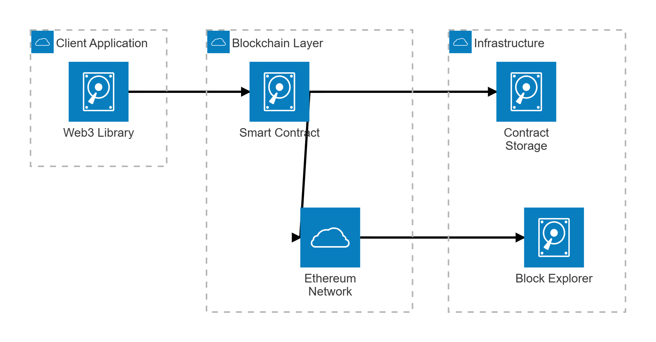
Fig (1) Architecture Diagram

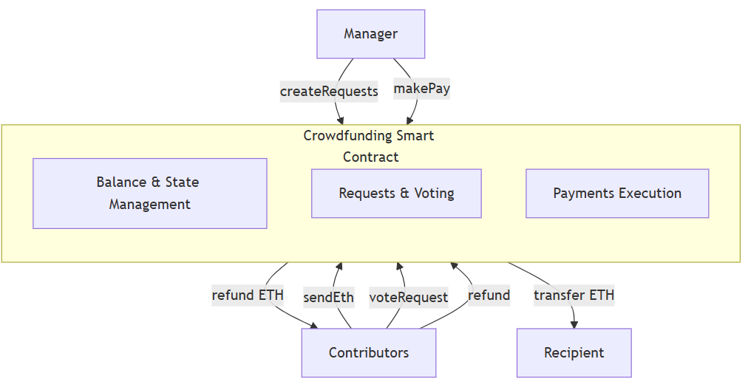

Fig (2) Context Diagram

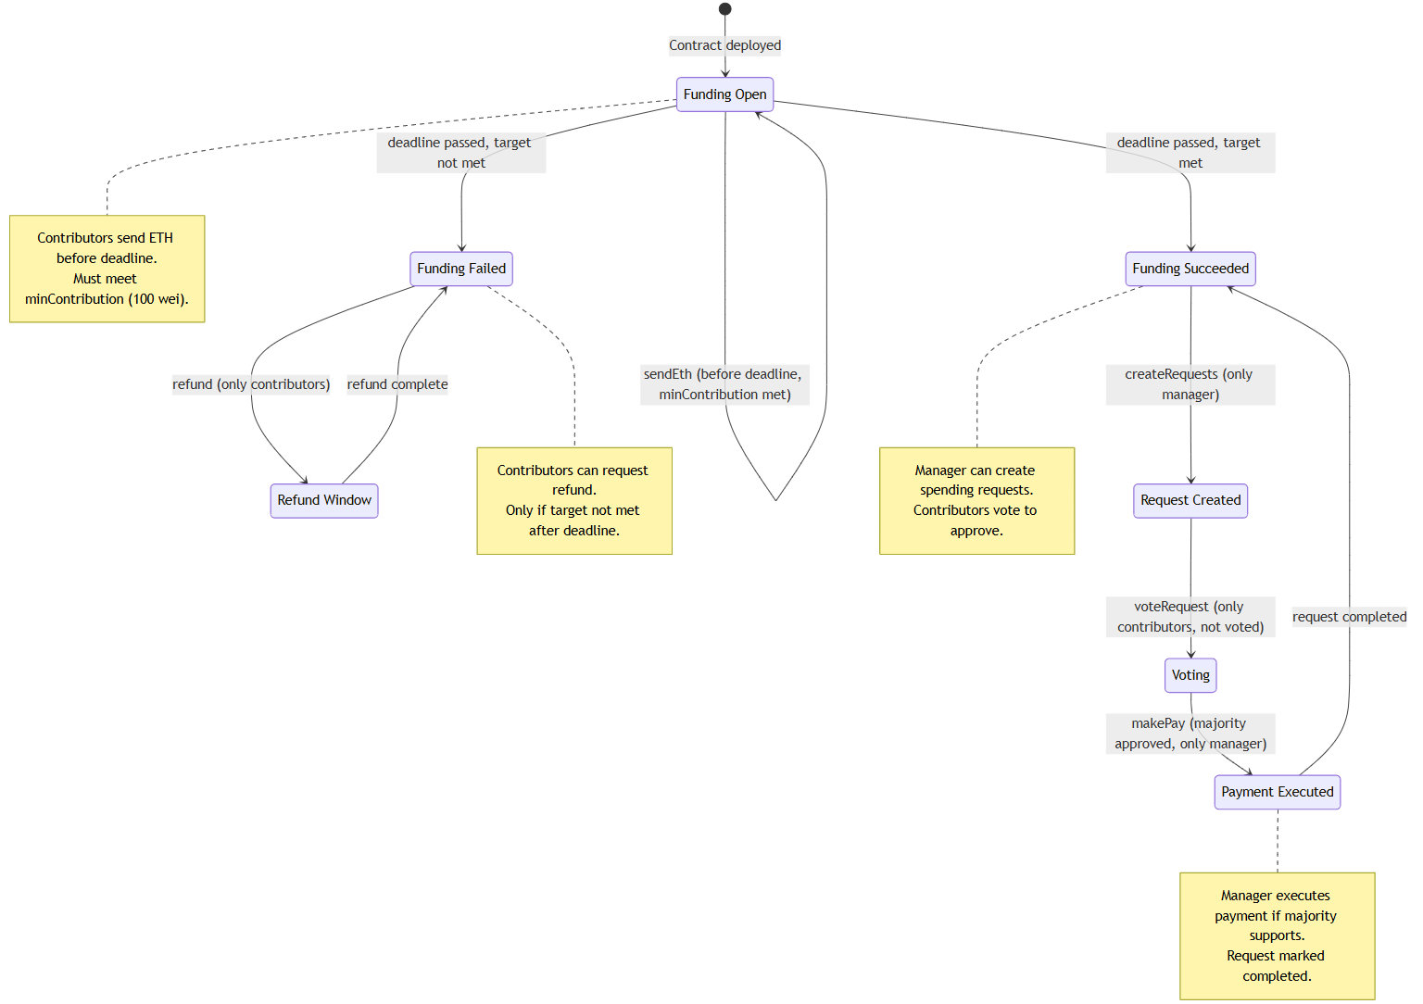

Fig (3) State Diagram

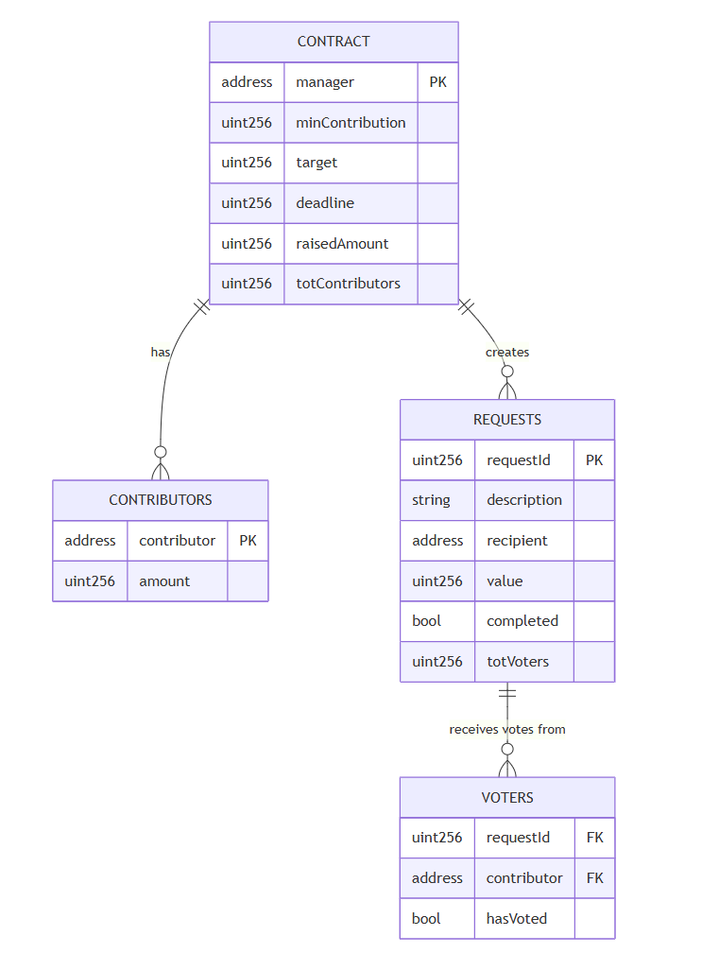
Fig (4) ER Diagram

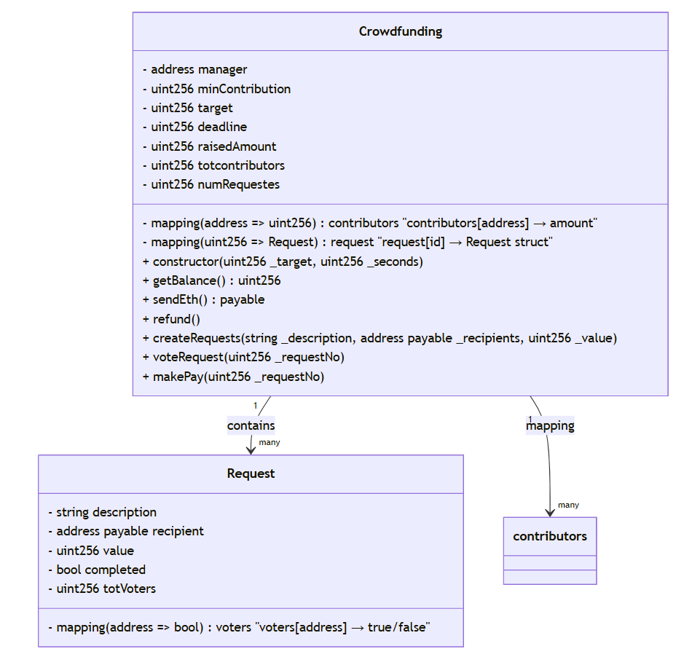

Fig (5) Class Diagram

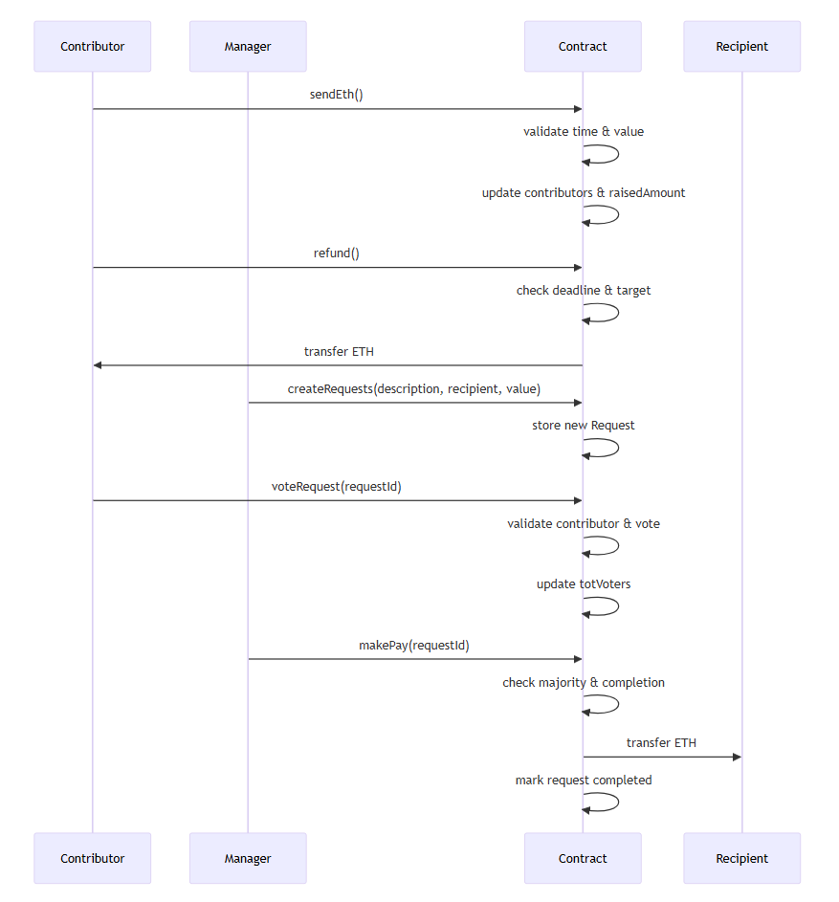

Fig (6) Sequence Diagram

