## **Running Backend Server:**

* Extract the zip folder in any directory.

For example – the zip folder is extracted in directory -> E:\xampp_7.3\htdocs

Then Open cmd in this directory or where you extracted your zip folder –

E:\xampp_7.3\htdocs\cura

Here, cura is the name of the project folder.

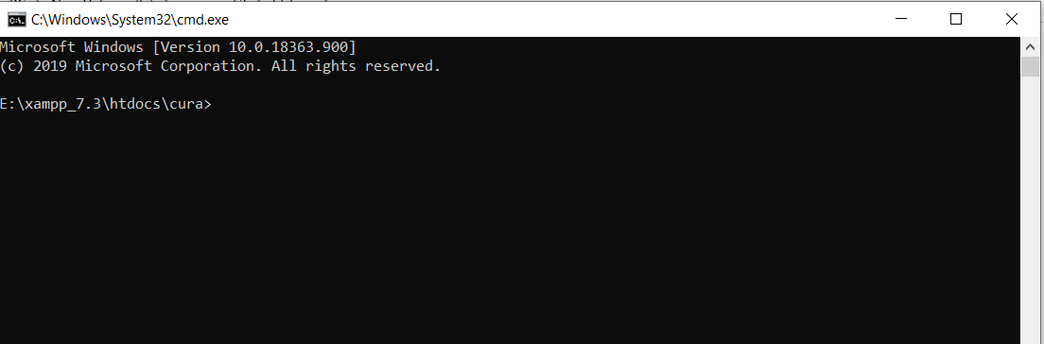

## 

Run command “cd nodejsBackend” to run the backend.

Run command “node server.js” to start the backend server.

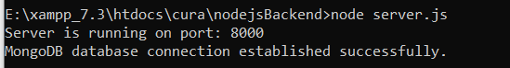

Now, the backend is running.

## **Running Frontend Server:**

Open cmd in this directory or where you extracted your zip folder. –

E:\xampp_7.3\htdocs\cura

Here, cura is the name of the project folder.

To run frontend , run the command in the project folder –

npm start

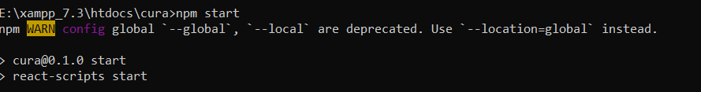

It will redirect to the browser.