Deployment Manual: Data Weaver-Distributed Agentic Data Pipeline

- Overview
The Distributed Agentic Data Pipeline is a multi-node AI system that automates dataset integration using a two-agent architecture:
  - Mapper Agent (Node 1) → Schema inference & ERD generation
  - Aggregator Agent (Node 2) → Data transformation, joins, validation
The system is orchestrated using:
  - LangGraph (agent workflow)
  - FastAPI (service layer)
  - Streamlit (UI dashboard)
  - Tailscale (secure node-to-node networking)
- Target Deployment Architecture
Production Topology
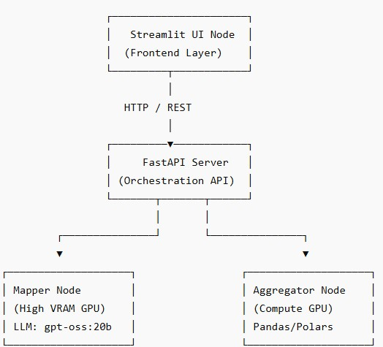
- Prerequisites
Hardware Requirements
Component Minimum Requirement Mapper Node 24–36 GB VRAM GPU
Aggregator Node 12–16 GB VRAM GPU
API Server 8 GB RAM
UI Server 4 GB RAM

Software Requirements
  - Python 3.10+
  - Docker (recommended for production)
  - Git
  - Tailscale
  - CUDA Toolkit (if GPU-enabled)
- Repository Setup Step 1: Clone Repository
git clone https://github.com/htmw/S2026A-Team2.git cd S2026A-Team2
Step 2: Environment Setup
Create virtual environments per service:
python -m venv venv source venv/bin/activate # Linux/macOS venv\Scripts\activate # Windows
Install dependencies:
pip install -r requirements.txt 5. Environment Configuration
Create a .env file in the root:
# API
API_HOST=0.0.0.0
API_PORT=8000

# Agent Nodes
MAPPER_NODE_URL=http://<mapper-node-ip>:8001
AGGREGATOR_NODE_URL=http://<aggregator-node-ip>:8002

# Model Configuration
MODEL_NAME=gpt-oss:20b

# Data Paths
DATA_INPUT_PATH=/data/input
DATA_OUTPUT_PATH=/data/output

# Tailscale Network
TAILSCALE_AUTH_KEY=<your-auth-key>
6. Network Setup (Tailscale) Step 1: Install Tailscale curl -fsSL https://tailscale.com/install.sh | sh Step 2: Authenticate tailscale up --authkey <your-auth-key> Step 3: Verify Connectivity
tailscale status
ping <peer-node-name>
Ensure all nodes:
- Can reach each other via private Tailscale IPs
- Use those IPs in .env 7. Model Deployment
Step 1: Install Model Runtime
Depending on your implementation (e.g., Ollama or local runner):
ollama pull gpt-oss:20b Step 2: Run Model Service ollama serve
Ensure:
- Model is accessible via API
- Ports are open internally (not public)
8. Service Deployment 8.1 Mapper Node Deployment
cd services/mapper
uvicorn main:app --host 0.0.0.0 --port 8001
Responsibilities:
- Schema inference
- ERD generation 8.2 Aggregator Node Deployment
cd services/aggregator uvicorn main:app --host 0.0.0.0 --port 8002
Responsibilities:
- Data joins
- Schema validation
- Invariant checks 8.3 FastAPI Orchestrator
cd services/api
uvicorn main:app --host 0.0.0.0 --port 8000
Responsibilities:
- Workflow orchestration
- Routing requests between agents 8.4 Streamlit UI Deployment
cd ui
streamlit run app.py --server.port 8501
- Docker-Based Deployment (Recommended) Build Images
docker build -t agentic-api ./services/api docker build -t mapper-node ./services/mapper docker build -t aggregator-node ./services/aggregator docker build -t streamlit-ui ./ui
Docker Compose Example
version: '3.8'

services: api: image: agentic-api ports:
  - "8000:8000" env_file:
  - .env

mapper:
image: mapper-node ports:
  - "8001:8001"

aggregator:
image: aggregator-node ports:
  - "8002:8002"
ui: image: streamlit-ui ports: - "8501:8501" Run:
docker-compose up -d
- Data Pipeline Execution Trigger Pipeline POST /run-pipeline
Payload:
{
"input_files": ["customers.csv", "orders.csv"]
}
Expected Outputs
  - Cleaned dataset
  - ERD visualization
  - Data dictionary
  - Validation logs
- Monitoring & Logging
Logs
  - API logs → /logs/api.log
  - Mapper logs → /logs/mapper.log
  - Aggregator logs → /logs/aggregator.log
Health Check Endpoints
GET /health
GET /mapper/status
GET /aggregator/status
- Security Considerations
  - Use Tailscale private network (no public exposure)
  - Enable API authentication (JWT recommended)
  - Restrict ports using firewall rules
  - Store secrets in vault or environment variables
- Scaling Strategy
Horizontal Scaling
  - Add more Aggregator nodes for parallel processing
  - Load balance via API gateway
Vertical Scaling
  - Increase GPU VRAM for Mapper node (improves reasoning quality)
- Failure Handling
Failure Type Mitigation
Node failure Retry via orchestrator
Model timeout Fallback to cached schema
Data explosion Enforced row-count invariant

- Rollback Strategy
  - Maintain versioned Docker images
  - Use tagged releases:
docker pull agentic-api:v1.2
  - Rollback via:
docker-compose down docker-compose up -d --build 16. Post-Deployment Validation Checklist:
  - All services reachable
  - Tailscale network stable
  - Model responding
  - Pipeline executes end-to-end
  - UI reflects results correctly
- Known Limitations
  - High VRAM dependency for Mapper agent
  - Latency increases with dataset size
  - Requires stable inter-node networking
- Conclusion
This deployment setup enables a production-grade distributed AI pipeline with:
  - Deterministic validation (not just LLM guessing)
  - Modular scaling across nodes
  - Clear separation of reasoning vs execution

