KneeVision: Knee Osteoarthritis Detector
Daniel Fox, Manohar Killamsetti, Siming Li, Sarvesh Shah, Swatej Mella, Deep Patel
Seidenberg School of Computer Science and Information Systems
Pace University, New York, NY, USA

Abstract—Knee osteoarthritis (KOA) is a leading cause of chronic disability globally, yet achieving rapid and objective diagnosis remains a significant challenge due to the subjective na- ture of manual radiographic interpretation. This paper presents KneeVision, a web-based application that leverages deep learning to automate the detection and grading of knee osteoarthritis severity. A combined dataset of 75,000 knee X-ray images across five Kellgren-Lawrence (KL) grades was constructed using real radiographic data augmented with synthetically generated images from class-conditional Deep Convolutional Generative Adversarial Networks (DCGANs). EfficientNet-B4, pretrained on ImageNet, was adopted as the classification backbone with a custom classifier head, trained using a two-stage fine-tuning strategy. The system achieves approximately 93% validation and test accuracy across all five KL grades, demonstrating the viability of deep learning for consistent, automated knee osteoarthritis grading from X-ray images.
Index Terms—Deep Learning, Knee Osteoarthritis, Kellgren- Lawrence Grading, Medical Imaging, X-ray Analysis, Web-based Application, Computer-Aided Diagnosis, Musculoskeletal Health, Automated Grading, EfficientNet, DCGAN.

- Introduction
Knee osteoarthritis (KOA) is a prevalent and disabling joint disease whose occurrence has doubled in older adults since the mid-20th century. It arises when the knee joint becomes inflamed due to regular wear and tear, causing progressive degradation of the knee cartilage — the protective tissue covering the bone — leading to long-term structural damage [1]. As the global population ages, KOA has become one of the leading causes of pain and physical disability worldwide, placing a significant burden on both patients and healthcare systems [2].
Diagnosis of KOA is predominantly performed through clinical examination and X-ray imaging, with the Kellgren- Lawrence (KL) grading system serving as the standard mea- sure of disease severity [3]. The KL system classifies knee osteoarthritis into five grades — 0 through 4 — based on radio- graphic features such as joint space narrowing, osteophyte for- mation, and subchondral sclerosis. However, interpreting these features is inherently subjective. Aligning patient-reported symptoms with radiographic findings is difficult, and grading the same X-ray can yield different results across clinicians, making diagnosis inconsistent and observer-dependent [4].
This inconsistency has significant clinical consequences. Misgrading can lead to delayed treatment, inappropriate in- tervention, or missed progression of the disease. There is therefore a clear need for automated, objective tools that can
assist clinicians in grading KOA severity consistently and reliably.
Deep learning has emerged as a promising direction for automated medical image analysis, with convolutional neural networks demonstrating strong performance on classification tasks across radiology [5]. However, applying these methods to KOA grading presents its own challenges — the visual differences between adjacent KL grades are subtle, and the limited availability of large, well-labelled knee X-ray datasets makes robust model training difficult.
KneeVision addresses these challenges through an end- to-end automated KOA grading system. It combines syn- thetic data generation through DCGANs with a fine-tuned EfficientNet-B4 backbone to produce a robust, automated KOA grading system. The following sections detail the dataset construction, methodology, and system components.

- Methodology

- Dataset
KneeVision’s development is built around two datasets: the Mendeley I dataset (Chen, Pingjun [6]) and the Kaggle KOA dataset [7]. Both contain knee X-ray images spanning all five KL grades (0–4). The Mendeley I dataset comprised 8,260
images at a uniform resolution of 224×224 pixels, while the Kaggle dataset comprised 400 images at variable dimensions.
Preprocessing began with manual removal of corrupted or clinically invalid images — cases containing surgical hardware such as knee screws were excluded. Since the Kaggle images had variable dimensions, a Python script performing multi- signal ROI cropping via a joint detection algorithm was applied to standardize them, centering the region of interest consistent with the fixed-resolution Mendeley I images. After combining both datasets and completing preprocessing, the total usable image count stood at 8,684 — insufficient for training a robust deep learning classifier.
To resolve this, five class-conditional Deep Convolutional Generative Adversarial Networks (DCGANs) were trained — one per KL grade — on the combined real dataset to generate synthetic X-ray images. The architecture of each DCGAN is detailed in Fig. ??. Synthetic images were combined with the original dataset to produce a final training set of 75,000 images, with 15,000 images per grade, fully resolving the class imbalance problem.

- Frontend Architecture
The frontend of KneeVision is constructed using React
18 and TypeScript. Vite serves as the build environment, enabling hot reloading during development and fast production builds with tree-shaking. Tailwind CSS provides a utility-first styling framework with mobile-first breakpoints and built- in dark mode support. The application comprises five main pages: Landing, Login, Register, Upload, and Image Gallery. State management is handled through React’s useState and useEffect hooks, and Vite’s proxy configuration forwards client-side requests to the Express backend without CORS violations. File upload functionality is implemented using the react-dropzone library, supporting JPG, PNG, WebP, and DICOM formats with live preview and upload progress visualization. The interface was initially prototyped in Figma, with the landing page reflecting the platform’s target metrics: over 95% model accuracy, under five seconds analysis time, and full KL grade 0–4 coverage.
- Backend Architecture
The backend is implemented in Node.js using the Express.js web framework, chosen for its non-blocking I/O design which is well-suited to handling parallel processes such as image uploading and inference. RESTful API endpoints are organized into three categories: authentication endpoints (/api/v1/auth/register, /api/v1/auth/login), image handling endpoints (/uploads/presign,
/uploads/:key, /api/v1/images), and health
checks (/health). Stateless authentication is implemented via JWT tokens issued upon successful login, carrying userId and user email claims with a one-hour expiration. The requireAuth middleware verifies token presence and validity on all protected routes, returning HTTP 401 for expired or malformed tokens. Password hashing is performed using bcrypt with 10 salt rounds. The Sharp library handles server-side image preprocessing, performing grayscale conversion and aspect-ratio-preserving resize to match model input requirements.
- Database and Cloud Infrastructure
KneeVision uses MongoDB, hosted on MongoDB Atlas, as its primary database. Three collections are maintained: users (storing userId, email, passwordHash, and timestamp, with a unique index on email to prevent duplicate entries), images (storing fileUrl, originalName, contentType, uploadedBy, and timestamps), and predictions (storing imageId as a foreign key, KL grade, confidence score, per-class probability values, and model version). The schema supports multiple predictions per image across multiple model versions. For production de- ployment, the infrastructure is designed around AWS services
  - S3 for image storage, EC2 or Lambda for the Express server and ML inference engine, and CloudFront CDN for frontend asset delivery. In Sprint 1, images were stored via a local filesystem mount at /uploads/ with presign endpoints returning local disk paths.
- DevOps and Quality Assurance
Version control and collaboration are managed through GitHub, with a branch protection strategy that disallows direct commits to the master branch. All features are developed on independent feature branches and merged via pull requests requiring at least one reviewer. A CI/CD pipeline runs the full test suite on every push. Project backlog and sprint planning are managed in Jira, with commit messages linked to corresponding SCRUM tickets. Code quality is enforced through ESLint and Prettier, applied via pre-commit hooks using Husky.
Testing is conducted using Jest for backend unit and in- tegration tests, and Vitest with React Testing Library for frontend component tests. Sprint 1 produced a total of 86 tests across eight modules with zero failures and an estimated coverage of approximately 89%. Backend modules include:
imageProcessor.js (11 tests, ∼95%), db.js (6 tests,
∼90%), and API Routes (17 tests, ∼88%). Frontend modules include: LoginForm (10 tests, ∼92%), RegisterForm (10 tests,
∼91%), ImageGallery (8 tests, ∼90%), ImageUploader (8 tests, ∼85%), and Pages (16 tests, ∼88%).
- Machine Learning Pipeline
  - Data Augmentation via DCGAN: Given that the com- bined real dataset totalled only 8,684 images across five KL grades, synthetic data generation was necessary to build a robust classifier. Five Deep Convolutional Generative Adver- sarial Networks (DCGANs) were trained — one per KL grade
  - on the preprocessed real images. Each DCGAN consists of a Generator that takes a 100-dimensional Gaussian noise vector and progressively upsamples it through four transposed convolution layers with batch normalization and ReLU ac-
tivations, outputting a 64×64 synthetic X-ray image. The Discriminator mirrors this with four strided convolution layers,
batch normalization, and LeakyReLU activations, outputting a scalar probability of the image being real. Both networks were trained adversarially — the Discriminator learning to distinguish real from fake, the Generator learning to fool it. The resulting synthetic images were combined with the original dataset to produce a final training set of 75,000 images, with 15,000 per grade, resolving the class imbalance problem entirely.
  - Model Selection: Initial experiments were conducted with the Compact Convolutional Transformer (CCT), which combines convolutional tokenization with transformer-based self-attention. Despite being well-suited for image classifica- tion, CCT plateaued at around 57% validation accuracy and showed no meaningful improvement with further training. The fundamental issue was that transformer-based architectures re- quire large amounts of data to learn reliable attention patterns
  - even at 75,000 images, the model struggled to generalize. CCT was abandoned in favour of a convolutional approach.
EfficientNet-B4 was selected as the final backbone. Unlike transformers, convolutional networks carry strong inductive biases — locality and translation invariance — that are well

matched to the structured, repeatable patterns in knee X- rays such as joint space narrowing, osteophyte formation, and subchondral sclerosis. EfficientNet-B4 scales network depth, width, and input resolution jointly via a compound coefficient, giving it significantly more representational capacity than smaller variants without a proportional increase in computa- tional cost. Pretrained on ImageNet, it arrives with rich low- level feature representations that transfer effectively to the radiographic domain.
  - Architecture: The original EfficientNet-B4 classifier was replaced with a custom head: Dropout(0.4) → Linear(1792, 512) → ReLU → Dropout(0.3) → Linear(512, 5), mapping the 1792-dimensional pooled feature vector to five KL grade
classes. The total model comprises approximately 17.5 million parameters. The architecture is illustrated in Fig. 1.
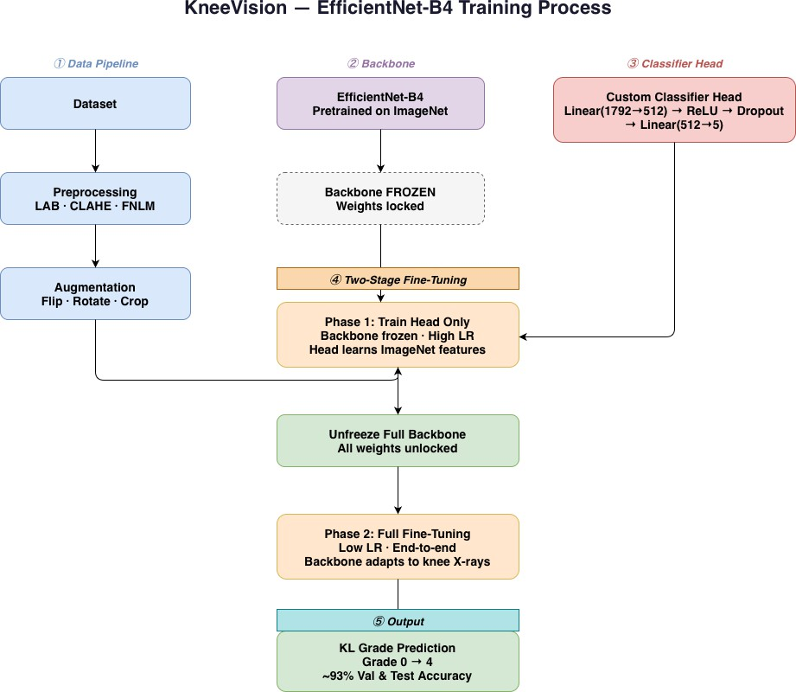

Fig. 1. KneeVision model overview: EfficientNet-B4 backbone with custom classifier head and two-stage fine-tuning strategy.

  - Two-Stage Fine-Tuning: Training was conducted on an NVIDIA H100 GPU via Google Colab using a two-stage strat- egy designed to avoid destabilizing the pretrained backbone too early.
In Stage 1, the backbone was fully frozen and only the classifier head was trained for 15 epochs using the Adam optimizer at a learning rate of 0.001 with ReduceLROnPlateau scheduling. This allowed the head to establish stable, meaning- ful representations before any backbone weights were touched, reaching 60.57% validation accuracy.
In Stage 2, the entire model was unfrozen and trained end- to-end for up to 150 epochs with differential learning rates — 3×10⁻⁵ for the backbone and 1.5×10⁻⁴ for the classifier head
  - allowing the backbone to adapt to the radiographic domain
without overwriting its pretrained features too aggressively. A cosine annealing scheduler decayed the learning rate to 1 × 10⁻⁷. Mixup augmentation (α=0.2) blended training image pairs and their labels each batch as a strong regularizer, and
label smoothing (ε=0.1) prevented overconfident predictions. Online augmentation during this stage included random crop (256→224), horizontal flip, rotation (±10◦), affine translation (5%), scale jitter (95–105%), color jitter (brightness/contrast
±20%), and random erasing (p=0.2). Early stopping with a patience of 30 epochs was applied to prevent overfitting. Batch size was set to 256 to fully utilize H100 memory. This strategy
reached approximately 93% validation and test accuracy across all five KL grades.
References
- R. C. Lawrence et al., “Estimates of the prevalence of arthritis and other rheumatic conditions in the United States,” Arthritis & Rheumatism, vol. 58, no. 1, pp. 26–35, 2008.
- D. T. Felson, “Epidemiology of hip and knee osteoarthritis,” Epidemio- logic Reviews, vol. 10, pp. 1–28, 1988.
- J. H. Kellgren and J. S. Lawrence, “Radiological assessment of osteo- arthrosis,” Annals of the Rheumatic Diseases, vol. 16, no. 4, pp. 494– 502, 1957.
- A. Kinds et al., “Radiographic features of osteoarthritis and inter- observer variability,” Osteoarthritis and Cartilage, vol. 20, no. 9, pp. 981–986, 2012.
- G. Litjens et al., “A survey on deep learning in medical image analysis,” Medical Image Analysis, vol. 42, pp. 60–88, 2017.
- P. Chen, “Knee osteoarthritis severity grading dataset,” Mendeley Data, 2018. [Online]. Available: https://data.mendeley.com/datasets/56rmx5bjcr/1
- “Knee osteoarthritis dataset with severity grading,” Kaggle. [On- line]. Available: https://www.kaggle.com/datasets/shashwatwork/knee- osteoarthritis-dataset-with-severity

