KneeVision
User Manual
AI-Assisted Knee X-ray Analysis Platform

Document Type | User Manual
Project | KneeVision
Course Deliverable | CS691 Sprint 3 Final Application Artifact
Version | v1.0.0
Application URL | https://frontend-three-khaki-28.vercel.app/
Prepared Date | May 2026

Revision History
Version | Date | Description
v1.0.0 | May 2026 | Initial final user manual for Sprint 3 Wiki submission.

Table of Contents
- 1. Introduction
- 2. Access Requirements and Demo Account
- 3. Application Layout
- 4. Registering and Logging In
- 5. Dashboard
- 6. Uploading a Knee X-ray and Running AI Analysis
- 7. Understanding the Results Page
- 8. History, Filtering, Deletion, and CSV Export
- 9. Sidebar Search
- 10. Educational Quiz
- 11. Profile and Settings
- 12. Logging Out
- 13. Troubleshooting
- 14. Glossary

1. Introduction

1.1 Purpose
This user manual explains how to access and operate KneeVision, a web-based AI-assisted knee X-ray analysis platform. It is written for users who need to complete the normal application workflow: create or use an account, upload a knee X-ray image, review the AI-assisted output, check saved records, export results, and use the educational quiz features.

1.2 Intended Users
- Research users who need to organize knee X-ray analysis records and export prediction history.
- Clinicians or medical reviewers who want a structured interface for reviewing AI-assisted KL grade outputs.
- Medical students who want to practice KL grade recognition through quiz-style cases.
- Course evaluators who need to test the final MVP workflow during the CS691 Sprint 3 review.

1.3 Scope of the Application
KneeVision supports user authentication, image upload, AI-assisted prediction, result review, saved analysis history, CSV export, educational tooltips, profile preferences, display settings, and a KL grading quiz. The deployed build uses a Vercel frontend, a Render backend, and a Hugging Face ML service as shown in the application settings page.
Medical Use Notice
KneeVision is an AI-assisted educational and research support tool. It is not a diagnostic device and should not replace clinical judgment, formal radiology review, or medical decision-making. Confidence scores indicate model certainty for the selected class, not clinical accuracy.

2. Access Requirements and Demo Account

2.1 Application URL
Open the deployed frontend application at: https://frontend-three-khaki-28.vercel.app/

2.2 Demo Account
Use the following account for final demo testing:
Field | Value
Email | 123@gmail.com
Password | 123456789

2.3 Browser and Device Requirements
- Use a modern desktop browser such as Google Chrome, Microsoft Edge, Firefox, or Safari.
- A stable internet connection is required because the frontend, backend API, and ML service are deployed separately.
- For the best layout, use a laptop or desktop screen. Smaller screens are supported, but the desktop view is recommended for grading and review.
- Allow file download permissions if you plan to export prediction history as CSV.

2.4 Recommended Input Files
- Recommended for final demo: clear JPG or PNG knee X-ray images.
- The interface may allow additional file extensions such as WebP or DICOM, but the final MVP workflow is tested and recommended with JPG and PNG knee X-ray images.
- Avoid heavily blurred images, images where the knee joint is cropped out, or files that do not contain a knee X-ray.
- For immediate prediction testing, upload one image at a time. Batch upload is available for storage/gallery use, but a single-image workflow is easier to verify during the demo.

3. Application Layout

3.1 Public Pages
Before signing in, the application provides a landing page, login page, and registration page. The landing page introduces KneeVision and provides navigation to the authentication screens.
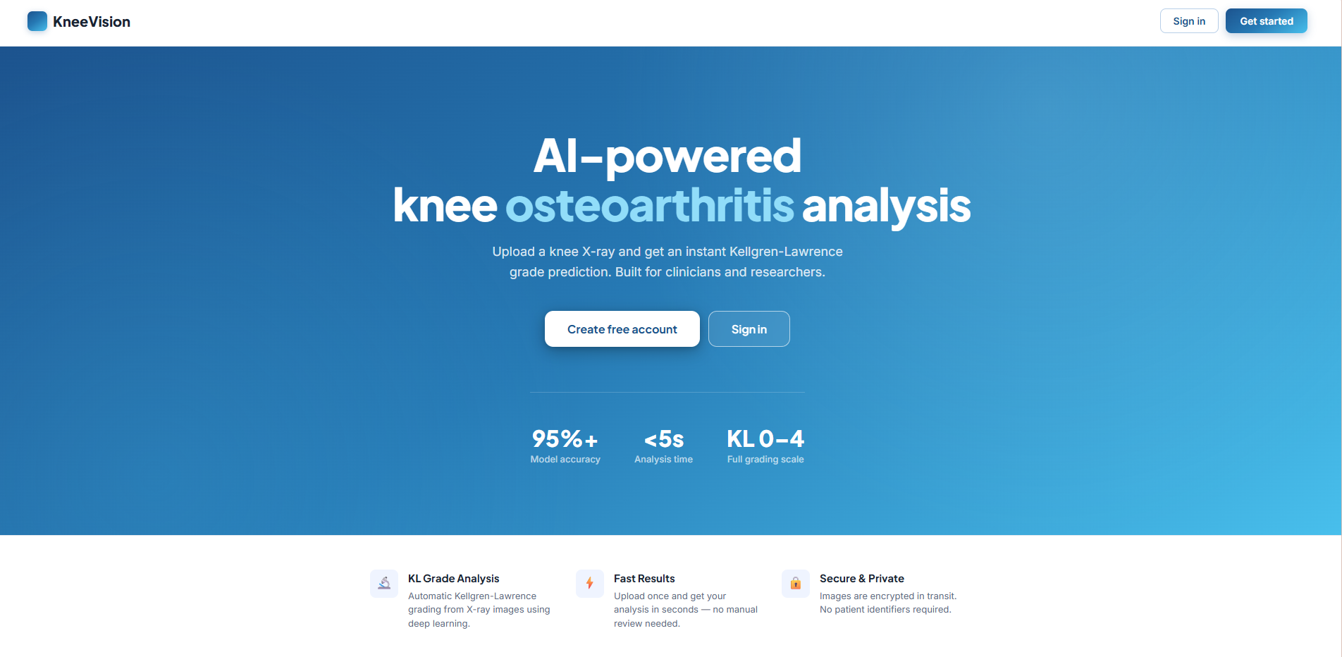

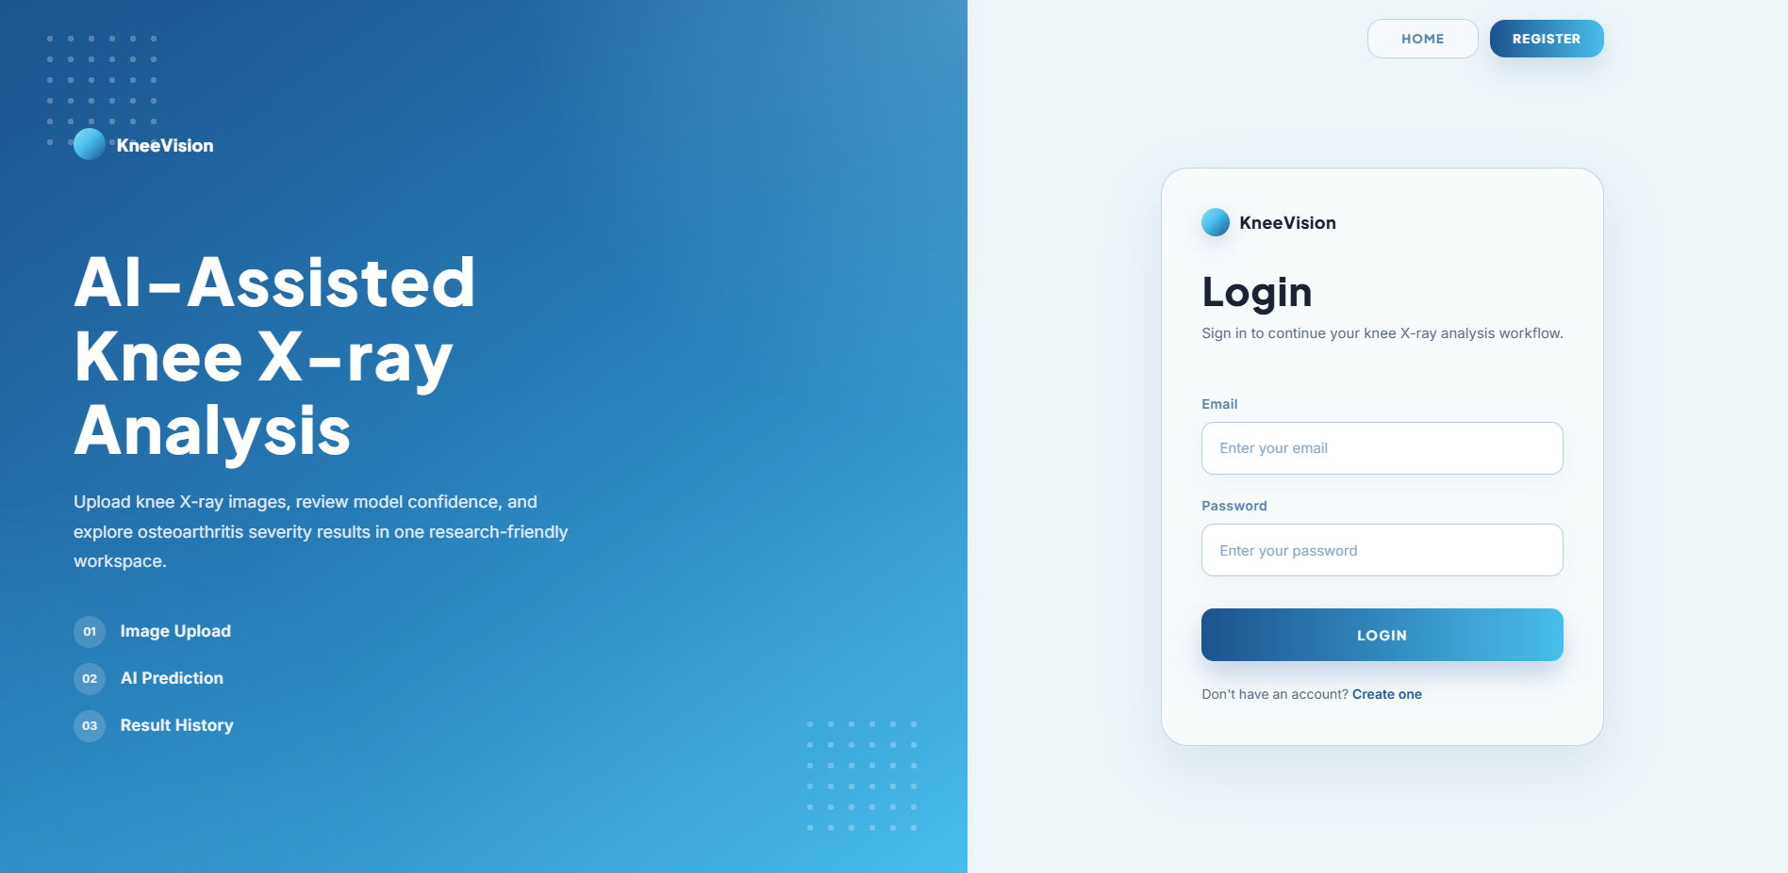

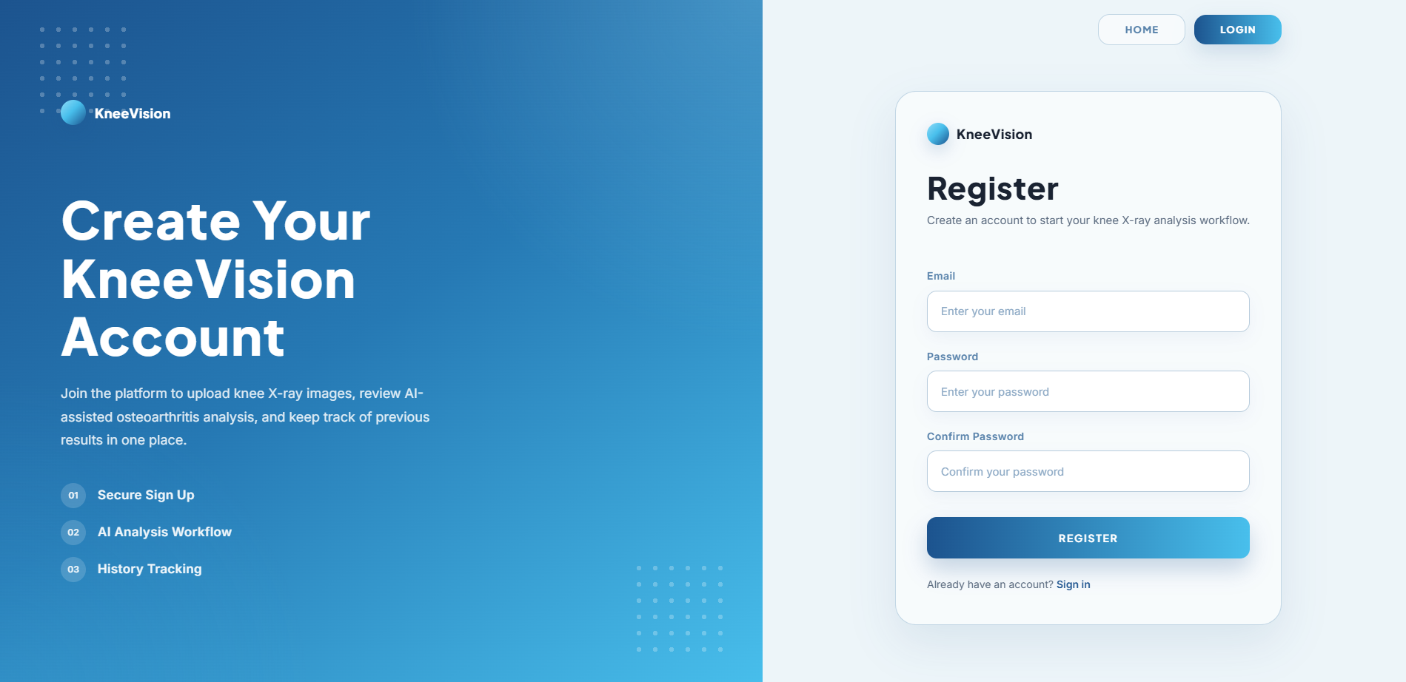

3.2 Authenticated Workspace
After login, KneeVision opens the dashboard-first workspace. The left sidebar contains the main navigation groups and a persistent search box. The workspace header shows the current page title, date, and workspace label.
Area | Description
Workspace Navigation | Dashboard, Upload, History, and Quiz.
Account Navigation | Profile and Settings.
Sidebar Search | Search by case number or file name.
User Card | Displays the signed-in user and provides the Logout action.

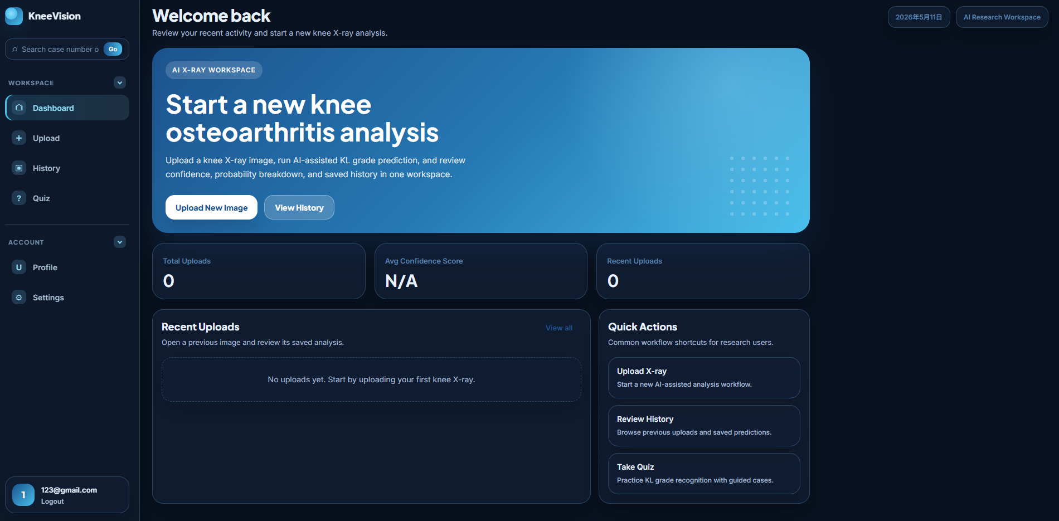

4. Registering and Logging In

4.1 Register a New Account
1. Open the application URL.
2. Select Register from the public page or login page.
3. Enter an email address.
4. Enter a password with at least 8 characters.
5. Re-enter the same password in Confirm Password.
6. Click Register.
7. After successful registration, the application redirects back to the login screen.
Validation Rules
The registration form requires an email address, a password of at least 8 characters, and a matching confirmation password. If validation fails, an error message is displayed above the submit button.

4.2 Login
1. Open the application URL.
2. Select Login.
3. Enter the demo account email or your registered account email.
4. Enter the account password.
5. Click Login.
6. If authentication succeeds, the application stores the session token in the browser and opens the Dashboard.
Old Token Issue
If the page shows unauthorized errors or fails to load data after deployment changes, log out and log in again. If the issue continues, clear the browser local storage for the site and sign in again.

5. Dashboard
The Dashboard is the main starting point after login. It provides a quick summary of the user account activity and shortcuts to the most important workflows.
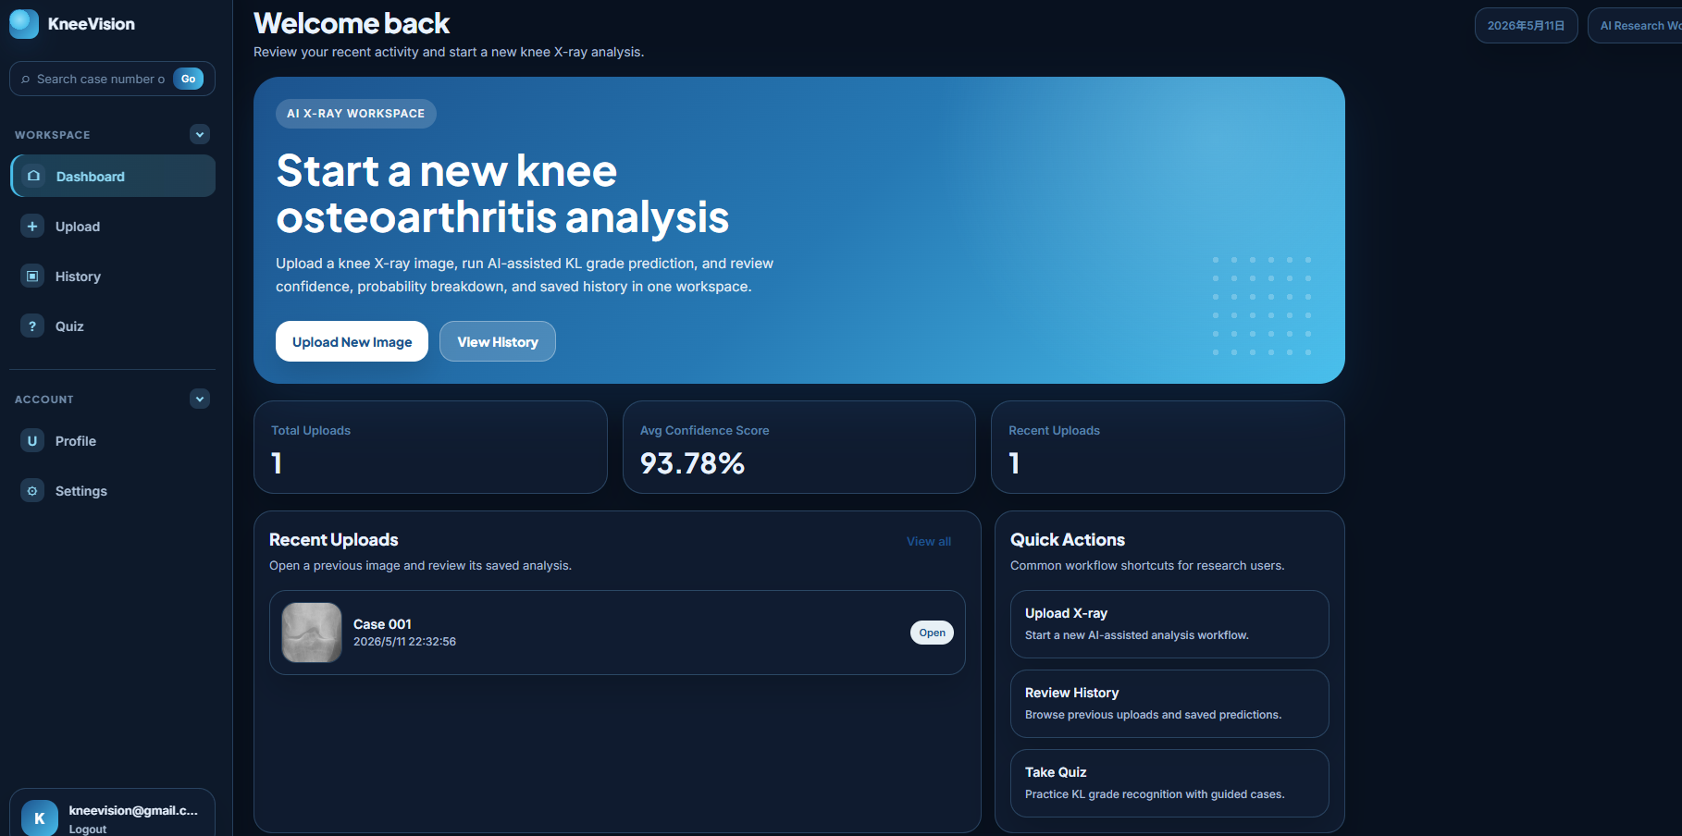

Dashboard Element | Purpose
Upload New Image | Starts a new knee X-ray upload and AI analysis workflow.
View History | Opens saved uploads and prediction records.
Total Uploads | Shows the number of uploaded images for the current account.
Average Confidence Score | Shows the average confidence value across saved predictions when available.
Recent Uploads | Displays recent image records that can be reopened.
Quick Actions | Provides shortcuts for Upload, History, and Quiz.

6. Uploading a Knee X-ray and Running AI Analysis

6.1 Upload Workflow
1. Log in to KneeVision.
2. Open Upload from the sidebar or click Upload New Image from the Dashboard.
3. Drag a supported image file into the upload area, or click the upload area to browse local files.
4. Confirm that the selected file appears in the preview list.
5. Click Upload.
6. Wait while the application uploads the file and runs AI analysis.
7. After the prediction is returned, the application opens the Results page automatically.
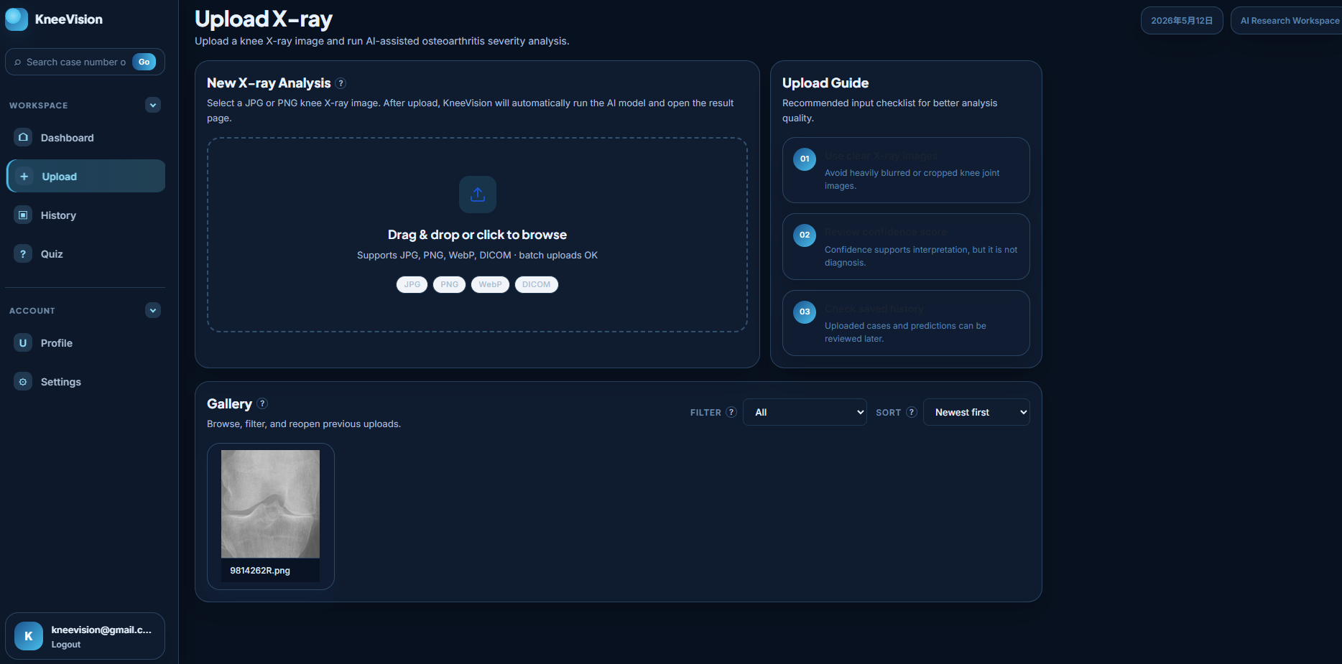

6.2 Upload Guide
- Use clear X-ray images with the knee joint visible.
- Avoid severe blur, excessive cropping, or images that are unrelated to knee X-rays.
- Review the confidence score after analysis. The confidence value supports interpretation but is not a diagnosis.
- Use the History page to review uploaded cases and predictions later.

6.3 Gallery on the Upload Page
The lower part of the Upload page shows previously uploaded images for the current account. Users can filter by date range and sort by newest, oldest, or filename order. Selecting an image reopens its saved analysis workflow when available.
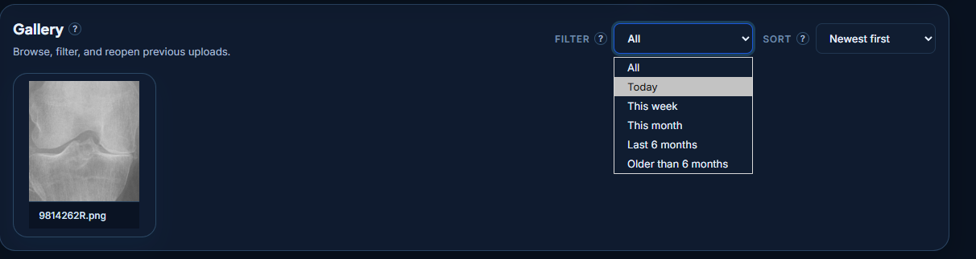

Technical Workflow Summary
From the user perspective, one upload triggers three backend steps: request an upload target, transfer the image file, and register the image record. After registration, the frontend calls the prediction endpoint and displays the returned AI result.

7. Understanding the Results Page
The Results page is the main review screen for AI-assisted output. It combines the prediction class, confidence, image view, heatmap explanation, probability distribution, summary, similar reference cases, and a case-level chat panel.
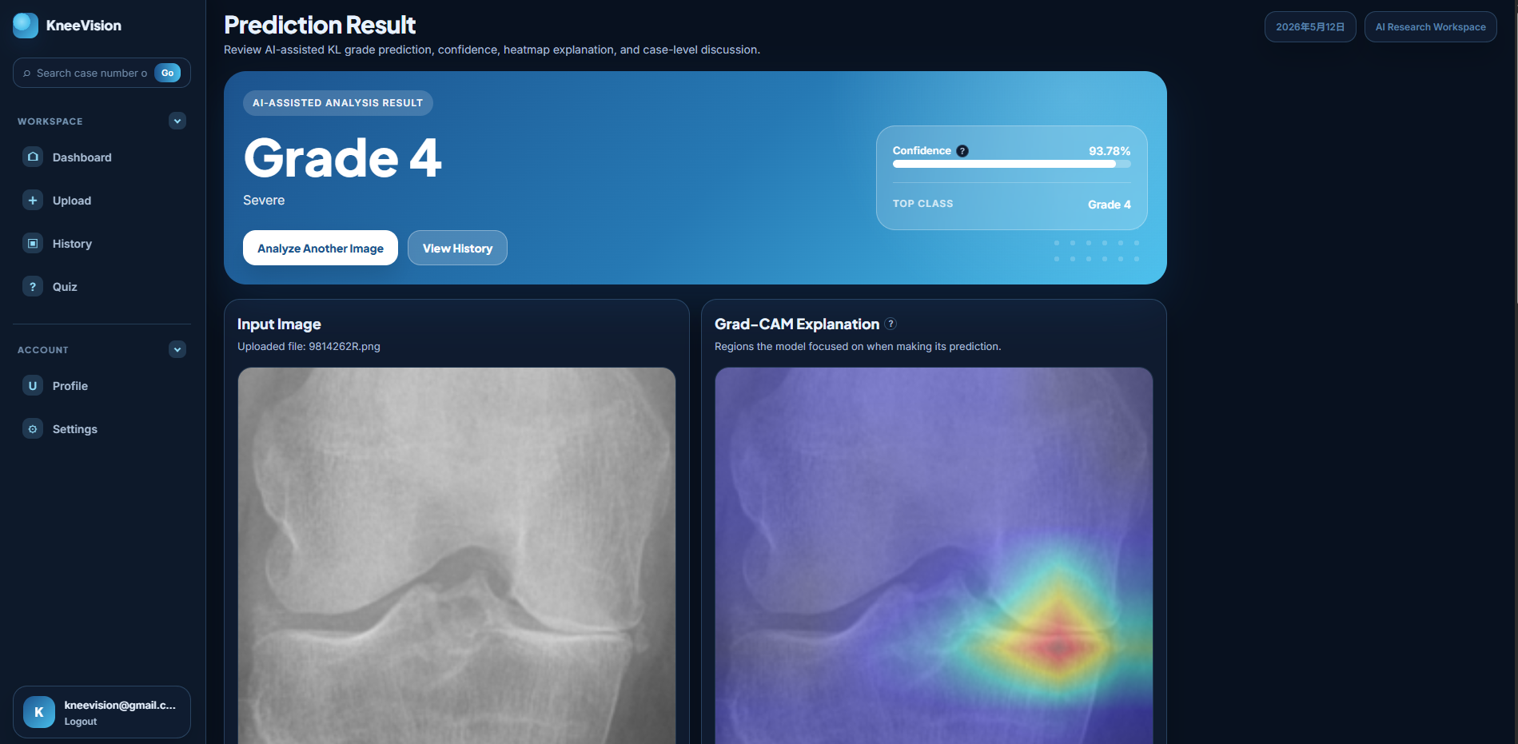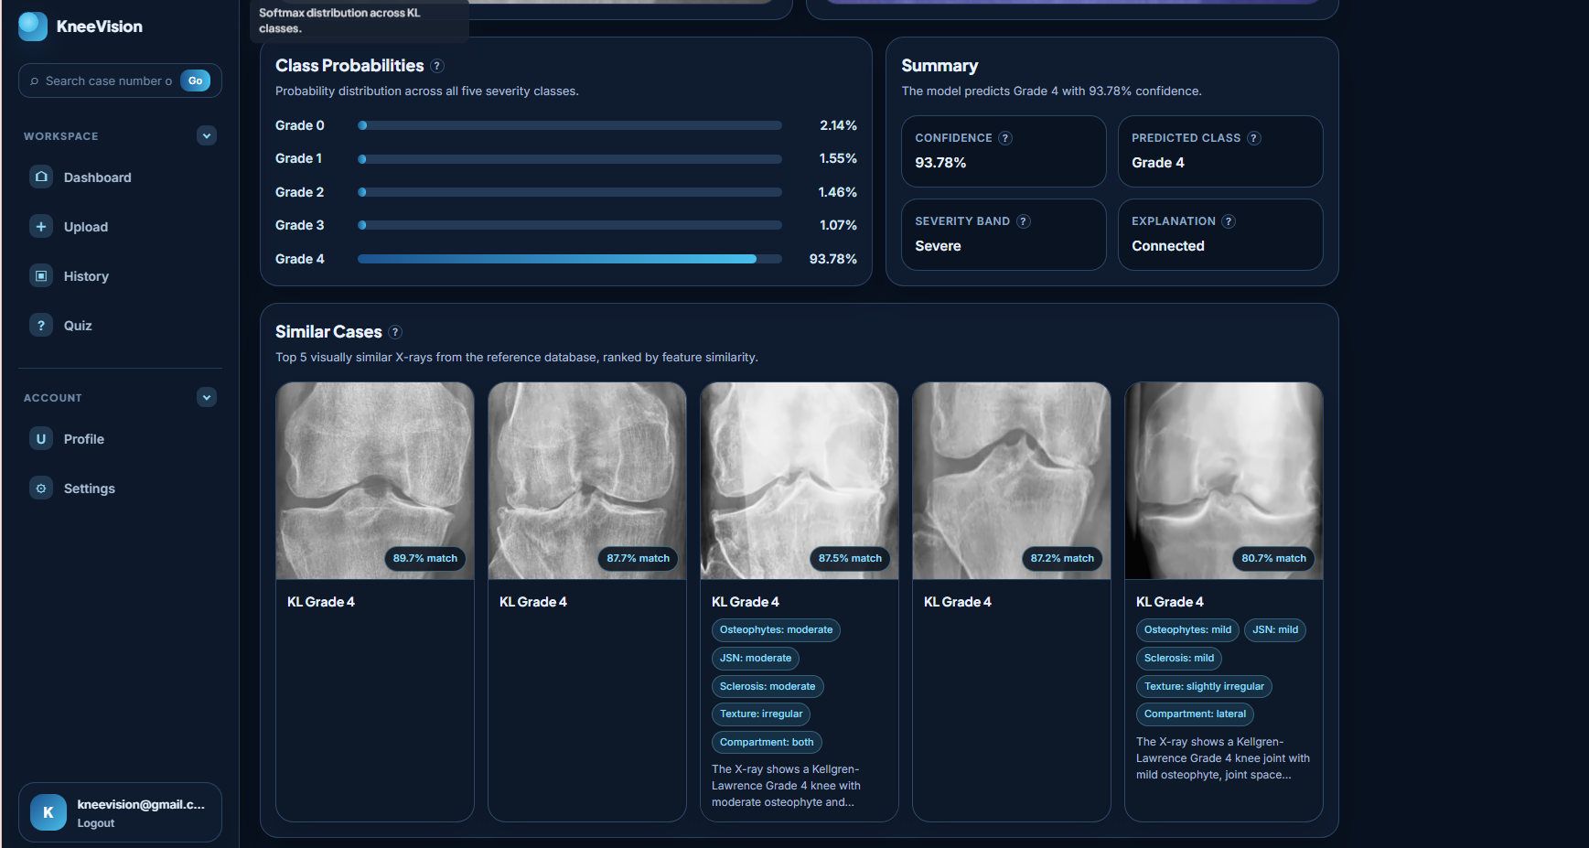

Result Element | Meaning
Predicted Grade | The predicted Kellgren-Lawrence grade returned by the model, displayed as Grade 0 to Grade 4.
Severity Label | A readable severity band derived from the predicted grade.
Confidence | Model certainty for the selected class. It is not the same as clinical accuracy.
Top Class | The class with the highest probability score.
Input Image | The uploaded image used for analysis.
Grad-CAM Explanation | A heatmap-style view showing image regions that influenced the model output. If the service does not return a heatmap, a placeholder preview may be shown.
Class Probabilities | A probability distribution across the five KL grade classes.
Summary | A short generated or backend-provided explanation of the result.
Similar Cases | Reference cases ranked by visual or feature similarity when available.
Ask about this X-ray | A chat panel for asking contextual questions about the grade, findings, and similar cases.

Result Interpretation
Do not treat the predicted grade or chat response as a final medical conclusion. The result should be reviewed by a qualified professional if used in any medical or research decision context.

8. History, Filtering, Deletion, and CSV Export
The History page stores uploaded cases and their saved prediction information for the signed-in account. It is designed for review and research-style record management.
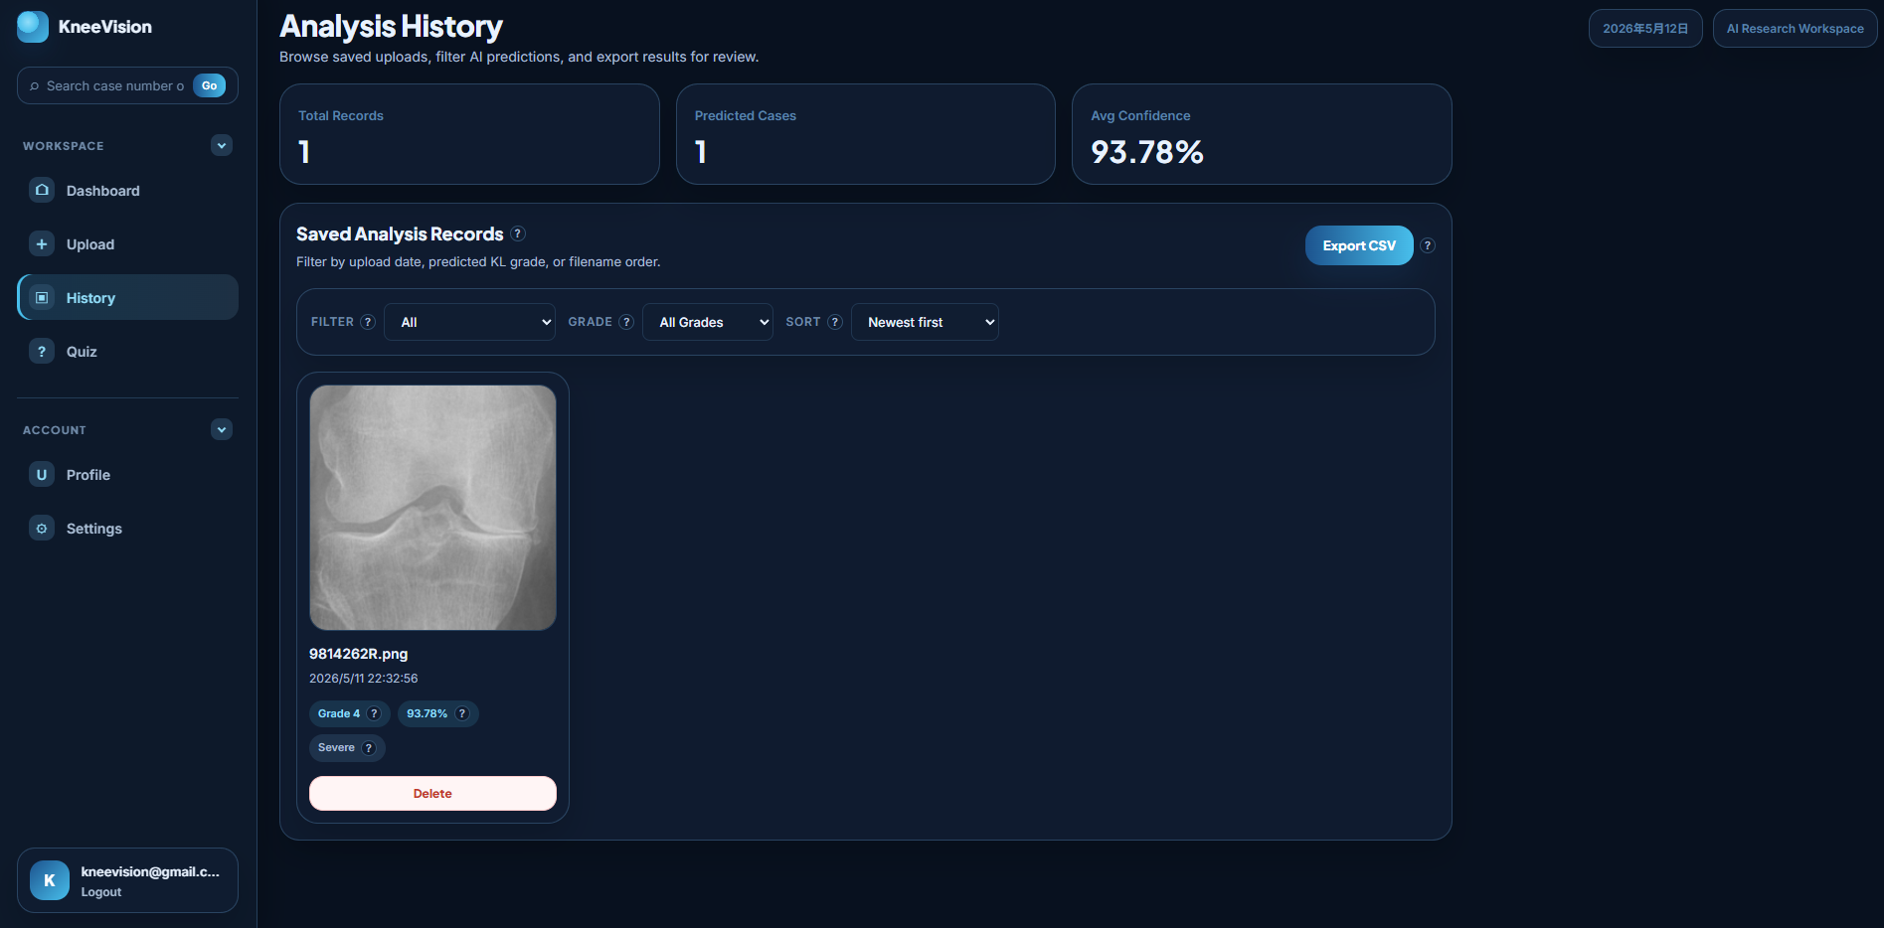

8.1 Summary Statistics
- Total Records: total number of image records shown for the account.
- Predicted Cases: number of records with a saved prediction grade.
- Average Confidence: average model confidence across records that include confidence values.

8.2 Filtering and Sorting
Control | Available Options
Date Filter | All, Today, This week, This month, Last 6 months, Older than 6 months.
Grade Filter | All Grades, Grade 0, Grade 1, Grade 2, Grade 3, Grade 4.
Sort | Newest first, Oldest first, Name (0-9, A-Z).

8.3 Open a Saved Record
1. Open History from the sidebar.
2. Apply filters or sorting if needed.
3. Click a history card to reopen that image and its saved analysis view.

8.4 Export CSV
1. Open History.
2. Click Export CSV.
3. Allow the browser to download the file if prompted.
4. Open the downloaded CSV in Excel, Google Sheets, or another spreadsheet tool for offline review.

8.5 Delete a Record
1. Open History.
2. Click Delete on the target history card.
3. Read the confirmation dialog carefully.
4. Click Delete to confirm or Cancel to keep the record.
Deletion Warning
Deleting an analysis removes the uploaded image, the AI prediction, and related chat history for that record. The action cannot be undone through the user interface.

9. Sidebar Search
The search box in the sidebar allows users to find a saved case by case number or file name. This is useful when the History page contains many records.
1. Locate the search box in the left sidebar.
2. Enter a case number or part of a file name.
3. Click Go.
4. If a match is found, the matching case opens. If no match is found, the application displays a short notification.
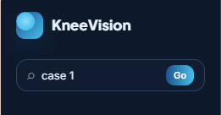

10. Educational Quiz
The Quiz page is an educational feature for practicing KL grade recognition. It presents X-ray cases, asks the user to choose a KL grade, and provides immediate feedback.
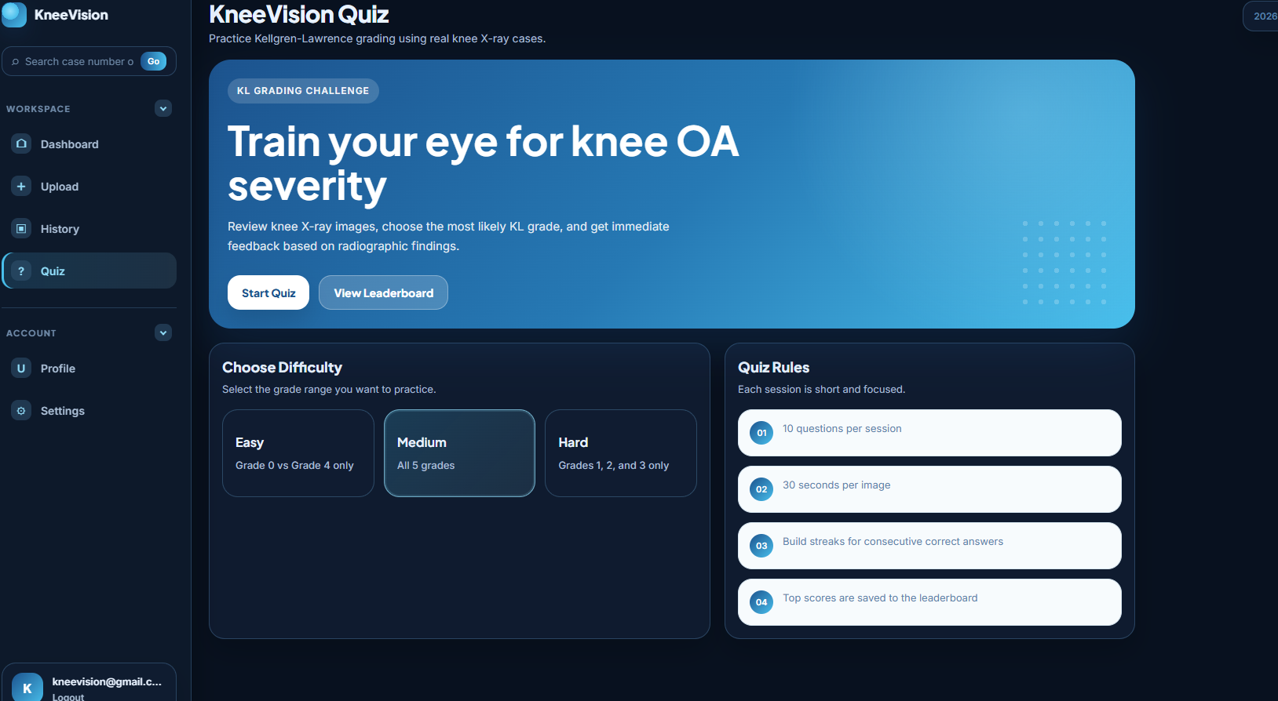

10.1 Difficulty Levels
Difficulty | Question Scope
Easy | Grade 0 vs Grade 4 only.
Medium | Grades 0, 1, 2, 3, and 4.
Hard | Grades 1, 2, and 3 only.

10.2 Quiz Rules
- Each quiz contains 10 questions.
- Each question has a 30-second timer.
- The user selects one of the KL grade options.
- After submission, the app shows whether the answer was correct and displays key visual findings.
- At the end, the app shows score, accuracy, grade-level breakdown, and leaderboard options.
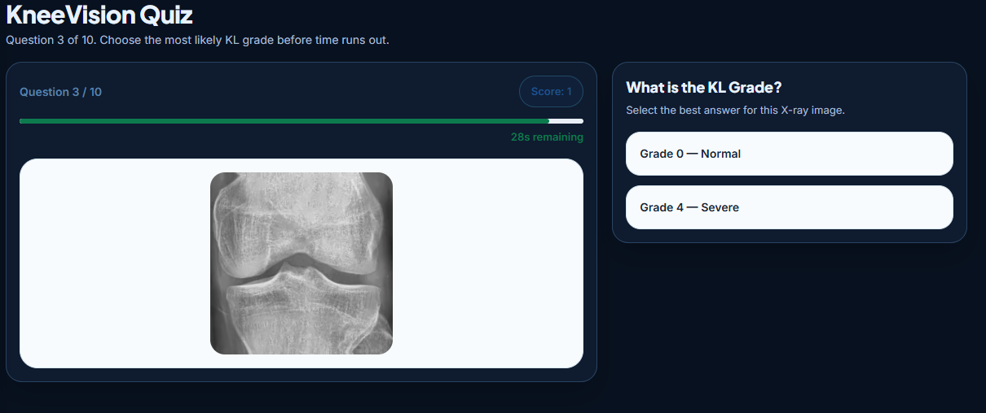

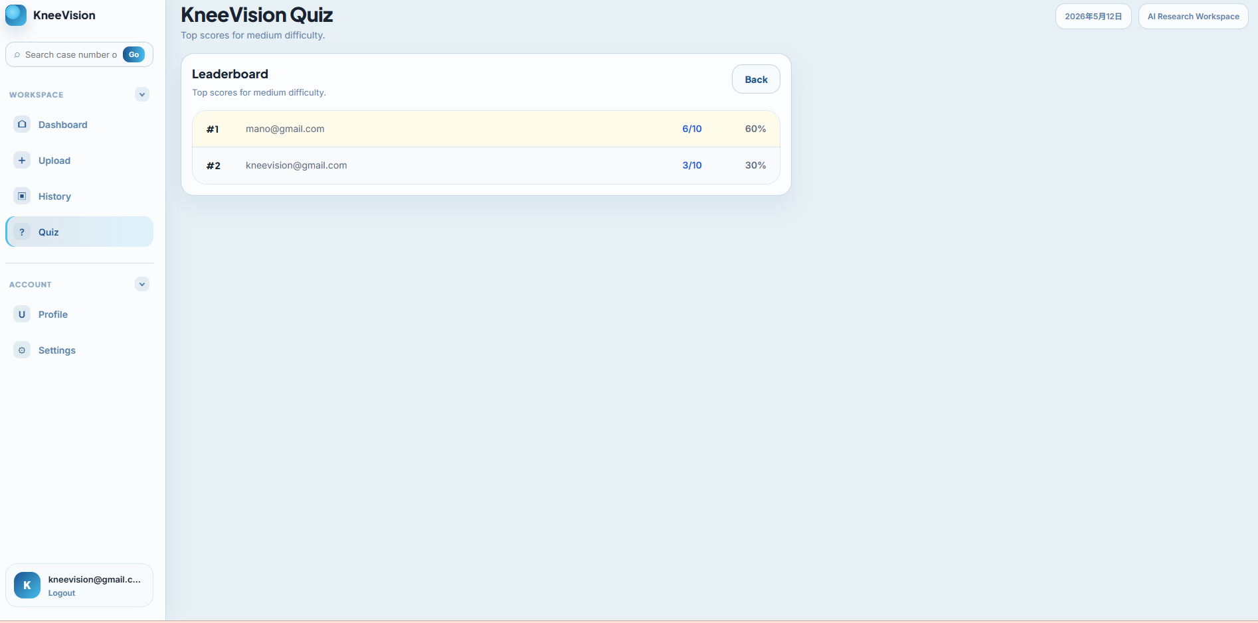

11. Profile and Settings

11.1 Profile
The Profile page displays account information and local profile preferences. The email is read from the signed-in account. The username and profile photo are stored locally in the browser in the current build.
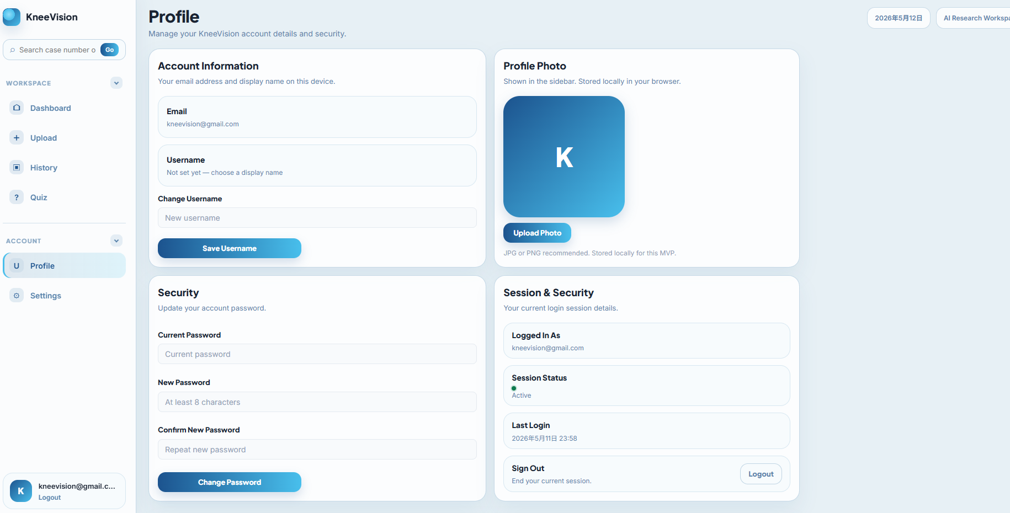

Profile Feature | Description
Email | Shows the signed-in account email when available.
Username | Allows the user to set a display name for the current browser session/storage.
Profile Photo | Allows the user to upload or remove a photo shown in the sidebar. This is stored locally in the browser.
Password Form | Validates password input rules in the interface. Backend password update support depends on the final backend configuration.
Delete Account | Clears local account state and logs the user out in the current frontend build. Use carefully during demo testing.

11.2 Settings
The Settings page controls local display and interface preferences for the current browser. These settings do not change saved analysis data.
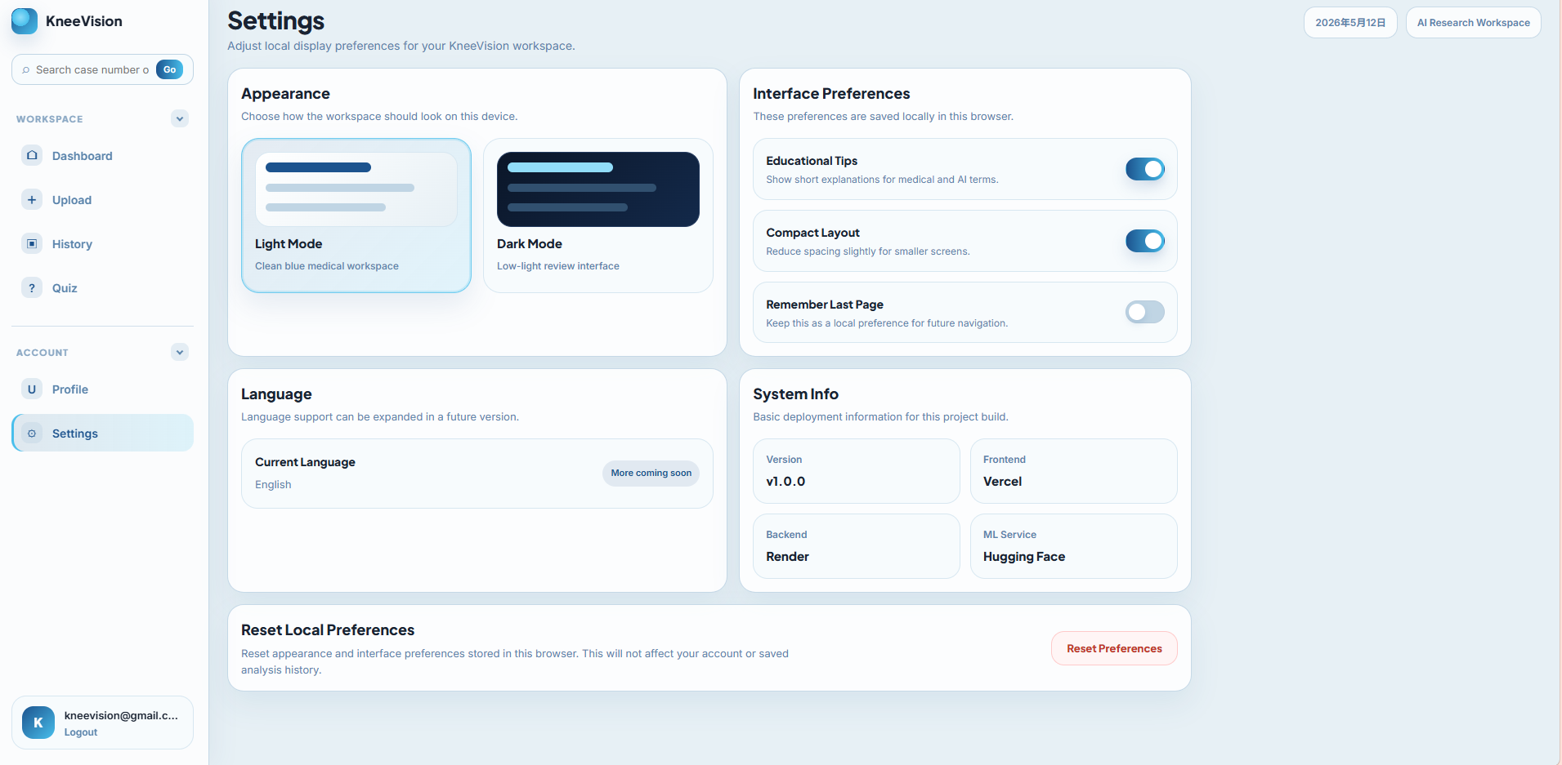

Setting | Function
Light Mode / Dark Mode | Changes the visual theme of the workspace.
Educational Tips | Shows or hides short explanations for medical and AI terms.
Compact Layout | Reduces spacing for smaller screens.
Remember Last Page | Stores a local preference for future navigation.
Language | Current build uses English. More language support may be added later.
System Info | Displays version and deployment information: frontend on Vercel, backend on Render, ML service on Hugging Face.
Reset Preferences | Resets local appearance and interface preferences without deleting analysis history.

Local Preferences
Theme, tips, compact layout, last-page preference, username, and profile photo are stored in the browser. If browser data is cleared or a different browser is used, these local preferences may not carry over.

12. Logging Out
1. Locate the user card at the bottom of the left sidebar.
2. Click Logout.
3. The application clears the current session and returns to the public/authentication flow.
Security Reminder
Always log out after using the demo account on a shared or classroom computer.

13. Troubleshooting
Issue | Likely Cause | Recommended Action
Application URL does not open | Frontend deployment may be inactive or the URL was copied incorrectly. | Reopen the official Vercel link and check network connection.
Login fails | Wrong credentials, old token state, or backend authentication issue. | Verify the demo account, then clear site local storage and log in again.
Dashboard or History shows unauthorized / 401 behavior | Stored token may be outdated after switching environments. | Log out and log in again. If needed, clear local storage for the site.
Upload succeeds but prediction fails | ML service or backend prediction endpoint may be unavailable, or the input file may not be suitable. | Retry with a clear JPG/PNG knee X-ray and wait a few seconds. If it still fails, check backend/ML deployment status.
Image preview is missing | Some file types, especially DICOM, may not generate browser previews. | Use JPG or PNG for the final demo workflow.
Older uploaded image cannot be displayed | Temporary deployment storage may have been reset. | Upload a fresh image and run a new analysis.
CSV does not download | Browser blocked download or backend export request failed. | Allow downloads for the site and retry Export CSV.
Search returns no match | Case number or filename does not exist in the current account history. | Check the History page and search using a shorter filename keyword.
Chat response fails | Chat endpoint or network request failed. | Retry the message. If it continues, review the result manually.

14. Glossary
Term | Meaning
KneeVision | The project application for AI-assisted knee X-ray review.
KL Grade | Kellgren-Lawrence osteoarthritis severity grade from 0 to 4.
Confidence | The model certainty value for the selected predicted class.
Class Probabilities | The distribution of model probability across KL classes.
Grad-CAM | A visual explanation method that highlights image areas influencing model prediction.
Similar Cases | Reference cases ranked by similarity to the current X-ray image.
CSV Export | A downloadable spreadsheet-style file containing saved prediction history.
Local Storage | Browser-based storage used for session tokens and local interface preferences.

