**Practical GWAS Using Linux and R**

**Dates**

23-27 October 2017

**Course Overview**

The past decade has witnessed an astonishing development and the universal use of genome wide association studies (GWAS) in identification and characterisation of genetic variants underlying disorders and other variations in human and other species, which has an immense impact in biomedical research. This is owing to the ability to generate and process large quantity of genetic polymorphisms as well as to integrate with other sources such as gene expression and methylation. To tackle challenges in GWAS, a lot of methods and techniques have been established but many others are still evolving.

**Targeted audience and assumed background**

The purpose of this workshop is to render both a broad picture and computational details of GWAS to biomedical researchers and related fields. It sets to explore the biological, statistical, and computational concepts, methodologies and practices involving a variety of software but with highlights on Linux and R. Examples of consortium contributions will also be given. These will be particularly beneficial to those who come with their own problems.

**Workshop structure**

The workshop contains both lecture and computer sessions, designed to help participants to understand the background, methodology and implementation. The computer session is designed to facilitate data analysis and interpretation.

**WHERE**

Freie Universität Berlin, Institute of Biology, Königin-Luise-Str. 1-3, 14195 Berlin-Dahlem.

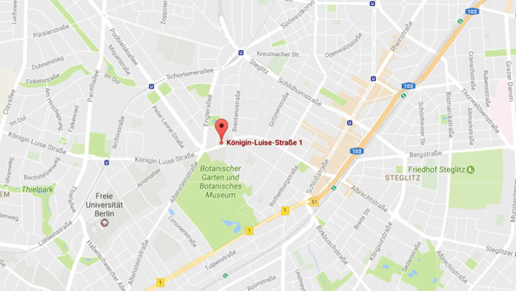

**Curriculum**

The workshop consists of the following modules.

Module 1. Overview

Module 2. Genetic association

Module 3. GWAS

Module 4. Advanced topics

Module 5. Additional topics

Each takes approximately a day.

**INSTRUCTOR**

Dr Jing Hua Zhao

Trained in medicine, medical statistics and statistical genetics, he had worked on statistical and computational methods for epidemiological and public health studies at several institutions until 2005, when he joined the MRC Epidemiology Unit, University of Cambridge, to work on design and analysis of GWASs such as the EPIC-Norfolk, the Fenland and the InterAct. He has also participated in numerous genetic analysis workshops which involve not only simulated but also real data such as those from the Framingham heart study.

Besides data analysis, software development and other academic activities, he has also had tutorials on genetic dissection of complex traits with focus on GWAS at UseR! 2008, 2009, and 2010 Conferences and contributed one Henry-Stewart talk on genetic association with R.