The Penniless Pilgrim Riddle:

After months of travel, you’ve arrived at Duonia, home to the famous temple that’s the destination of your pilgrimage. The walk from the welcome center to the temple isn't a long one ... but there’s a problem:

The city imposes a unique tax: The tax begins at 0, increases by 2 silvers by every block you walk east, doubles by every block you walk south. A walk west-bound or north-bound will however decreases by 2 and by half, respectively.

You will start from the very north-west corner of Duonia, and you must walk to the welcome center 5 blocks to the east. You already owe the city 10 silvers. Now, you need to reach the infamous temple, located at the south-east corner. You bring no silver at all, and you can’t walk the path you’ve trodden, though you can cross path. How would you reach the temple without paying any tax?

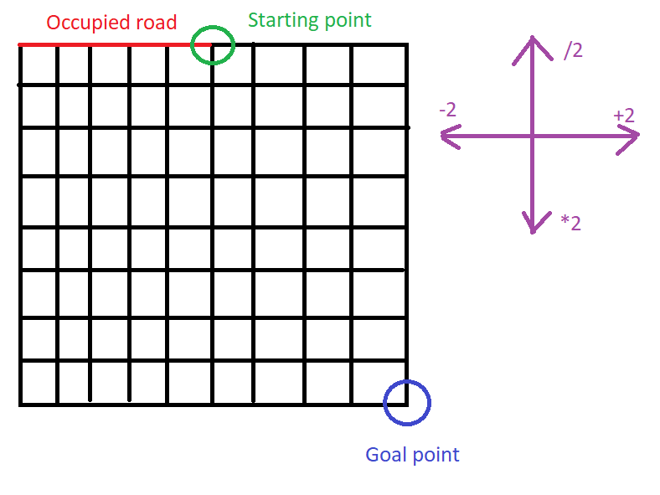

STATE:

INITIAL STATE: (0, 5), 10

ACTION: {L, R, U, D}

GOAL: (10, 10), <= 0

PATH COST: (L, -2), (R, +2), (U, /2), (D, \*2) 🡪 Cost

OUTPUT

• Time complexity (number of nodes expanded in order to solve the puzzle)

• Space complexity (number of nodes kept in memory)

• The sequence of moves from the starting position to the temple and the remaining silver “owed”.