OTS

[[面试经验] 大软软OTS](https://www.1point3acres.com/bbs/forum.php?mod=viewthread&tid=458174&extra=page%3D1%26filter%3Dsortid%26sortid%3D311%26searchoption%5B3089%5D%5Bvalue%5D%5B5%5D%3D5%26searchoption%5B3089%5D%5Btype%5D%3Dcheckbox%26searchoption%5B3046%5D%5Bvalue%5D%253)

实在是想要快点完成笔试就没有看地里面经。。。几年前做过觉得特别简单所以感觉这次有点轻敌了。。。event是10/12的office experience

上题目：

1. Friends Circle 找bug，基本就是解决环的问题就好；可是不能copy paste我废话又太多在这个题上居然花了快半小时。。。。

547. Friend Circles https://leetcode.com/problems/friend-circles/description/

1. Implement Iterator Interface，题目写的不是很好，但基本就是说你这个class会实现一个iterator interface，然后有两个function叫Current()和MoveNext(), 请分别实现之
2. GenerateLargestNumber by removing n digits. 这题我就没刷过。。。现场搜了leetcode发现原题，但原题是找最小的，只剩十分钟来不及思考随便改了一下就交了。。。现在想想有bug。。。。

402. Remove K Digits <https://leetcode.com/problems/remove-k-digits/description/> lc题目是找最小的， 规律就是每次都去掉第一个开始递减的数； 这道题找最大的

那就去掉第一个开始递增的数，比如321456， 去掉一个数，那就去掉1

string removeKdigits(string num, int k) {

string res = ""; // res就看做是一个栈

int keep = num.size() - k;

for(auto c : num){

while(k && res.size() != 0 && res.back() < c){

res.pop\_back();

k--;

}

res.push\_back(c);

}

res.resize(keep);

int idx =0 ;

while(res.size() != 0 && res[0]=='0') {

res.erase(res.begin());

}

return res == ""? "0" : res;

}

[新鲜巨硬OTS](https://www.1point3acres.com/bbs/forum.php?mod=viewthread&tid=457440&extra=page%3D1%26filter%3Dsortid%26sortid%3D311%26searchoption%5B3089%5D%5Bvalue%5D%5B5%5D%3D5%26searchoption%5B3089%5D%5Btype%5D%3Dcheckbox%26searchoption%5B3046%5D%5Bvalue%5D%253)

1. 反向斐波那契数列， 写个函数，take in两个输入，输出一个反向的序列。

F(n) = f(n-1) –f(n-2)

1. debug, str 转 int16 那个题。
2. 在BST binary search tree中找下一个比给定target大的数。

270. Closest Binary Search Tree Value <https://leetcode.com/problems/closest-binary-search-tree-value/description/>

[微软ots](https://www.1point3acres.com/bbs/forum.php?mod=viewthread&tid=457381&extra=page%3D1%26filter%3Dsortid%26sortid%3D311%26searchoption%5B3089%5D%5Bvalue%5D%5B5%5D%3D5%26searchoption%5B3089%5D%5Btype%5D%3Dcheckbox%26searchoption%5B3046%5D%5Bvalue%5D%253)

1. debug题 大概mystery function 判断在干什么 其实是在找a b是不是direct/indirect friend 给的dfs bug是没有visited array

2. two sum sorted array

[167. Two Sum II - Input array is sorted](https://leetcode.com/problems/two-sum-ii-input-array-is-sorted/description/)

3. 储存文件 给几个api 用给的api写一个怎么存file的function 其中一个是从开头开始存 另一个是从某一点开始存 反正很简单 注意看清楚题目就行 题目很长

[巨硬OTS（C++职位)](https://www.1point3acres.com/bbs/forum.php?mod=viewthread&tid=456905&extra=page%3D1%26filter%3Dsortid%26sortid%3D311%26searchoption%5B3089%5D%5Bvalue%5D%5B5%5D%3D5%26searchoption%5B3089%5D%5Btype%5D%3Dcheckbox%26searchoption%5B3046%5D%5Bvalue%5D%253)

帮家属申了巨硬家的software enginner II, HR发来OTS上写的是Junior engineer，有点驴头不对马嘴。可能因为申的C++职位，题都是和pointer相关，五题共45分钟，时间也是有点紧。。。Anyways，题跟地里看到的OTS题目都不太一样，来汇报一下：1. merge two sorted array, return一个sorted array [88. Merge Sorted Array](https://leetcode.com/problems/merge-sorted-array/description/)  
2. 括号match，输入是一个string，查大中小括号match的对不对 [20. Valid Parentheses](https://leetcode.com/problems/valid-parentheses/description/)

**解答: https://leetcode.com/problems/valid-parentheses/discuss/9222/My-0ms-c++-solution-using-stack**3. 给了一个错误的function pointer declaration，要求修改为正确的  
4. 给了一段constructor和deconstructor被call的顺序错了的代码，要求修改为正确的并写出output  
5. 没来得及做就到时间了 T.T  
题都没做完，肯定是跪了，哎。。。

[巨硬 OTS 11/30](https://www.1point3acres.com/bbs/forum.php?mod=viewthread&tid=456368&extra=page%3D1%26filter%3Dsortid%26sortid%3D311%26searchoption%5B3089%5D%5Bvalue%5D%5B5%5D%3D5%26searchoption%5B3089%5D%5Btype%5D%3Dcheckbox%26searchoption%5B3046%5D%5Bvalue%5D%253)

1. check if string p is in string b, 力叩 耳拔，除了寫function還要解釋假設跟寫testcase

[28. Implement strStr()](https://leetcode.com/problems/implement-strstr/description/)

2. debug題，地理也有，function是把str轉成數字  
3. 力叩 腰溜屋

[165. Compare Version Numbers](https://leetcode.com/problems/compare-version-numbers/description/)

**解答: https://leetcode.com/problems/compare-version-numbers/discuss/50767/My-2ms-easy-solution-with-CC++**

[巨婴奥体爱死](https://www.1point3acres.com/bbs/forum.php?mod=viewthread&tid=450417&extra=page%3D1%26filter%3Dsortid%26sortid%3D311%26searchoption%5B3089%5D%5Bvalue%5D%5B5%5D%3D5%26searchoption%5B3089%5D%5Btype%5D%3Dcheckbox%26searchoption%5B3046%5D%5Bvalue%5D%253)

奥体爱死 三道题  
1.求所以大于给定数的2数组合(就是找2个数的和大于给定的值啊，for for 呗.)  
2.一个数组有个数是0，问你从指[定位](http://www.1point3acres.com/warald-evaluation-%E5%85%8D%E8%B4%B9%E5%92%A8%E8%AF%A2%E8%83%8C%E6%99%AF%E8%AF%84%E4%BC%B0%E5%AE%9A%E4%BD%8D/" \t "_blank)置能不能调到这里

leetcode 55 jump game <https://leetcode.com/problems/jump-game/description/>

3.问你前后intervals会不会有conflict

[M家哦踢哎斯](https://www.1point3acres.com/bbs/forum.php?mod=viewthread&tid=448849&extra=page%3D1%26filter%3Dsortid%26sortid%3D311%26searchoption%5B3089%5D%5Bvalue%5D%5B5%5D%3D5%26searchoption%5B3089%5D%5Btype%5D%3Dcheckbox%26searchoption%5B3046%5D%5Bvalue%5D%253)

1. 利口伞把尔变形， 变得不多原题会做肯定能做出来.

382. Linked List Random Node <https://leetcode.com/problems/linked-list-random-node/description/>

2. 利口伞室， 原题

30. Substring with Concatenation of All Words <https://leetcode.com/problems/substring-with-concatenation-of-all-words/description/>

leetcode 30 解答 <http://www.cnblogs.com/grandyang/p/4521224.html>

3. 便利耳差树，不让用低轨，没说什么顺序感觉是开放的吧，写啥都行。

<https://github.com/Alex1888/My-Code-Library/blob/master/Binary%20Tree%20Operation.md>

[新鲜微软OTS面筋 10.22](https://www.1point3acres.com/bbs/forum.php?mod=viewthread&tid=448629&extra=page%3D1%26filter%3Dsortid%26sortid%3D311%26searchoption%5B3089%5D%5Bvalue%5D%5B5%5D%3D5%26searchoption%5B3089%5D%5Btype%5D%3Dcheckbox%26searchoption%5B3046%5D%5Bvalue%5D%253)

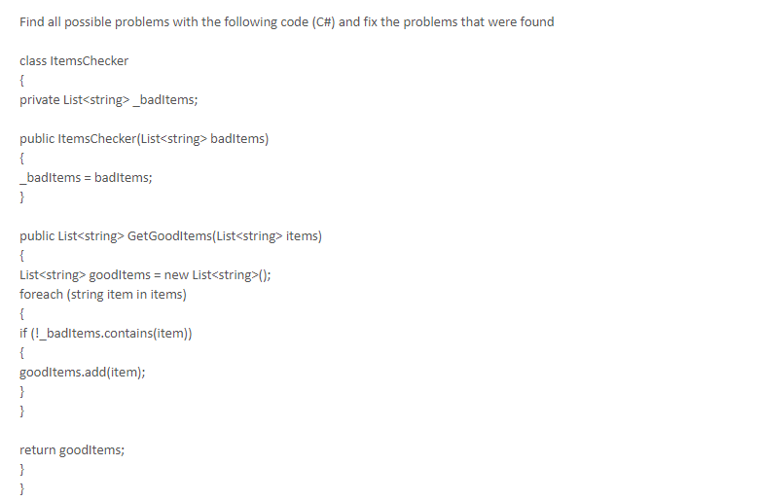

List里copy的是引用,不是值copy,要用

for (var item in baditems){

\_badItems.add(new string(item));

}

https://social.msdn.microsoft.com/Forums/zh-CN/d118aba8-0fae-45b1-a3f2-7ad5ce13cde4/c252261996820010listltgt361712054032473214781996820010listltgt?forum=visualcshartzhchs

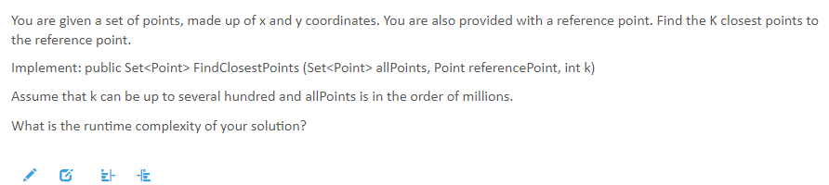

第二题  
leetcode Add Two Numbers

[2. Add Two Numbers](https://leetcode.com/problems/add-two-numbers/description/) 这个是倒叙的

<http://www.cnblogs.com/grandyang/p/6216480.html> 这个是正序的 [445. Add Two Numbers II](https://leetcode.com/problems/add-two-numbers-ii/description/)

/\*\*

\* Definition for singly-linked list.

\* struct ListNode {

\* int val;

\* ListNode \*next;

\* ListNode(int x) : val(x), next(NULL) {}

\* };

\*/

[MS 10/22 CSE hiring event](https://www.1point3acres.com/bbs/forum.php?mod=viewthread&tid=448430&extra=page%3D1%26filter%3Dsortid%26sortid%3D311%26searchoption%5B3089%5D%5Bvalue%5D%5B5%5D%3D5%26searchoption%5B3089%5D%5Btype%5D%3Dcheckbox%26searchoption%5B3046%5D%5Bvalue%5D%253)

周日交了OTS  
1. C# Task.Delay vs Thread.sleep

https://stackoverflow.com/questions/20082221/when-to-use-task-delay-when-to-use-thread-sleep

The biggest difference between Task.Delay and Thread.Sleep is that Task.Delay is intended to run asynchronous. It does not make sense to use Task.Delay in synchronous code. It is a VERY bad idea to use Thread.Sleep in asynchronous code.

Use Thread.Sleep when you want to block the current thread.

Use Task.Delay when you want a logical delay without blocking the current thread.

2. topo sort 拓扑排序

<https://songlee24.github.io/2015/05/07/topological-sorting/>

207. Course Schedule <https://leetcode.com/problems/course-schedule/description/>

3. compare version

[巨婴 ots 十月](https://www.1point3acres.com/bbs/forum.php?mod=viewthread&tid=447992&extra=page%3D1%26filter%3Dsortid%26sortid%3D311%26searchoption%5B3089%5D%5Bvalue%5D%5B5%5D%3D5%26searchoption%5B3089%5D%5Btype%5D%3Dcheckbox%26searchoption%5B3046%5D%5Bvalue%5D%3)

1. 简单array partition

561. Array Partition I <https://leetcode.com/problems/array-partition-i/description/>

2. 拓扑排序  
3. 2个人做游戏，给定一个正整数，每个人轮流减去一个完全平方数（减去的结果要非负），先得到0的人赢。  
注意这个题就是讲了下规则，并没有定输入输入。

464. Can I Win <https://leetcode.com/problems/can-i-win/description/> 给了我们一堆数字，然后两个人，每人每次选一个数字，看数字总数谁先到给定值

解答: http://www.cnblogs.com/grandyang/p/6103525.html

[M家 OTS](https://www.1point3acres.com/bbs/forum.php?mod=viewthread&tid=447877&extra=page%3D1%26filter%3Dsortid%26sortid%3D311%26searchoption%5B3089%5D%5Bvalue%5D%5B5%5D%3D5%26searchoption%5B3089%5D%5Btype%5D%3Dcheckbox%26searchoption%5B3046%5D%5Bvalue%5D%253)

一个小时，三道算法题，时间还是有点紧张，code写的不够clean，备注感觉也没写好，感觉挂了，发出来为后面的面试攒人品。  
  
1. merge two sorted singly-linked list

[21. Merge Two Sorted Lists](https://leetcode.com/problems/merge-two-sorted-lists/description/)

2. task 执行顺续(topological soft) 写了无数遍的拓扑排序因为看到第三题有点懵，也没写好。汗  
3.  题目真的太长，英语捉急。。感觉是个阅读理解题，题目长度比我当年考托福的作文的都写得长，光读题就花了十几分钟。不知道地里有没有这道题的面经，我没有看太多面经，没有见过 ==|||  
  
    大意有一个city,有一排building, 有两个暴徒 站在这排building 左右两边要摧毁这一排building，两边的暴徒，只有在building的height 是暴徒前进的方向上升序排列的时候，才能连续摧毁，也就是说，如果不是升序，只能摧毁当前building，不能连续摧毁，求最少的需要的move次数  
    input 是所有building 的 heights  
-baidu 1point3acres  
希望能帮到大家。

[巨硬hiring events OA](https://www.1point3acres.com/bbs/forum.php?mod=viewthread&tid=444854&extra=page%3D1%26filter%3Dsortid%26sortid%3D311%26searchoption%5B3089%5D%5Bvalue%5D%5B5%5D%3D5%26searchoption%5B3089%5D%5Btype%5D%3Dcheckbox%26searchoption%5B3046%5D%5Bvalue%5D%253)

一共3题：第一题是debug。

说数字a和b，  每次a和b只能增加或者减少1. 直到a = x， b = y 返回， x， y是targe。   
changeToTarget(a, b, x, y) {  
...  
}  
很简单，主要就是while的条件有错。 还有几个其他小错。没记太清。但是确实很简单，不用担心，  
  
第二题： 利口三儿吧， 没有任何变形

[328. Odd Even Linked List](https://leetcode.com/problems/odd-even-linked-list/description/)

第三天： 利口一六五。有点不同是是不用return 1，0，-1，  只用return positive， 0， negative 就行。[165. Compare Version Numbers](https://leetcode.com/problems/compare-version-numbers/description/)

[微软oa](https://www.1point3acres.com/bbs/forum.php?mod=viewthread&tid=442770&extra=page%3D1%26filter%3Dsortid%26sortid%3D311%26searchoption%5B3089%5D%5Bvalue%5D%5B5%5D%3D5%26searchoption%5B3089%5D%5Btype%5D%3Dcheckbox%26searchoption%5B3046%5D%5Bvalue%5D%253)

1. 一段c 的代码， 好像是删除链表的一个节点，问有没有问题。问题好像是链表删除后pointer没有释放，即是和别的node没联系了可是还是会影响内存  
2. 给出两个用linked list表示的数，求两个数的和，用linkedlist 的形式返回。例如12345: 1->2->3->4->5   
3. 把一个linked list分成两个linked list, 一个包含原链表index基数node, 另一个包含偶数，都得按照原来链表顺序

[一点点软OTS](https://www.1point3acres.com/bbs/forum.php?mod=viewthread&tid=442267&extra=page%3D1%26filter%3Dsortid%26sortid%3D311%26searchoption%5B3089%5D%5Bvalue%5D%5B5%5D%3D5%26searchoption%5B3089%5D%5Btype%5D%3Dcheckbox%26searchoption%5B3046%5D%5Bvalue%5D%253)

1. Delete (N-1)th node in a singly linked list of N nodes  
2. Rotate a linked list by kth node

[Microsoft OA 新鲜出炉](https://www.1point3acres.com/bbs/forum.php?mod=viewthread&tid=441127&extra=page%3D1%26filter%3Dsortid%26sortid%3D311%26searchoption%5B3089%5D%5Bvalue%5D%5B5%5D%3D5%26searchoption%5B3089%5D%5Btype%5D%3Dcheckbox%26searchoption%5B3046%5D%5Bvalue%5D%253)

1. Describe what happens underneath the covers when you type bing.com or google.com n a web browser.   
2. Determin whether an input string has balanced braces or not. String may include any of the following characters "{}[]()". Examples: "{[]()}" -> valid. "{[]()}" -> invalid.  
3. Suppose we could access yesterday's stock prices as a list, where:   
   - The indices are the time in minutes past trade opening time, which was 9:30 am local time.   
   - The values are the prices in dollars of Microsoft stock at that time.   
So if the stock cost $500 at 10:30 am, stock\_prices\_yesterday[60] = 500.. From 1point 3acres bbs  
Write an efficient function that takes stock\_prices\_yesterdayand returns the bst profit I could have made from 1 purchase and 1 sale of 1 Microsoft stock yesterday.

[121. Best Time to Buy and Sell Stock](https://leetcode.com/problems/best-time-to-buy-and-sell-stock/description/) 只进行一次交易

[巨硬在线鄙视](https://www.1point3acres.com/bbs/forum.php?mod=viewthread&tid=440465&extra=page%3D1%26filter%3Dsortid%26sortid%3D311%26searchoption%5B3089%5D%5Bvalue%5D%5B5%5D%3D5%26searchoption%5B3089%5D%5Btype%5D%3Dcheckbox%26searchoption%5B3046%5D%5Bvalue%5D%253)

第一个是改错题，其他帖子也有的，就是那个Int16.Parse()的那段代码  
第二题是给出两个数，返回他们之间的质数

[204. Count Primes](https://leetcode.com/problems/count-primes/description/)  
第三题是给出一个整形数组，要求返回每个数字出现的次数

[巨硬新鲜OTS](https://www.1point3acres.com/bbs/forum.php?mod=viewthread&tid=440348&extra=page%3D1%26filter%3Dsortid%26sortid%3D311%26searchoption%5B3089%5D%5Bvalue%5D%5B5%5D%3D5%26searchoption%5B3089%5D%5Btype%5D%3Dcheckbox%26searchoption%5B3046%5D%5Bvalue%5D%253)

上周末做了他家三题的OTS。  
总体感觉不是很难，写的话比写代码要用更多的时间哈哈。  
题目都是地里 & 利口有的题目，重点说两道算法题。  
一道是颜色排序的变种，基本上只是加了一个概念多调用一个不需要自己写的function. check 1po

[75. Sort Colors](https://leetcode.com/problems/sort-colors/description/)in

t3acres for more.  
第二个是子序列的最大乘积

[152. Maximum Product Subarray](https://leetcode.com/problems/maximum-product-subarray/description/)

[巨硬Hiring Event OA 求米](https://www.1point3acres.com/bbs/forum.php?mod=viewthread&tid=440230&extra=page%3D1%26filter%3Dsortid%26sortid%3D311%26searchoption%5B3089%5D%5Bvalue%5D%5B5%5D%3D5%26searchoption%5B3089%5D%5Btype%5D%3Dcheckbox%26searchoption%5B3046%5D%5Bvalue%5D%253)

1. 一个整数转换string的函数，让你找错。 (我找的是没考虑负数和0， 不知道还有没有其他)  
2. linkedlist让先连odd再连even俩并一起  
3. 两个linkedlist整数相加成一个新的linked list

[巨硬 新鲜 OA](https://www.1point3acres.com/bbs/forum.php?mod=viewthread&tid=437851&extra=page%3D2%26filter%3Dsortid%26sortid%3D311%26searchoption%5B3089%5D%5Bvalue%5D%5B5%5D%3D5%26searchoption%5B3089%5D%5Btype%5D%3Dcheckbox%26searchoption%5B3046%5D%5Bvalue%5D%253)

https://stackoverflow.com/questions/2657810/deep-copy-vs-shallow-copy

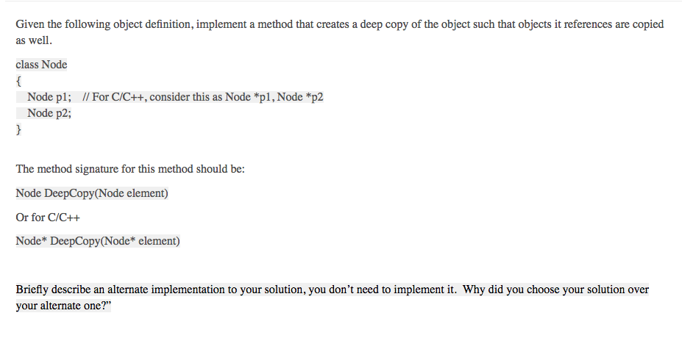

Node\* DeepCopy(Node\* element){

Node\* res = new Node();

Res->p1 = new Node(element->p1);

Res->p2 = new Node(element->p2);

Return res;

}

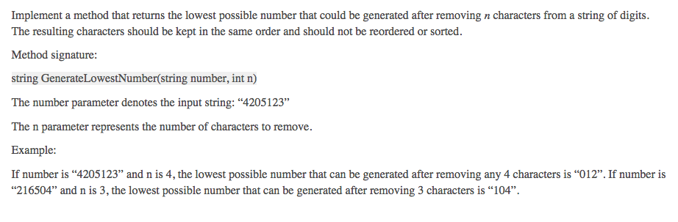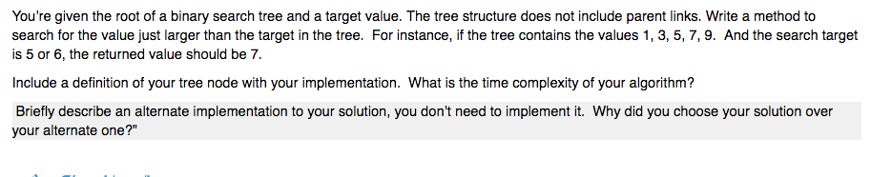

[巨硬ots](https://www.1point3acres.com/bbs/forum.php?mod=viewthread&tid=435132&extra=page%3D2%26filter%3Dsortid%26sortid%3D311%26searchoption%5B3089%5D%5Bvalue%5D%5B5%5D%3D5%26searchoption%5B3089%5D%5Btype%5D%3Dcheckbox%26searchoption%5B3046%5D%5Bvalue%5D%253)

第一题改错  
给了person 类 包含名字和熟人  
错误的函数是是否能从本人根据熟人找到另一个人 LC上有类似的题  
  
第二题level order traversal 但是不让用queue

[102. Binary Tree Level Order Traversal](https://leetcode.com/problems/binary-tree-level-order-traversal/description/)  
  
第三题判断树是不是balanced 问可不可以O（N）

[微软oa](https://www.1point3acres.com/bbs/forum.php?mod=viewthread&tid=434788&extra=page%3D2%26filter%3Dsortid%26sortid%3D311%26searchoption%5B3089%5D%5Bvalue%5D%5B5%5D%3D5%26searchoption%5B3089%5D%5Btype%5D%3Dcheckbox%26searchoption%5B3046%5D%5Bvalue%5D%253)

一小时三道题  
第一道语法改错； 第二道是两个数组排序，把小的放进大的里 (LC88)； 第三题就是两个链表做加法 （左至右） 也是lc原题  
  
写了很多comments和test case。。

[刚收到2题版OTS 求信息](https://www.1point3acres.com/bbs/forum.php?mod=viewthread&tid=434324&extra=page%3D2%26filter%3Dsortid%26sortid%3D311%26searchoption%5B3089%5D%5Bvalue%5D%5B5%5D%3D5%26searchoption%5B3089%5D%5Btype%5D%3Dcheckbox%26searchoption%5B3046%5D%5Bvalue%5D%253)

今天刚刚收到一个OTS，是8月10号Office365 hiring event

Test duration: 55 mins

2 questions: 1 easy/med, 1 hard

The programs need to compile

It’s better if all the test cases pass

但是看地里最近都没有2题版本的OTS了，求信息

[巨硬OTS](https://www.1point3acres.com/bbs/forum.php?mod=viewthread&tid=434010&extra=page%3D2%26filter%3Dsortid%26sortid%3D311%26searchoption%5B3089%5D%5Bvalue%5D%5B5%5D%3D5%26searchoption%5B3089%5D%5Btype%5D%3Dcheckbox%26searchoption%5B3046%5D%5Bvalue%5D%253)

三个题  
第一个找bug，C的，把数组往后移动N个位置，memory没有allocate，移动顺序不对  
第二个version 比较  
第三个linkedlist相加

[软家 ots面经](https://www.1point3acres.com/bbs/forum.php?mod=viewthread&tid=433969&extra=page%3D2%26filter%3Dsortid%26sortid%3D311%26searchoption%5B3089%5D%5Bvalue%5D%5B5%5D%3D5%26searchoption%5B3089%5D%5Btype%5D%3Dcheckbox%26searchoption%5B3046%5D%5Bvalue%5D%253)

1. debug - remove node from linked list (c#)  
2. 乐扣 会议室问题  
3. 路径问题变种：如何从源路径到目标路径

[Microsoft OTS](https://www.1point3acres.com/bbs/forum.php?mod=viewthread&tid=431978&extra=page%3D2%26filter%3Dsortid%26sortid%3D311%26searchoption%5B3089%5D%5Bvalue%5D%5B5%5D%3D5%26searchoption%5B3089%5D%5Btype%5D%3Dcheckbox%26searchoption%5B3046%5D%5Bvalue%5D%253)

1. Friend Circle 的改错题  
2. count and say  
3. 给一个string， 判断有没有substring是palindrome。长度大于2的才算。

[巨硬的新鲜OTS](https://www.1point3acres.com/bbs/forum.php?mod=viewthread&tid=431719&extra=page%3D2%26filter%3Dsortid%26sortid%3D311%26searchoption%5B3089%5D%5Bvalue%5D%5B5%5D%3D5%26searchoption%5B3089%5D%5Btype%5D%3Dcheckbox%26searchoption%5B3046%5D%5Bvalue%5D%253)

一共两道题，貌似巨硬的题库蛮大的  
  
一共就给60分钟，没办法测试正确性，所以最好建议写大量的comment来解释自己的思路，即使代码写的不能运行  
  
第一题 蠡口 柳林刘   
-baidu 1point3acres  
第二题 就是硬复制一个graph，蠡口上有类似的

[Azure OTS](https://www.1point3acres.com/bbs/forum.php?mod=viewthread&tid=431381&extra=page%3D2%26filter%3Dsortid%26sortid%3D311%26searchoption%5B3089%5D%5Bvalue%5D%5B5%5D%3D5%26searchoption%5B3089%5D%5Btype%5D%3Dcheckbox%26searchoption%5B3046%5D%5Bvalue%5D%253)

第一题：代码找错 给定一个Person类，包含两个field (name / friendship which is a list of person) 和两个函数 (constructor / foo) 问 foo函数是做什么的？有什么bug ，如何fix。  
foo的实现大概用stack在social network上做DFS，由于没有保存访问过的点，因此会出现死循环，我的解决方案是用一个hashset保存访问过得点，遇到访问过得点时不再push stack  
  
第二题：LC02  
  
第三题：LC229 若无法写出O(1) space解法可以给出次优解

[巨硬OTS](https://www.1point3acres.com/bbs/forum.php?mod=viewthread&tid=431358&extra=page%3D2%26filter%3Dsortid%26sortid%3D311%26searchoption%5B3089%5D%5Bvalue%5D%5B5%5D%3D5%26searchoption%5B3089%5D%5Btype%5D%3Dcheckbox%26searchoption%5B3046%5D%5Bvalue%5D%253)

三道题  
1： 地里的class Person, 有一个constructor, 潜在bug是 没有null checking Acquaintancep[] 这个参数  
另外一个潜在bug是，Mystery() 方法的do while循环里边的foreach 必须去掉，否则死循环，而且每次弹出来都是最后一个friend。 一旦这个last friend不是你要找的，直接stack overflow, outofMemory了。  
2. 第二题，topK 最近的点，考点就是要写最大堆。还要写class Point, 然后添加对两点距离的逆序排序的comparator。  
3. 第三题，给一颗binary tree, 要求打印这棵树，从下到上，从右到左。给出几个test case.  
. 1point3acres  
最后coding 题目都给下时空复杂度，有时间再添加些comment啥的。

[微软OTS](https://www.1point3acres.com/bbs/forum.php?mod=viewthread&tid=430278&extra=page%3D2%26filter%3Dsortid%26sortid%3D311%26searchoption%5B3089%5D%5Bvalue%5D%5B5%5D%3D5%26searchoption%5B3089%5D%5Btype%5D%3Dcheckbox%26searchoption%5B3046%5D%5Bvalue%5D%253)

1. 给了一段C# 代码，delete a Node in a linked list. 让你找茬。  
2. count and say  
3. sort color

[MS OTS](https://www.1point3acres.com/bbs/forum.php?mod=viewthread&tid=429883)

第一题是debug, 地里经常见的查这个人是不是在关系网中的题。二三题见附件。第三题搞不清想要实现成什么效果，挂。

第二题是不是就让写个接口，不用实现出来吧。只写接口感觉太简单了。  
  
第三题是leetcode原题(Leetcode 253. Meeting Rooms II)，而且是面经

[253. Meeting Rooms II](https://leetcode.com/problems/meeting-rooms-ii/description/)

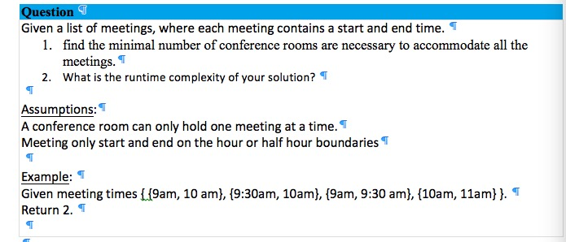

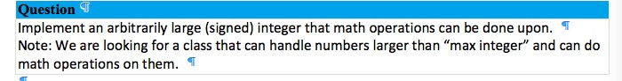

[微软OTS](https://www.1point3acres.com/bbs/forum.php?mod=viewthread&tid=429696&extra=page%3D2%26filter%3Dsortid%26sortid%3D311%26searchoption%5B3089%5D%5Bvalue%5D%5B5%5D%3D5%26searchoption%5B3089%5D%5Btype%5D%3Dcheckbox%26searchoption%5B3046%5D%5Bvalue%5D%253)

一小时，三道题  
1.找bug, shift array往右移N位。  
2. merge two sorted array, in place  
3. 李扣 壹柒壹，input是array of string 然后每一个都convert

[微软 OTS 面经](https://www.1point3acres.com/bbs/forum.php?mod=viewthread&tid=429490&extra=page%3D2%26filter%3Dsortid%26sortid%3D311%26searchoption%5B3089%5D%5Bvalue%5D%5B5%5D%3D5%26searchoption%5B3089%5D%5Btype%5D%3Dcheckbox%26searchoption%5B3046%5D%5Bvalue%5D%253)

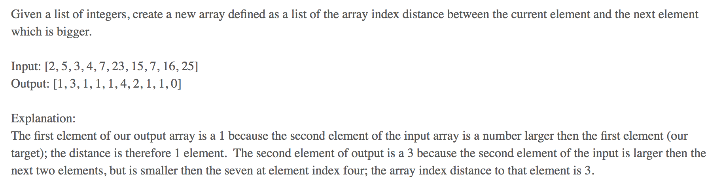

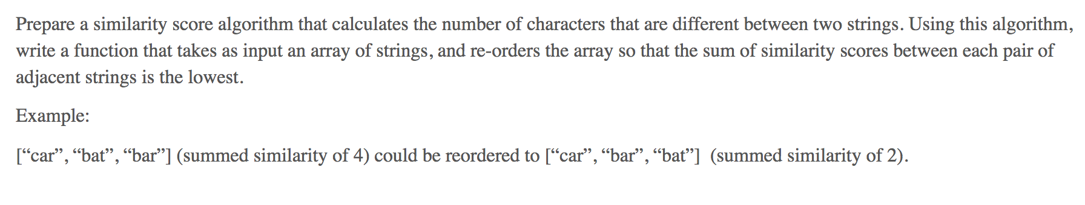

第一题我没理解错的话应该是单调栈，均摊复杂度是O(N)

// Given a list of integers, create a new array defined as

// a list of the array index distance between current and next

// element which is bigger.

// E.g. Input: [2,5,3,4,7,23,15,7,16,25]

// Output: [1,3,1,1,1,4,2,1,1,0]

import java.util.\*;

class Solution {

    public int[] nextBiggerDistance(int[] arr) {

        int n = arr.length;

        int[] res = new int[n];

        // val will keep track of possible candidates for each iteration:

        // Elements on the right without any larger in the middle. (not blocked)

        Stack<Integer> index = new Stack<>();

        Stack<Integer> val = new Stack<>();

        for (int i = n - 1; i >= 0; --i) {

            while (!val.isEmpty() && val.peek() <= arr[i]) {

                index.pop();

                val.pop();

            }

            if (val.isEmpty()) {

                res[i] = 0;

            } else {

                // arr[i] < val.peek()

                res[i] = index.peek() - i;

            }

            val.push(arr[i]);

            index.push(i);

        }

        return res;

    }

}

class Test {

    public static void main(String[] args) {

        Solution s = new Solution();

        System.out.println(Arrays.toString(

            s.nextBiggerDistance(new int[] {

                2,5,3,4,7,23,15,7,16,25

            })

        ));

    }

}

[微软 OTS 面经 2018.6.25 hiring event](https://www.1point3acres.com/bbs/forum.php?mod=viewthread&tid=429482&extra=page%3D2%26filter%3Dsortid%26sortid%3D311%26searchoption%5B3089%5D%5Bvalue%5D%5B5%5D%3D5%26searchoption%5B3089%5D%5Btype%5D%3Dcheckbox%26searchoption%5B3046%5D%5Bvalue%5D%253)

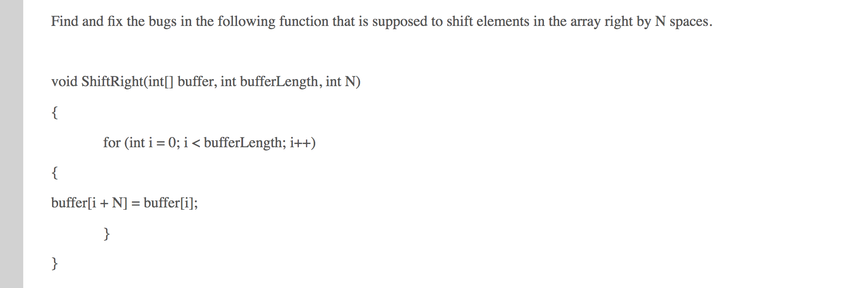

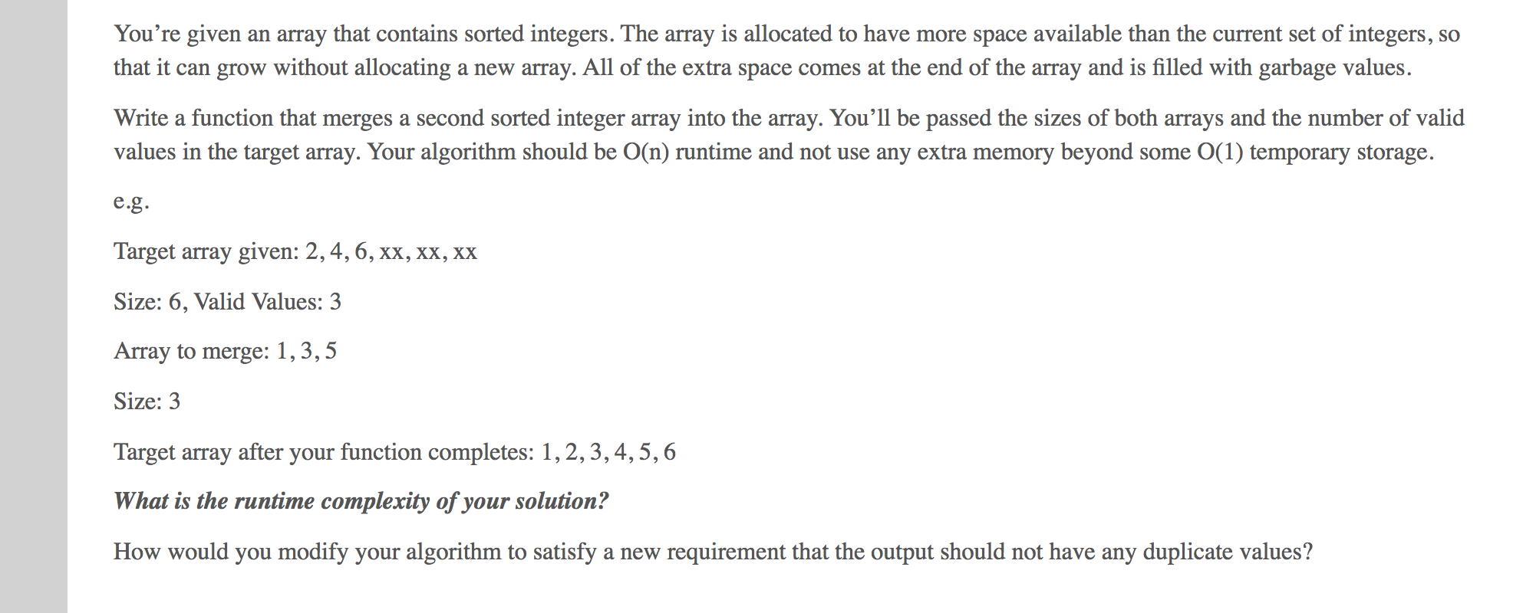

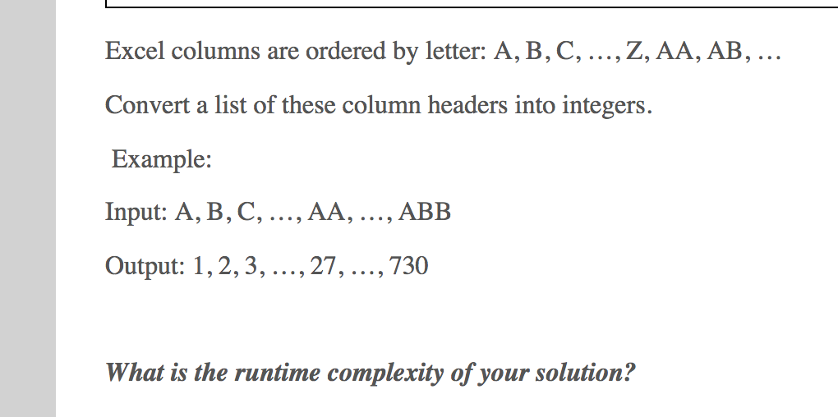

[巨硬OTS 06-10-2018](https://www.1point3acres.com/bbs/forum.php?mod=viewthread&tid=429472&extra=page%3D2%26filter%3Dsortid%26sortid%3D311%26searchoption%5B3089%5D%5Bvalue%5D%5B5%5D%3D5%26searchoption%5B3089%5D%5Btype%5D%3Dcheckbox%26searchoption%5B3046%5D%5Bvalue%5D%253)

1. implement the function atoi(int base\_eight) that convert a string of base eight digits into its correct integer.  
没看错，是int base\_eight, 可是题目写着string of base eight digits， function名字是atoi(), convert string to integer。  
愣了很久，写了个convert base 8 to decimal的内容。  
  
2. PrintVertically(int num), without using any string/ character conversion. 是int, 所以要注意negative integer  
<http://www.1point3acres.com/bbs/thread-279976-1-1.html>  
  
3. 里口溜石。改， return nth lexicographical order of permutations，   
0,1,2,3,4,5,6,7,8,9  
string NthPerm(int  n)， 这里的n 是原版的k。 原版的n 应该是 10.

[硬硬OTS](https://www.1point3acres.com/bbs/forum.php?mod=viewthread&tid=428433&extra=page%3D2%26filter%3Dsortid%26sortid%3D311%26searchoption%5B3089%5D%5Bvalue%5D%5B5%5D%3D5%26searchoption%5B3089%5D%5Btype%5D%3Dcheckbox%26searchoption%5B3046%5D%5Bvalue%5D%253)

第一題找錯  
題目給了一個function是要將一個string 轉換成int, 就是stol().  
時間太趕沒能記下原function，不過就找出幾個常見的錯誤( 沒有考慮overflow, 判決正負號沒有寫對，etc...)  
  
第二題 莉蔻-貳伍貳  
  
第三題 莉蔻-參捌 (簡化版)  
莉蔻原題是給定一個int n, 然後要依序計算出每個stage的值，最後返回第n-stage的string.  
OTS比較簡單, 就單純給你一個input string, 要你返回他的對應output strung (ex. 1113 -> 3113)

[巨硬笔试](https://www.1point3acres.com/bbs/forum.php?mod=viewthread&tid=428134&extra=page%3D2%26filter%3Dsortid%26sortid%3D311%26searchoption%5B3089%5D%5Bvalue%5D%5B5%5D%3D5%26searchoption%5B3089%5D%5Btype%5D%3Dcheckbox%26searchoption%5B3046%5D%5Bvalue%5D%253)

OA，三个题，1小时  
  
题1. 实现一个iterative quick sort  
https://www.geeksforgeeks.org/iterative-quick-sort/

题2:给了一段code,大致就是一个class，里面存了人名字，还有所有和这个人是朋友的人的名字。   
**find friend**  
code里面实现的一个function,去查找这个人和function input的另一个人是不是朋友（就是从这个人开始做BFS）。找错误，错误大致有两个：  
1. 如果friend relationship有环，那么这个function根本不会结束，需要一个visited ma p  
2. 某个地方可能pop from empty stack  
  
题3: sort color原题，给了三个priority的task,要求按照priority high first, medium second, low last 排序。

[巨硬 OTS](https://www.1point3acres.com/bbs/forum.php?mod=viewthread&tid=428019&extra=page%3D2%26filter%3Dsortid%26sortid%3D311%26searchoption%5B3089%5D%5Bvalue%5D%5B5%5D%3D5%26searchoption%5B3089%5D%5Btype%5D%3Dcheckbox%26searchoption%5B3046%5D%5Bvalue%5D%253)

找出下面的flaws和limitations  
  
        static bool ConvertToNumber(string s)  
        {  
            bool canConvert = false;  
            try  
            {. check 1point3acres for more.  
                int n = Int16.Parse(s);  
                if (n != 0)  
                {  
                    canConvert = true;  
                }  
            }  
            catch (Exception ex) {  
  
            }  
            bool retval = false;  
            if (canConvert == true)  
            {  
                retval = true;  
            }  
            return retval;  
        }

[巨硬OTS](https://www.1point3acres.com/bbs/forum.php?mod=viewthread&tid=427307&extra=page%3D2%26filter%3Dsortid%26sortid%3D311%26searchoption%5B3089%5D%5Bvalue%5D%5B5%5D%3D5%26searchoption%5B3089%5D%5Btype%5D%3Dcheckbox%26searchoption%5B3046%5D%5Bvalue%5D%253)

三道老题，  
  
第一题，改错， 找朋友， 老题，stack pop需要check是否为空， 可能有环  
第二题，sort color  
第三题， 里的扣 散吧 简化版

[微软OA](https://www.1point3acres.com/bbs/forum.php?mod=viewthread&tid=427208&extra=page%3D3%26filter%3Dsortid%26sortid%3D311%26searchoption%5B3089%5D%5Bvalue%5D%5B5%5D%3D5%26searchoption%5B3089%5D%5Btype%5D%3Dcheckbox%26searchoption%5B3046%5D%5Bvalue%5D%253)

OA一个小时，三道题，一道改错，两道编程，说是人工阅卷没有编译器-baidu 1point3acres  
1. remove node in linked list. Find bugs  
我找到的是list 只有一个节点时会报错  
还有就是prev, current assignment order is wrong  
  
2. similar to sort color， each task is a string and given an API to get priority of each task, sort tasks by priorities. Only have 3 priorities, high, mid, low  
leetcode 其实无  
  
3. Create a string seqence by reading  
input -> output:  
1 -> one 1 -> 11  
11 -> two 1s -> 21  
313 -> one 3, one 1, one 3 -> 131113  
write function to do this  
22231:  
Initially 3 个2 读作32  
之后1个3 读作13  
1个1 读作11  
result = 321311

[巨硬OTS一周后，收到邮件ApplicationStatus变成In Process](https://www.1point3acres.com/bbs/forum.php?mod=viewthread&tid=426428&extra=page%3D3%26filter%3Dsortid%26sortid%3D311%26searchoption%5B3089%5D%5Bvalue%5D%5B5%5D%3D5%26searchoption%5B3089%5D%5Btype%5D%3Dcheckbox%26searchoption%5B3046%5D%5Bvalue%5D%253)

OTS的内容  
1. 电话格式  
2. A -> X, B -> Y. 就是挑bug  
3. Sort Color  
  
题目很简单。。就写comment写的很虚。一行代码三行comment吧。。

[巨硬 面筋](https://www.1point3acres.com/bbs/forum.php?mod=viewthread&tid=426126&extra=page%3D3%26filter%3Dsortid%26sortid%3D311%26searchoption%5B3089%5D%5Bvalue%5D%5B5%5D%3D5%26searchoption%5B3089%5D%5Btype%5D%3Dcheckbox%26searchoption%5B3046%5D%5Bvalue%5D%253)

乐扣 尔霸武  
  
BFS相似的debug

Fibonacci sequence

[微软 hiring event](https://www.1point3acres.com/bbs/forum.php?mod=viewthread&tid=425996&extra=page%3D3%26filter%3Dsortid%26sortid%3D311%26searchoption%5B3089%5D%5Bvalue%5D%5B5%5D%3D5%26searchoption%5B3089%5D%5Btype%5D%3Dcheckbox%26searchoption%5B3046%5D%5Bvalue%5D%253)

1. 李口 clone graph  
2. 李口 151 我记得是不让用stringbuilder  
3. 李口 285  
还有一个题朋友的OA里面有  
李口 402

[巨硬 OTS 六④ AZURE BIG DATA](https://www.1point3acres.com/bbs/forum.php?mod=viewthread&tid=425684&extra=page%3D3%26filter%3Dsortid%26sortid%3D311%26searchoption%5B3089%5D%5Bvalue%5D%5B5%5D%3D5%26searchoption%5B3089%5D%5Btype%5D%3Dcheckbox%26searchoption%5B3046%5D%5Bvalue%5D%253)

1. 里扣的 武叁. check 1point3acres for more.  
2. 找bug，给a b x y，一个function写了如何将a = x b = y. From 1point 3acres bbs  
3.里扣的  嗣凛贰

[巨硬 5/25 Hire Event OTS](https://www.1point3acres.com/bbs/forum.php?mod=viewthread&tid=425635&extra=page%3D3%26filter%3Dsortid%26sortid%3D311%26searchoption%5B3089%5D%5Bvalue%5D%5B5%5D%3D5%26searchoption%5B3089%5D%5Btype%5D%3Dcheckbox%26searchoption%5B3046%5D%5Bvalue%5D%253)

地里经常出现的那道找错题，题目本身是C#写的，我记不住原本的代码了，我把框架用Java描述一下。Mystery方法就是用Stack模拟DFS找亲戚。我写的错误有：

* Constructor没有判断relatives是否为空
* Stack pop方法之前没有判断是否为栈空
* 没有handle朋友圈循环问题，应该有HashSet去重

1. class Person {
2. String name;
3. Person[] relatives;
5. public Person(String name, Person[] relatives) {
6. if (name == null) {
7. throw invalidParameterException("no name");
8. }
9. this.name = name;
10. this.relatives = relatives;
11. }
13. public List<Person> mystery() {
14. List<Person> list = new ArrayList<>();-baidu 1point3acres
15. Stack<Person> stack = new Stack<>();
16. for (Person r : relatives) {
17. stack.push(r);
18. }
19. Person person = stack.pop();
20. list.add(person);
21. for (Person r: person.relatives) {
22. stack.push(r);
23. }
24. return list;

|  |
| --- |
| 2. 一个排列的数组，让找出每一个数字出现的次数，比如[2,2,5,5,5,6,9,9,9]  -baidu 1point3acres 返回： 2:2 5:3 6:1 9:3  3. 给2个int组成一个range，让输出range中的所有prime numbers，比如给定 i = 2, j = 12 返回：2,3,5,7,11-baidu 1point3acres |

Top of Form

Bottom of Form

[巨硬UST组OA面经](https://www.1point3acres.com/bbs/forum.php?mod=viewthread&tid=425114&extra=page%3D3%26filter%3Dsortid%26sortid%3D311%26searchoption%5B3089%5D%5Bvalue%5D%5B5%5D%3D5%26searchoption%5B3089%5D%5Btype%5D%3Dcheckbox%26searchoption%5B3046%5D%5Bvalue%5D%253)

1. 利特口妖酒妖，需要写comment自己clarify一下，按照example给的是二进制8位，自己要考虑正常32位int的情况  
2.利特口耳污散变种，输入给你的是时间格式，比如0900AM，2330PM。格式不gurantee是4位int表示时间，也可能是900AM。需要自己转化成可以比较的interval。

[微软 OTS](https://www.1point3acres.com/bbs/forum.php?mod=viewthread&tid=424352&extra=page%3D3%26filter%3Dsortid%26sortid%3D311%26searchoption%5B3089%5D%5Bvalue%5D%5B5%5D%3D5%26searchoption%5B3089%5D%5Btype%5D%3Dcheckbox%26searchoption%5B3046%5D%5Bvalue%5D%253)

第一题以前没见过，一个函数是yin 一个函数是yang相互调用，需要重新写函数并且解释yin 是干啥的。就是求一个数转化为多少个1  
第二题是修改原来的代码，原来的代码是二叉树查找一个节点如果找到就返回，找不到就返回空，现在需要改如果找不到找到比他大的下一个节点  
第三题里扣 气流

[MS 0514Event OTS](https://www.1point3acres.com/bbs/forum.php?mod=viewthread&tid=415748&extra=page%3D3%26filter%3Dsortid%26sortid%3D311%26searchoption%5B3089%5D%5Bvalue%5D%5B5%5D%3D5%26searchoption%5B3089%5D%5Btype%5D%3Dcheckbox%26searchoption%5B3046%5D%5Bvalue%5D%253)

Q2是里的扣二一,要 dedue

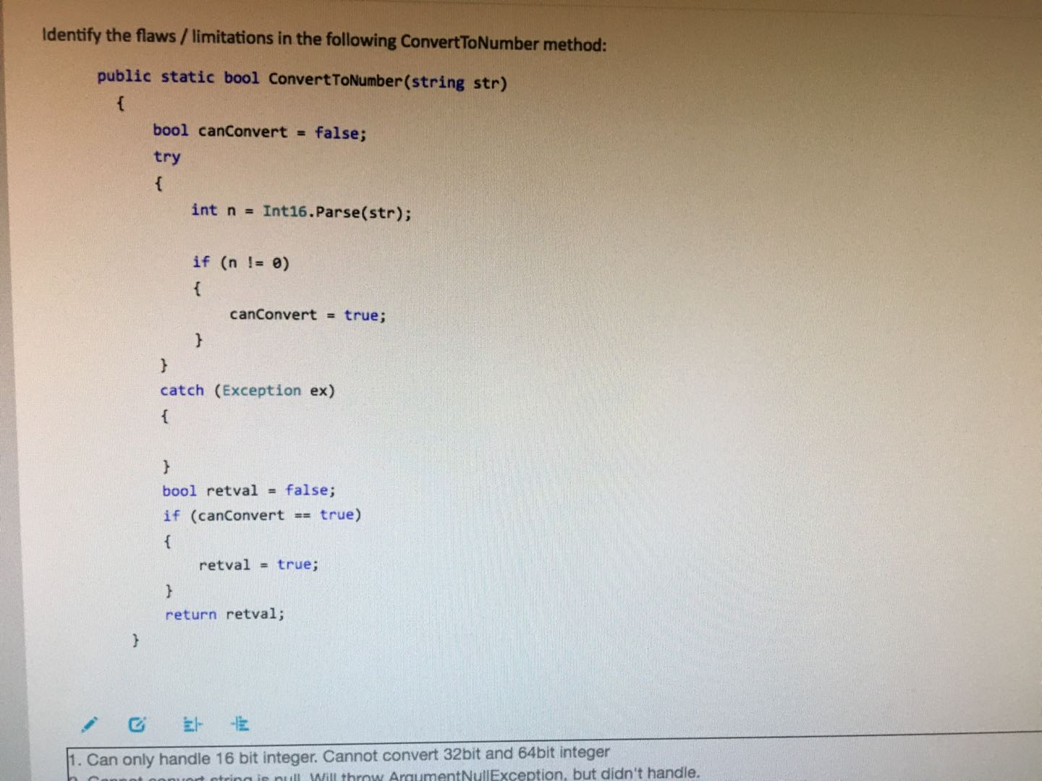

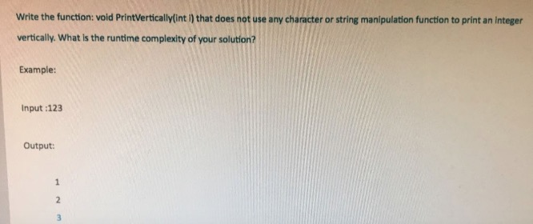

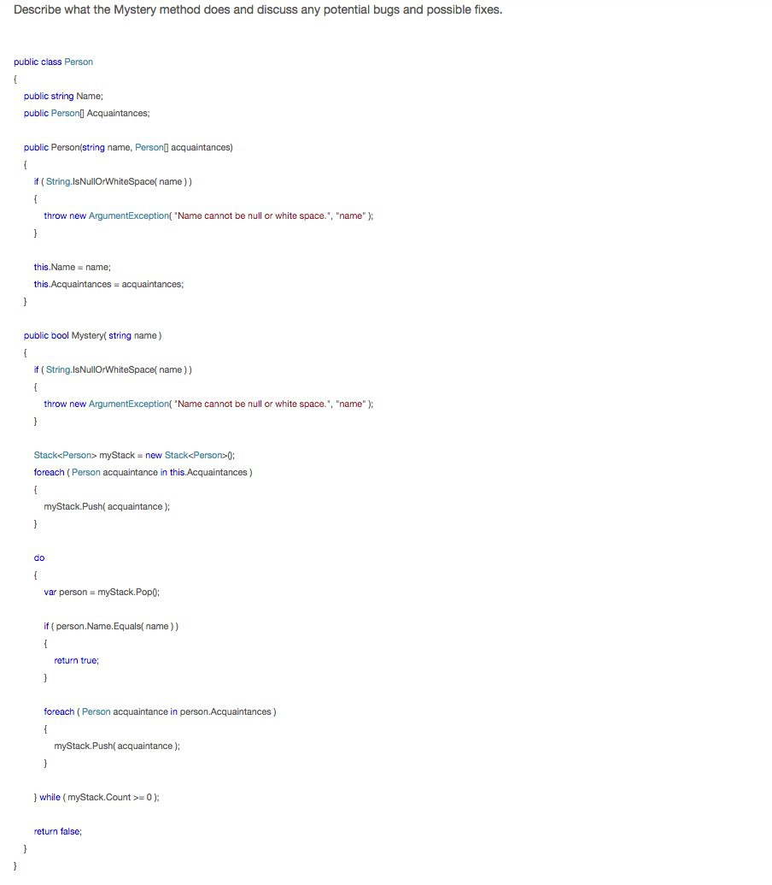

[Mircrosoft 0511 hiring event ost](https://www.1point3acres.com/bbs/forum.php?mod=viewthread&tid=415431&extra=page%3D3%26filter%3Dsortid%26sortid%3D311%26searchoption%5B3089%5D%5Bvalue%5D%5B5%5D%3D5%26searchoption%5B3089%5D%5Btype%5D%3Dcheckbox%26searchoption%5B3046%5D%5Bvalue%5D%253)

1. reverse string iteratively and reversely  
2. print an integer vertically  
3. 利口要要期，但是要求o(n)时间和o(1)空间

[微软OA](https://www.1point3acres.com/bbs/forum.php?mod=viewthread&tid=414611&extra=page%3D3%26filter%3Dsortid%26sortid%3D311%26searchoption%5B3089%5D%5Bvalue%5D%5B5%5D%3D5%26searchoption%5B3089%5D%5Btype%5D%3Dcheckbox%26searchoption%5B3046%5D%5Bvalue%5D%253)

总共两个题目  
  
第一个15分钟，第二个30分钟，分开计算时间  
  
1. 找一个无序数组的最大两个数值的和  
  
2. 给一系列朋友之间的关系，让你判断A和B两个人是否是朋友

[微软 OA](https://www.1point3acres.com/bbs/forum.php?mod=viewthread&tid=413239&extra=page%3D3%26filter%3Dsortid%26sortid%3D311%26searchoption%5B3089%5D%5Bvalue%5D%5B5%5D%3D5%26searchoption%5B3089%5D%5Btype%5D%3Dcheckbox%26searchoption%5B3046%5D%5Bvalue%5D%253)

微软 OA  
三道题目  
1. debug，给一个person。 就是注意stack 为空  
2. ADD TWO INTEGER  
3. KTH nearest point in a reference system, 用pq和hashmap就好了

[巨硬OTS](https://www.1point3acres.com/bbs/forum.php?mod=viewthread&tid=410737&extra=page%3D3%26filter%3Dsortid%26sortid%3D311%26searchoption%5B3089%5D%5Bvalue%5D%5B5%5D%3D5%26searchoption%5B3089%5D%5Btype%5D%3Dcheckbox%26searchoption%5B3046%5D%5Bvalue%5D%253)

1. Reverse a string recursively and iteratively  
2. Given a string of '0's, '1's, and '?'s, return all possible strings that can be created by replacing the '?'s with a '1' or a '0'. For example, "1001?0" would yield ["100110", "100100"]  
3. Write the funciton: void OrderProductsByPriority(string[] productCode) in O(n) time complexity.  
    a. Products are identified by alphanumeric codes. Each code is stored as a string. We have three types of products: high priority, medium priority, and low priority. Given an array of product codes, sort the array so that the highest priority products come at the beginning of the array, the medium priority products come in the middle, and the low priority customers come at the end. Within a priority group, order does not m[att](http://https//redirect.viglink.com?key=a1aa544c3b328def412653f9fc432107&u=https%3A%2F%2Fwww.att.com%2Fshop%2Fwireless%2Fdevices%2Fcellphones.html)er. You are given a priority function which, given a product code, return 1 for high, 2 for medium and 3 for low. This array may contain a large number of product codes, so do your best to minimize additional storage.   
    b. You are given this function for usage: private int GetPriority(string productCode). You dont need to implement this function.

[巨婴Online Test](https://www.1point3acres.com/bbs/forum.php?mod=viewthread&tid=410317&extra=page%3D3%26filter%3Dsortid%26sortid%3D311%26searchoption%5B3089%5D%5Bvalue%5D%5B5%5D%3D5%26searchoption%5B3089%5D%5Btype%5D%3Dcheckbox%26searchoption%5B3046%5D%5Bvalue%5D%253)

10分钟前出炉，面的是5月11号的巨婴Universal Store Hiring event， 三题中有一题dp1. count 0 and 1 in an integer, 并没有说清楚是否要count leading zero， 给的例子只count 了8位， 只有一个leading 0, 所以不知道到底怎样才是对的https://www.1point3acres.com/bbs/static/image/smiley/QQ/em23.gif  
2. union two sorted list with distinct value  
3. 里的扣wildcard matching 变种， 就是少了一个？，巨婴都考dp了，是我人品不好吗https://www.1point3acres.com/bbs/static/image/smiley/QQ/em25.gif  
  
还有一个要注意的是你要在60分钟内点提交，不然算超时..........我也是醉了，我就看着时间走完，然后点提交说我超时........内心是崩溃的  
  
估计要跪，无所谓，反正是拿来练练手的，为以后面试攒攒人品也好

[巨硬新版在线测试](https://www.1point3acres.com/bbs/forum.php?mod=viewthread&tid=410261&extra=page%3D3%26filter%3Dsortid%26sortid%3D311%26searchoption%5B3089%5D%5Bvalue%5D%5B5%5D%3D5%26searchoption%5B3089%5D%5Btype%5D%3Dcheckbox%26searchoption%5B3046%5D%5Bvalue%5D%253)

最近做了个 office三六五 组的新版ots，可以跑test case，暂时还没见到地里做新ots的帖子，贡献一点数据攒攒人品，一共2题45min，一题简单(15min)一题稍难(30min)，注意每题都时间限制，注意做完前一题才能看到后一题。

1. 找一个数组中最大的两个，返回两者之和  
   2. 判断两者是否是直接或者间接盆友，比如a b是盆友，bc是盆友，那么ac就是朋友

他给了几个test case你可以跑，但是看不到case只能看到pass几个fail几个，lz用的c++，注意这里头文件要自己加，namespace也是自己加，不然编译报错。然后注释尽量写仔细一点。开始正式做题前会有sample question，界面允许在文本框里复制粘贴你自己敲的代码，你可以先感受下新的界面和操作，不然第一题15min手忙脚乱不熟悉真的挺紧张的。希望各位都有好运。

[MS OTS](https://www.1point3acres.com/bbs/forum.php?mod=viewthread&tid=407427&extra=page%3D3%26filter%3Dsortid%26sortid%3D311%26searchoption%5B3089%5D%5Bvalue%5D%5B5%5D%3D5%26searchoption%5B3089%5D%5Btype%5D%3Dcheckbox%26searchoption%5B3046%5D%5Bvalue%5D%253)

1. Debug: given a, b, x, and y, a while loop to make a == x && b == y  
2. Reformat phone numbers in a String array, 123-456-7890 => 456-123-7890  
3. Reverse first N elements of a singly-linked list.

[软家OA 跪经](https://www.1point3acres.com/bbs/forum.php?mod=viewthread&tid=402514&extra=page%3D3%26filter%3Dsortid%26sortid%3D311%26searchoption%5B3089%5D%5Bvalue%5D%5B5%5D%3D5%26searchoption%5B3089%5D%5Btype%5D%3Dcheckbox%26searchoption%5B3046%5D%5Bvalue%5D%253)

第一题找错：  
给了段代码，是将数组中从某个元素开始的元素都后移n 位。  
1. 得从后面向前处理数组  
2. 数组越界。  
  
  
第二题：  
Leetcode 75, Sort Colors  
  
第三题：  
Leetcode 171, Excel Sheet Column Number

[巨硬 hire event 4/20](https://www.1point3acres.com/bbs/forum.php?mod=viewthread&tid=385837&extra=page%3D3%26filter%3Dsortid%26sortid%3D311%26searchoption%5B3089%5D%5Bvalue%5D%5B5%5D%3D5%26searchoption%5B3089%5D%5Btype%5D%3Dcheckbox%26searchoption%5B3046%5D%5Bvalue%5D%253)

1. node deep coyp.   
class Node {  
Node p1;  
Node p2;  
}  
  
2. reverse string 比利口要简单，没要求去空格  
  
3. 不记得了，脑子不好使了。 大概是关于树的题目，挺简单的

[发个ots面经](https://www.1point3acres.com/bbs/forum.php?mod=viewthread&tid=381949&extra=page%3D3%26filter%3Dsortid%26sortid%3D311%26searchoption%5B3089%5D%5Bvalue%5D%5B5%5D%3D5%26searchoption%5B3089%5D%5Btype%5D%3Dcheckbox%26searchoption%5B3046%5D%5Bvalue%5D%253)

60分钟三道题  
1. deep copy node,  
2. 乐扣伊舞伊  
3. BST 找比target 大的最小的数

[MS OTS](MS%20OTS)

第一题C# Debug， 然后里扣的 version number 和 linked list 加法

