
Faculty of Engineering and Technology Electrical and Computer
Engineering Department

Digital SYSTEMS
ENCS2340

Verilog HDL Project

Prepared by: Hatoon Hmouz - 1241706

Instructor: Dr. Ali Abdo

Section: Sec 4

Date:20/1/2026

Objectives

The objective of this project is to design and test different combinational digital circuits using Verilog HDL and the Quartus software. The project focuses on understanding how complex digital systems can be built using smaller modules and connected together using structural design concepts.
In Question 1, basic multiplexers (2×1 and 4×1) are implemented and combined to build a complete system. In Question 2, a 1-bit adder is implemented and used to build a 4-bit adder, along with additional logic blocks such as multiplexers, OR gates, and AND gates. Simulation results are used to verify the correctness of each module.

Table of Contents
Objectives 2
List of Figures 4
Multiplexer Design: 5
Procedure and Discussion 5
MUX 2x1 6
MUX 4x1 7
Structural System Design 8
Conclusion 9
Arithmetic and Logic System: 10
Procedure and Discussion 10
1-bit Adder 10
4-bit Adder 10
Quad MUX 2x1 12
4-bit OR Array 13
4-bit AND Array 14
Final System Design 15
Conclusion 17
References 18

List of Figures
Figure 1 Vector waveform simulation results of 2x1 mux 6
Figure 2: The block diagram for 2x1 MUX 6
Figure 3: Vector waveform simulation results of 4x1 mux 7
Figure 4: The block diagram of 4x1 mux 7
Figure 5: Vector waveform simulation results of the system 8
Figure 6: Structural block diagram of the system. 8
Figure 7: Vector waveform simulation results of the 1-bit adder 10
Figure 8: Vector waveform simulation results of the 4 bit-adder/subtractor 11
Figure 9: The structural block diagram of the 4-bit adder using full adders 11
Figure 10: Vector waveform simulation results of the Quad MUX 2x1 12
Figure 11: Vector waveform simulation results of Quad MUX 2x1 4-bit 12
Figure 12 : The structural block diagram of the Quad MUX 2x1 4-bit 13
Figure 13: Vector waveform simulation results of the 4-bit OR array 13
Figure 14: The block diagram of the 4-bit OR array 14
Figure 15: Vector waveform simulation results of the 4-bit AND array 14
Figure 16: The block diagram of the 4-bit AND array 15
Figure 17: Vector waveform simulation results of the final system 16
Figure 18: The block diagram of the final system 16

Multiplexer Design:

Procedure and Discussion
This project focuses on designing and implementing a combinational digital system using Verilog HDL with the help of Quartus II software. The system is designed using a structural method, where small modules were designed and tested separately, then connected together to build the complete circuit.

The main components used in this design are multiplexers. A 2×1 multiplexer and a 4×1 multiplexer was designed as separate modules. Later, combined these modules to form the complete system.

The final circuit consists of two 4×1 multiplexers and one 2×1 multiplexer. Four inputs are connected to each 4×1 multiplexer. The outputs of these two multiplexers are then connected to a 2×1 multiplexer, which selects the final output using an additional select signal.

This design demonstrates how an 8×1 multiplexer can be built using smaller multiplexers.

MUX 2x1
module hatoon (I0, I1, S0, F);
input I0, I1;
input S0;
output F;
assign F= (I0 & !S0) | (I1&S0);
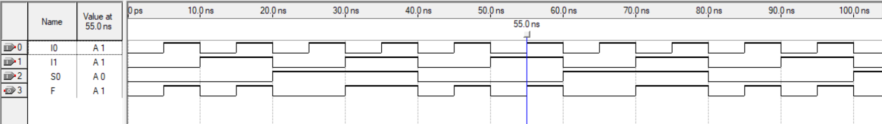
endmodule
Figure 1 Vector waveform simulation results of 2x1 mux
Simulation Result: A 2×1 multiplexer is a combinational circuit that selects one of two inputs based on a selector and then sends it to the output (1).The simulation shows the selector controls the output correctly. When S = 0, the output Y follows I [0], and when S = 1, the output Y follows I [1]. This confirms correct 2×1 multiplexer operation.

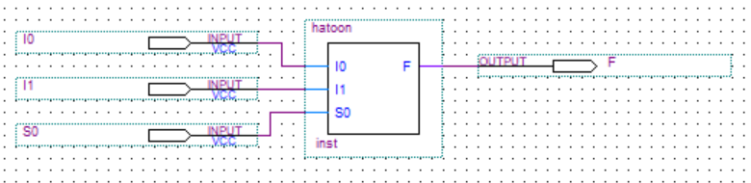
Figure 2: The block diagram for 2x1 MUX

MUX 4x1
module hmouz (I0, I1, I2, I3, S0, S1, F);
input I0, I1, I2, I3;
input S0, S1;
output F;
assign F= (I0 & !S1 & !S0)|
(I1 & !S1 & S0)|
(I2 & S1 & !S0)|
(I3 & S1 & S0);
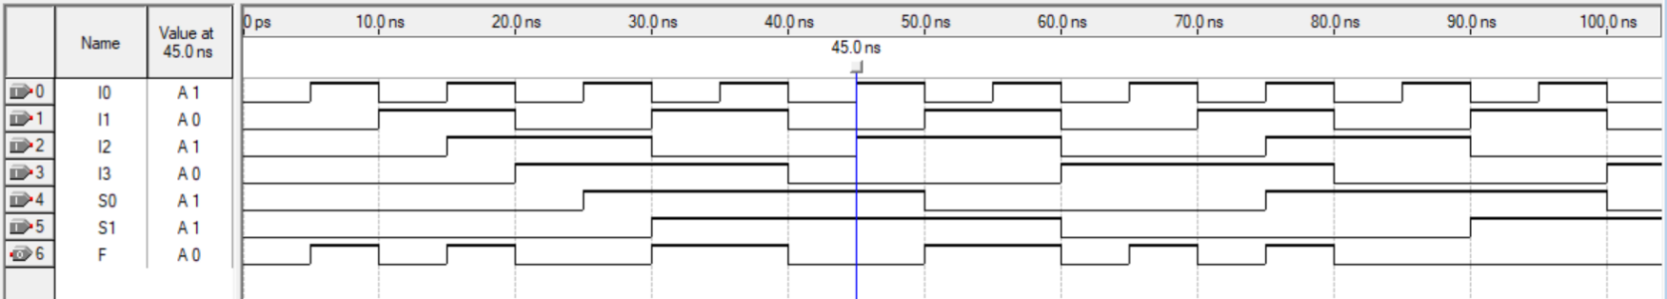
endmodule
Figure 3: Vector waveform simulation results of 4x1 mux

Simulation Result: A 4×1 multiplexer selects an output from the four input signals, where the chosen input is determined by two selectors. The waveform shows that the output correctly according to the selectors. The two selectors control which input is shown in the output, so when the selectors change the output switches and match the value of the input (if S0 S1 == 11 the I3 is the output). The observed waveform behavior confirms correct 4x1 mux function.
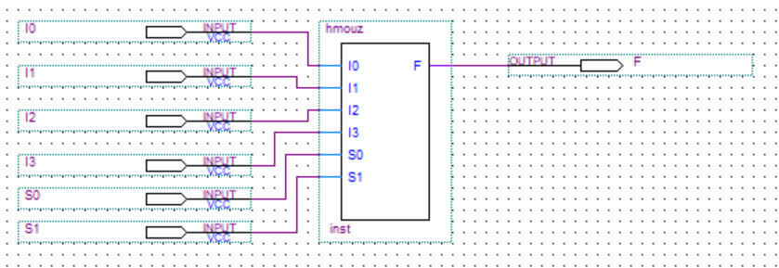
Figure 4: The block diagram of 4x1 mux

Structural System Design
module h1241706(I0, I1, I2, I3, I4, I5, I6, I7, S0, S1, S2, F);
input I0, I1, I2, I3, I4, I5, I6, I7, S0, S1, S2;
output F;
wire F0, F1;
hmouz mux41(I0, I1, I2, I3, S0, S1, F0);
hmouz mux42(I4, I5, I6, I7, S0, S1, F1);
hatoon mux2(F0, F1, S2, F);
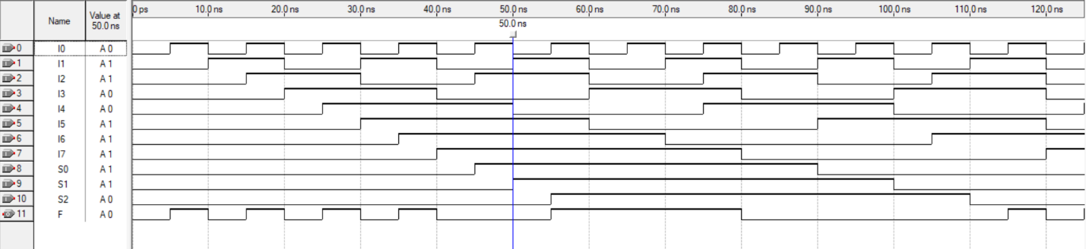
endmodule
Figure 5: Vector waveform simulation results of the system
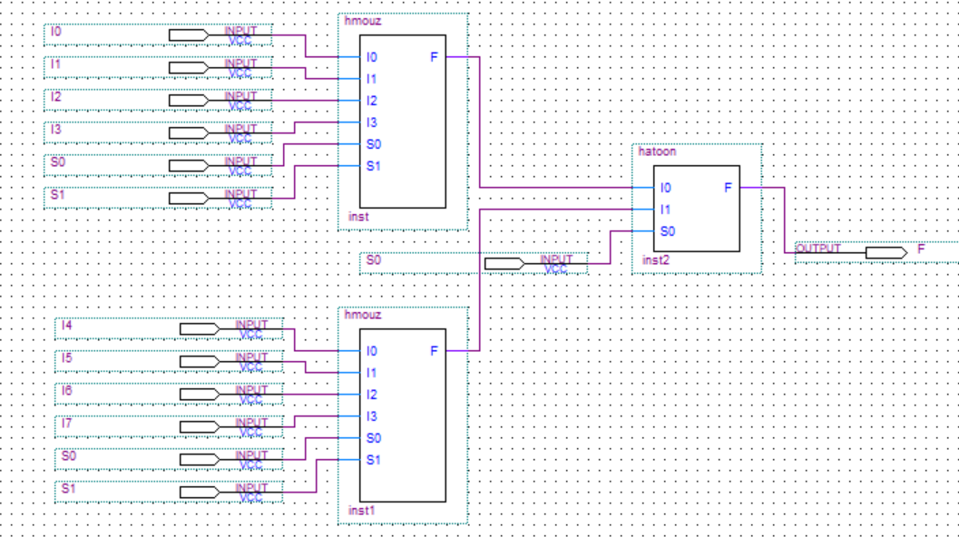
Simulation Result: The system is designed structurally by connecting the previously implemented multiplexer modules (two 4x1 mux and one 2x1 mux). The simulation shows that the final system operates correctly as designed. This module is the final System it’s built by connecting two 4x1 mux and one 2x1 mux by structural modeling. The output changes according to the selector, for example the first 4x1 mux the output is I3 == 0 and the second 4x1 mux the output Is I6 == 1 then the final output will be I3 because S2=0.

Figure 6: Structural block diagram of the system.

Conclusion
The designed modules were simulated using the Quartus II simulation tool to make sure that the operations work correctly. Each module was simulated separately on its own by applying different input and selector.
From the simulation waveforms results, it shows that the outputs change correctly according to the expected behavior of the multiplexers. For the 2×1 multiplexer, the output depends on the selected input based on the selector (if s==0 then the output will be I0, and if s==1 then the output will be I1). For the 4×1 multiplexer, the output corresponds to the selected input based on the two selectors (if s1==0 and s2==0 then the output will be I0, if s1==1 and s2==0 then the output will be I1, if s1==0 and s2==1 then the output will be I2, and if s1==1 and s2==1 then the output will be I3).
The final system was also simulated to ensure and check that the overall design works correctly when all modules are connected together. The simulation results confirm that the system behaves as expected.

Arithmetic and Logic System:

Procedure and Discussion

1-bit Adder
A full adder is a combinational circuit that performs addition of 3 one-bit binary numbers. It has 2 inputs and a carry input and 2 outputs. (2)
module FA (a, b, cin, sum, cout);
input a, b, cin;
output sum, cout;
assign {cout, sum} = a+b+cin;
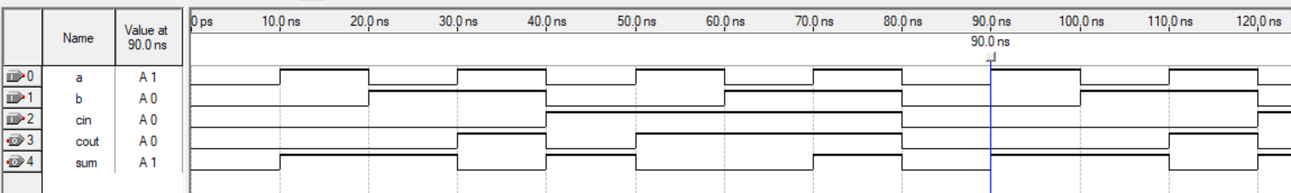
endmodule
Figure 7: Vector waveform simulation results of the 1-bit adder
The waveform demonstrates correct full adder operation. For example, when a==1 && b==0 && cin==0 the output sum ==1 and cout==0. This confirms the correctness of the adder implementation.

4-bit Adder
The 4-bit adder is constructed by using four 1-bit full adder modules. The carry-out of each stage is connected to the carry-in of the next stage. A binary adder / subtractor can do both the addition and subtraction of binary numbers in the same circuit, performing the operation depends on the values of control signal. (3)

module hmouz (A, B, M, Sum, Cout);
input [3:0] A, B;
input M;
output [3:0] Sum;
output Cout;
wire [3:0] BXOR;
wire c1, c2, c3;
assign BXOR [0] = B [0] ^ M;
assign BXOR [1] = B [1] ^ M;
assign BXOR [2] = B [2] ^ M;
assign BXOR [3] = B [3] ^ M;
FA a0(A [0], BXOR [0], M, Sum [0], c1);
FA a1(A [1], BXOR [1], c1, Sum [1], c2);
FA a2(A [2], BXOR [2], c2, Sum [2], c3);
FA a3(A [3], BXOR [3], c3, Sum [3], Cout);
assign overFlow = c3 ^ Cout;
endmodule
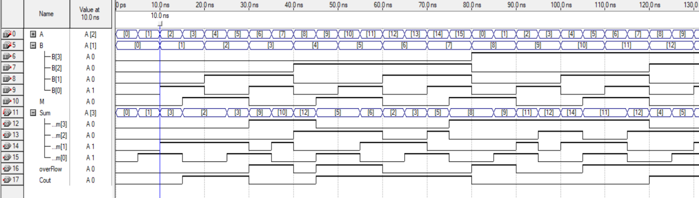
The simulation verifies correct binary addition of two 4-bit numbers. For example, when adding 2 to 1 it gives 3 with a carry out of 0. Showing the addition of two 4-bit binary numbers A=0001 and B=0011, producing a sum of 0011 and a carry out of 0. The waveforms showed that the 4-bit ripple adder worked properly, delivering accurate sums and carry-out values.

Figure 8: Vector waveform simulation results of the 4 bit-adder/subtractor

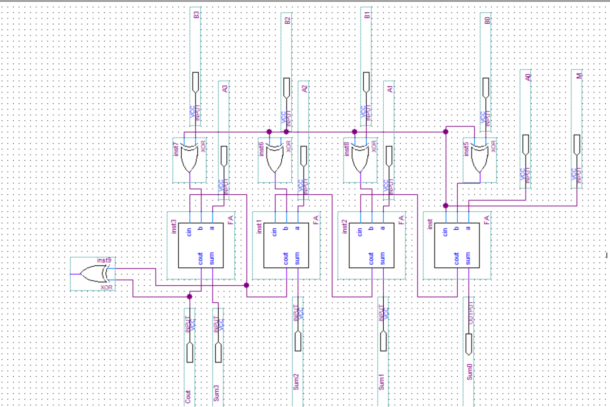
Figure 9: The structural block diagram of the 4-bit adder using full adders

Quad MUX 2x1

1-bit MUX 2x1
module mux2(I0, I1, S, Y);
input I0, I1, S;
output Y;
assign Y = (I0 & !S) | (I1 & S);
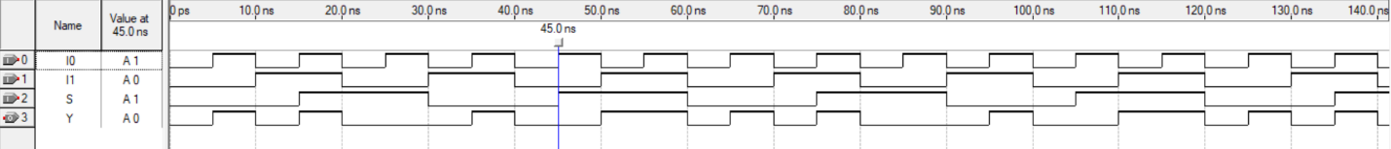
endmodule
Figure 10: Vector waveform simulation results of the Quad MUX 2x1
The simulation shows the selector controls the output correctly. When S = 1, the output Y follows I [1], and when S = 0, the output Y follows I [0]. In this example, when S=1 then the output follows I[1] and become equals to 0. This confirms correct 2×1 multiplexer operation.

Quad MUX 2x1 4-bit
module hatoon (A, B, S, Y);
input [3:0] A, B;
input S;
output [3:0] Y;
mux2 m0(A [0], B [0], S, Y [0]);
mux2 m1(A [1], B [1], S, Y [1]);
mux2 m2(A [2], B [2], S, Y [2]);
mux2 m3(A [3], B [3], S, Y [3]);
endmodule
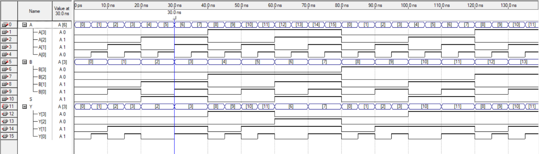
Figure 11: Vector waveform simulation results of Quad MUX 2x1 4-bit
The vector waveform simulation confirms the correct operation of the 4-bit Quad 2x1 multiplexer. The same selector controls all four bits and each output changes according to the selected input. When the selector is set to 0, the output match the values of input A, and hen the selector is set to 1, the output match the values of input B. This confirms that the 4-bit mux is working correctly.
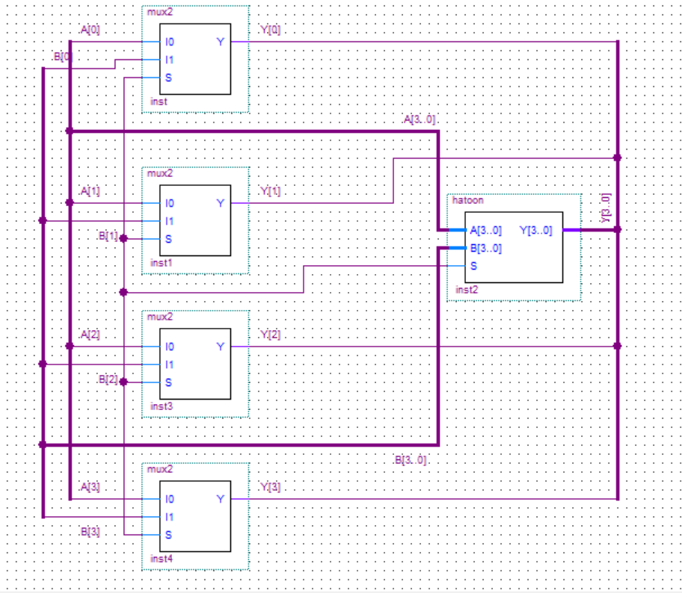
Figure 12 : The structural block diagram of the Quad MUX 2x1 4-bit

4-bit OR Array
This module has two 4-bit input (A, B), and one 4-bit output (Y). It is a logical operation that computes the logical OR operation on each bit of the two 4-bit inputs and produces one if one of the bits is equal to one and produces zero if both bits are equal to zero.
The Boolean expression is X= A+B. (4)

module ORR (A, B, Y);
input [3:0] A, B;
output [3:0] Y;
assign Y=A|B;
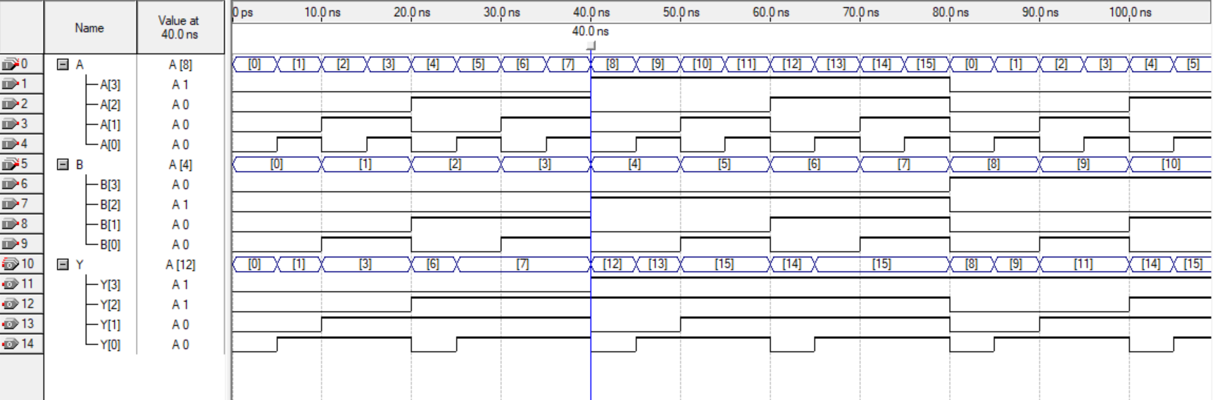
endmodule
Figure 13: Vector waveform simulation results of the 4-bit OR array
Simulation Result: Each output bit correctly represents the OR operation of the corresponding input bits. The simulation shows the Bitwise OR's results in many cases. For example, when A = 1000, B = 0100, the result is correctly displayed as 1100.
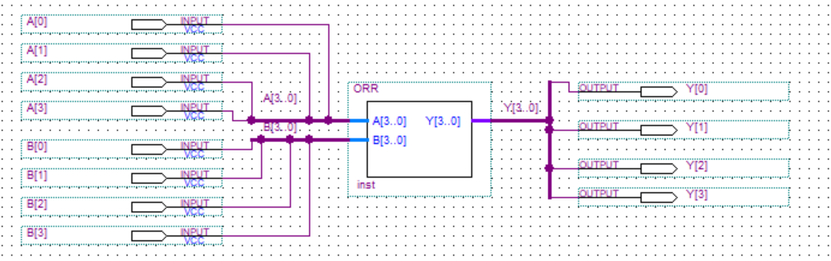
Figure 14: The block diagram of the 4-bit OR array

4-bit AND Array
This module has two 4-bit input (A, B), and one 4-bit output (Y). It performs a logical AND operation between each bit of the two 4-bit inputs, and produces one if both of the bits are equal to one and produces zero if both bits are equal to zero or one of them. The Boolean expression is X = A.B. (5)

module ANDD (A, B, Y);
input [3:0] A, B;
output [3:0] Y;
assign Y=A&B;
endmodule
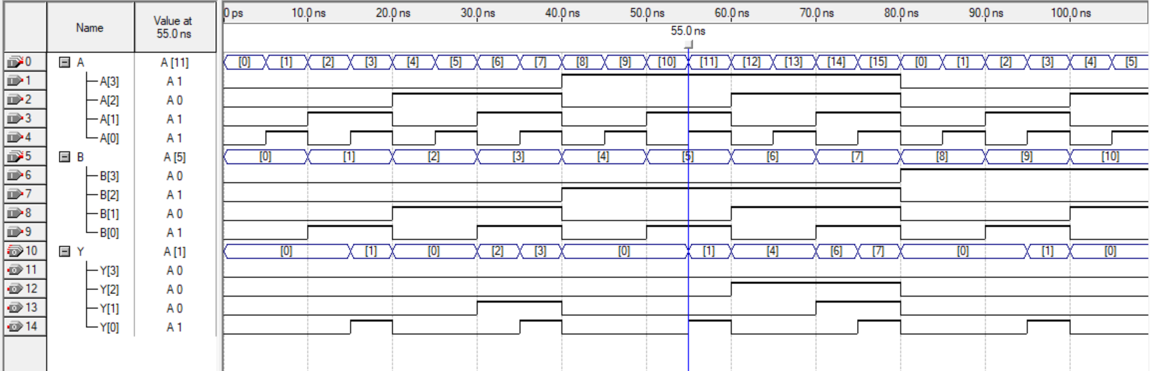
Figure 15: Vector waveform simulation results of the 4-bit AND array
Simulation Result: Each output bit correctly represents the AND operation of the corresponding input bits. The simulation shows the Bitwise AND's results in many cases. For example, when A = 1011, B = 0101, the result is correctly displayed as 0001.
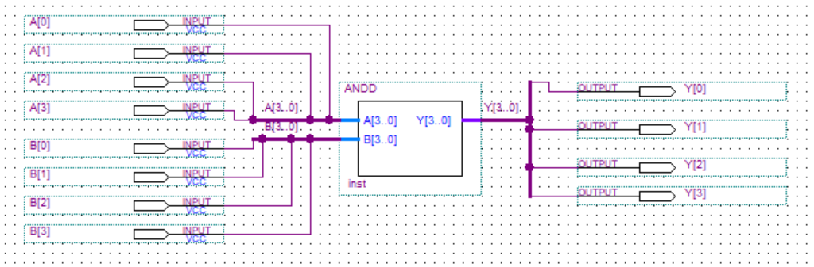
Figure 16: The block diagram of the 4-bit AND array

Final System Design
The final system integrates the 4-bit adder, OR array, AND array, and Quad MUX 2×1 using structural design.

module h1241706(A, B, S0, S1, R, OverFlow);
input [3:0] A, B;
input S0, S1;
output [3:0] R;
output OverFlow;
wire [3:0] addsub, andd, orr, L;
wire cout , overf;
hmouz h1(A, B, S0, addsub, cout , overf);
ANDD and1 (A, B, andd);
ORR or1 (A, B, orr);
hatoon h2 (andd, orr, S0, L);
assign R = (!S1)? addsub: L;
assign OverFlow = (!S1) ? overf :0 ;
endmodule
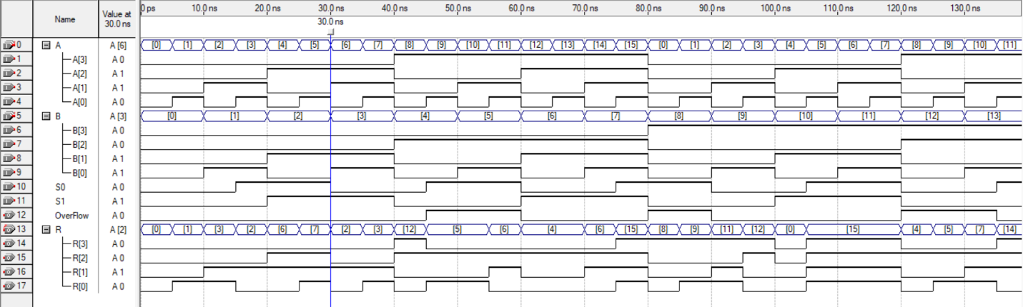
Figure 17: Vector waveform simulation results of the final system

The simulation confirms correct operation of the complete system and proper interaction between all submodules. In this example, A = 0110 and B = 0011, with control signals S0 = 0 and S1 = 1. Since S0 = 0 and Cin = 0, the adder performs addition and produces A + B = 1001 with no overflow.
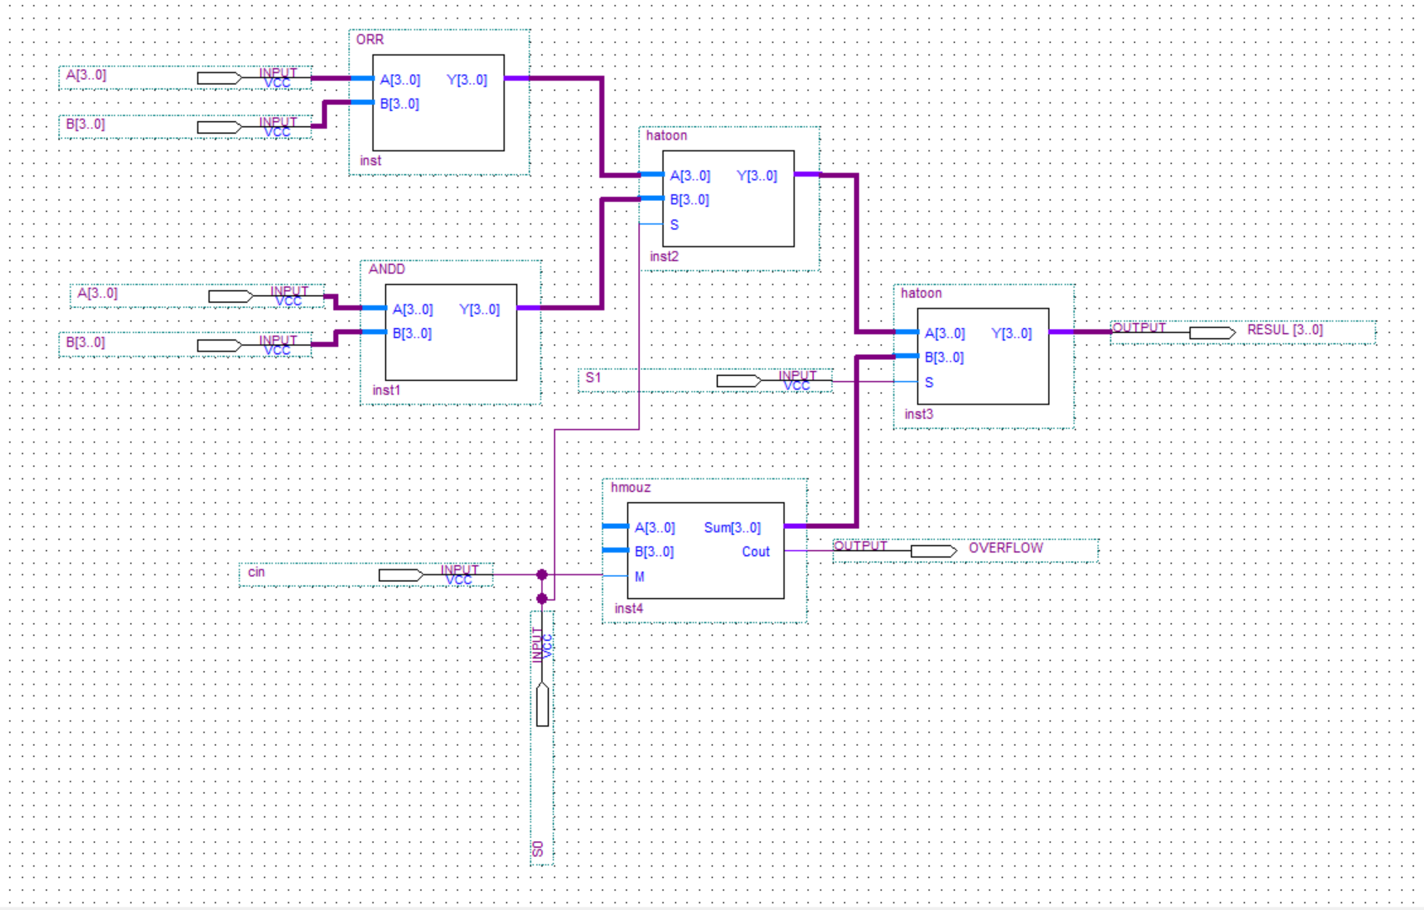
Then the logic blocks generate A OR B = 0111 and A AND B = 0010. The first multiplexer selects the AND output, and since S1 = 1, the logic path is selected by the second mux. Therefore, the final output of the system is 0010, and the overflow signal remains zero.
Figure 18: The block diagram of the final system

Conclusion
This project focused on building a small arithmetic and logic system, each block was first implemented separately. A 4-bit digital system was designed and implement it using Verilog HDL. At first, implementing a 1-bit full adder, which then used it structurally to build a 4-bit adder/subtractor, which performs both addition and subtraction depending on the inputs. As the subtraction operation was achieved using the 2s complement.
In addition, 2x1 mux was implemented and used structurally to build a quad 2x1mux. 4-bit AND and OR logic arrays were also designed separately. All theses blocks were then connected to form the final system shown in the final block diagram.
Simulation results verified the correct operation of each individual block as well as for the final system. The waveform results clearly show correct addition, subtraction, AND, OR operations, along with proper result selections and overflow.
In conclusion, this project successfully demonstrates how complex digital systems can be constructed from simple modules.

References
[Book].
[Online]. - https://www.geeksforgeeks.org/digital-logic/multiplexers-in-digital-logic/.
[Online]. - https://www.geeksforgeeks.org/digital-logic/multiplexers-in-digital-logic/.
[Online] // https://www.geeksforgeeks.org/digital-logic/full-adder-in-digital-logic/.
[Online] // https://www.geeksforgeeks.org/digital-logic/4-bit-binary-adder-subtractor/.
[Online] // https://www.geeksforgeeks.org/digital-logic/logic-gates/.
[Online] // https://www.geeksforgeeks.org/digital-logic/logic-gates/.

