***Tomeo: Video Editor for Sports Enthusiasts***

**Introduction**

The development of the ‘Tomeo’ video player involved 3 iterations. There were 2 surveys conducted between two iterations to receive feedback from potential users before moving on to the next iteration.

The report would give the reader an overall understanding of the development process of the video player – Tomeo. It includes a detailed description of the multiple iterations done by the team.

At all stages of the development, there were notable changes made to the prototype of the application. The prototypes were inspired by renowned video players, such as the VLC media player and the windows media player. The design choices were also hugely dependent on user feedback on usability heuristics.

We followed agile principles for the development of this software. A Microsoft Teams chat was created for communication between team members. A Gitlab repository for the project was also created with separate branches for each developer (as shown on the left) and the main branch to commit to after we have finalized each iteration. Our working techniques included frequent meetings and the usage of Kanban boards. Each person was assigned a specific task to work on. Below is a screenshot of the usage of the Kanban board which was created through an application called Trello.

**Iteration 1:**

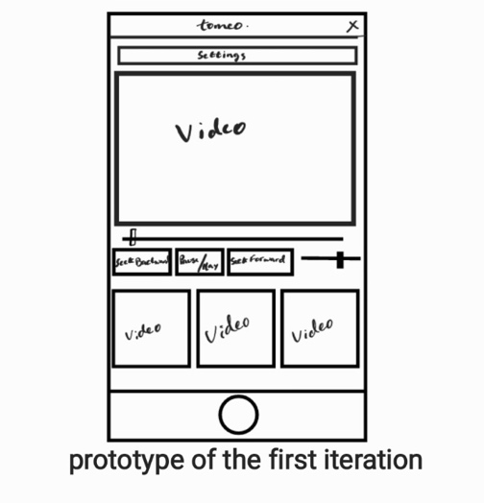The first iteration aimed to review the given code, ‘Tomeo’, and improve it by creating buttons (Pause, Play, Settings) and our first slider-bar (Volume).

The addition of buttons and a slider bar was our priority since we needed to get a basic understanding of the layout. We decided that the app will be made available on mobile devices and tablets.

The prototyping technique we used was sketching, as it was easier for us to brainstorm ideas and make constructive criticisms throughout our multiple iterations.

**The key results of the questionnaires after the 1st and 2nd iterations:**

The results of the survey revealed that a vast number of people believe that “A wide variety of features and functionalities” were the most important aspect of a video player. Henceforth, is reflected in our requirements.

We have also decided to “display multiple videos in the current playlist of the window” similar to the skeleton code provided as this was the most popular choice.

It was considered that the option for users to adjust the Brightness, Hue, Contrast Saturation and many other colour settings, assuming that they were viable in later iterations if not in the current iteration.

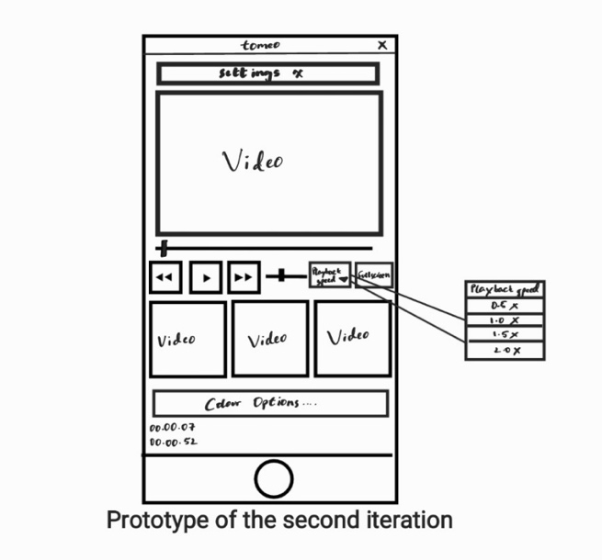 **Iteration 2:**

We came to a conclusion to continue with the initial code, ‘tomeo’ because we didn’t want to reiterate the process of the development and overcomplicate it.

In this cycle, we successfully identified most of the requirements of the app. This is the stage where we came across most of our limitations and technical difficulties.

Adding functionalities to buttons and creating additional buttons was the priority in this iteration. Since this is almost the midpoint of the development cycle, we had to make sure that the application can show the working minimal functional requirements of a video player. Implementing a working full-screen option was also an important requirement of the prototype.

**Iteration 3:**

As our final iteration, we finalized most of our features and functionalities within the time constraints. We also managed to tackle most of the limitations and technical difficulties from the previous iteration. Although we have multiple non-functional buttons in the menu drop-down, the functional buttons seem to prove the working and efficiency of the video player.

The layout didn’t undergo any major changes; however, a number of functionalities were added to existing buttons: Seek forward, seek backward, and playback speed. It is important to note that the colour options dropdown box, has working brightness, contrast, Hue and saturation sliders. The full-screen option was also implemented but is partially working.

The theme of the video player was chosen as dark grey against a black layout. With the implementation of the chosen colour combination, a dark-themed layout was created which was what most of the users expected to see in a video player.

There was a volume label created, which reflected changes in the volume slider. Additional buttons were created in the menu drop-down box which includes: Settings, save, open file, report any issues, and quit. However, these buttons don’t have any functionalities.

**Usability Heuristics:**

Before we started our systems development life-cycle, our team did extensive research on Ben Schneiderman’s eight Golden Rules of Interface Design [1] and Jakob Nielsen’s 10 general principles [2]. We established ourselves with some core values, aims, and motivations for usability heuristics that we must strictly adhere to during our SDLC.

|  |  |
| --- | --- |
| Heuristic | Functionality and features that enabled helped to achieve |
| Users should have a sense of control for any usage and functionality - their actions must be reversible. | Allow undo/redo and toggling (Pause/Play button). |
| The functionalities must be predictable. To reduce the user's cognitive load, the labels for buttons and slider bars must describe their actions from well-known and established symbols and conventions. | (Volume slider-bar) and its label and locations. |
| Provide slightly more advanced features and functionalities for more sophisticated or niche-users. | Saturation, Contrast, Brightness and Hue options are important for certain people with visual impairments (Colour blindness, Extreme light sensitivity, Night blindness, and Photosensitive Epilepsy). |
| Buttons, Combo-box, and Slider-bar should respond varyingly with different input magnitudes supplied, to ensure that it allows users to learn from their own actions | The volume slider bar changes the volume of the video as the user slides across the slider. |
| Incorporate progress indicators, to provide feedback on periodic changes in real-time. | (Seek-slider bar) correctly identifies the video duration and current duration. |

|  |  |  |
| --- | --- | --- |
| Iterations | Improvements | Limitations and Technical Difficulties |
| Iteration 1 | * Volume-slider bar working. * Pause/Play button working. | * Background of the window flashes as the window expands. |
| Iteration 2 | * Fully functioning seek-slider bar. Video duration and current duration were correctly identified. * Fullscreen working. * Conventional symbols used to label the buttons. | * Colour options cannot be reopened once it is closed. * Duplicate videos at the bottom. * Seek Forward and Seek Backward buttons not working yet. * Fullscreen is somewhat buggy at times. Triggers flashes as the window expand. * Pause/Play buttons still don’t toggle * Playback speed unrecognized. * Static Seek Slider. |
| Iteration 3 | * Seek Slider moves in real-time. * Pause/Play button labels toggle. * Menu drop-down with more buttons. * seek Forward and seek backward working for 5s at a time. * Colour options can now open, close, and reopen. * Brightness, Contrast, Hue, and Saturation sliders affect the main video. * Volume label changes its value. | * Duplicate videos at the bottom but no more than 2 similar videos at a time. * The window still flashes as it expands but the background color is now consistent. * Failing to exit Fullscreen mode. |

**References:**

[1] Jakob Nielsen. 10 Usability Heuristics for User Interface Design. Nielsen Norman Group. [Online].[Accessed 12th December 2022]. 2020. Available from: <https://www.nngroup.com/articles/ten-usability-heuristics/>

[2] Ben Schneiderman. The Eight Golden Rules of Interface Design. The University of Maryland. [Online]. Available from: <https://www.cs.umd.edu/users/ben/goldenrules.html/>

[3]