**Figure 1**. Study sites. I took rainfall data (Jan 2015 to Dec 2016) from the admin units where the study sites were located according to the map you sent. The admin1 units are colored in blue and the admin2 units are outlined in black. Rainfall patterns were similar when run with admin1 and admin2.

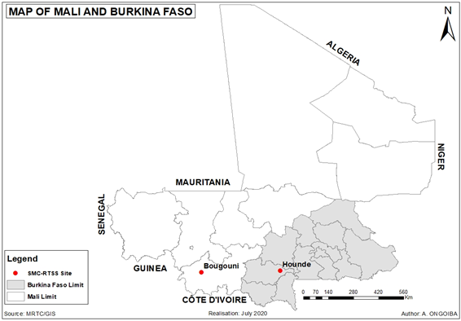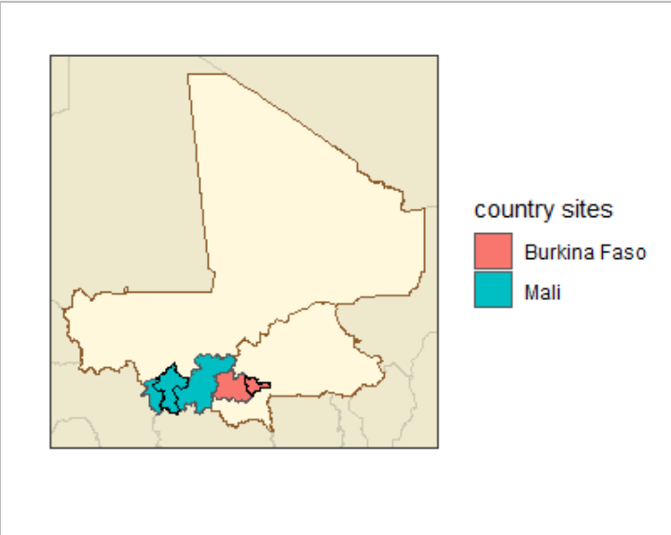

**Figure 2**. Clinical incidence among children 0-5 years. Colored lines indicate *malariasimulation* results under different EIR / transmission intensity values. Black lines indicate clinical results from the study sites in 2015 and 2016. *malariasimulation* results factor in 45% treatment coverage with AL, 0% bednet coverage, and a 25% *arabiensis*, 25% *funestus*, and 50% *gambiae* vector composition.

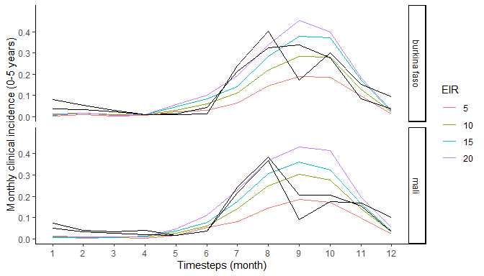

**Figure 3**. Figure 2 with 100% *arabiensis*

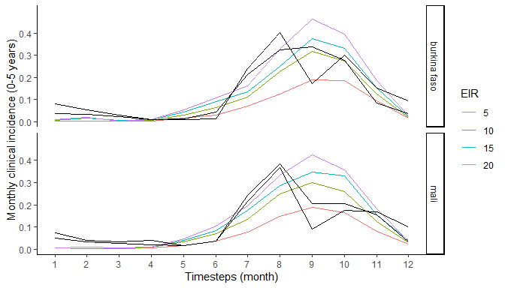

**Figure 4**. Figure 2 with 100% *funestus*

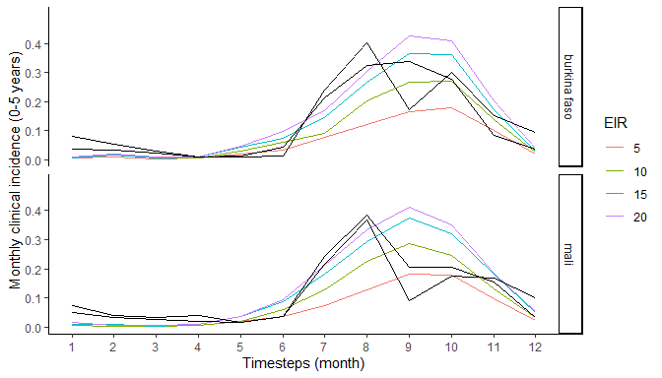

**Figure 4**. Figure 2 with 100% *gambiae*

