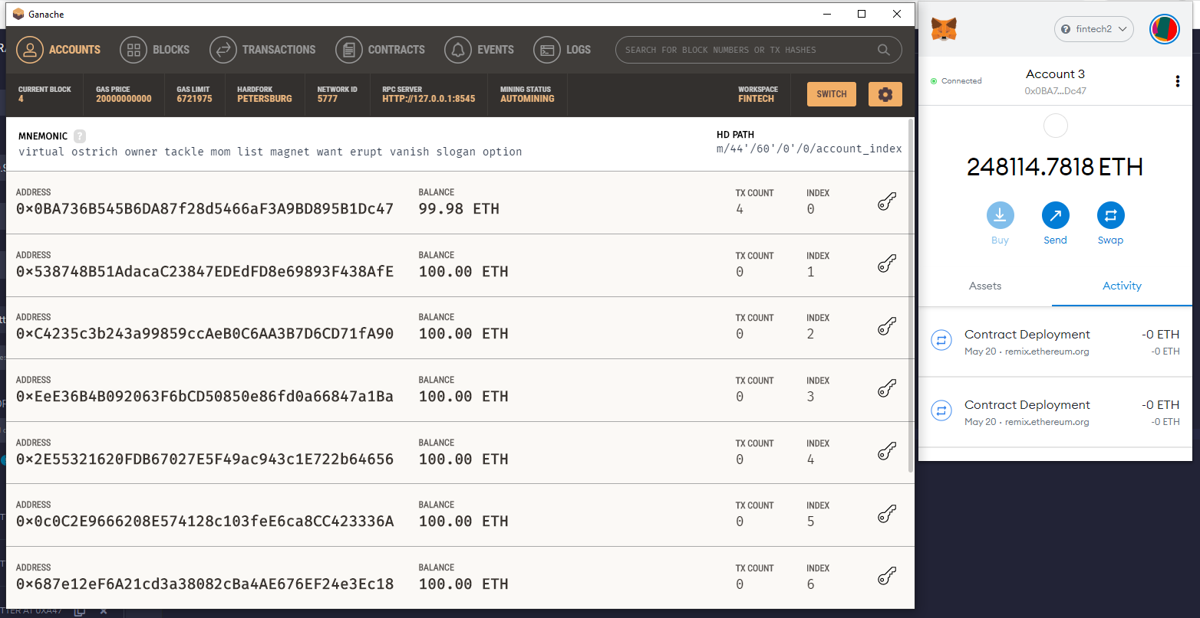

I was able to get my ganache connected with metamask.

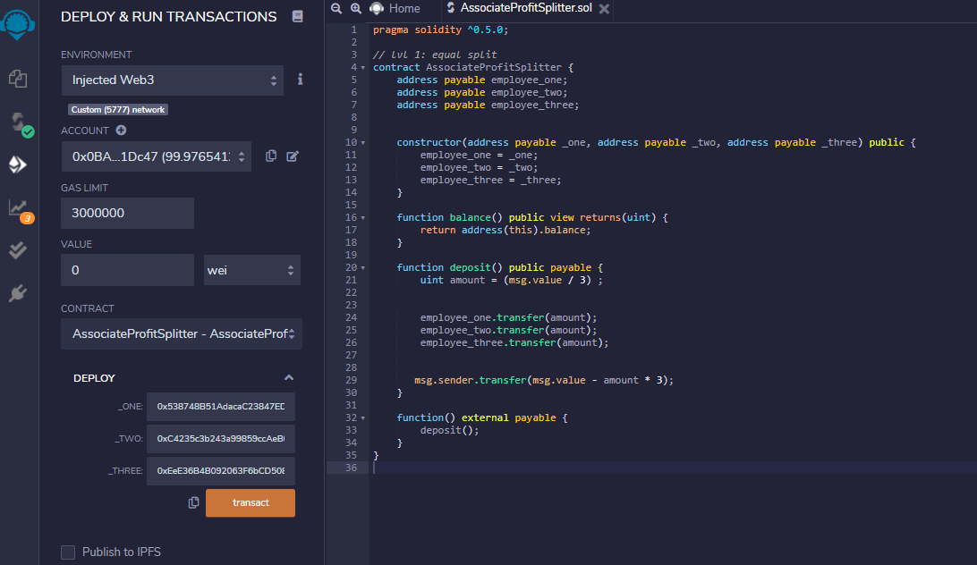

I was also able to compile it and connected it with remix account from metamask and first one in Ganache, the next three accounts shown above. When I deployed it.

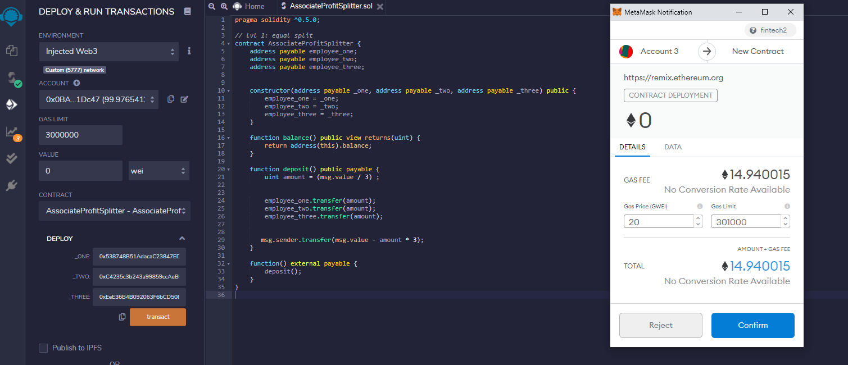

My test run when I tried to deploy it.

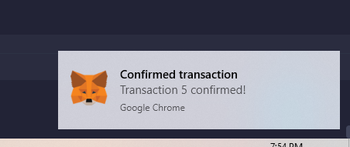

It went through. However I can’t seem to get it to transfer eth or wei. Because I got a gas limit error.