LifeVerse Review Volume 04 Implementation
UX/UI implementation package for architect review. Source of truth priority: Volume 01, Volume 02, Volume 03, Volume 04.
Generated by Codex after implementing Volume 04 inside the existing LifeVerse / Life Sim layer.

1. Executive Summary
- LifeVerse was refactored from tab/dashboard presentation toward a world-first game UX.
- Permanent HUD is reduced to time, day, money, health, energy, and current reminder.
- Phone, Journal, Map, and Pause now act as in-game device/menu overlays.
- Context interaction now shows location-relevant actions near the world view.
- Fast Forward and Life Report presentation now use timeline/chapter structures.
- Gameplay actions still route through Command Bus, Simulation Engine, Event Bus, Trace Engine, State Store, and UI.

2. Files Changed
- index.html
- app.js
- styles.css
- package.json
- lifeverse-ux.js
- tests/lifeverse-volume04-ux.test.js

3. New Files Added
- lifeverse-ux.js
- tests/lifeverse-volume04-ux.test.js
- tools/build_volume04_review.py

4. Screenshots / Implementation Evidence
Live screenshot capture was attempted but blocked by the local headless Chrome GPU failure and incomplete bundled Playwright package. To avoid fake evidence, the first image is explicitly labeled as a before reference reconstruction from the implementation diff, not a live screenshot. The after images are implementation evidence diagrams generated from the new Volume 04 UX structure.
Before reference: dashboard-like issue recorded from previous structure.
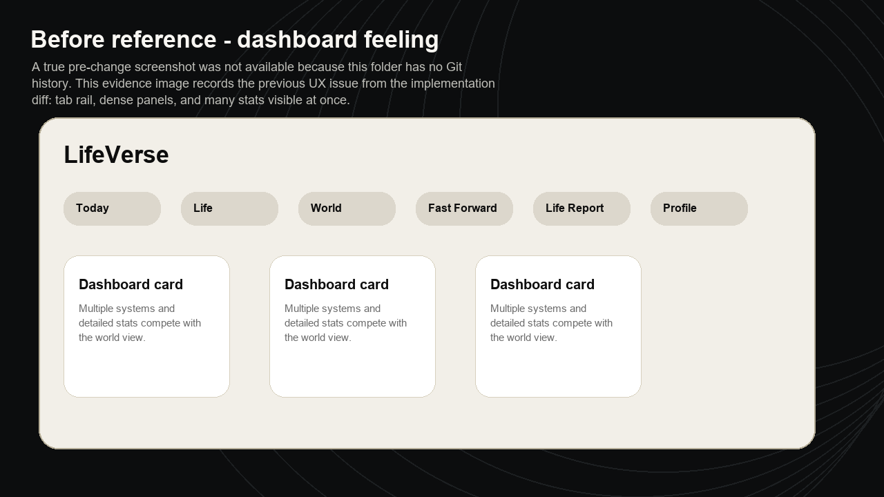
After: world-first LifeVerse shell.
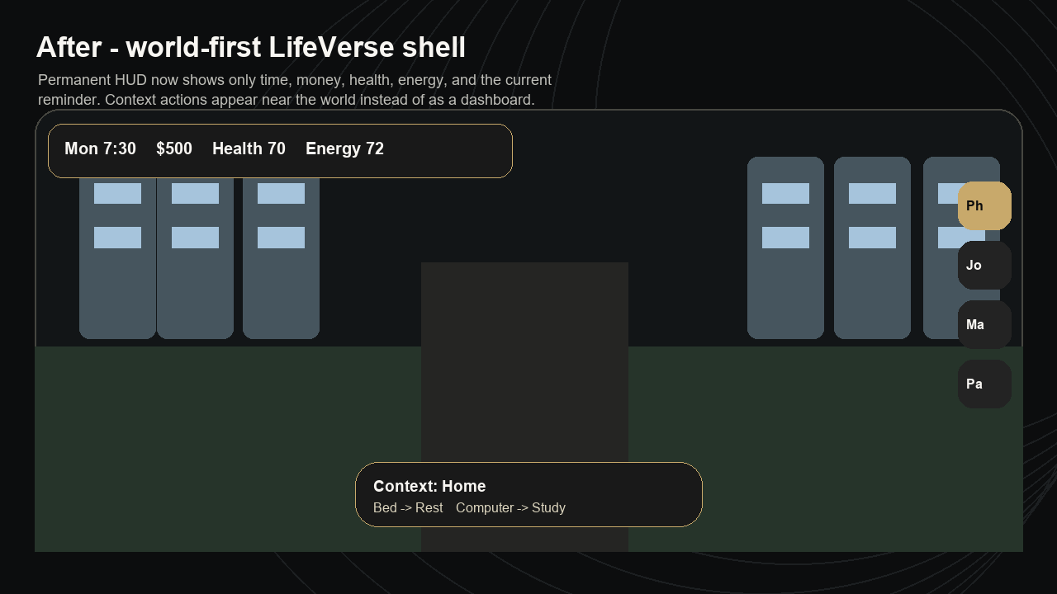
After: in-game phone overlay.
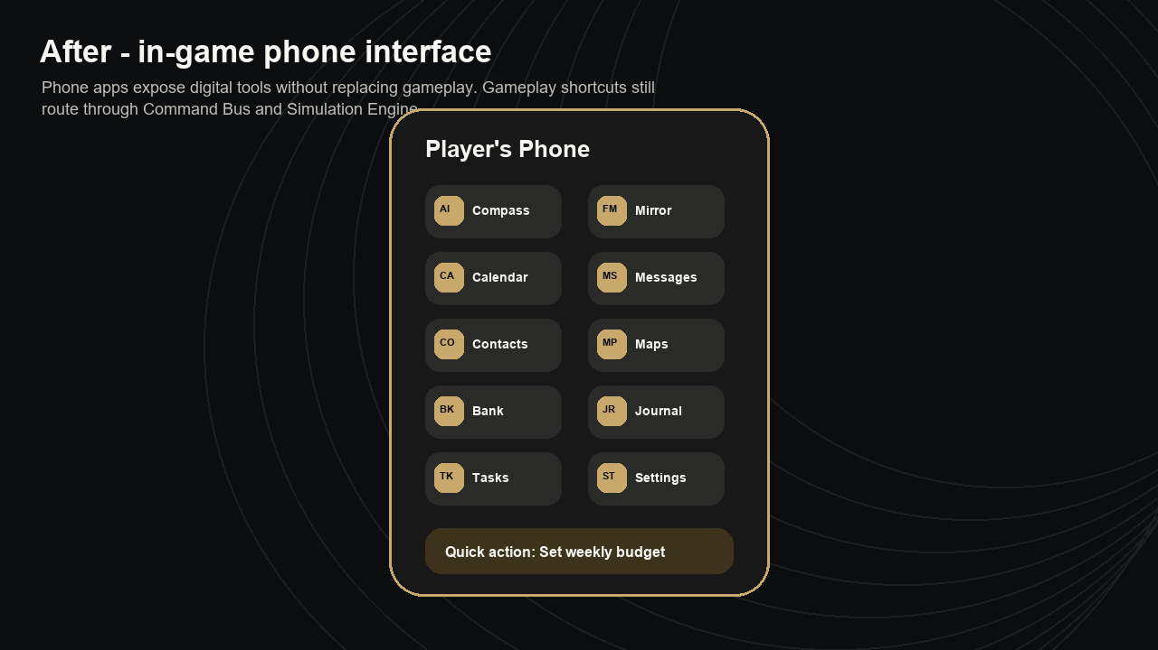
After: Fast Forward and Life Report presentation.
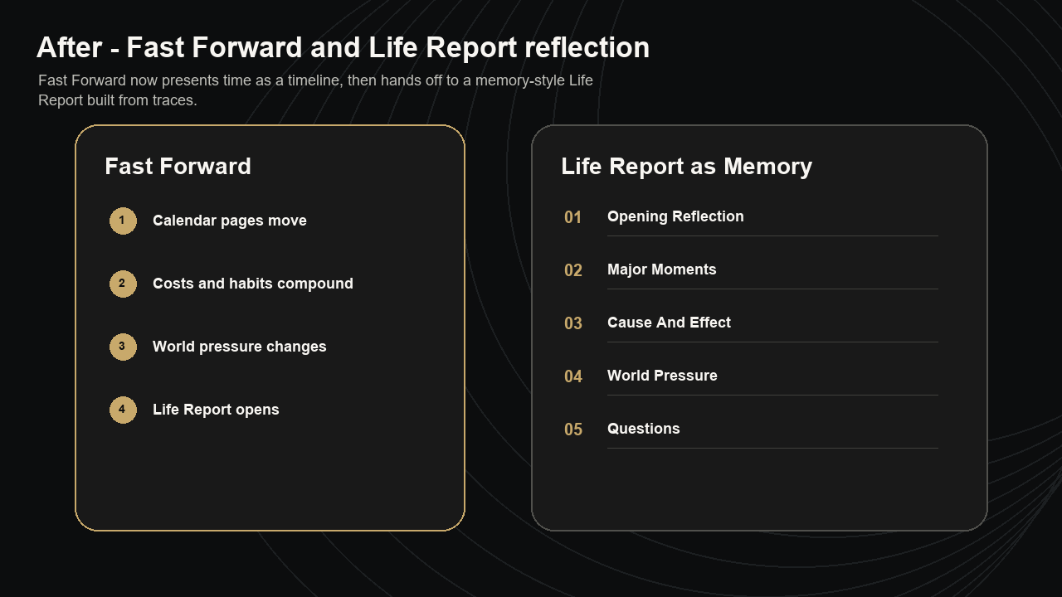

5. UX Changes By Volume 04 Chapter
Volume 04 Area | Implementation
Chapter 03 Navigation | Replaced traditional in-game tab bar with Phone, Journal, Map, and Pause dock. Query-param startup support was added for testing/review only.
Chapter 04 HUD | Permanent HUD now exposes only critical information and moves detailed needs to dynamic warnings.
Chapter 05 Context Interaction | Current location now exposes context actions such as Bed, Computer, Fridge, Workplace, Food Court, Gym Floor, Friend, and Quiet Bench.
Chapter 07 Smartphone UX | Added phone overlay with Compass AI, Future Mirror, Calendar, Messages, Contacts, Maps, Banking, Journal, Tasks, and Settings.
Chapter 09 Life Report | Report presentation uses reflective chapters: Opening Reflection, Major Moments, Cause And Effect, World Pressure, Lessons, Next Steps, Questions.
Chapter 11 Fast Forward | Fast Forward panel now shows a time-lapse sequence before running simulation periods.
Chapter 13 Visual Design System | Applied restrained black, warm off-white, gold accent, glass panels, consistent spacing, and reduced clutter.
Chapter 14 Motion | Added lightweight panel transition and timeline animation-ready structure. Final art and motion polish remain Volume 05.

6. Architecture Flow
Gameplay action flow:
UI -> Command Bus -> Simulation Engine -> Gameplay Systems -> Event Bus -> Trace Engine -> State Store -> UI
Volume 04 UX helpers are read-only presentation logic. They select HUD labels, phone apps, context prompts, timeline labels, and report chapters from existing state.

7. Full Source Code Of New Files

lifeverse-ux.js
(function () {
const game = window.LifeVerseGame || (window.LifeVerseGame = {});

function clamp(value, min = 0, max = 100) {
const number = Number(value);
if (!Number.isFinite(number)) return min;
return Math.max(min, Math.min(max, Math.round(number)));
}

function getMinimalHud(state) {
const time = game.getTimeSnapshot ? game.getTimeSnapshot(state) : {};
return {
time: time.time || "",
day: time.dayOfWeek || "",
date: time.date || "",
money: state.finance ? Math.round(Number(state.finance.money) || 0) : 0,
health: state.health ? clamp(state.health.physical) : 0,
energy: state.needs ? clamp(state.needs.energy) : 0,
objective: getCurrentObjective(state)
};
}

function getCurrentObjective(state) {
if (!state) return "Observe the district and choose one grounded action.";
if (state.finance && Number(state.finance.money) < 120) return "Money is tight. Find income or reduce spending.";
if (state.needs && Number(state.needs.energy) < 28) return "Energy is low. Rest before taking on heavy tasks.";
if (state.health && Number(state.health.physical) < 40) return "Health needs attention. Choose recovery or care.";
if (state.needs && Number(state.needs.stress) > 72) return "Stress is high. Slow down and lower pressure.";
if (state.career && Number(state.career.readiness) < 35) return "Build readiness through work, study, or networking.";
return "Live one meaningful block of today, then reflect on the consequence.";
}

function getCriticalNeeds(state) {
if (!state || !state.needs) return [];
const checks = [
["energy", "Energy", state.needs.energy, "low"],
["hunger", "Food", state.needs.hunger, "low"],
["sleep", "Sleep", state.needs.sleep, "low"],
["social", "Social", state.needs.social, "low"],
["stress", "Stress", state.needs.stress, "high"],
["hygiene", "Hygiene", state.needs.hygiene, "low"]
];
return checks
.map(([key, label, value, direction]) => ({ key, label, value: clamp(value), direction }))
.filter((need) => need.direction === "high" ? need.value >= 70 : need.value <= 35);
}

function getPhoneApps(state) {
return [
{ id: "compass-ai", title: "Compass AI", text: "Ask for support without leaving the world.", icon: "AI", target: "compass" },
{ id: "future-mirror", title: "Future Mirror", text: "Reflect on a decision before acting.", icon: "FM", target: "mirror" },
{ id: "calendar", title: "Calendar", text: `${(state.schedule || []).length} life blocks recorded.`, icon: "CA", view: "journal" },
{ id: "messages", title: "Messages", text: "Check support and relationship context.", icon: "MS", view: "life", systemId: "relationships" },
{ id: "contacts", title: "Contacts", text: "See people who shape your support network.", icon: "CO", view: "journal" },
{ id: "maps", title: "Maps", text: state.world ? state.world.district : "District map", icon: "MP", view: "map" },
{ id: "banking", title: "Banking", text: `Cash ${formatMoney(state.finance ? state.finance.money : 0)}`, icon: "BK", view: "life", systemId: "finance" },
{ id: "journal", title: "Journal", text: "Read traces, reports, and reflection prompts.", icon: "JR", view: "journal" },
{ id: "tasks", title: "Tasks", text: getCurrentObjective(state), icon: "TK", view: "today" },
{ id: "settings", title: "Settings", text: "Save, reset, help, and accessibility.", icon: "ST", view: "pause" }
];
}

function getLocationInteractions(state, locationId, activities = []) {
const locationActions = {
home: [
{ object: "Bed", hint: "Sleep, nap, or reset your energy.", activityId: "rest" },
{ object: "Computer", hint: "Study, work online, or review budget.", activityId: "study-block" },
{ object: "Fridge", hint: "Eat or plan cheaper meals.", activityId: "budget-review" }
],
work: [
{ object: "Workplace", hint: "Take a shift or prepare for a better role.", activityId: "work-shift" },
{ object: "Manager", hint: "Build performance and reputation.", systemId: "career", actionId: "prepare-portfolio" }
],
food: [
{ object: "Food Court", hint: "Eat, recover energy, and spend carefully.", activityId: "eat-meal" }
],
gym: [
{ object: "Gym Floor", hint: "Exercise to build health and resilience.", activityId: "exercise" }
],
mall: [
{ object: "Shopping Mall", hint: "Spend for relief, but notice the money trade-off.", activityId: "shopping" },
{ object: "Bank Kiosk", hint: "Review savings pressure.", systemId: "finance", actionId: "set-week-budget" }
],
park: [
{ object: "Friend", hint: "Talk and protect your support network.", activityId: "meet-friend" },
{ object: "Quiet Bench", hint: "Reflect before the next decision.", activityId: "journal-reflection" }
]
};
const available = new Set((activities || []).map((activity) => activity.id));
return (locationActions[locationId] || []).filter((action) => {
if (action.activityId) return available.has(action.activityId);
return true;
});
}

function getFastForwardTimeline(days = 30) {
const count = Math.max(1, Number(days) || 30);
if (count <= 7) {
return [
"Today repeats into a week of routines.",
"Needs, work pressure, and relationships drift.",
"A short Life Report captures the pattern."
];
}
if (count <= 30) {
return [
"Calendar pages move through one month.",
"Rent, food, transport, and habits compound.",
"World conditions nudge money, stress, and opportunity.",
"Life Report opens with the clearest causes."
];
}
if (count <= 365) {
return [
"Months pass through changing routines.",
"Skills, health, relationships, and savings compound.",
"NPC and world pressure reshape opportunity.",
"Life Report becomes a chapter summary."
];
}
return [
"Years pass as repeated choices become identity.",
"Career, education, housing, health, and relationships compound.",
"World changes create pressure and opportunity.",
"Life Report reflects on direction, not just numbers."
];
}

function getReportChapters(report = {}) {
return [
{ title: "Opening Reflection", items: report.overview ? [report.overview] : [] },
{ title: "Major Moments", items: report.majorEvents || report.consequences || [] },
{ title: "Cause And Effect", items: report.causeAndEffect || [] },
{ title: "World Pressure", items: report.worldExplanations || [] },
{ title: "Lessons", items: report.behaviourPatterns || [] },
{ title: "Next Steps", items: report.recommendations || [] },
{ title: "Questions", items: report.reflectionQuestions || [] }
].filter((chapter) => chapter.items && chapter.items.length);
}

function formatMoney(value) {
const amount = Math.round(Number(value) || 0);
return `$${amount.toLocaleString()}`;
}

game.lifeVerseUx = {
getMinimalHud,
getCurrentObjective,
getCriticalNeeds,
getPhoneApps,
getLocationInteractions,
getFastForwardTimeline,
getReportChapters
};
})();

tests/lifeverse-volume04-ux.test.js
const assert = require("assert");
const fs = require("fs");
const path = require("path");
const vm = require("vm");

const root = path.join(__dirname, "..");
const sandbox = {
window: {},
console
};
vm.createContext(sandbox);

[
"event-bus.js",
"trace-engine.js",
"command-bus.js",
"state-store.js",
"persistence-service.js",
"save-service.js",
"entity-models.js",
"component-registry.js",
"service-registry.js",
"simulation-engine.js",
"lifeverse-state.js",
"lifeverse-time.js",
"lifeverse-needs.js",
"lifeverse-player.js",
"lifeverse-activities.js",
"lifeverse-career.js",
"lifeverse-education.js",
"lifeverse-finance.js",
"lifeverse-housing.js",
"lifeverse-transportation.js",
"lifeverse-relationships.js",
"lifeverse-health.js",
"lifeverse-mental-wellbeing.js",
"lifeverse-economy.js",
"lifeverse-npc-simulation.js",
"lifeverse-world-simulation.js",
"lifeverse-progression.js",
"lifeverse-system-registry.js",
"lifeverse-life-report.js",
"lifeverse-fast-forward.js",
"lifeverse-core.js",
"lifeverse-ux.js"
].forEach((file) => {
const source = fs.readFileSync(path.join(root, file), "utf8");
vm.runInContext(source, sandbox, { filename: file });
});

const game = sandbox.window.LifeVerseGame;
const state = game.createInitialState({ profile: { username: "UX Tester" } });
game.installLifeVerseArchitecture(state);

const beforeHudState = JSON.stringify(state);
const hud = game.lifeVerseUx.getMinimalHud(state);
assert.ok(hud.time, "minimal HUD shows in-game time");
assert.ok(Object.prototype.hasOwnProperty.call(hud, "money"), "minimal HUD shows money");
assert.ok(Object.prototype.hasOwnProperty.call(hud, "health"), "minimal HUD shows health");
assert.ok(Object.prototype.hasOwnProperty.call(hud, "energy"), "minimal HUD shows energy");
assert.ok(hud.objective, "minimal HUD shows current objective");
assert.strictEqual(JSON.stringify(state), beforeHudState, "HUD helper does not mutate state");

const phoneApps = game.lifeVerseUx.getPhoneApps(state);
["Compass AI", "Future Mirror", "Calendar", "Messages", "Contacts", "Maps", "Banking", "Journal", "Tasks", "Settings"].forEach((title) => {
assert.ok(phoneApps.some((app) => app.title === title), `phone includes ${title}`);
});

const homeActivities = game.getAvailableActivities(state, { locationId: "home" });
const interactions = game.lifeVerseUx.getLocationInteractions(state, "home", homeActivities);
assert.ok(interactions.some((interaction) => interaction.object === "Bed" && interaction.activityId === "rest"), "context exposes bed sleep action");
assert.ok(interactions.some((interaction) => interaction.object === "Computer" && interaction.activityId === "study-block"), "context exposes computer study action");

const activity = game.performActivityCommand(state, "rest", { locationId: "home" });
assert.ok(!activity.error, "context activity routes through command system");
assert.ok(state.commandHistory.some((command) => command.type === "StartActivityCommand"), "context activity records command");
assert.ok(state.eventHistory.some((event) => event.type === "activity"), "context activity emits event");
assert.ok(state.traces.some((trace) => trace.eventType === "activity"), "context activity creates trace");

const phoneAction = game.performSystemActionCommand(state, "finance", "set-week-budget");
assert.ok(!phoneAction.error, "phone gameplay action routes through command system");
assert.ok(state.commandHistory.some((command) => command.type === "SystemActionCommand"), "phone action records system command");

const fastForward = game.fastForwardCommand(state, 30);
assert.ok(!fastForward.error, "Fast Forward command still completes");
assert.ok(state.eventHistory.some((event) => event.type === "fast-forward"), "Fast Forward creates domain event");
assert.ok(state.traces.some((trace) => trace.eventType === "fast-forward"), "Fast Forward creates trace");
assert.ok(fastForward.report.traceSummary.length, "Fast Forward report reads traces");

const report = game.generateLifeReportCommand(state, { type: "reflection" });
const chapters = game.lifeVerseUx.getReportChapters(report);
assert.ok(chapters.some((chapter) => chapter.title === "Cause And Effect"), "Life Report UX includes cause and effect chapter");
assert.ok(chapters.some((chapter) => chapter.title === "Questions"), "Life Report UX includes reflection questions");

const appSource = fs.readFileSync(path.join(root, "app.js"), "utf8");
assert.ok(appSource.includes("volume04-world-first"), "LifeVerse shell uses Volume 04 world-first class");
assert.ok(appSource.includes("lifeverse-phone-overlay"), "LifeVerse has in-game phone overlay");
assert.ok(appSource.includes("data-lifeverse-phone-action"), "Phone actions are represented in UI");
assert.ok(appSource.includes("data-lifeverse-system-action=\"finance:set-week-budget\""), "Phone gameplay shortcut uses command-routed system action");

console.log("LifeVerse Volume 04 UX tests passed.");

8. Exact Changed Functions From Modified Files

app.js - lifeVerseGameShell
function lifeVerseGameShell() {
const state = lifeVerseState();
const view = lifeVerseViewModel();
if (!state || !view) {
return `
<section class="lifeverse-shell">
<p class="eyebrow">LifeVerse</p>
<h3>LifeVerse is loading.</h3>
<p>Refresh once if the game systems do not appear.</p>
</section>
`;
}
return `
<section class="lifeverse-shell volume04-world-first" data-lifeverse-shell data-lifeverse-view="${escapeHTML(state.activeView || "today")}">
${lifeVerseTopHud(state, view)}
${lifeVerseCriticalNeeds(state)}
${lifeVerseWorldFirstContext(state, view)}
${lifeVerseGameDock(state)}
${lifeVerseOverlayPanel(state, view)}
</section>
`;
}

app.js - lifeVerseTopHud
function lifeVerseTopHud(state, view) {
const hud = lifeVerseEngine()?.lifeVerseUx?.getMinimalHud
? lifeVerseEngine().lifeVerseUx.getMinimalHud(state)
: {
time: view.time.time,
day: view.time.dayOfWeek,
date: view.time.date,
money: state.finance.money,
health: state.health.physical,
energy: state.needs.energy,
objective: view.needsSummary || "Choose one grounded action."
};
return `
<div class="lifeverse-hud">
<div class="lifeverse-time-card" aria-label="In-game time">
<span>${escapeHTML(hud.day)}</span>
<strong>${escapeHTML(hud.time)}</strong>
<small>${escapeHTML(hud.date)}</small>
</div>
<div class="lifeverse-hud-stats" aria-label="Minimal status">
<span><small>Money</small><strong>${formatCurrency(hud.money)}</strong></span>
<span><small>Health</small><strong>${Math.round(hud.health)}</strong></span>
<span><small>Energy</small><strong>${Math.round(hud.energy)}</strong></span>
</div>
<div class="lifeverse-objective-pill">
<small>Current reminder</small>
<strong>${escapeHTML(hud.objective)}</strong>
</div>
</div>
`;
}

app.js - lifeVerseCriticalNeeds
function lifeVerseCriticalNeeds(state) {
const critical = lifeVerseEngine()?.lifeVerseUx?.getCriticalNeeds
? lifeVerseEngine().lifeVerseUx.getCriticalNeeds(state)
: [];
if (!critical.length) return "";
return `
<aside class="lifeverse-dynamic-hud" aria-label="Needs warning">
${critical.slice(0, 3).map((need) => `
<span><strong>${escapeHTML(need.label)}</strong>${Math.round(need.value)}/100</span>
`).join("")}
</aside>
`;
}

app.js - lifeVerseWorldFirstContext
function lifeVerseWorldFirstContext(state) {
const location = trackerState.lifeSim.currentLocation;
const locationInfo = lifeSimLocations.find((item) => item.id === location);
const activities = lifeVerseActivitiesForLocation(location);
const interactions = lifeVerseEngine()?.lifeVerseUx?.getLocationInteractions
? lifeVerseEngine().lifeVerseUx.getLocationInteractions(state, location, activities)
: [];
return `
<section class="lifeverse-context-prompt ${locationInfo ? "" : "is-exploring"}" aria-label="Context interaction">
<div>
<p class="eyebrow">${locationInfo ? "Context interaction" : "Explore mode"}</p>
<h3>${escapeHTML(locationInfo ? locationInfo.name : "Walk toward a place")}</h3>
<span>${escapeHTML(locationInfo ? locationInfo.description : "The world is the primary interface. Move near Home, Work, Food Court, Gym, Mall, or Park.")}</span>
</div>
<div class="lifeverse-context-actions">
${interactions.length ? interactions.map(lifeVerseContextButton).join("") : activities.slice(0, 2).map(lifeVerseActivityCard).join("")}
</div>
</section>
`;
}

app.js - lifeVerseContextButton
function lifeVerseContextButton(action) {
if (action.activityId) {
return `
<button class="lifeverse-context-button" type="button" data-lifeverse-activity="${escapeHTML(action.activityId)}">
<strong>${escapeHTML(action.object)}</strong>
<span>${escapeHTML(action.hint)}</span>
</button>
`;
}
return `
<button class="lifeverse-context-button" type="button" data-lifeverse-system-action="${escapeHTML(action.systemId)}:${escapeHTML(action.actionId)}">
<strong>${escapeHTML(action.object)}</strong>
<span>${escapeHTML(action.hint)}</span>
</button>
`;
}

app.js - lifeVerseGameDock
function lifeVerseGameDock(state) {
const items = [
["phone", "Phone"],
["journal", "Journal"],
["map", "Map"],
["pause", "Pause"]
];
const active = state.activeView || "today";
return `
<nav class="lifeverse-game-dock" aria-label="LifeVerse in-game tools">
${items.map(([id, label]) => `
<button type="button" data-lifeverse-tab="${id}" class="${active === id ? "is-active" : ""}">
<span>${label.slice(0, 2)}</span>
<strong>${label}</strong>
</button>
`).join("")}
</nav>
`;
}

app.js - lifeVerseOverlayPanel
function lifeVerseOverlayPanel(state, view) {
const active = state.activeView || "today";
if (active === "phone") return lifeVersePhonePanel(state);
if (active === "journal") return lifeVerseJournalPanel(state, view);
if (active === "map" || active === "world") return lifeVerseMapPanel(state);
if (active === "pause" || active === "profile") return lifeVersePausePanel(state, view);
if (active === "fastForward") return lifeVerseFastForwardPanel(state, view);
if (active === "report") return lifeVerseReportPanel(state, view);
if (active === "life") return lifeVerseLifePanel(state, view);
return "";
}

app.js - lifeVerseCloseOverlayButton
function lifeVerseCloseOverlayButton() {
return `<button class="lifeverse-mini-button" type="button" data-lifeverse-tab="today">Return to world</button>`;
}

app.js - lifeVersePhonePanel
function lifeVersePhonePanel(state) {
const apps = lifeVerseEngine()?.lifeVerseUx?.getPhoneApps
? lifeVerseEngine().lifeVerseUx.getPhoneApps(state)
: [];
return `
<section class="lifeverse-phone-overlay lifeverse-overlay-panel" aria-label="In-game phone">
<div class="lifeverse-phone-device">
<div class="lifeverse-phone-head">
<span>${escapeHTML(state.player.name || "Player")}'s Phone</span>
${lifeVerseCloseOverlayButton()}
</div>
<div class="lifeverse-phone-apps">
${apps.map((app) => lifeVersePhoneAppButton(app)).join("")}
</div>
<div class="lifeverse-phone-card">
<p class="eyebrow">Quick life actions</p>
<button type="button" data-lifeverse-system-action="finance:set-week-budget"><strong>Set weekly budget</strong><span>Banking -> Command Bus -> Simulation</span></button>
<button type="button" data-lifeverse-system-action="mentalWellbeing:stress-reset"><strong>Take a stress reset</strong><span>Wellbeing -> Command Bus -> Simulation</span></button>
</div>
</div>
</section>
`;
}

app.js - lifeVersePhoneAppButton
function lifeVersePhoneAppButton(app) {
const attrs = app.target
? `data-tab-jump="${escapeHTML(app.target)}"`
: `data-lifeverse-tab="${escapeHTML(app.view || "phone")}"`;
return `
<button type="button" class="lifeverse-phone-app" data-lifeverse-phone-action="${escapeHTML(app.id)}" ${attrs}>
<i>${escapeHTML(app.icon)}</i>
<strong>${escapeHTML(app.title)}</strong>
<span>${escapeHTML(app.text)}</span>
</button>
`;
}

app.js - lifeVerseJournalPanel
function lifeVerseJournalPanel(state, view) {
const report = view.latestReport;
return `
<section class="lifeverse-overlay-panel lifeverse-journal-panel">
<div class="lifeverse-panel-head">
<div>
<p class="eyebrow">Journal</p>
<h3>Reflection after living, not during living.</h3>
</div>
${lifeVerseCloseOverlayButton()}
</div>
${lifeVerseScheduleRail(state)}
<div class="lifeverse-section-title"><strong>Recent traces</strong><span>${(state.traces || []).length} total</span></div>
<div class="lifeverse-report-list">
${(state.traces || []).slice(-5).reverse().map((trace) => `
<span><b>${escapeHTML(trace.cause)}</b>${escapeHTML(trace.reflectionPrompt || "What can this teach you?")}</span>
`).join("") || `<span>No traces yet. Live one action first.</span>`}
</div>
<div class="lifeverse-journal-actions">
<button type="button" data-lifeverse-report-now>Create Life Report</button>
${report ? `<button type="button" data-lifeverse-tab="report">Read latest report</button>` : ""}
</div>
</section>
`;
}

app.js - lifeVerseMapPanel
function lifeVerseMapPanel(state) {
const locations = lifeSimLocations.map((location) => ({
...location,
active: trackerState.lifeSim.currentLocation === location.id
}));
return `
<section class="lifeverse-overlay-panel lifeverse-map-panel">
<div class="lifeverse-panel-head">
<div>
<p class="eyebrow">Map</p>
<h3>${escapeHTML(state.world.district)}</h3>
</div>
${lifeVerseCloseOverlayButton()}
</div>
<div class="lifeverse-map-grid">
${locations.map((location) => `
<article class="${location.active ? "is-current" : ""}">
<strong>${escapeHTML(location.name)}</strong>
<span>${escapeHTML(location.description)}</span>
</article>
`).join("")}
</div>
${lifeVerseWorldPanel(state, { compact: true })}
</section>
`;
}

app.js - lifeVersePausePanel
function lifeVersePausePanel(state, view) {
return `
<section class="lifeverse-overlay-panel lifeverse-pause-panel">
<div class="lifeverse-panel-head">
<div>
<p class="eyebrow">Pause</p>
<h3>Game controls and progress.</h3>
</div>
${lifeVerseCloseOverlayButton()}
</div>
<div class="lifeverse-pause-actions">
<button type="button" data-lifeverse-tab="phone">Continue</button>
<button type="button" data-lifeverse-tab="profile">Progress profile</button>
<button type="button" data-lifeverse-tab="fastForward">Fast Forward</button>
<button type="button" data-lifeverse-reset>Reset LifeVerse</button>
<button type="button" data-tab-jump="home">Exit to Compass</button>
</div>
${lifeVerseProfilePanel(state, view)}
</section>
`;
}

app.js - lifeVerseFastForwardPanel
function lifeVerseFastForwardPanel(state) {
const timeline = lifeVerseEngine()?.lifeVerseUx?.getFastForwardTimeline
? lifeVerseEngine().lifeVerseUx.getFastForwardTimeline(30)
: [];
return `
<section class="lifeverse-overlay-panel lifeverse-fast-forward-panel">
<div class="lifeverse-panel-head">
<div>
<p class="eyebrow">Fast Forward</p>
<h3>Watch time pass through routines, pressure, and consequence.</h3>
</div>
${lifeVerseCloseOverlayButton()}
</div>
<div class="lifeverse-time-lapse">
${timeline.map((item, index) => `
<article>
<i>${index + 1}</i>
<span>${escapeHTML(item)}</span>
</article>
`).join("")}
</div>
<div class="lifeverse-fast-grid">
<button type="button" data-lifeverse-fast-forward="7"><strong>7 days</strong><span>One week of routine</span></button>
<button type="button" data-lifeverse-fast-forward="30"><strong>30 days</strong><span>One month of costs and habits</span></button>
<button type="button" data-lifeverse-fast-forward="180"><strong>6 months</strong><span>Compounding study, work, money, and health patterns</span></button>
<button type="button" data-lifeverse-fast-forward="365"><strong>1 year</strong><span>Long-term adult-life consequences</span></button>
<button type="button" data-lifeverse-fast-forward="1825"><strong>5 years</strong><span>Major direction, stability, and opportunity effects</span></button>
</div>
<p class="lifeverse-note">Fast Forward is not prediction. It simulates possible consequences from current stats and habits.</p>
</section>
`;
}

app.js - lifeVerseReportPanel
function lifeVerseReportPanel(state, view) {
const report = view.latestReport;
if (!report) {
return `
<section class="lifeverse-overlay-panel lifeverse-report-panel">
<div class="lifeverse-panel-head">
<div>
<p class="eyebrow">Life Report</p>
<h3>No report yet.</h3>
</div>
${lifeVerseCloseOverlayButton()}
<button class="lifeverse-mini-button" type="button" data-lifeverse-report-now>Create report</button>
</div>
<p class="lifeverse-note">Make choices or use Fast Forward, then Life Report will explain what happened and why.</p>
</section>
`;
}
return `
<section class="lifeverse-overlay-panel lifeverse-report-panel">
<div class="lifeverse-panel-head">
<div>
<p class="eyebrow">Life Report</p>
<h3>${escapeHTML(report.title)}</h3>
<span>${escapeHTML(report.createdAt)}</span>
</div>
${lifeVerseCloseOverlayButton()}
</div>
<div class="lifeverse-memory-report">
${(lifeVerseEngine()?.lifeVerseUx?.getReportChapters
? lifeVerseEngine().lifeVerseUx.getReportChapters(report)
: []).map((chapter, index) => `
<article>
<i>${String(index + 1).padStart(2, "0")}</i>
<div>
<strong>${escapeHTML(chapter.title)}</strong>
${(chapter.items || []).slice(0, 5).map((item) => `<span>${escapeHTML(item)}</span>`).join("")}
</div>
</article>
`).join("")}
</div>
</section>
`;
}

app.js - updateLifeSimDom
function updateLifeSimDom() {
const shell = document.querySelector("[data-lifeverse-shell]");
if (shell) {
shell.outerHTML = lifeVerseGameShell();
}
const stats = lifeSimStats();
const statMap = {
money: `$${stats.money}`,
health: stats.health,
stress: stats.stress,
skills: stats.skills,
happiness: stats.happiness,
days: stats.daysPassed
};
Object.entries(statMap).forEach(([key, value]) => {
document.querySelectorAll(`[data-sim-stat="${key}"]`).forEach((node) => {
node.textContent = value;
});
});

const location = lifeSimLocations.find((item) => item.id === trackerState.lifeSim.currentLocation);
const title = document.querySelector("[data-sim-location-title]");
const description = document.querySelector("[data-sim-location-description]");
const activityList = document.querySelector("[data-sim-activity-list]");
const card = document.querySelector("[data-sim-location-card]");
if (location) {
if (card) card.classList.remove("is-empty");
if (title) title.textContent = location.name;
if (description) description.textContent = location.description;
if (activityList) activityList.innerHTML = lifeSimActivityButtons(location.id);
} else if (card) {
card.classList.add("is-empty");
card.innerHTML = `
<p class="eyebrow">Explore mode</p>
<h3>Find a glowing zone.</h3>
<p class="muted">Move near Home, Gym, Work, Food Court, Mall, or Park to unlock an action.</p>
<div class="sim-activity-list" data-sim-activity-list></div>
`;
}
}

app.js - performLifeVerseSystemAction
function performLifeVerseSystemAction(systemId, actionId) {
const engine = lifeVerseEngine();
const state = lifeVerseState();
if (!engine || !state || !systemId || !actionId) return null;
const runAction = engine.performSystemActionCommand || engine.performSystemAction;
if (!runAction) return null;
const result = runAction(state, systemId, actionId);
if (result && !result.error) {
trackerState.lifeVerse = result.state;
trackerState.lifeVerse.activeView = "today";
syncLifeSimFromLifeVerse();
trackerState.lifeSim.lastActivity = result.action.title;
trackerState.lifeSim.consequence = result.event.summary;
if (engine.saveLifeVerseState) engine.saveLifeVerseState(trackerState.lifeVerse, { slot: "autosave" });
} else if (result && result.error) {
trackerState.lifeSim.consequence = result.error;
}
return result;
}

9. Styles Added For HUD / Phone / Reports / Fast Forward
body.life-sim-active .volume04-world-first.lifeverse-shell {
inset: 0;
top: 0;
left: 0;
right: 0;
bottom: 0;
display: block;
pointer-events: none;
}

body.life-sim-active .volume04-world-first .lifeverse-hud {
position: absolute;
top: max(58px, calc(env(safe-area-inset-top) + 52px));
left: max(18px, env(safe-area-inset-left));
z-index: 9;
width: min(690px, calc(100vw - 190px));
display: flex;
align-items: stretch;
gap: 8px;
pointer-events: none;
}

body.life-sim-active .volume04-world-first .lifeverse-time-card,
body.life-sim-active .volume04-world-first .lifeverse-hud-stats,
body.life-sim-active .volume04-world-first .lifeverse-objective-pill,
body.life-sim-active .lifeverse-dynamic-hud,
body.life-sim-active .lifeverse-context-prompt,
body.life-sim-active .lifeverse-game-dock,
body.life-sim-active .lifeverse-overlay-panel {
border: 1px solid rgba(248, 246, 242, 0.14);
background: rgba(13, 13, 13, 0.56);
box-shadow: 0 22px 54px rgba(0, 0, 0, 0.32);
backdrop-filter: blur(18px);
}

body.life-sim-active .volume04-world-first .lifeverse-time-card {
min-width: 118px;
padding: 10px 12px;
border-radius: 18px;
}

body.life-sim-active .volume04-world-first .lifeverse-time-card strong {
font-size: 23px;
}

body.life-sim-active .volume04-world-first .lifeverse-hud-stats {
min-width: 254px;
display: grid;
grid-template-columns: repeat(3, minmax(0, 1fr));
padding: 8px;
border-radius: 18px;
}

body.life-sim-active .volume04-world-first .lifeverse-hud-stats span {
padding: 7px 8px;
border-radius: 13px;
}

body.life-sim-active .volume04-world-first .lifeverse-objective-pill {
max-width: 292px;
display: grid;
gap: 3px;
padding: 10px 13px;
border-radius: 18px;
color: #f8f6f2;
}

body.life-sim-active .volume04-world-first .lifeverse-objective-pill small {
color: rgba(248, 246, 242, 0.58);
font-size: 9px;
font-weight: 900;
letter-spacing: 0.08em;
text-transform: uppercase;
}

body.life-sim-active .volume04-world-first .lifeverse-objective-pill strong {
font-size: 12px;
line-height: 1.25;
}

body.life-sim-active .lifeverse-dynamic-hud {
position: absolute;
top: max(130px, calc(env(safe-area-inset-top) + 124px));
left: max(18px, env(safe-area-inset-left));
z-index: 9;
display: grid;
gap: 6px;
width: min(230px, 34vw);
padding: 8px;
border-radius: 18px;
pointer-events: none;
}

body.life-sim-active .lifeverse-dynamic-hud span {
display: flex;
justify-content: space-between;
gap: 10px;
padding: 7px 9px;
border-radius: 12px;
color: #f8f6f2;
background: rgba(200, 169, 107, 0.16);
font-size: 11px;
font-weight: 900;
}

body.life-sim-active .lifeverse-context-prompt {
position: absolute;
left: 50%;
bottom: max(28px, env(safe-area-inset-bottom));
z-index: 10;
width: min(520px, calc(100vw - 330px));
min-width: 320px;
transform: translateX(-50%);
display: grid;
grid-template-columns: 1fr auto;
gap: 12px;
align-items: center;
padding: 13px;
border-radius: 24px;
color: #f8f6f2;
pointer-events: auto;
}

body.life-sim-active .lifeverse-context-prompt.is-exploring {
opacity: 0.86;
}

body.life-sim-active .lifeverse-context-prompt h3 {
margin: 0 0 4px;
color: #fff;
font-size: 17px;
}

body.life-sim-active .lifeverse-context-prompt span {
color: rgba(248, 246, 242, 0.66);
font-size: 12px;
line-height: 1.35;
}

body.life-sim-active .lifeverse-context-actions {
display: flex;
gap: 7px;
align-items: stretch;
}

body.life-sim-active .lifeverse-context-button,
body.life-sim-active .lifeverse-context-actions .lifeverse-activity-card {
min-width: 122px;
max-width: 160px;
padding: 11px 12px;
border: 0;
border-radius: 18px;
color: #111;
background: linear-gradient(135deg, #c8a96b, #f8f6f2);
text-align: left;
box-shadow: 0 16px 32px rgba(0, 0, 0, 0.26);
}

body.life-sim-active .lifeverse-context-button strong,
body.life-sim-active .lifeverse-context-actions .lifeverse-activity-card strong {
display: block;
color: #111;
font-size: 13px;
}

body.life-sim-active .lifeverse-context-button span,
body.life-sim-active .lifeverse-context-actions .lifeverse-activity-card small,
body.life-sim-active .lifeverse-context-actions .lifeverse-activity-card span {
color: rgba(17, 17, 17, 0.68);
font-size: 10px;
line-height: 1.25;
}

body.life-sim-active .lifeverse-game-dock {
position: absolute;
top: 50%;
right: max(18px, env(safe-area-inset-right));
z-index: 11;
transform: translateY(-50%);
display: grid;
gap: 9px;
padding: 9px;
border-radius: 26px;
pointer-events: auto;
}

body.life-sim-active .lifeverse-game-dock button {
width: 62px;
height: 58px;
display: grid;
place-items: center;
gap: 2px;
border: 0;
border-radius: 18px;
color: rgba(248, 246, 242, 0.74);
background: rgba(248, 246, 242, 0.08);
}

body.life-sim-active .lifeverse-game-dock button.is-active {
color: #111;
background: #c8a96b;
}

body.life-sim-active .lifeverse-game-dock span {
width: 24px;
height: 24px;
display: grid;
place-items: center;
border-radius: 9px;
background: rgba(248, 246, 242, 0.12);
font-size: 10px;
font-weight: 1000;
}

body.life-sim-active .lifeverse-game-dock strong {
font-size: 9px;
}

body.life-sim-active .lifeverse-overlay-panel {
position: absolute;
top: max(58px, calc(env(safe-area-inset-top) + 52px));
right: max(94px, calc(env(safe-area-inset-right) + 86px));
bottom: max(24px, env(safe-area-inset-bottom));
z-index: 12;
width: min(430px, calc(100vw - 130px));
overflow: auto;
padding: 16px;
border-radius: 28px;
color: #f8f6f2;
pointer-events: auto;
scrollbar-width: none;
animation: lifeversePanelIn 180ms ease both;
}

body.life-sim-active .lifeverse-overlay-panel::-webkit-scrollbar {
display: none;
}

@keyframes lifeversePanelIn {
from {
opacity: 0;
transform: translateX(18px) scale(0.985);
}
to {
opacity: 1;
transform: translateX(0) scale(1);
}
}

.lifeverse-phone-device {
min-height: 100%;
display: grid;
grid-template-rows: auto 1fr auto;
gap: 14px;
}

.lifeverse-phone-head,
.lifeverse-journal-actions,
.lifeverse-pause-actions {
display: flex;
flex-wrap: wrap;
align-items: center;
justify-content: space-between;
gap: 8px;
}

.lifeverse-phone-head span {
font-weight: 1000;
}

.lifeverse-phone-apps {
display: grid;
grid-template-columns: repeat(2, minmax(0, 1fr));
gap: 10px;
}

.lifeverse-phone-app,
.lifeverse-phone-card button,
.lifeverse-journal-actions button,
.lifeverse-pause-actions button {
display: grid;
gap: 5px;
min-width: 0;
padding: 12px;
border: 1px solid rgba(248, 246, 242, 0.12);
border-radius: 20px;
color: #f8f6f2;
background: rgba(248, 246, 242, 0.08);
text-align: left;
}

.lifeverse-phone-app i {
width: 34px;
height: 34px;
display: grid;
place-items: center;
border-radius: 13px;
color: #111;
background: #c8a96b;
font-size: 11px;
font-style: normal;
font-weight: 1000;
}

.lifeverse-phone-app span,
.lifeverse-phone-card span {
color: rgba(248, 246, 242, 0.62);
font-size: 11px;
line-height: 1.3;
}

.lifeverse-phone-card {
display: grid;
gap: 8px;
padding: 12px;
border-radius: 22px;
background: rgba(200, 169, 107, 0.12);
}

.lifeverse-map-grid,
.lifeverse-time-lapse,
.lifeverse-memory-report {
display: grid;
gap: 10px;
margin-top: 14px;
}

.lifeverse-map-grid {
grid-template-columns: repeat(2, minmax(0, 1fr));
}

.lifeverse-map-grid article,
.lifeverse-time-lapse article,
.lifeverse-memory-report article {
display: grid;
gap: 5px;
padding: 12px;
border: 1px solid rgba(248, 246, 242, 0.12);
border-radius: 18px;
background: rgba(248, 246, 242, 0.07);
}

.lifeverse-map-grid article.is-current {
border-color: rgba(200, 169, 107, 0.72);
background: rgba(200, 169, 107, 0.16);
}

.lifeverse-map-grid span,
.lifeverse-memory-report span,
.lifeverse-time-lapse span {
color: rgba(248, 246, 242, 0.68);
font-size: 12px;
line-height: 1.35;
}

.lifeverse-time-lapse article,
.lifeverse-memory-report article {
grid-template-columns: auto 1fr;
}

.lifeverse-time-lapse i,
.lifeverse-memory-report i {
width: 28px;
height: 28px;
display: grid;
place-items: center;
border-radius: 50%;
color: #111;
background: #c8a96b;
font-size: 11px;
font-style: normal;
font-weight: 1000;
}

.lifeverse-memory-report div {
display: grid;
gap: 7px;
}

10. Tests And Full Test Output

> steady-compass-ui@1.0.0 test
> node tests/lifeverse-phase1.test.js && node tests/lifeverse-phase2.test.js && node tests/lifeverse-phase3.test.js && node tests/lifeverse-phase4.test.js && node tests/lifeverse-volume03-architecture.test.js && node tests/lifeverse-volume04-ux.test.js

LifeVerse Phase 1 tests passed.
LifeVerse Phase 2 tests passed.
LifeVerse Phase 3 tests passed.
LifeVerse Phase 4 tests passed.
LifeVerse Volume 03 architecture tests passed.
LifeVerse Volume 04 UX tests passed.

11. Known Issues
- Live screenshot capture could not complete in this environment because Chrome headless GPU failed and bundled Playwright lacked playwright-core.
- The 3D world still uses the existing WebGL/procedural Life Sim layer. Final art direction, character assets, production animation, and visual polish belong to Volume 05.
- The new UX shell is presentation-layer focused. It does not add new gameplay systems beyond existing Volume 02 systems.
- Phone apps that jump to outer Compass sections intentionally preserve the existing Compass platform rather than duplicating those systems inside LifeVerse.

12. What Still Belongs To Volume 05
- Production anime character model, rig, and animation set.
- Final Singapore-inspired environment art, lighting, materials, and VFX.
- Final icon artwork, phone UI artwork, HUD polish, and motion effects.
- Audio, haptics, camera polish, weather visuals, and full cinematic Fast Forward sequence.

13. Next Recommended Step
Review this package against Volume 04. After approval, deploy the current build to Vercel, then begin Volume 05 visual production without changing the Volume 04 UX rules.

