**Course Code: CSE 429**

**Quiz: 1**

**Corse name: Compiler Design**



**Marks: 20**

**minutes**

**Time: 20**

1. Consider the following expression:

[6]

Position = Initial +( Rate *60)/10

What will be the parse tree and three address code for the given statement?

Answer:

Three address code:

t1 = ( Rate *60)

t2 = t1 / 10

t3 = initial +t2

position = t3

Parse Tree:

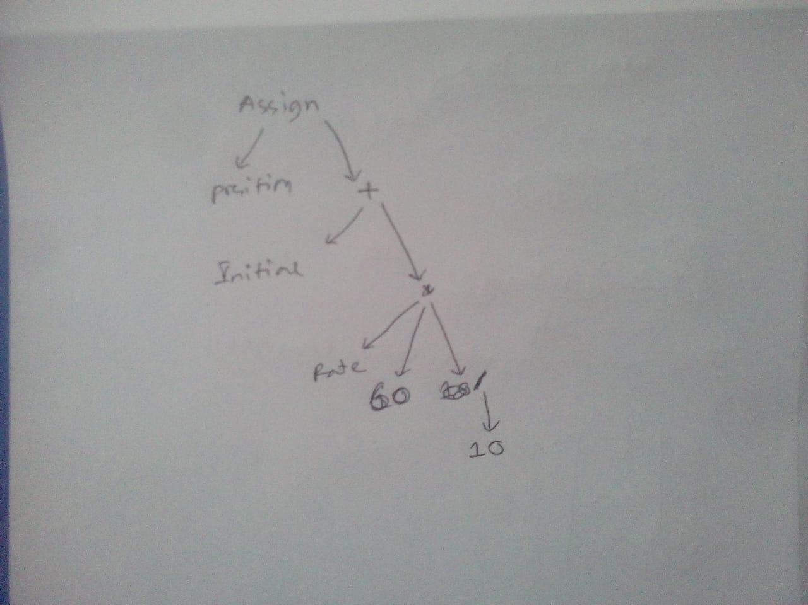

1. Write a regular expression for the following language:
   1. The set of strings over alphabet ∑= {a, b} which starts with aba and ends with bab. [4]

Answer:

Regular Expression = (abab +(aba(ab+ba+aa+bb)* bab))^+

* 1. The set of all strings of 0’s and 1’s containing 101 as a substring. [4]

Answer: ((0+1)*101(0+1)*)

1. Write English definition of the following RE: [2]

**(0|1)+ 01**

Answer: all strings of 0’s and 1’s having 01 as a substring.

1. Write notes on: [4]
   1. Symbol table

Answer : **Symbol table** is an important data structure created and maintained by **compilers** in order to store information about the occurrence of various entities such as variable names, function names, objects, classes, interfaces, etc. **Symbol table** is used by both the analysis and the synthesis parts of a **compiler.**

* 1. Panic mode recovery.

Answer: When a parser encounters an error anywhere in the statement, it ignores the rest of the statement by not processing input from erroneous input to delimiter, such as semicolon. This is the easiest way of error-**recovery** and also, it prevents the parser from developing infinite loops.