**Course Code: CSE 429**

**Quiz: 1**

**Corse name: Compiler Design**



**Marks: 20**

**minutes**

**Time: 20**

1. How compiler differs from interpreter? [4]
2. Write a regular expression for the following language: [3]

The set of strings over alphabet ∑= {0, 1} which starts and ends with different symbols.

1. Write total 6 scenarios including 3 test cases that will satisfy and 3 scenarios which will not satisfy the given problem description of the following RE:

|  |  |
| --- | --- |
| [3] | **(1+Ɛ)(00*1)*0\*** |
|  |
| 4. Consider the following code snippet: | [8] |
| void main() |  |
| { |  |
| int number, odd=0,even=0; |  |
| scanf("%d", &number); |  |
| if(number % 2 == 0) |  |
| even++; |  |
| else |  |
| odd++; |  |

}

What are the tokens, lexemes and pattern for the given scenario?

**Answer 4:**

**Tokens:** Token is a sequence of characters that can be treated as a single logical entity.

Typical tokens are,

1) Identifiers 2) keywords 3) operators 4) special symbols 5)constants

**Lexeme:** A lexeme is a sequence of characters in the source program that is matched by the pattern for a token.

**Patterns:** There is a set of strings in the input for which the same token is produced as output. This set of strings is described by a rule called a pattern associated with the token.

|  |  |  |
| --- | --- | --- |
| Lexeme | Token | Pattern |
| void | keyword |  |
| main | keyword |  |
| ( | separator |  |
| ) | separator |  |
| int | keyword |  |
| number | identifier |  |
| , | separator |  |
| odd | identifier |  |
| = | operator |  |
| 0 | literal |  |
| even | identifier |  |
| scanf | keyword |  |
| %d | keyword |  |
| if | keyword |  |
| % | operator |  |
| == | operator |  |
| ++ | operator |  |
| ; | separator |  |
| { | separator |  |
| } | separator |  |
| 2 | literal |  |

Answer 01 :

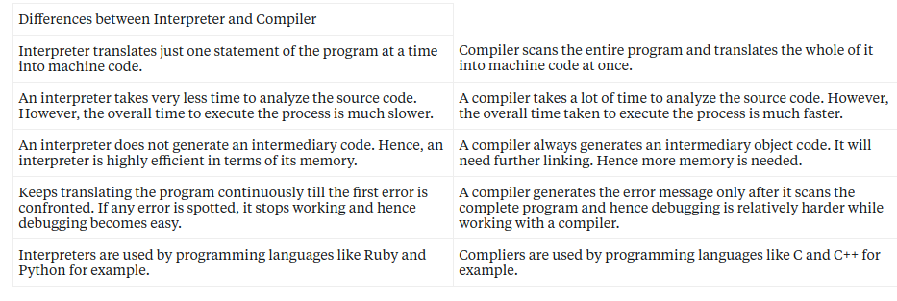

Answer 02:

(0(0+1)*1)^+ + ((1(1+0)*)^+