**Course Code: CSE 429**

**Quiz: 1**

**Corse name: Compiler Design**



**Marks: 20**

**minutes**

**Time: 30**

1. Let L ={a, b} [5]

Suppose you have come across the following scenario:

“The set of all strings consisting of a or b which starts with even number of a’s and ends

with **abb**.”

Write the regular expression for this language.

Answer :

Regular expression 1 = (aabb | ( aaaa)^+bb)^+

Regular expression 2 = (aabb + (aaaa)^+bb)*

2. What will be the transition diagram of the following FA: [3]

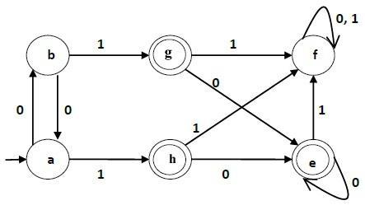

Answer:

Transition Table:

|  |  |  |
| --- | --- | --- |
| State / input | 0 | 1 |
| a | b | h |
| b | a | g |
| f | f | f |
| *g | e | f |
| *h | e | f |
| *e | e | f |

3. Consider the following NFA N over alphabet ∑= {a,b}. Construct a DFA D by using subset

|  |  |
| --- | --- |
| construction, so that D accepts the same language as N does. | [12] |

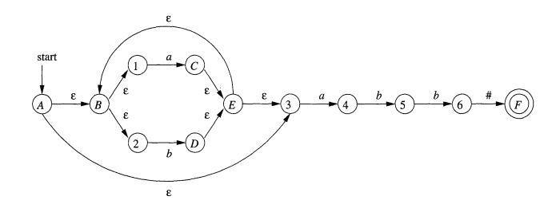

Answer :

1. NFA Transition table

|  |  |  |  |  |
| --- | --- | --- | --- | --- |
| State/input | epsilon(ep) | a | b | # |
| A | {B,3} | - | - | - |
| {B,3} | 2 | 4 | - | - |
| C | E | - | - | - |
| D | E | - | - | - |
| E | {3,B} | - | - | - |
| {3,B} | 1 | 4 | - | - |
| *F | - | - | - | - |
| 1 | - | C | - | - |
| 2 | - | - | D | - |
| 3 | - | 4 | - | - |
| 4 | - | - | 5 | - |
| 5 | - | - | 6 | - |
| 6 | - | - | - | F |

Transition Diagram:

Own task