**Object-Oriented Programming Lab#8, Fall 2019**

**Today’s Topics- “*Exception”***

**Problem 1:**

1. Write the following Java application.

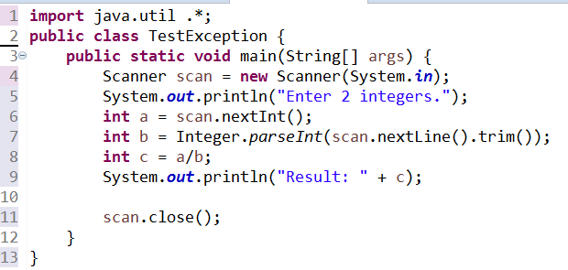

Now run the application 4 times with the following input and save the screenshot of output.

**Run1**: 6, 3

**Run2**: 6, a

**Run3**: a, 6

**Run4**: 6, 0

1. Add appropriate try/catch to handle the exceptions of problem 1.

**Problem 2:**

1. Write the following Java application and update main as below.
   1. Call ***throwException(105)*** and run it. Take the screen shot of the output and save it.
   2. Update the parameter to -5 and run it. Take the screen shot of the output and save it.
   3. Call ***throwException*** again with 200 as parameter. Add appropriate try/catch and print the message.

|  |
| --- |
| **public** **class** TestException {  **public** **static** **void** main(String[] args) {  // follow instruction above  }    **public** **static** **void** throwException(**int** n) **throws** InvalidParameterException, IOException{  Integer.*parseInt*("2");  **if** (n<=0){  // throw InvalidParameterException with message set to "Parameter must be greater than 0.";  }    **if** (n>100){  // throw IOException with message set to "Parameter must be smaller than 100.";  }    System.***out***.println(n*n);  }  } |

**Problem 3(Project Related):**

1. Update the **BankAccount** project and throw exceptions for invalid inputs.
   1. Update **withdraw**() to throw **InsufficientBalanceException**
      1. In ***BankAccount*** class, throw the InsufficientBalanceException (use InsufficientBalanceException(**double** amt) constructor) if withdraw amount results the balance to go below **minimumBalance**. Pass (accountBalance -minimumBalance) as the parameter of ***InsufficientBalanceException*** constructor.
      2. In ***SavingAccount*** class, throw the InsufficientBalanceException (use InsufficientBalanceException(**double** amt) constructor) if withdraw amount is more than maximum withdraw limit. Pass maximum withdraw limit as the parameter of ***InsufficientBalanceException*** constructor.
   2. In **Bank** class, do not handle the ***InsufficientBalanceException*** in **withdraw()** method, just pass it in the method header.
   3. In **main** method, handle the ***InsufficientBalanceException*** and show a pop-up message with appropriate message.

***Code of InsufficientBalanceException:***

**public** **class** InsufficientBalanceException **extends** Exception {

**public** InsufficientBalanceException(String message) {

**super**(message);

}

**public** InsufficientBalanceException(**double** amt) {

**super**("Can't withdraw more than " + amt + " taka.");

}

}