**Object-Oriented Programming Lab#8, Fall 2019**

**Today’s Topics- “*Exception”***

**Problem 1:**

1. Write the following Java application.

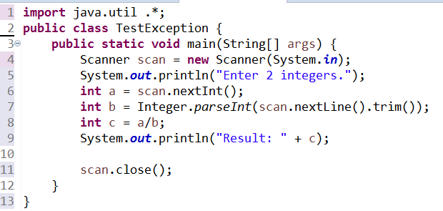

Now run the application 4 times with the following input and save the screenshot of output.

**Run1**: 6, 3

**Run2**: 6, a

**Run3**: a, 6

**Run4**: 6, 0

1. Add appropriate try/catch to handle the exceptions of problem 1.

**Problem 2:**

Complete the following Java application and update main as below.

* 1. Call ***throwException(105)*** and run it. Take the screen shot of the output and save it.
  2. Update the parameter to -5 and run it. Take the screen shot of the output and save it.
  3. Call throwException again with 200 as parameter. Add appropriate try/catch and print the message.

|  |
| --- |
| **public** **class** TestException {  **public** **static** **void** main(String[] args) {  // follow instruction above  }    **public** **static** **void** throwException(**int** n) **throws** InvalidParameterException, IOException{  Integer.*parseInt*("2");  **if** (n<=0){  // throw InvalidParameterException with message set to "Parameter must be greater than 0.";  }    **if** (n>100){  // throw IOException with message set to "Parameter must be smaller than 100.";  }    System.***out***.println(n*n);  }  } |

**Problem 3(Project Related):**

Update the **Employee** project and throw exceptions for invalid inputs.

1. Update ***IncreaseSalary***() to throw ***InvalidSalaryException***
   * 1. In **SalariedEmployee** class, throw the ***InvalidSalaryException*** if parameter is less than 0. Pass “Increase amount should be a positive number.” as the parameter of ***InvalidSalaryException*** constructor.
     2. In ***HourlyEmployee*** class, throw the **InvalidSalaryException** if hourly rate becomes more than 500. Pass “Hourly rate can’t be more than 500” as the parameter of ***InvalidSalaryException*** constructor.
     3. In ***CommissionEmployee*** class, throw the ***InvalidSalaryException*** if parameter is commission becomes more than 30. Pass “Commission cannot be more than 30%” as the parameter of ***InvalidSalaryException*** constructor.
2. In UapCse class do not handle the InvalidSalaryException in increaseSalary method.
3. In main, handle the InvalidSalaryException and show a pop-up message with appropriate message.

***Code of InvalidSalaryException***:

**public** **class** InvalidSalaryException **extends** Exception {

**public** InvalidSalaryException(String message) {

**super**(message);

}

}