**Lab#1, Fall 2019  
CSI 204, Object-Oriented Programming Lab**

**Basics for Today’s Lab**

**Structure/Format of Class**

<modifier> class <class name>{

// Declare attributes

<modifier> <data type> <attribute name>;

<modifier> <data type> <attribute name> [=<value >] ;

// Constructor

<modifier> <class name> (<argument>){

<statements>;

}

// Method

<modifier> <return type > <method name>(<argument>){

<statements>;

}

} // end of class

**Application Class - with main method**

**public** **class** Test{

**public** **static** **void** main(String[] args) {

//Statements;

**int** a=3;

**int** b = 4;

**int** c = a+b;

System.***out***.println(c);

}

}

**Input and Output**

**Standard Java Output**

***System.out*** is standard out in Java

***System.err*** is error out in Java

**Example:**

**public** **class** TestMain {

**public** **static** **void** main(String[] args) {

System.***out***.println("Welcome to Java!");

}

}

**Standard Java Input**

* Scanner class is in jdk 1.5

**Problems/Assignments**

**Problem1: Write a program that will print/display “Hello World!” in the screen.**

**Steps:**

1. Create a java class that will have the main method and display the “Hello World!”. See below for steps.
   1. Open NotePad or TextPad and create a blank document from File Menu.
   2. Now in the document create a class named “HelloWorld”.

*public class HelloWorld{*

*}*

* 1. Add the main method.

*public static void main(String[] args){*

*}*

* 1. Add the following statement inside the main method to print/display the text “Hello World!”

*System.out.println(“Hello World!”);*

* 1. Save the file as **HelloWorld.java**. Choose “All Files” option from “Save as type” drop down as shown below. Save the file in any location or you can choose “C:\Temp” folder.

**Note**: The file name should be exactly the same as class name. For this case it would be “HelloWorld”

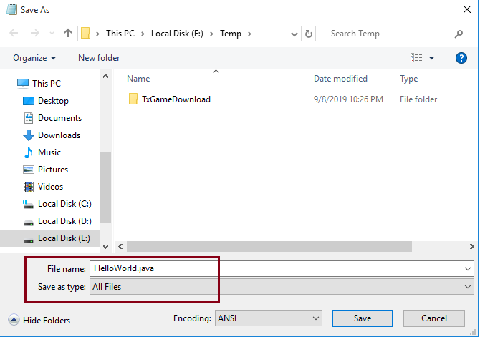

1. Now compile the file. See below for steps.
   1. Open command prompt.
   2. If you need to change directory, change it using cd command [Example command show below]

*cd “C:\Temp”*

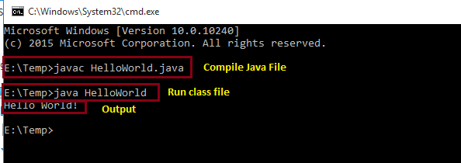

* 1. Now compile the file using following command.

*javac HelloWorld.java*

**Note**: Compiling the .java file will create file with same name as the java file with extension .class. So for this case it will generate a file named **HelloWorld.class**. Open Windows explorer and check if the .class file is created or not.

1. Now run the class file using the command below.

*java HelloWorld*

**Note**: Do not use the .class extension.

**Problem 2: Write a Java program to find the max and min of 3 values.**

1. Repeat steps of problem#1 to find the max and min of 3 numbers.
   1. Inside main, declare 3 integer variables and assign 3 different values.
   2. Implement the logic to find the max and min of those 3 values and print the values.

|  |  |
| --- | --- |
| **Sample Input** | **Sample Output** |
| 6, 9, 4 | Max: 9  Min: 4 |

**Problem 3:** Write a Java program to find the summation and average of 3 integer values.

|  |  |
| --- | --- |
| **Sample Input** | **Sample Output** |
| 6, 6, 7 | Sum: 19  Avg: 6.33 |