1. Perform FCFS and shortest job first CPU scheduling algorithm on the following case:

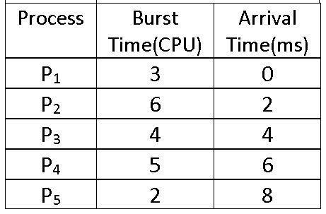

1. Perform Priority Scheduling CPU scheduling algorithm on the following case:

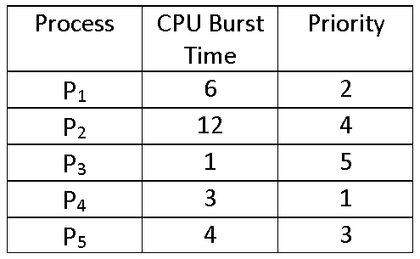

1. Perform Round Robin CPU scheduling algorithm on the following case(Quantam 3):

