Show all cartoons’ name

select CartoonName
from Main

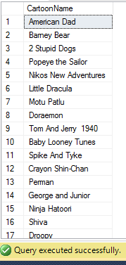
Sort all cartoons’ in alphabetic order

select CartoonName
from Main
order by CartoonName

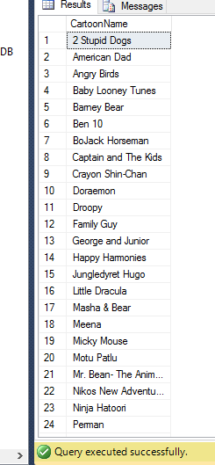

Find all cartoons’ name with relasing year between 1995 and 2000

select CartoonName
from Main
where ReleaseYear between 1995 and 2000

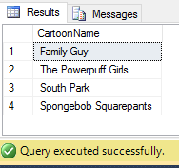

Find runtime average of all cartoons’

select avg (Runtime)
from Main
where CartoonId between 8001 and 8038

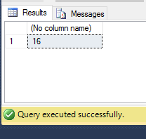

Show plot about number 8021 cartoon

select Plot
from Main
where CartoonId = '8021'

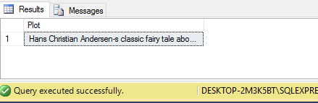

Show all information about the cartoon ‘Spongebob Squaerepants’

select *
from Main
where CartoonName ='Spongebob Squarepants'

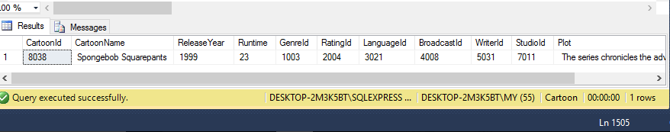

Show total count of cartoon id with running time of 11 min
select count (Runtime)
from Main
where CartoonId between 8001 and 8038 and Runtime = 11;

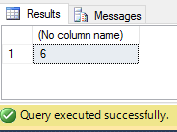

Show the total count of cartoons that has running time more than 8 min

select count (Runtime)
from Main
where Runtime>8

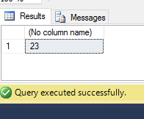

Remove duplicates from location

select distinct Location
from Studio

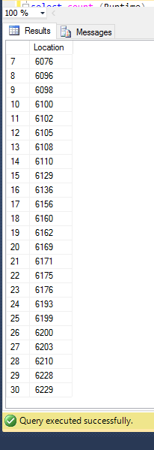

Find the names of all writer whose name includes the substring "ael"

select WriterName
from Writer
where Writername like '%ael%'

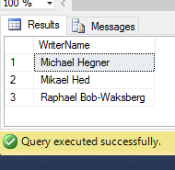

Find the names of all cartoons’ where studio id is 7004 or runtime is 11 min

(select CartoonName from Main where StudioId = '7004')
union
(select CartoonName from Main where Runtime = '11')

