**Show all cartoons’ name**

select CartoonName

from Main

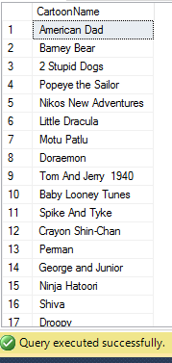

**Sort all cartoons’ in alphabetic order**

select CartoonName

from Main

order by CartoonName

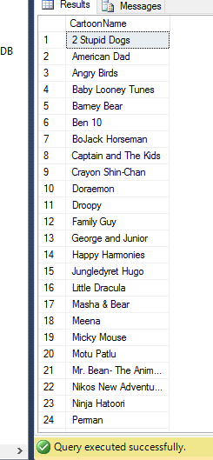

**Find all cartoons’ name with relasing year between 1995 and 2000**

select CartoonName

from Main

where ReleaseYear between 1995 and 2000

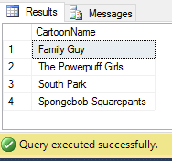

**Find runtime average of all cartoons’**

select avg (Runtime)

from Main

where CartoonId between 8001 and 8038

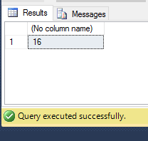

**Show plot about number 8021 cartoon**

select Plot

from Main

where CartoonId = '8021'

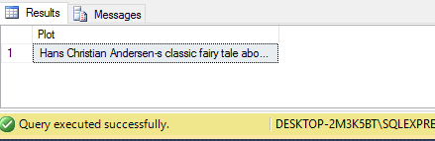

**Show all information about the cartoon ‘Spongebob Squaerepants’**

select *

from Main

where CartoonName ='Spongebob Squarepants'

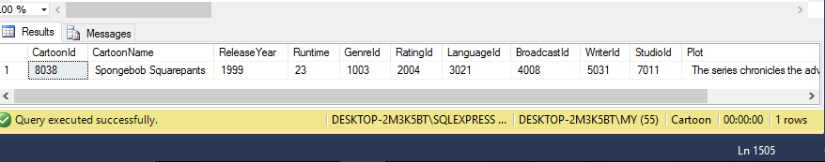

**Show total count of cartoon id with running time of 11 min**

select count (Runtime)

from Main

where CartoonId between 8001 and 8038 and Runtime = 11;

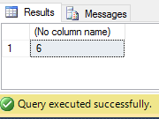

**Show the total count of cartoons that has running time more than 8 min**

select count (Runtime)

from Main

where Runtime>8

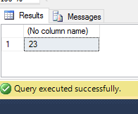

**Remove duplicates from location**

select distinct Location

from Studio

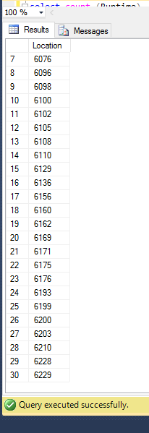

**Find the names of all writer whose name includes the substring "ael"**

select WriterName

from Writer

where Writername like '%ael%'

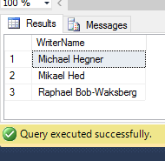

**Find the names of all cartoons’ where studio id is 7004 or runtime is 11 min**

(select CartoonName from Main where StudioId = '7004')

union

(select CartoonName from Main where Runtime = '11')

