1. Created and configured a public GitHub repository
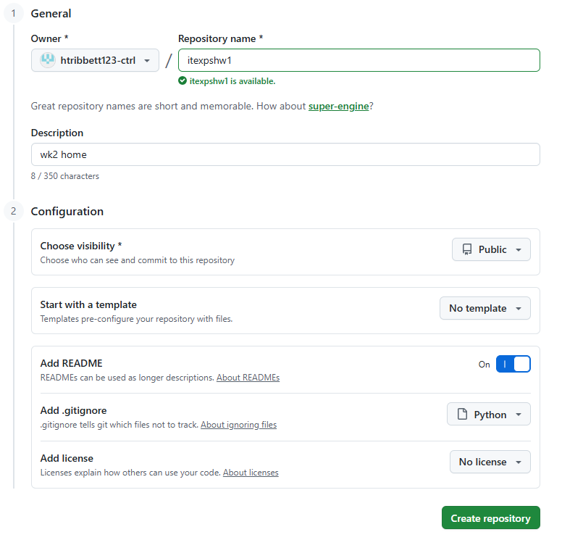
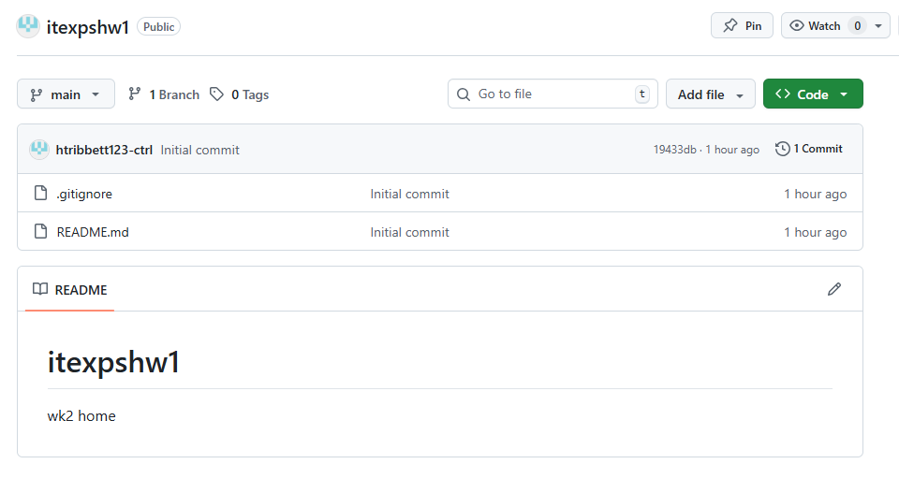
2. Cloned remote repository to local development environment.
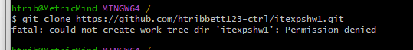

Resolved directory permission issue by navigating to appropriate working directory.

My access is being denied because I am in my root (/) and in Git Bash it is not writable

So I have to run tis command to solve this problem
cd ~ takes me right to my home directory
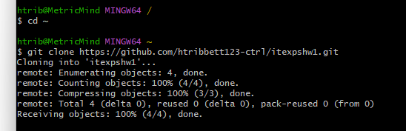
Run pwd:
Am in my home folder/directory
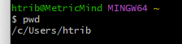
Now I move inside folder:


3. Add two text files (1.txt, 2.txt) each having 2 lines for text
File 1.txt
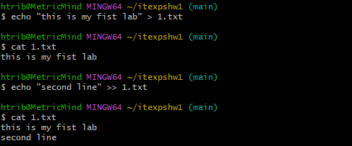
File 2.txt
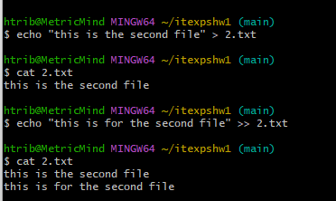
Now I will add:
File has not been staged yet
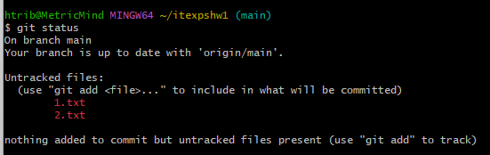

Used git add . to add all files
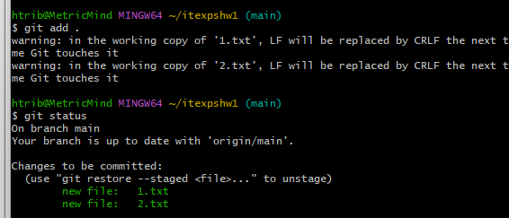
4. Commit the changes to your local repository with message "Initial Structure"
When I commit it commit the file that I have staged
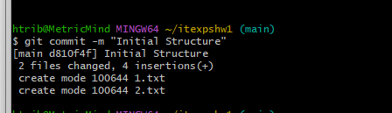

Pushed updates to remote repository.
5. Push the file to remote repository on github
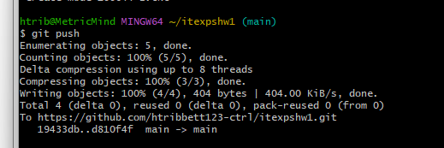

Changes have been pushed to repo:
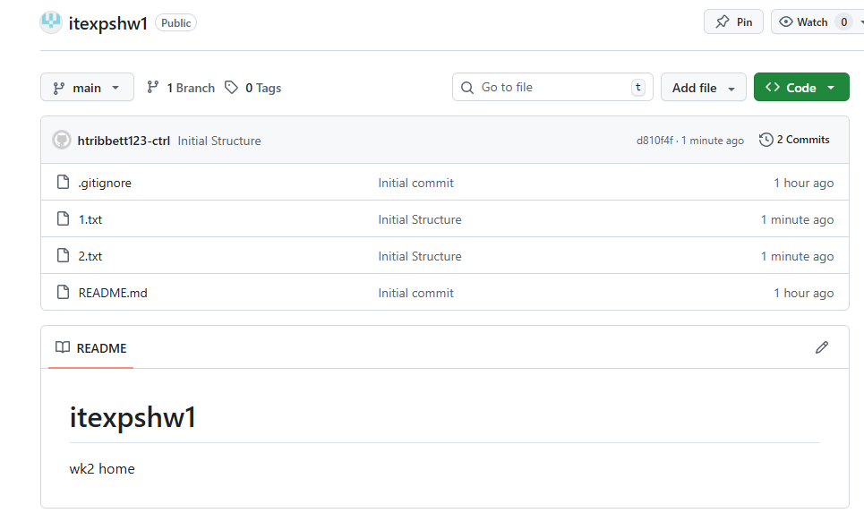

Implemented feature branching workflow (main + feature branch).
Create a local branch with name f1
Am in main branch
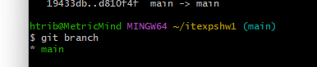
Created branch and 7. switch local repository to new branch
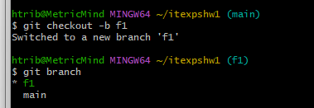

8. Add a new file 3.txt with two lines of text to the branch
Created file and checking branch
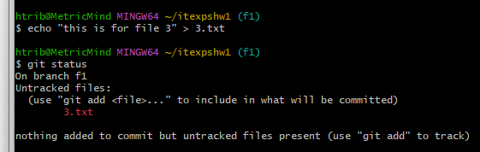
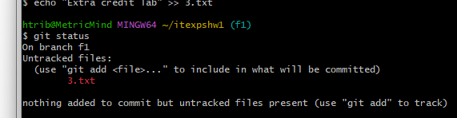

3.txt is now staged
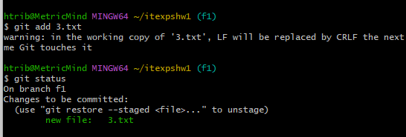
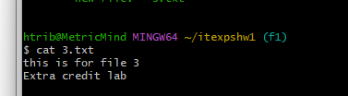

Now we commit:
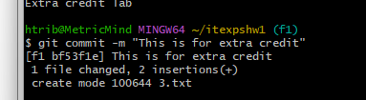
Now we switch to main branch to push.
We have to be in main branch because that is the branch that will receive the changes
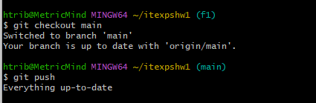

Merged feature branch into main using Git merge.
now I merged f1
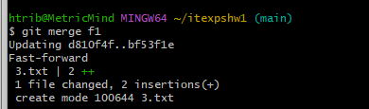
Now we push:
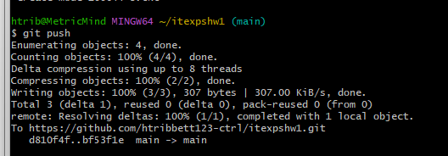

3.txt Added to repo
